**AtkinsJacobs**

via Bravo

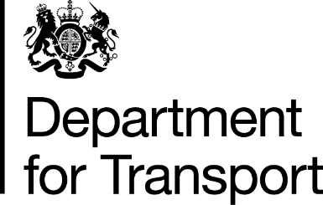

Department for Transport

Group Commercial Directorate

Great Minster House

Horseferry Road

London

SW1P 4DR

Web Site: [www.dft.gov.uk](http://www.dft.gov.uk)

21 February 2020

**OFFICIAL**

Dear Sir/Madam

**SPECIALIST PROFESSIONAL AND TECHNICAL SERVICES FRAMEWORK**

**Lot 1 - Technical Consultancy, Engineering Advice, Research and Innovation**

**1-990 TETI1014 OLEV/CCAV -Access to Finance for SMEs**

On behalf of the Secretary of State for Transport, I am authorised to accept your proposal of 20 January 2020 for the above Package Order at the prices/rates quoted.

This Package Order start date is 21 February 2020, and the completion date is 30 April 2020.

The authorised maximum Package Order cost is **£99,998.68** (excluding VAT). This cost is not to be exceeded without prior written approval of the Procurement Officer.

x is the Project Sponsor, and can be contacted direct on x to arrange a start-up meeting.

Any queries relating to this letter and its contents should be sent via Bravo messaging.

Yours faithfully