Licensing opportunity information sheet

History of Science: Meteorology

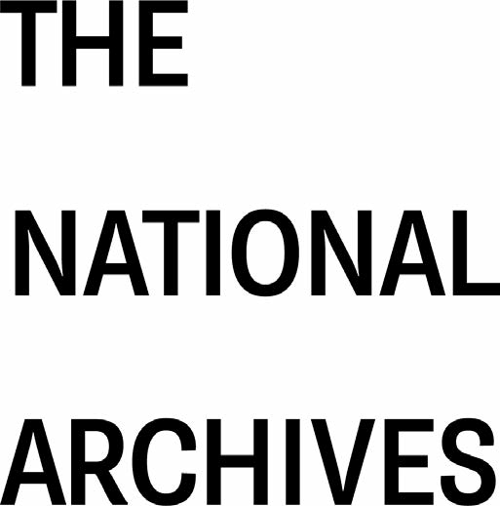
1. INTRODUCTION

  - The Records of the Meteorological Office

The records of the Meteorological Office and predecessor and related bodies, records of the Kew Observatory and private papers of associated personnel are the subject of this digitisation opportunity. The record series encompassed by this opportunity are BJ 1 and BJ 3-10, covering a date range of approximately 1818-1991. These records are a rich repository of scientific history and cover subjects ranging from terrestrial magnetism and atmospheric phenomena to scientific instruments and expeditions. Included here are the official and scientific papers of Admiral Robert Fitzroy, as well as material relating to the Royal Charter Storm of October 1859, which led to the first storm warnings being issued in 1860.

  - Administrative background

Arising out of the Brussels Conference of Maritime Nations in 1853 and consultations, initiated by the Board of Trade with the Royal Society in the following year, a Meteorological Department of the Board was formed at the beginning of August 1854 for the collection and co-ordination of meteorological observations made at sea.

Its first Superintendent, Admiral Robert Fitzroy, extended the functions of the department by initiating regular weather reports from a network of land stations, employing for the purpose the recently invented electric telegraph. With their aid he issued storm warnings to certain ports for the benefit of seamen and also began the practice of 'forecasting'.

In 1867 the name of the department was changed to the Meteorological Office and in the same year the office was transferred from the Board of Trade and placed under the administrative control of a Meteorological Committee, the members of which were appointed by the Royal Society. A grant in aid was assigned by the Treasury, the committee being responsible for the administration of the grant.

In 1877, following a review of these arrangements by a Treasury committee, the committee was replaced by a paid council of six members, of whom the Hydrographer of the Navy was one and the remaining five were nominated by the Royal Society. R H Scott, who had been the director of the Office since 1867, became Secretary of the Meteorological Council, while retaining informal administrative control.

In 1905, following the recommendations of another Treasury committee, the Office was placed under the management of a reconstituted Meteorological Committee, consisting of the director as chairman, the hydrographer, two members appointed by the Royal Society, and one each appointed by the Board of Trade, the Board of Agriculture and Fisheries and the Treasury. This committee was responsible for administering the Treasury grant in aid, but the director was responsible for the day-to-day administration of the office.

During this period the Office developed steadily and by 1914 it was organised into separate Marine, Forecast and Storm Warning, Statistics and Library, Observing, Instruments, and Correspondence and Accounts Branches. In 1910 it took over from the National Physical Laboratory administration of Kew Observatory.

During the First World War three other meteorological services were developed: that of the Air Ministry, responsible for the supply of information for airships; that of the Admiralty, developed to meet the needs of the Royal Navy; and the Meteorological Section of the Royal Engineers, formed to meet the requirements of aircraft and gas warfare in France. The unco-ordinated development of these four services resulted in serious duplication and overlap, and by 1922, following the recommendations of a sub-committee of the Research Committee of the Cabinet, the three younger services were absorbed into the Meteorological Office, which was to become a 'central State Meteorological Service'.

The reconstituted office was attached originally to the Civil Aviation Department of the Air Ministry, the director being appointed by the Air Council. The sub-committee's recommendation that there should be a 'board of management' for the Office was met by a reorganised Meteorological Committee, representative of all departmental and scientific interests concerned, to which all important policy questions affecting the office and all appointments to higher posts on its staff were referred for advice. In 1927 the office's responsibility for research into atmospheric pollution was transferred to the Department of Scientific and Industrial Research.

Meanwhile, the development of the Fleet Air Arm resulted in the Navy establishing its own meteorological service in ships carrying aircraft. In 1937, to overcome the organisational anomalies that were becoming apparent, it was decided to transfer the administrative functions of the Naval Division of the Meteorological Office to the Admiralty's Hydrographic Department.

Since 1990 the Meteorological Office has been an executive agency within the Ministry of Defence, the chief executive being responsible to the Secretary of State for Defence. In addition to its defence role the Office provides meteorological services for the public services, the press, industry and the public, and undertakes research in meteorology and geophysics.

2. SCOPE OF THE DIGITISATION OPPORTUNITY

2.1 Record series
See Appendix A for detailed metadata.

Record series: | Description:
BJ 1: Kew Observatory: Correspondence and Papers, 1821-1968 | This series reflects the work of the Kew Observatory under its various committees and as the Observatory Department of the National Physical Laboratory, with registered files from 1821 onwards. Correspondence and papers of various officers of the observatory include those of John Welsh, John Peter Gassiot, Balfour Stewart, Samuel Jeffery (or Jeffrey), George Matthews Whipple, Robert Henry Scott and Francis John Welsh Whipple. Publications on meteorology and associated subjects include several by Sir Edward Sabine and George Matthews Whipple, and parliamentary papers, 1854-1875. Other papers include some Meteorological Office monthly reports, 1916-1924.
BJ 3: Sir Edward Sabine: Correspondence and papers, 1818-1877  [excluding BJ 3/ 1, 16-18, 22 & 58-63] | This series comprises the personal letters and papers of Sir Edward Sabine, and official correspondence, papers and letter books of his Magnetic Department.  The correspondence is mainly from the period preceding James Clark Ross' Antarctic expedition and the period immediately after. The papers relate mainly to the establishment of magnetic observatories overseas and to various scientific observations, reflecting the liaison between the Magnetic Department and the overseas observatories. Included is a particularly rich collection of letters to Sabine from Dr Humphrey Lloyd of Trinity College, Dublin.
BJ 4: Meteorological Research Flight, 1947-1965 | This series contains specimens of readings of the Meteorological Research Flight. In 1942, an RAF Flight equipped with Spitfire and Boston aircraft was set up at Boscombe Down, Wiltshire, to investigate meteorological problems associated with the wartime operations of aircraft. In 1946 this Flight was moved to the Royal Aircraft Establishment (RAE) at Farnborough, Hampshire, where it has remained ever since. It was then formally recognised as the Meteorological Research Flight (MRF) with responsibility for conducting atmospheric research from aircraft. The information obtained by the Flight is used in the preparation of weather reports.
BJ 5: Meteorological Office: Administrative Records, 1910-1998 | This series contains files of the Air Ministry, Royal Air Force and Meteorological Office relating to a wide range of business. Subject matter includes international co-operation and research into meteorology and oceanography, meteorological intelligence during the Second World War, a 'Meteorological War Book' (1948-1956), technical research reports and many aspects of the organization of the Meteorological Office and its work.
BJ 6: Board of Trade: Meteorological Department: Meteorological Charts relating to Royal Charter Storm, 1859-1861 | This series contains charts prepared by Admiral Robert Fitzroy relating to the storm of October 1859 in which the iron ship Royal Charter was wrecked. The charts can be consulted in their published form in BJ 6/3.
BJ 7: FitzRoy Papers, 1843-1881 | This series consists of official and scientific papers of Vice-Admiral Robert FitzRoy. Apart from one box of semi-official correspondence dated 1843-1857 from Admiral C R Moorsom, this series relates entirely to FitzRoy's career after 1854. It includes weather charts and reports of collected scientific observations on meteorology and hydrography by FitzRoy and others; memoranda to his secretary Henry Babbington on synoptic and wind charts; and administrative records of the Meteorological Department, including minutes to the Board of Trade on the finances of the department.
BJ 8: Meteorological Committee and Council: Minutes and Reports, 1867-1937 | This series consists of minutes and reports of the Meteorological Committee and Meteorological Council which controlled the work of the Meteorological Office. The minutes contain internal indexes, consolidated for 1867 to 1905 in BJ 8/16.
BJ 9: Board of Trade: Meteorological Department: Registers of Correspondence, 1853-1868 | This series comprises eight volumes of Meteorological Department correspondence registers for out-letters and four volumes of in-letters, as well as some items of associated correspondence found loose in the volumes.  Apart from BJ 9/11 all the registers are indexed, but only by name and (apart from 'telegraphy') not by subject. Loose correspondence found in the registers has been extracted and allocated a separate piece number in this series: BJ 9/13  These registers relate, in the main, to original correspondence and drafts which can be found in the collection of Fitzroy papers in BJ 7; the registers also contain reference to correspondence which does not appear in BJ 7 and vice versa.
BJ 10: Board of Trade and successors: Meteorological Department and successors: Registers of Instruments Supplied for Meteorological Purposes, 1854-c.1915 | Registers recording the issue and return of barometers, hydrometers and thermometers to agents and ships by the Meteorological Department of the Board of Trade and its successors, the Meteorological Committee and the Meteorological Council.  The series contains the five registers that have survived (the existence of a sixth is inferred). Each register provides dates of issue to agents, issue from agents to ships etc, return of instruments and remarks. The makeup of the registers is varied and complex. Dates in the registers are expressed with the last two digits of the year first; for example, 10 May 1879 is rendered as 79.5.10, but it is uncertain that this convention was applied consistently.

3. THEMES

4. DOCUMENT FORMAT
Documents can take the form of tagged files, both loose and housed in boxes, bound volumes and sleeved files.

5. FURTHER OPTIONS FOR DIGITISATION
Additional material about meteorological phenomena and scientific exploration in general may be found in records of the Admiralty (ADM). In particular, captains’ logs in ADM 51 contain details of weather encountered during voyages.
The National Meteorological Library and Archive may be contacted for related archival material held by the Met Office. Potentially relevant material relating to the Royal Observatory in Greenwich is likely to be held at the Caird Library and Archive in the National Maritime Museum.

5. DOCUMENT EXAMPLES

5.1 BJ 1

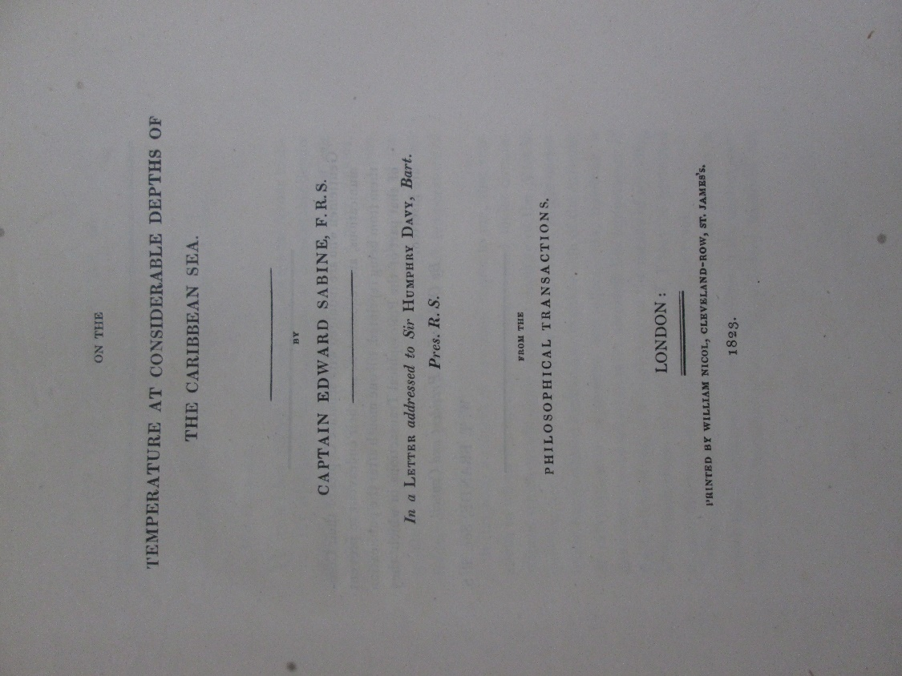
Figure 1: BJ 1/155: On the temperature at considerable depths of the Caribbean Sea, 1823

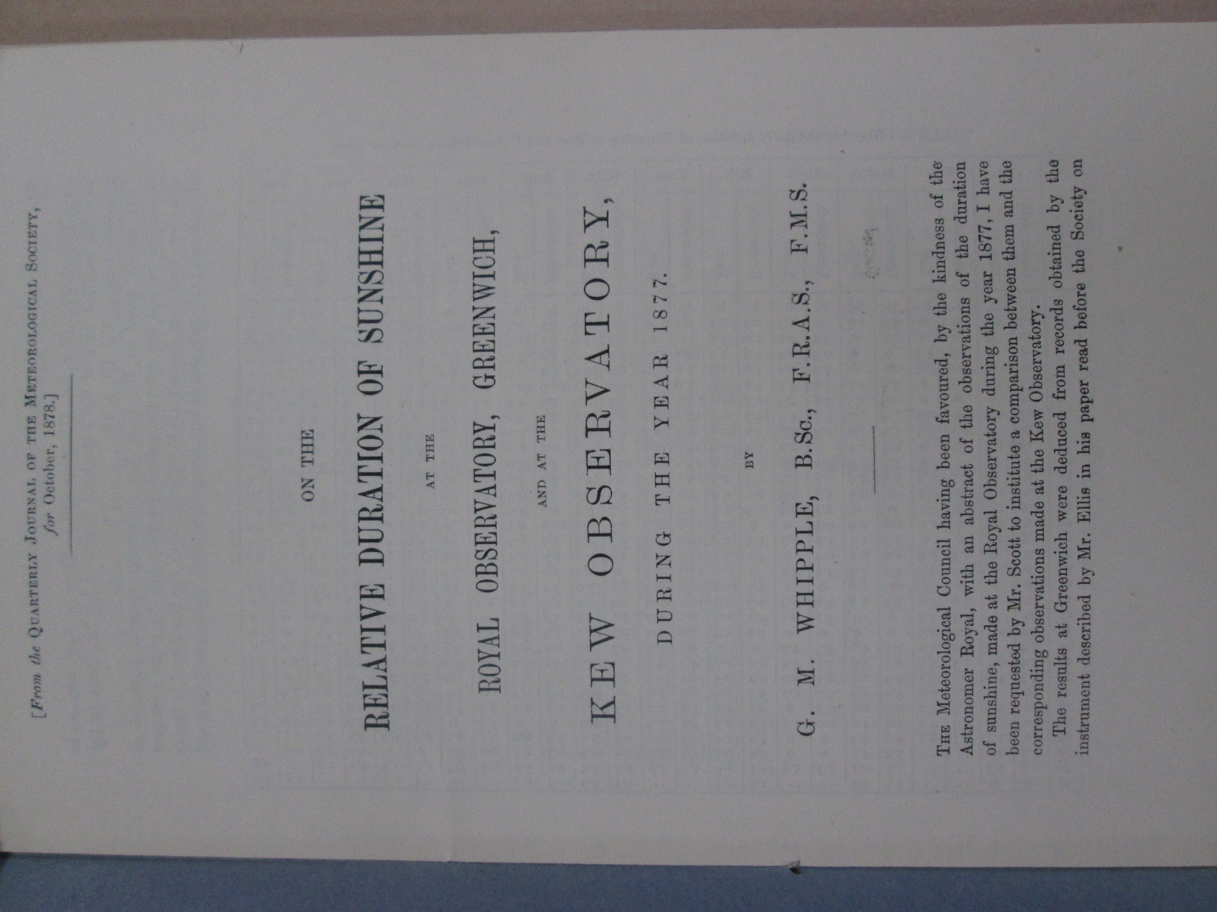
Figure 2: BJ 1/177: On the relative duration of sunshine at the Royal Observatory, Greenwich and at the Kew Observatory, during 1877, 1878

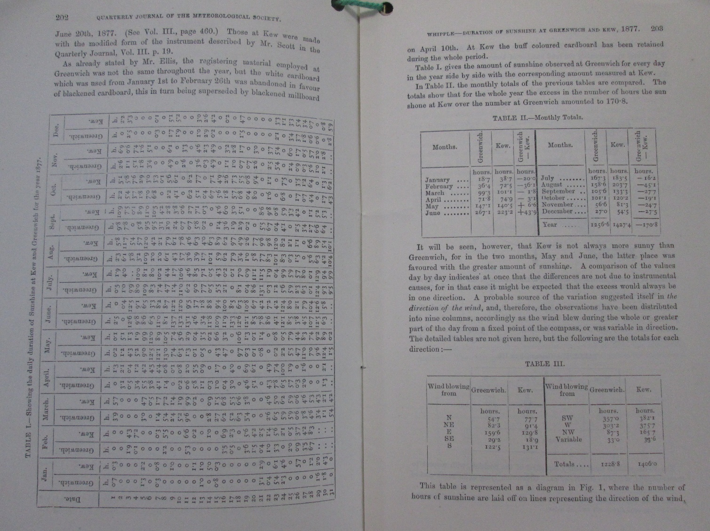
Figure 3: BJ 1/177: On the relative duration of sunshine at the Royal Observatory, Greenwich and at the Kew Observatory, during 1877, 1878

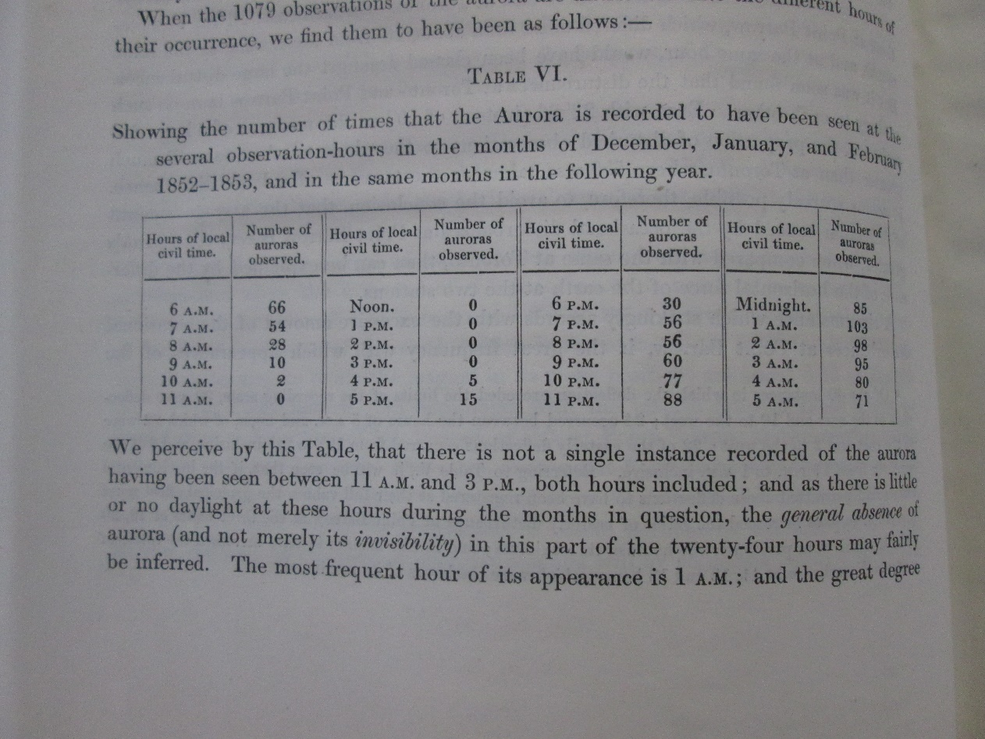
Figure 4: BJ 1/169: Hourly observations of the magnetic declination made by Captain Rochfort Maguire, R.N., and the officers of HMS `PLOVER', in 1852, 1853 and 1854 at Point Barrow, on the shores of the Polar Sea, 1857

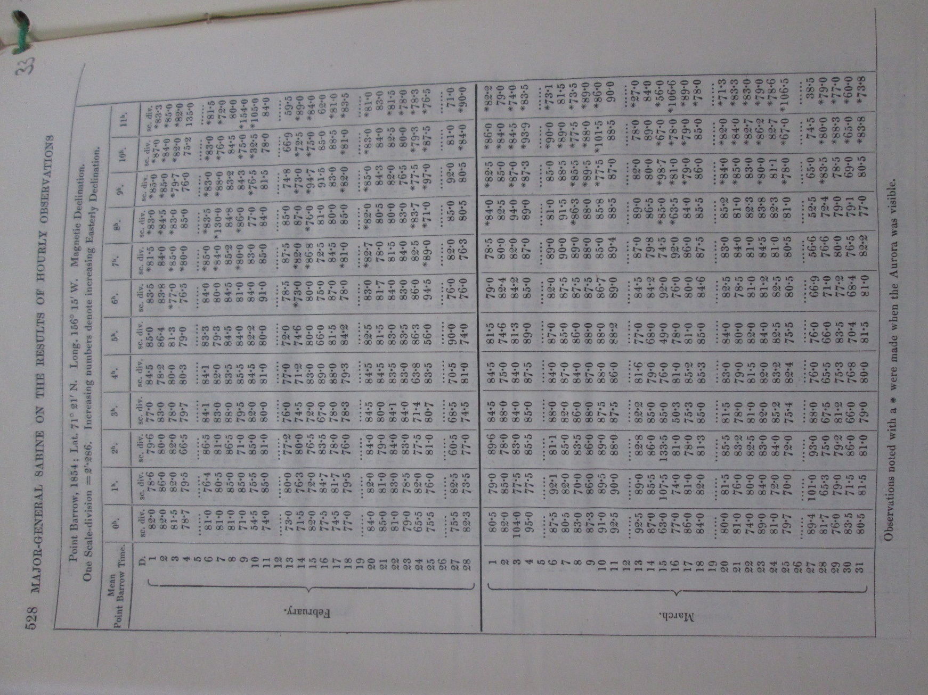
Figure 5: BJ 1/169: Hourly observations of the magnetic declination made by Captain Rochfort Maguire, R.N., and the officers of HMS `PLOVER', in 1852, 1853 and 1854 at Point Barrow, on the shores of the Polar Sea, 1857

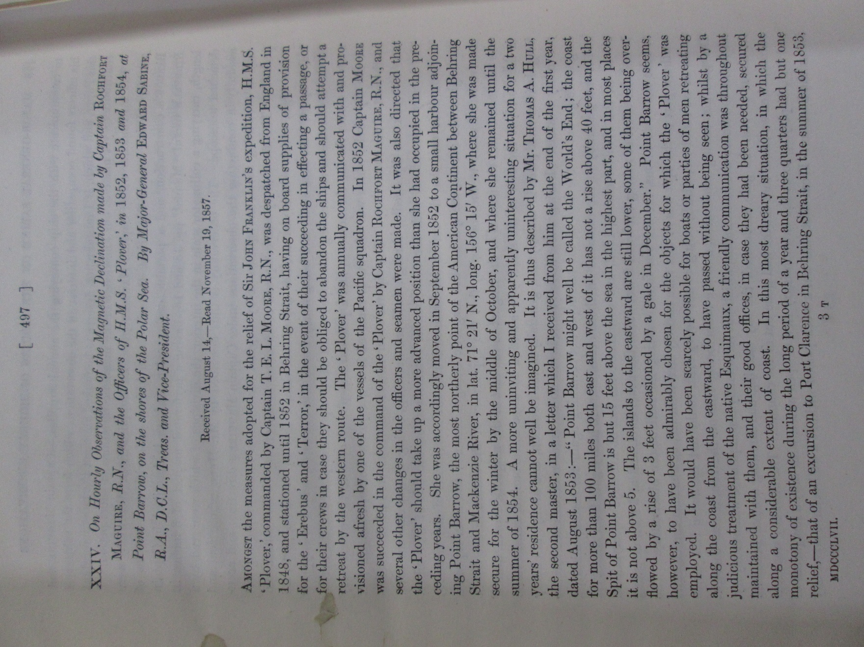
Figure 6: BJ 1/169: Hourly observations of the magnetic declination made by Captain Rochfort Maguire, R.N., and the officers of HMS `PLOVER', in 1852, 1853 and 1854 at Point Barrow, on the shores of the Polar Sea, 1857

5.2 BJ 3

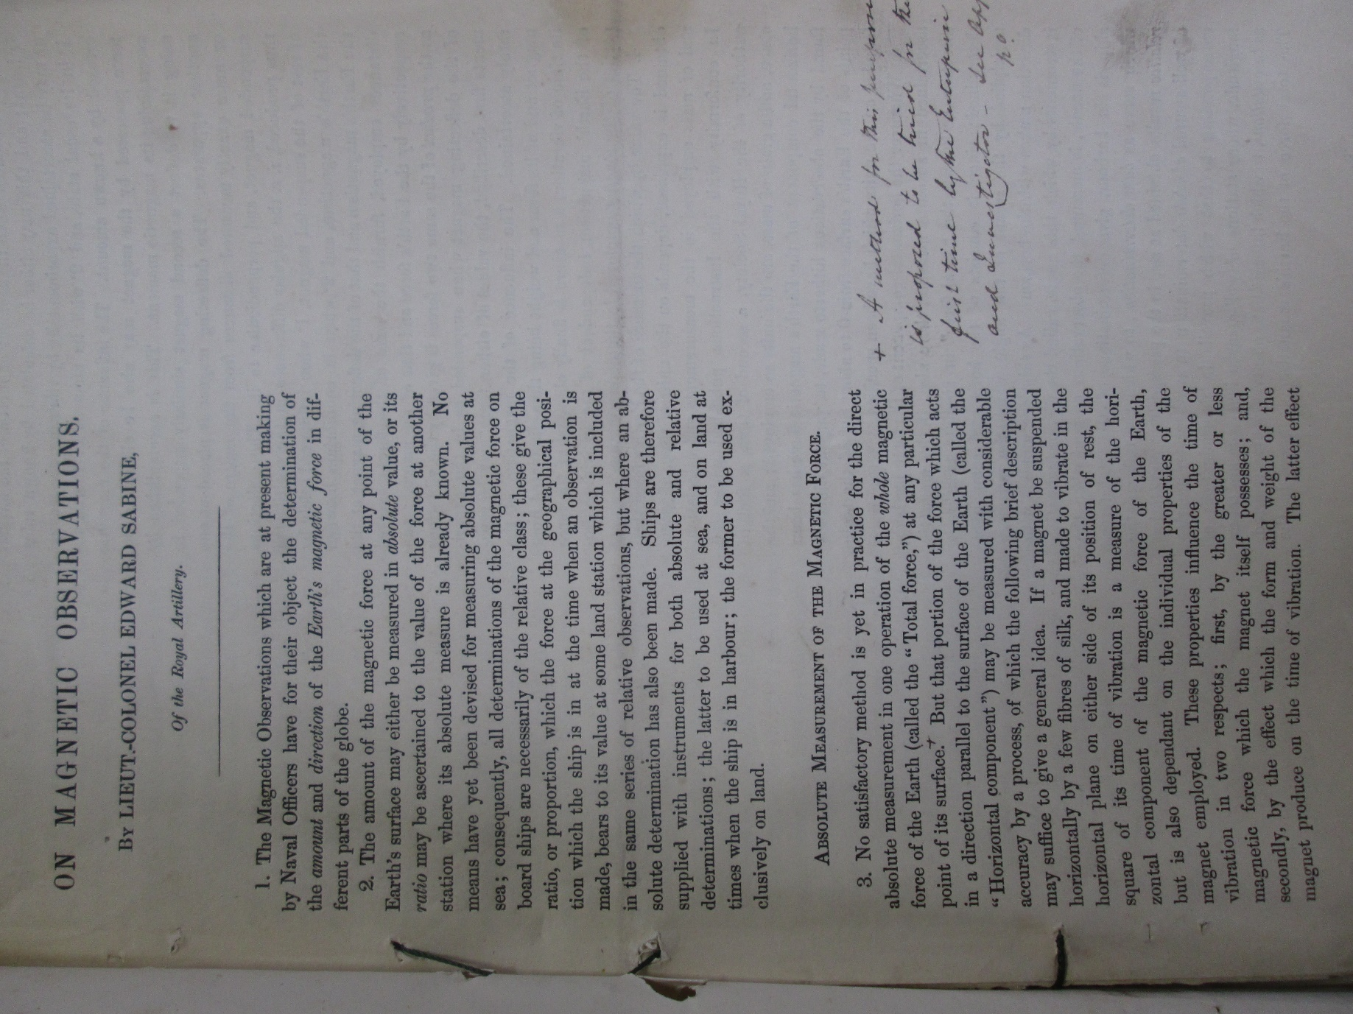
Figure 7: BJ 3/52: Sabine's Magnetic Instructions for Her Majesty's Ships ENTERPRISE and INVESTIGATOR, 1842-1856

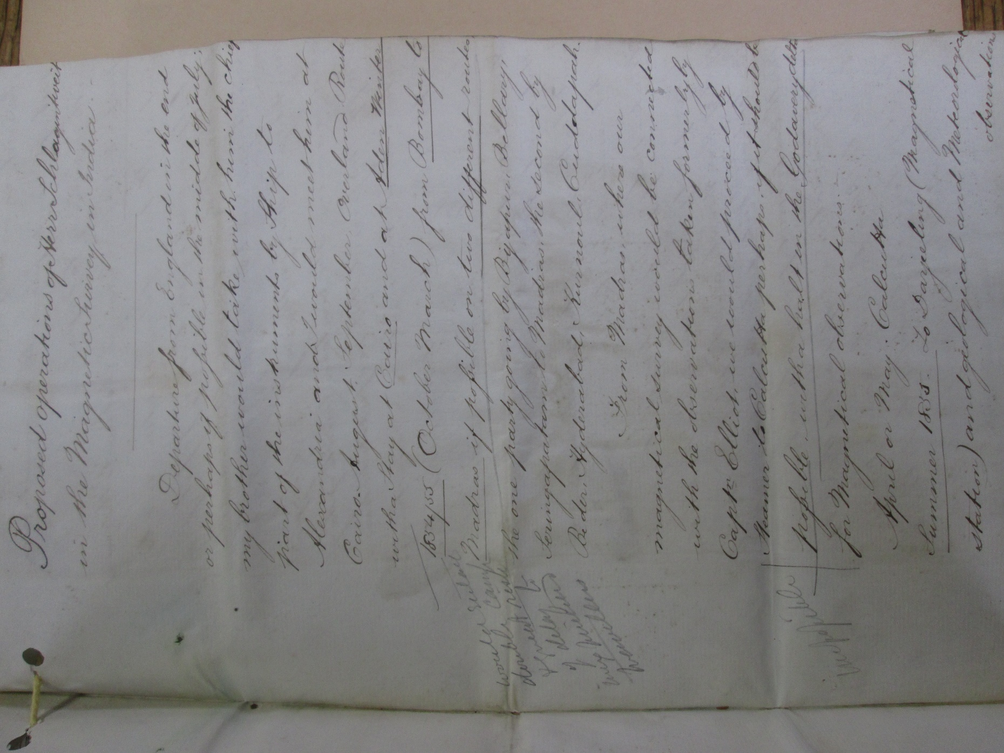
Figure 8: BJ 3/52: Magnetic survey of India, 1842-1856

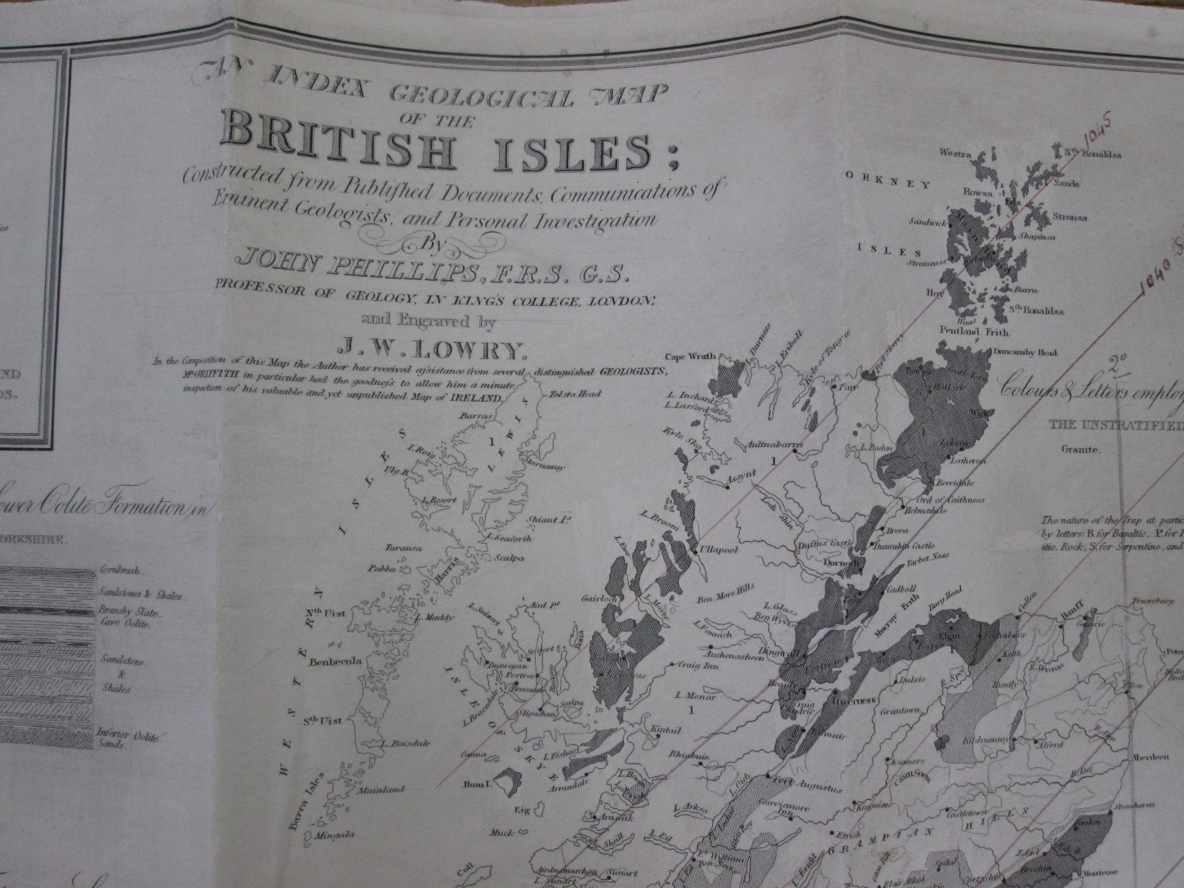
Figure 9: BJ 3/19: Letters to Sabine from R.W. Fox at Falmouth, including map of the British Isles with annotations of magnetic observations, 1838-1845

5.3 BJ 4

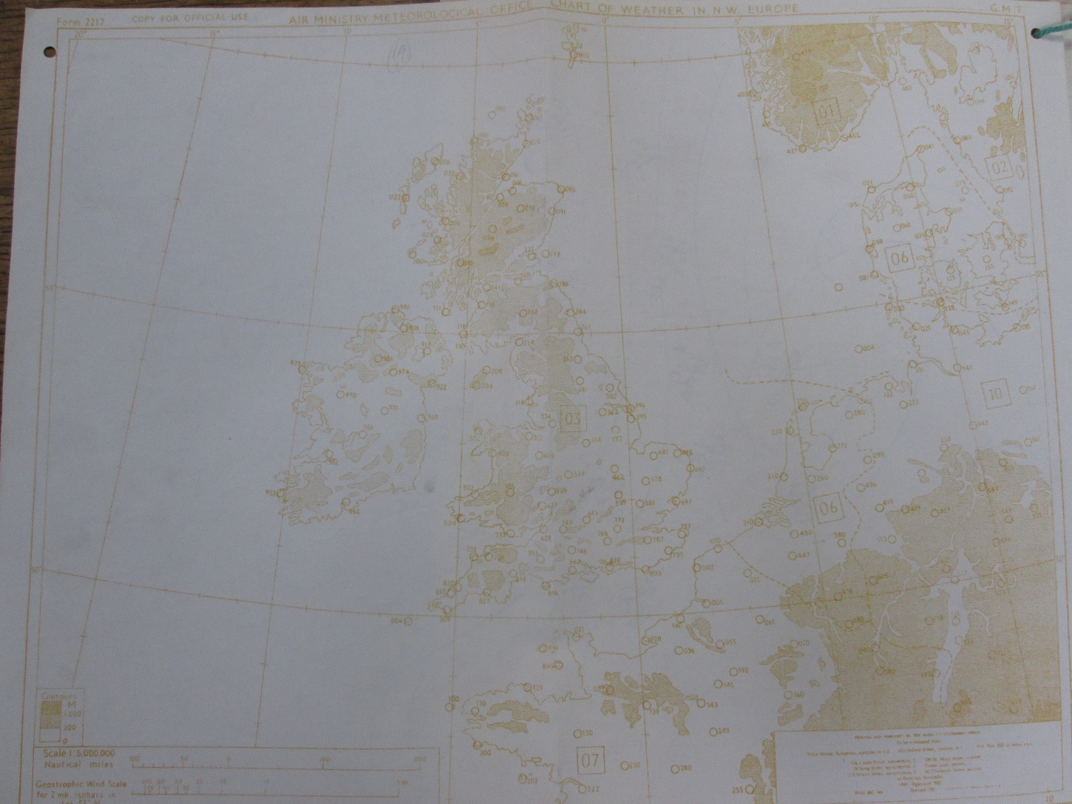
Figure 10: BJ 4/14: Chart of weather in NW Europe and accompanying data, 1958

5.3 BJ 7

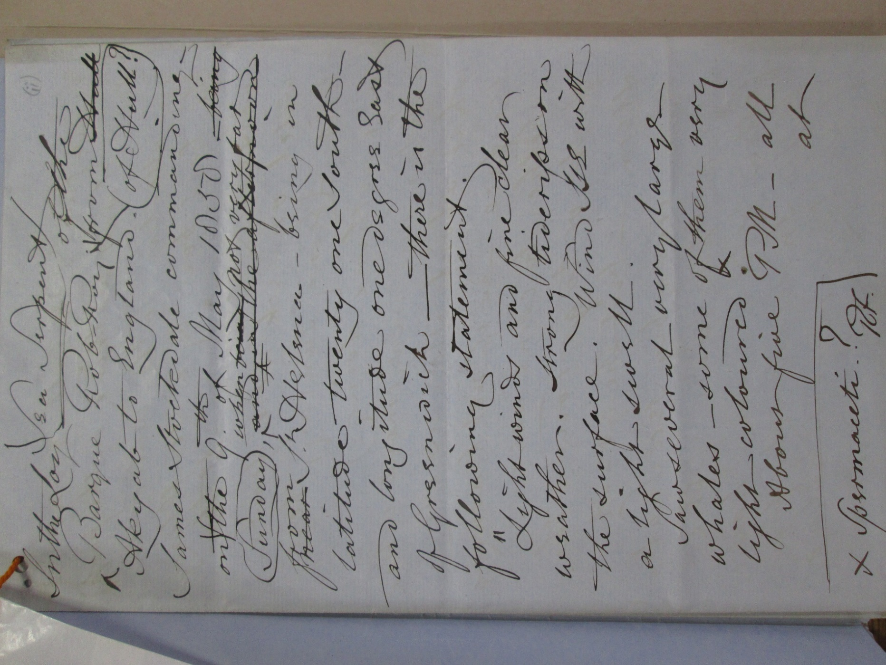
Figure 11: BJ 7/49: Sea serpents: reports of observations, 1863-1881

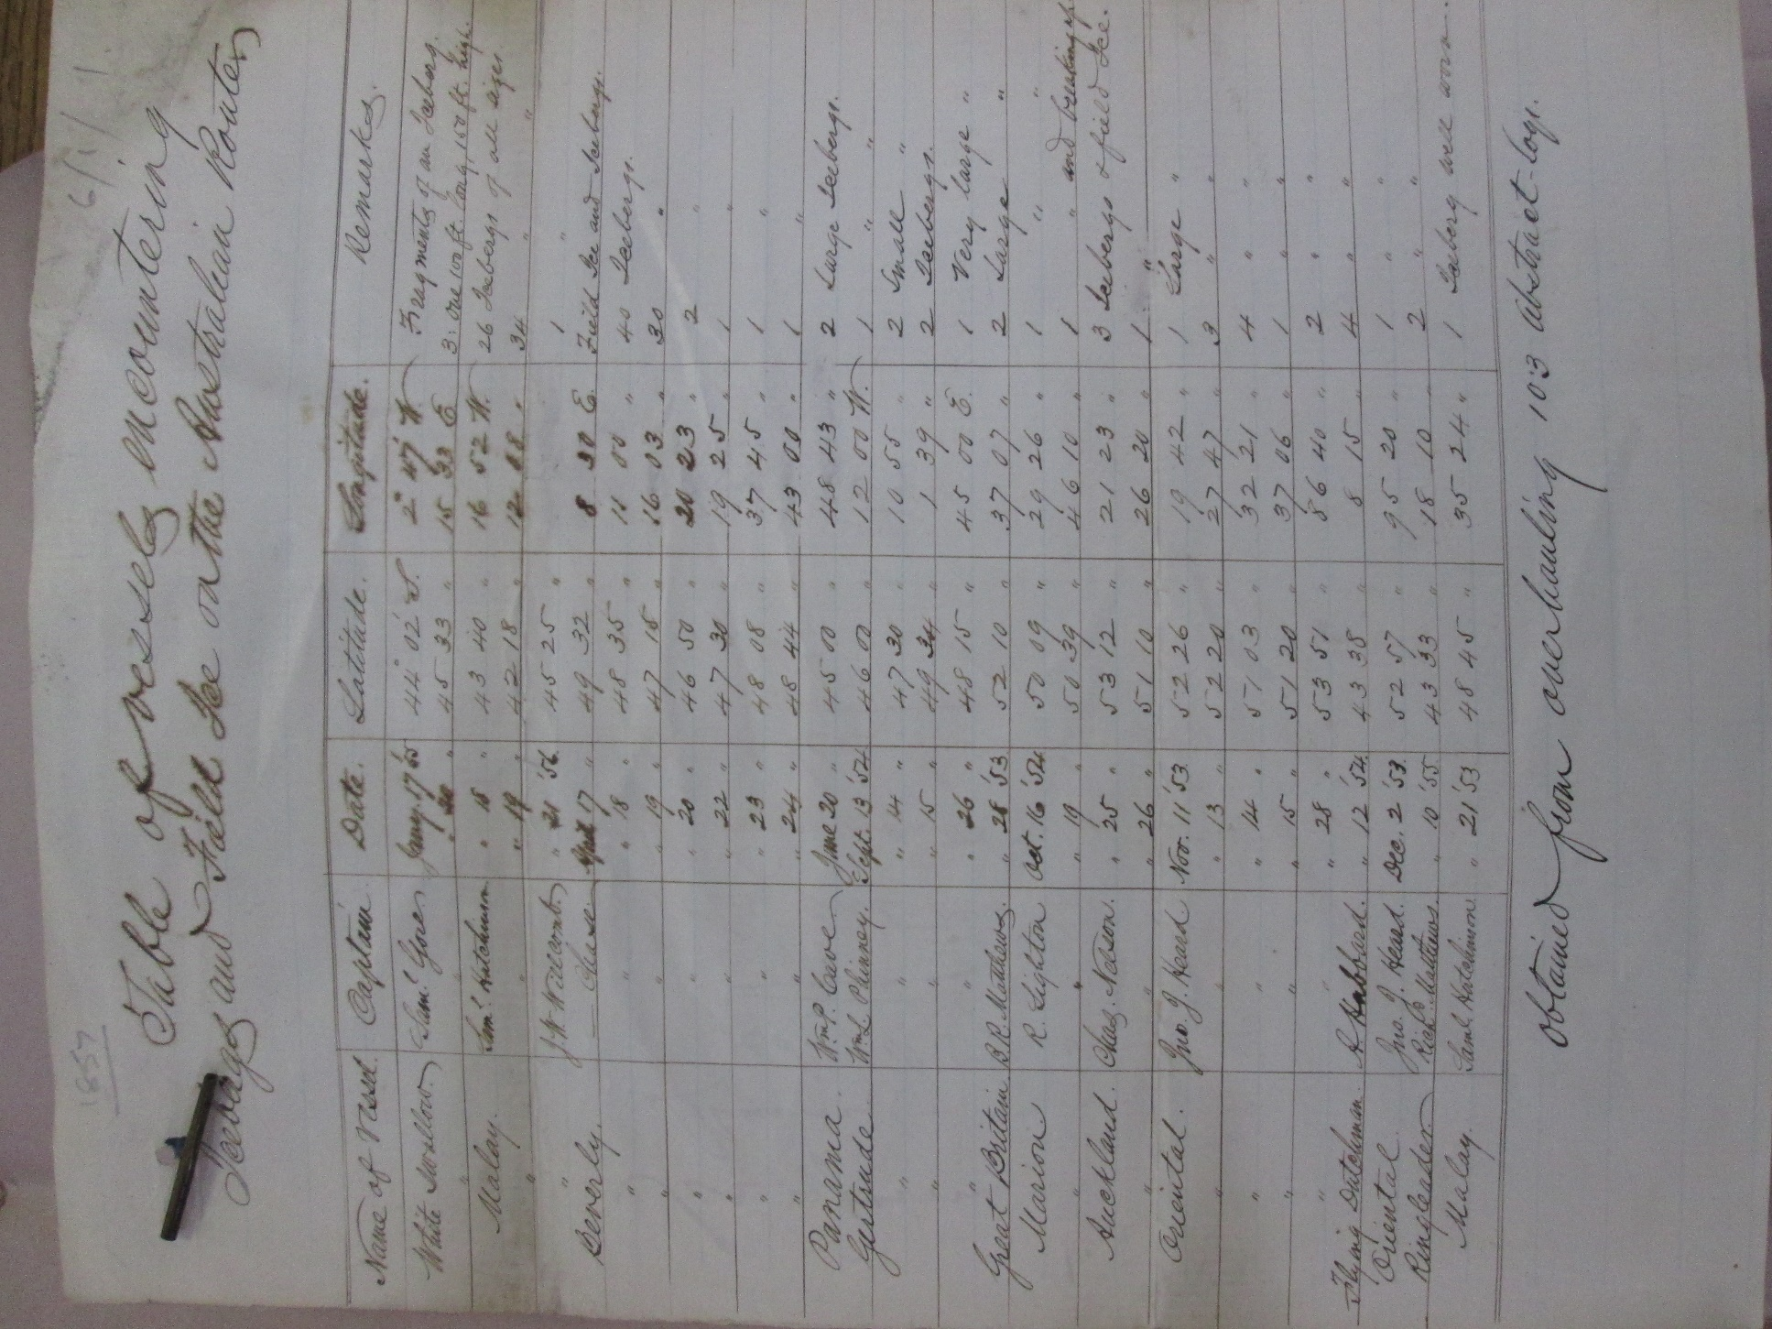
Figure 12: BJ 7/90: Table sent by Matthew Maury of vessels encountering icebergs and field ice on the Australian route, abstracted from 103 abstract logs, 1857 Dec.

