NRS Glasshouses – Contracts Finder Early Engagement

Ref: CR2020/21/067, Forest Research, Glasshouse Replacement 2021
Location: Northern Research Station (NRS), Bush Estate, Roslin, Midlothian, EH25 9SY
Region: Scotland
Responses: Interested parties are invited to provide written responses at any time up to COB on Friday 16th April 2021. We are seeking; (high-level) technical solutions/options, typical lead/build times, rough costings (for business case/budget purposes) and any examples/reference projects.
Site Visits: Site visits can be arranged by appointment. Note that other building works are currently underway, so access restrictions and COVID-safe working arrangements are in place.
Suppliers are assured that their involvement in this Early Engagement will not in itself prejudice their inclusion in any subsequent related procurement process/tendering exercise that may be conducted.

Description
Forest Research (FR) is currently undertaking work to consolidate a number of teams at its Northern Research Station campus. As part of this work we are looking to replace some of our current existing glasshouses with new facilities based within the nursery area. In a bid to understand what is available and what might be feasible, we are seeking outline proposals for replacement glasshouse facilities.

Current Facilities
FR’s glasshouse facilities at NRS currently comprise 5 separate units of different dimensions which, in total, provide 181m² of useable bench space. Each of these units has separate environmental controls, with some units also having artificial lighting, humidifying and bench heating capabilities. It is expected that all these units will be demolished and removed as part of the NRS site development work.

Requirements
FR requires replacement glasshouse facilities which will be used for a range of research and experiments, rather than horticultural production. We are seeking proposals that satisfy the following requirements:
- A minimum of 180m² of useable bench space spread across 1 or more glasshouses.
- A minimum of 5 separate working compartments of roughly equal size
- A durable construction with a planned operational life of at least 20 years.
- Each compartment to have independent automatic climate (temperature and humidity) control.
- One compartment is to have misting capability.
- One compartment is to have bench heating capability.
- Growing lights are required in all compartments with adequate working lighting in other areas (e.g. any vestibule or plant room).
- Water supply within each compartment.
- Mains electricity and gas are available on site. Proposals should be able to demonstrate energy efficiency and proposals that seek to minimise energy consumption and, if possible, to utilise low carbon alternate energy sources, would be welcome.
- Mains water supply is available on site. Proposals should be able to demonstrate water efficiency and proposals that seek to minimise water consumption and take advantage of rainwater harvesting would be welcome. A minimum of 10,000 – 15,000 litres of water storage is required.

Site
A site for the replacement glasshouses has been identified. The site comprises an open area of hard standing with access to mains water, drainage, electricity and gas – although each of these would require connection to a new facility as required. A ground radar survey of the site will be available in due course.
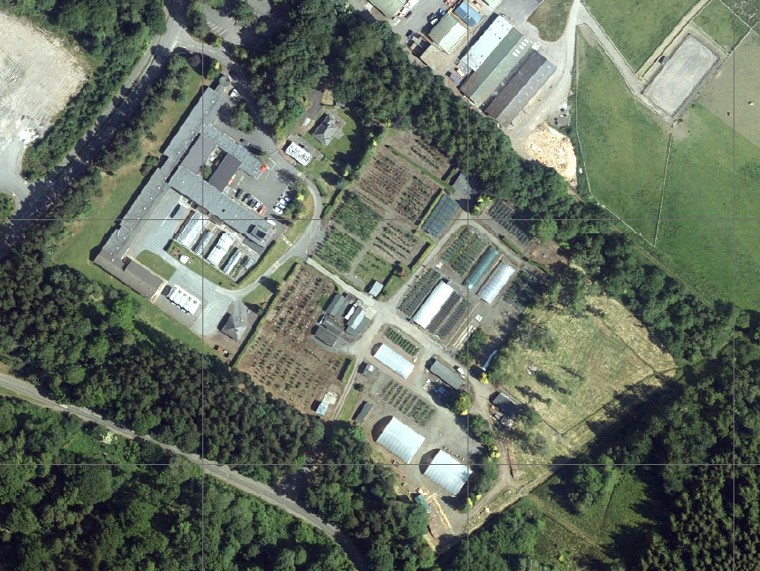
Proposed Location
Current Glasshouses
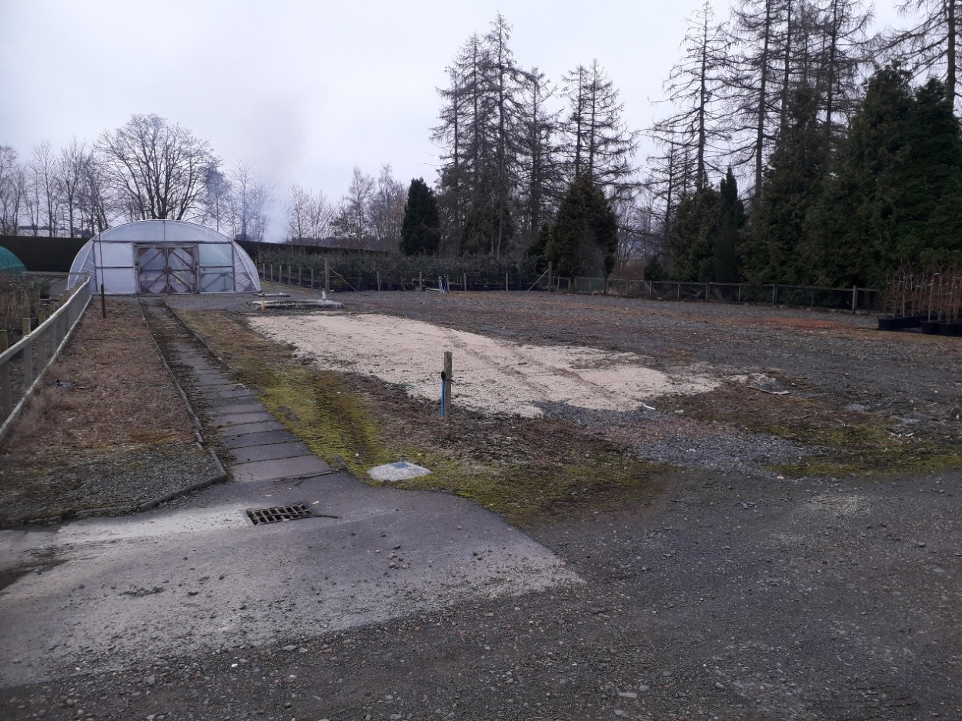
Gas
Water
Water
Water

