**Specification for research project**

COF-ADA Analysis and Attribution of Causal Self-Evident Reactionary Delays

The draft research specification that follows, outlines RSSB’s proposed approach to develop and test a proof of concept to identify and analyse self-evident causal reactionary delay chains, to improve performance, attribution analysis and enable automating reactionary delay attribution.

A pre-tender supplier engagement meeting has been arranged for 13 September 2019 at 14:30 – 16:30, at the RSSB offices in Moorgate, London. The purpose of this meeting is to:

* Provide an outline of the project proposal
* Provide interested suppliers with an opportunity to discuss, understand and inform the research specification

Suppliers should be prepared to discuss the following:

* What data and information would suppliers require access to, in order to deliver robust outcomes?
* Are the timescales sufficient to deliver quality outputs to time?
* What are the challenges and barriers to delivering this work? What enablers would support successful delivery of the project?
* What is the estimated effort to deliver this work to quality and time?

Suppliers wishing to attend in person or by dialling into the meeting should contact [Tanja.Odinsen@rssb.co.uk](mailto:Shareditt@rssb.co.uk) to confirm attendees (maximum two people per supplier).

1. RSSB overview

RSSB is a membership organisation that supports the GB rail industry by:

* **Understanding risk** – Using safety intelligence with the latest risk modelling to inform members and support safe decision making.
* **Guiding standards** – Creating, reviewing and simplifying GB standards; managing the Rule Book and making it easier for the railway to deliver efficiently and safely.
* **Facilitating cross-industry collaboration** – As an independent cross-industry body, supporting activities which require collaboration such as supplier assurance schemes, confidential reporting and developing industry strategies.
* **Managing research, development and innovation** – Undertaking, commissioning and managing research and innovation programmes to address current and future needs and providing knowledge for decision making; supporting implementation and promoting step changes to deliver industry strategies.

1. Background

Delay attribution is the industry process for identifying and allocating responsibility of delay causes, to help responsible parties determine action plans for improving performance. The measuring and recording of delay causes are undertaken via the industry system TRUST[1], taking “real-time data feeds of train locations from the signalling system and compares this with the timetable to work out where each train is and to identify if there are any delays” (ORR Delay Attribution Review, 2019, p.12)[2]. When a delay incident is recorded above the threshold of 3 minutes, it must be investigated to explain and attribute the cause and responsible party.

Attributed above threshold delays are identified as **primary** or **reactionary** delay. Primary delay is accrued from a new incident directly delaying the running of a train service, except from reactionary incidents which are delays linked to an existing incident. In 2018/19, over 11.9 million delay minutes were reactionary, comprising 71% of total delay minutes on the network. As such, majority of delay attribution processes and resources are consumed with investigating and attributing reactionary delays.

Any delay below 3 minutes is considered sub-threshold, which will be unattributed, unless it causes an above threshold reactionary delay to another service. In some cases, it is not possible to identify the delay cause and/or responsible owner. Such incidents will be attributed uninvestigated or unexplained. In 2018/19, there were over 972,000 primary and reactionary delay minutes uninvestigated or unexplained, comprising 5.8% of total delay minutes on the network. Consequently, limiting the options to understand and improve performance. The figure below provides a high-level overview of the delay attribution process, and distinguishes between attributed, unattributed, uninvestigated, and unexplained delays.

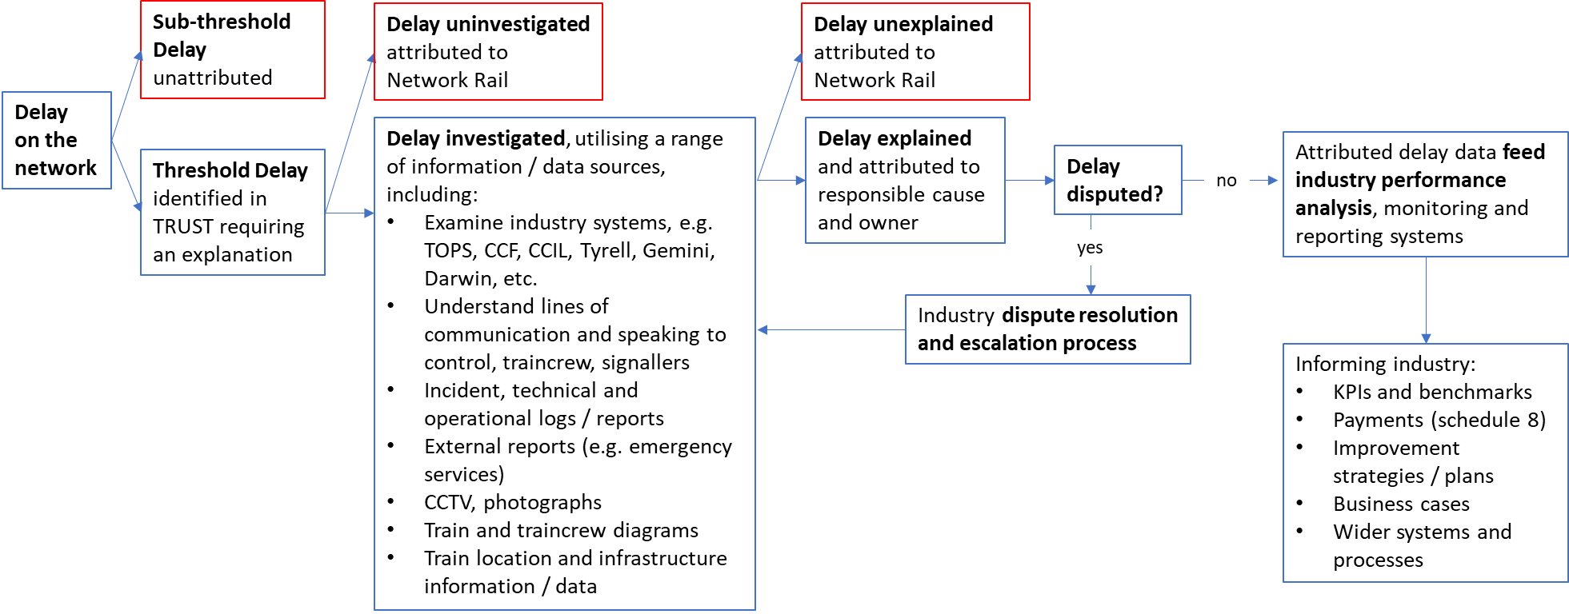

To support the delay attribution process, the rules, principles, guidance and resources are available at [http://www.delayattributionboard.co.uk](http://www.delayattributionboard.co.uk/). These are managed by the Delay Attribution Board (DAB), who lead, monitor and advise the effectiveness and accuracy of the delay attribution process.

Recently, the ORR undertook a review of delay attribution following concerns raised by industry during the Network Rail periodic review (PR18) consultation2. This surfaced challenges regarding the accuracy and consistency of delay attribution, adverse impacts of reactionary delay, potential for perverse behaviours/incentives, substantial resources required to attribute and dispute delays with limited investigation and analysis time available. The ORR concluded scoping the review of delay attribution in July 2019, making 10 recommendations to industry. The next phase will be led by industry to identify and implement the options to close out the recommendations by April 2021. This research is aligned to supporting the ORR review of delay attribution, and should support in closing out recommendation 9, advising “Network Rail and DAB to develop a proposal for greater automation of the attribution of reactionary delay” (p. 31).

Automating reactionary delay attribution is a significant challenge which the rail industry has been attempting to solve for over 20 years. There are a multitude of data requirements and variables that inform delay attribution, which often need human communication and interpretation to understand the delay incident and apply the appropriate rule(s) to codify the delay. This is particularly the case for complex scenarios, such as handling split responsibility delays, distinguishing between primary and reactionary delay when the following train has a train fault, reactionary delays incurred from early running trains, accounting for changes in train regulation policies, or distinguishing delays from temporary / emergency speed restrictions on 4 rail lines. Hence, any developed solution should cater for a mix of manual and automated attribution, whilst also enabling manual interventions.

Advances in data science, big data analytics and availability of train and infrastructure data, present new opportunities for research to understand how to automate reactionary delay attribution. This may include understanding lessons learnt from previous work and building on existing feasibility research or academic studies exploring automation[3]. A key gap in existing knowledge is understanding the fundamental nature of reactionary delays, before they are attributed, what self-evident causal reactionary chains look like, how they can be automatically investigated and analysed for better delay attribution and performance analysis. Therefore, this project involves fundamental and applied research to develop and test a proof of concept which identifies and analyses self-evident causal reactionary delay chains. Doing so is expected to enable better performance analysis, attribution analysis and automating reactionary delay attribution. Given the impact delay attribution has on industry wide processes, governance and structures, this research will require understanding the industry change management requirements, and how the demonstrator will progress through higher technology readiness levels[4].

The research will also require robust consultation with key industry stakeholders and groups, including the Better Operations Programme Board (BOPB), Delay Attribution Board (DAB), ORR Delay Attribution Review Working Group (DAWG), Route Performance Measurement Managers Group (RPMMG) and Delay Attribution Managers Group (DAMG). Representatives from these groups comprise the project steering group, who will support and steer the research. The steering group informed the primary and secondary research questions and key terms of reference, which can be found in Appendix A. The primary research questions are presented below as the key challenges to be addressed through this work:

1. How will self-evident causal reactionary delay chains be identified, analysed, and to what % of accuracy and consistency can this be repeatedly achieved?
2. How can we demonstrate improving performance, attribution analysis and automating reactionary delay attribution through self-evident causal reactionary delay chains?
3. How can we automate reactionary delay attribution and what are the industry change management requirements for this?
4. Objectives

This research sets out to develop and test a proof of concept that identifies and analyses self-evident reactionary chains, to improve performance, attribution analysis and enable the automation of attributing reactionary delays. It is expected that the output of the research will be a demonstrator with a route to market fully defined, including ownership, governance, sustainability and change controls of the solution. The demonstrator should be able to run in ‘shadow mode’, at the same time as live delay attribution and performance analysis and reporting, to understand what actions could have been taken through the solution.

The high-level objectives for COF-ADA are:

1. Define the industry, functional and non-functional requirements of a novel solution to identify and analyse self-evident causal reactionary delays
2. Define and agree potential approaches to identify and analyse self-evident causal reactionary delays
3. Develop the agreed approach into a proof of concept solution
4. Test and demonstrate the validity and reliability of the proof of concept
5. Support the industry change management and implementation of the proof of concept solution

There are 4 work packages (WP) to delivering this research. RSSB led the project development (WP1) and procurement, and the supplier is expected to lead the delivery of WPs 2, 3 and 4. A high level overview of the WPs, key timescales and deliverables are illustrated below, which will be detailed in the following sections.

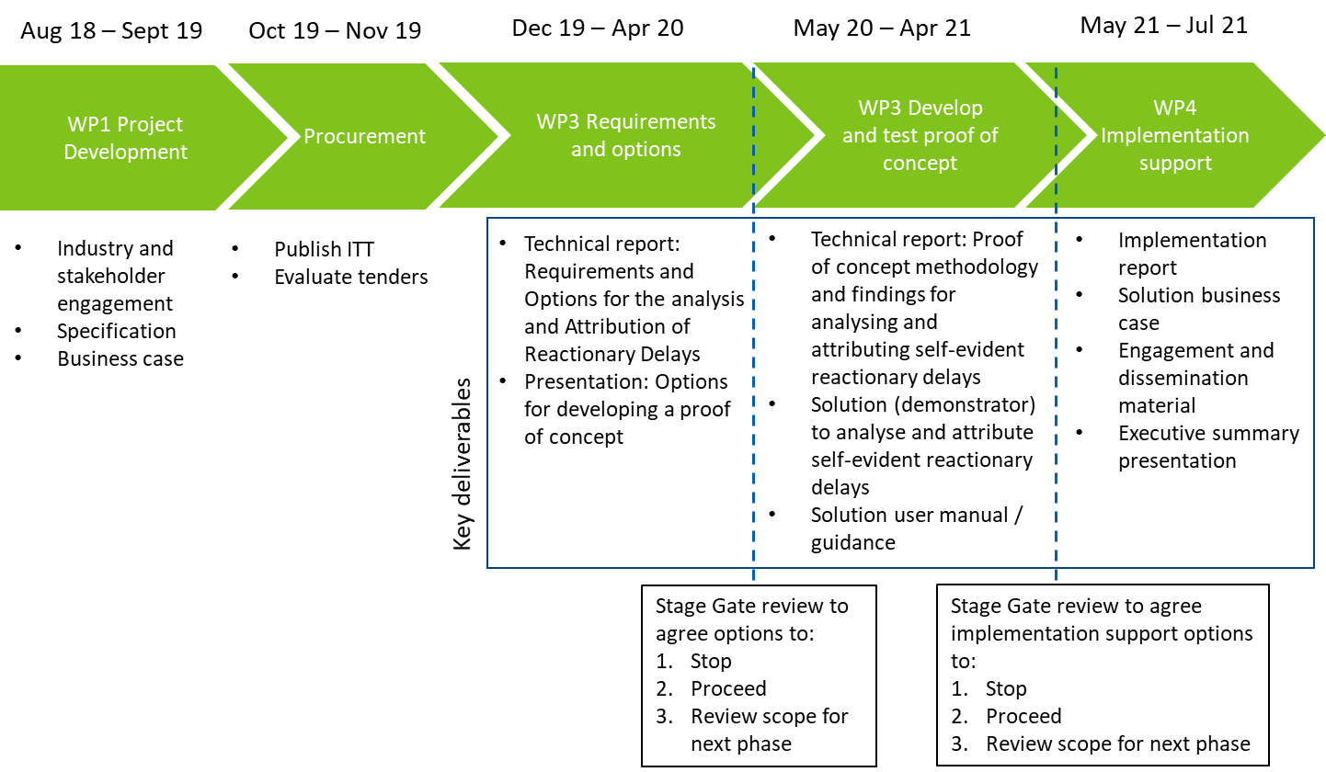

1. Scope

This section defines the high-level whole project scope. A specific scope relevant to each WP is detailed in Section 5 Project Structure.

|  |  |
| --- | --- |
| **In scope** | **Out of scope** |
| * Define the requirements and options to develop a proof of concept solution to identify causal self-evident reactionary delay chains for automating attribution and improving performance analysis   + Undertake a desk-based review   + Robust industry consultation to agree solution success criteria, minimum industry and end-user requirements   + Process and attribution mapping of the agreed scenarios to be tested * Evaluate the options for solution development and consult the DAB and BOPB on these * Develop a proof of concept including a graphic user interface and establish its feasibility * Creation of a ‘truth’ dataset to test and establish the validity and reliability of the solution * Define the available level of IP for any algorithm and solution that is accessible for industry wide use * Work with TOCs and associated NR routes to test and demonstrate the effectiveness of the solution, including the validity and reliability across agreed scenarios * Support the industry change management and implementation of the solution   + Define the change management requirements and steps to progress the solution to a market ready product, including proposing hard-coded rules for automating delay attribution   + Undertake an economic assessment of the industry adoption of the outputs   + Prepare engagement and support materials / guidance   + Present the findings to up to 5 industry groups | * Changes to staff job roles/design * Automating the attribution of primary delays * Schedule 8 and other financial contractual arrangements * Validating the solution against manual delay attribution * Staff competency framework for delay attribution * Market ready product * Undertaking full industry consultation process to change delay attribution rules * Live / actual attribution of reactionary delays (i.e. the research will end with a demonstrator and proposal of hard-coded rules to implement the solution) * Predicting and preventing delays |

1. Project structure

This project is structured in 4 work packages, **of which Work Packages COF-ADA-02, COF-ADA-03, and COF-ADA-04 are subject to this tender**. Each work package is outlined below, including the timescales, scope and deliverables.

|  |  |
| --- | --- |
| **Work Package COF-ADA-01 (underway)** | |
| **Title** | **Analysis and Attribution of Causal Self-Evident Reactionary Delays - RSSB project definition** |
| **Delivery** | RSSB |
| **Start** | August 2018 |
| **Completion** | September 2019 |

|  |  |
| --- | --- |
| **Work Package COF-ADA-02** | |
| **Title** | **Requirements and Options (objective 1 & 2)** |
| **Delivery** | Subject to this competitive tender |
| **Start** | December 2019 |
| **Completion** | April 2020 |
| **Scope** | **1. Define the industry, functional and non-functional requirements to identifying and analysing self-evident causal reactionary delay chains**   * Undertake a desk-based review to understand the requirements for developing the proof of concept. This should consider previous, current and academic work, delay attribution rules and principles, good practice guidance, ORR review of delay attribution, international practice, current / near future (1-5 years) systems a solution would need to interface with (e.g. traffic management, ERTMS). * Undertake extensive industry consultation to identify minimum industry and end-user requirements for the proof of concept. This must include senior and practitioner representatives from NR, TOCs, FOCs and supply chain. The consultation should: understand the industry barriers, constraints and opportunities; required change management processes and behaviours; agreed mix of complex and frequent scenarios to map reactionary chains; and the acceptable level of accuracy. * Understand the performance and delay attribution workflows to inform developing the proof of concept * Attribution mapping / decision trees of reactionary delay chains across agreed scenarios varying in delay frequency and complexity * Define what causal self-evident reactionary delay chains looks like, how accurate and consistent identification and allocation of reactionary chains can be achieved within defined boundaries * Define the agreed industry success criteria for the solution, including the % accuracy of identifying reactionary delay chains against the rules, % of consistency allocating reactionary delay chains, and % of reactionary scenarios that can be identified and allocated to the agreed level of accuracy and consistency. * Define what good looks like to implement the solution, including better transparency, the required resources, sustainability costs, and management of disputes * Identify the reactionary delay scenarios that cannot be causally identified within a chain * Identify what will be lost from manual delay attribution through automation (e.g. communication and interpretation) and how to mitigate this   **2. Evaluate and present the options for a solution to be developed.**   * For each option, consider the data, features and operations that satisfy the functional and industry requirements * The strengths, limitations and viability of each option * Consult industry practitioners and senior stakeholders on the proposed options and agree the reactionary delay scenarios in which the solution will be developed and tested against. This should include, as a minimum, consulting the BOPB and DAB. review group. |
| **Deliverables** | This work package shall produce as a minimum the following deliverables:   1. **Technical report: Requirements and Options for developing a proof of concept to analyse and attribute causal self-evident reactionary delays.** This report shall include as a minimum, findings from the desk-based review, industry consultation, attribution mapping, synthesis and analysis of the options for developing a proof of concept. This shall include understanding the methodology of how causal self-evident reactionary chains will be investigated and analysed for performance and attribution analysis and enable automation to the agreed industry success criteria. 2. **Presentation: Options for developing a proof of concept.** The presentation illustrates the key findings from this work package and presents the options for developing a proof of concept to the agreed industry success criteria. This should be used as part of consulting industry practitioners and senior stakeholders, to confirm the option that shall proceed to development and testing.   All deliverables shall be submitted to RSSB for review and comment before approving the final deliverable. All documentation to be produced in the standard RSSB format and to be made widely available. |

**Stage Gate**

***Following delivery of work package COF-ADA-02, a stage gate review meeting will be held with the project steering group to agree the options for progressing the research, informed by evidence gathered. Depending on the outcome of this review, the project will either: (1) Stop, (2) Proceed to the next work package, or (3) Review the scope and proceed with a revised scope.***

|  |  |
| --- | --- |
| **Work Package COF-ADA-03** | |
| **Title** | **Develop and test proof of concept (Objectives 3 & 4)** |
| **Delivery** | Subject to this competitive tender |
| **Start** | May 2020 |
| **Completion** | April 2021 |
| **Scope** | **3. Develop a proof of concept solution to identify and analyse self-evident causal reactionary delay chains, which should cater for:**   * Accurately distinguishes the difference between primary and reactionary delays * Existing delay attribution data and other available data that increase the accuracy and consistency of identifying and allocating causal self-evident reactionary delays * Following a rules-based approach (existing, new, or combination, which achieves the best accuracy and consistency) * Modifying rules and reactionary delay scenarios without compromising effectiveness, and any required change processes to be followed * Identifying options for improving performance and delay attribution * A mix of manual and automated analysis, including manually intervening automated scenarios * Aligning to delay attribution governance (e.g. auditing, disputes, etc.) and quality assurance methods (existing or new to support the solution) * Creation of a ‘truth’ dataset and calibration method * A useable graphic user interface * Open source solution, accessible for industry use and further development * Interfacing with current industry systems, and potential near future systems (e.g. ERTMS, traffic management, TRUST replacement). * Feasibility results of the proof of concept, including whether ‘live’ analysis is possible. * Where necessary, undertake any additional refining and retesting * A robust testing plan to demonstrate the effectiveness of the proof of concept   **4. Test and demonstrate the effectiveness of the proof of concept in at least two locations, including one north and one south GB locations**   * The testing should include:   + Running the solution in ‘shadow mode’, at the same time as live delay attribution and performance analysis and reporting, to gather statistical evidence and understand what actions could have been taken   + Understanding the application of the solution across agreed scenarios   + Demonstrating the tested applicability, effectiveness, validity and reliability of the solution   + Understanding any false negatives and false positives   + Any identified changes to the performance and attribution profile through the application of the solution   + Usability of the graphic user interface   + The estimated industry benefits and impact of the solution, including the reactionary, primary and sub-threshold delays * Define the hard-coded rules, evidence and requirements to automate reactionary delay attribution using the proof of concept solution developed * Develop a user manual / guidance for the proof of concept |
| **Deliverables** | * **Technical report: Proof of concept methodology and findings for analysing and attributing self-evident reactionary delays.** This report details the methodology taken to develop and test the proof of concept, and the demonstrated effectiveness of the solution. This shall include as a minimum;   + Solution design, functional and non-functional outline, technical architecture, and next steps and requirements in the route to market.   + Testing methodology   + Analysis and findings on the effectiveness of the solution, including its validity, reliability, feasibility, applicability, and performance benefits and impact   + Hard coded rules for effective performance analysis and automating reactionary delay attribution[5]. * **Solution (demonstrator) to analyse and attribute self-evident reactionary delays**. The developed solution, including any software application / graphic user interface and developed algorithms shall be accessible via SPARK[6] in an open source framework, for RSSB members to develop further for NR, TOC, FOC, supplier systems. The solution must interface with current industry systems and allow interfacing with potential near future systems (1-5 years). * **Solution user manual / guidance.** This report shall include as a minimum guidance on the installation, use and troubleshooting of the solution, including quality assurance and calibration methods, how to use the solution to improve performance and attribution analysis, and automating reactionary delay attribution.   All deliverables shall be submitted to RSSB for review and comment before approving the final deliverable. All documentation to be produced in the standard RSSB format and to be made widely available. |

**Stage Gate**

**Following delivery of work package COF-ADA-03, a stage gate review meeting will be held with the project steering group to agree the options for progressing the research, informed by evidence gathered. Depending on the outcome of this review, the project will either: (1) Stop, (2) Proceed to the next work package, or (3) Review the scope and proceed with a revised scope.**

|  |  |
| --- | --- |
| **Work Package COF-ADA-04** | |
| **Title** | **Implementation support and change management (objective 5)** |
| **Delivery** | Subject to this competitive tender |
| **Start** | May 2021 |
| **Completion** | July 2021 |
| **Scope** | **5. Support the industry implementation and change management process to adopt the novel solution, including:**   * 2 Workshops with practitioner and senior stakeholders to support the industry use of the demonstrator solution and understand next steps in the route to market. * An implementation strategy/roadmap to industry wide use of the solution * Guidance and training materials to support practitioner and senior staff * Promotional and engagement support (e.g. workshops, communications material) * Recommendations and implications on current practice, including alignment to the PIMS and RM3P self-assessments and increasing maturity levels * Define the industry change management and engagement processes required to implement the solution, including governance, change controls, defining responsibility of maintaining inputs/validation of the solution. This should include guidance for managing change and industry behaviours * Economic assessment for industry adoption of the solution * Presentation of the findings to up to 5 industry groups, including BOPB, DAB, DAWG. |
| **Deliverables** | 1. **Implementation report**. This report shall, as a minimum, detail the implementation strategy for the route to market and industry wide adoption, including recommendations for current practice, industry change management, engagement, staff training, solution ownership and sustainability requirements for industry wide adoption. The implementation report shall also identify potential tangible and intangible benefits from implementing the solution (without further development) to improve performance of today’s railway. 2. **Solution business case.** This report shall detail as a minimum,a realistic economic assessment of the industry wide adoption of the solution, including potential impact on passengers and improving operational performance. 3. **Engagement and dissemination material** to brief practitioner and senior staff on the solution, including preparing material (e.g. PowerPoint slides) to support staff briefing workshops/training[7]. 4. **Executive summary presentation**. This presentation covers the key findings from the research, and the presentation will be provided by the supplier to the project steering group and up to 5 industry groups.   All deliverables shall be submitted to RSSB for review and comment before approving the final deliverable. All documentation to be produced in the standard RSSB format and to be made widely available. |

1. Methodology

Suppliers are expected to explain the methodology that they are intending to use to successfully meet the COF-ADA **work package requirements**. The work package requirements are detailed within the following sections:

* Objectives
* Scope
* Project structure (including detailed scope and deliverables)

The work package requirements are set in context by:

* Background

1. Stakeholder roles and responsibilities

This project requires robust stakeholder engagement and management. This will include consulting industry practitioners and senior stakeholders, with access facilitated through the project steering group. Practitioners to be consulted should be nominated via the DAB in the first instance, and where required the DAMG, RPMMG and DAWG. Senior stakeholders should be nominated and consulted via the BOPB.

The key stakeholders and their responsibilities are detailed in the table below.

|  |  |  |
| --- | --- | --- |
| **Stakeholder(s)** | **General role in project** | **Specific role in acceptance of deliverables** |
| RSSB Project Manager | The RSSB Project Manager is the first point of contact during project delivery and is responsible for the detailed project management including project schedules, cost reporting and other relevant project management tasks.  The Project Manager leads the project in organising meetings, etc and ensures timely and effective delivery towards project objectives. | Facilitates technical review and acceptance processes, identifies and monitors corrective actions where needed, including facilitating decision making. |
| RSSB Technical Lead | Throughout the project, the RSSB Technical Lead ensures that technical aspects are reflected accurately.  Technical aspects can refer to specific issues around railway signalling, track engineering, safety relevant operations or any other specialist field. | Reviews emerging outputs from a technical perspective. |
| Industry sponsor | The Industry Sponsor acts as figurehead for the research, championing its importance and its outputs.  The Industry Sponsor forms part of the project steering group, however, their key role as sponsor is to provide steer to the research as it progresses and to exert pressure on industry to make use of its findings. | Reviews emerging outputs from a technical perspective. |
| Project steering group | The project steering group ensures the project delivers to industry needs. As such, it helps formulate specifications, assesses tenders, reviews draft and final outputs and other relevant tasks.  The steering group includes representatives from key industry groups, including the DAB, BOPB, DAMG, RPMMG, and the DAWG. | Reviews emerging outputs from a technical perspective. |
| Primary client group | The primary client group is made up of RSSB members and other stakeholders across industry. | Informed of deliverables. |

1. Timescales

RSSB expects the work to start in December 2019 and conclude by July 2021. However, these are indicative dates and RSSB will consider bids that cannot meet these expectations if the supplier includes a robust project plan and an explanation as to why they cannot meet the preferred start and end dates, while still meeting the project objectives.

1. Critical success criteria and risk management

The following critical success criteria have been identified to help ensure successful delivery and to increase likelihood of industry acceptance/implementation:

* **Impartial, evidenced-based, and transparent approach to the consultation, development, testing and reporting**. This must be demonstrated throughout the research, by all parties involved, including for example, keeping audit trails, declaring any conflicts of interest, regular communication with key stakeholders.
* **Key engagement with critical groups and focused messaging on benefits.** RSSB, the supplier and project steering group must work collaboratively to agree and implement a robust project communication and engagement plan throughout project delivery.
* **Feasible, applicable and effective outputs / solution** that aligns with industry expectations, structure, processes, governance, ways of working, systems and requirements**.** Work package 2 must establish the minimum industry requirements and success criteria in which the proof of concept will be tested against. Suppliers must manage the industry’s expectations through identifying any parts of the solution that cannot be developed or tested to meet industry’s requirements and success criteria.
* **Identifying the performance and delay attribution benefits and impacts**. This should include understanding the options to improve performance and attribution analysis of reactionary delays, and any indirect benefits applicable to improving the analysis of prime cause, unexplained and uninvestigated delays.
* **Enabling recommendation 9 from the ORR review of delay attribution to be closed out** (automating reactionary delay attribution). RSSB and the supplier will liaise with the DAWG to align and support this recommendation.

The following risks have been identified to highlight where the project may encounter issues during delivery:

* **Scope creep** – mitigated through project governance structure, close engagement with key stakeholders and managing and engaging stakeholders should be factored within budgets.
* **Managing conflicting stakeholder views** – mitigated through the supplier’s expertise in stakeholder management and applying appropriate methods to manage and resolve conflict. Where necessary, the supplier can be supported by RSSB and the project steering group.
* **The solution does not meet industry requirements or expectations** – mitigated by stage gates at key junctions in the research. Should it emerge that automating reactionary delay attribution is not possible, the research may still deliver a benefit through focusing outputs on improving performance
* **Access to staff, information and data** - mitigated through securing industry support at the BOPB, DAB and through the project steering group.

A detailed risk and mitigations register should be provided as part of the submission illustrating required actions to support the success of the work package.

Appendix A: Research questions and terms of reference

**Primary and secondary research questions,** representing the challenges to be addressed through this project:

1. **How will self-evident causal reactionary delay chains be identified, analysed, and to what % of accuracy and consistency can this be repeatedly achieved?** 
   1. How much of the total reactionary delay profile will this cover?
   2. How will this help staff better understand reactionary delays and mitigate the adverse impact of reactionary delays?
   3. How will this improve operational performance?
   4. What impact will this have on understanding unattributed, uninvestigated, and unexplained delays?
2. **How can we demonstrate improving performance and automating reactionary delay attribution through self-evident causal reactionary delay chains?** 
   1. How will testing be undertaken to demonstrate the effectiveness of the solution?
   2. How will false positives and false negatives be identified?
   3. How will the benefits and impacts of the solution be assessed?
3. **How can we automate reactionary delay attribution and what are the industry change management requirements for this?** 
   1. How will data science and analytics enable automation (e.g. self-learning)?
   2. What is the balance of rule simplicity vs complexity that would enable automation?
   3. What and how many hard-coded rules will be required to achieve the highest level of agreed accuracy and consistency?
   4. What required inputs are available now or would be needed to enable automation?
   5. How will industry undergo change management to automate reactionary delay attribution?

**Key terms of reference** provide clarity on the key references applicable to this project:

* **Good delay attribution** is the *timely accurate identification and consistent allocation* of delay causes and responsible parties, to understand the impact of delays and inform action plans for improving operational performance
* The **accurate identification of a reactionary delay** is when the identified reactionary delay *is* a reactionary delay, and correctly allocated (validity)
* The **consistent allocation of a reactionary delay** is when the reactionary delay is allocated *the same in every situation* (reliability)
* **Reliability events** occur when a train is unable to make all booked calls shown on the train schedule, including part and full cancellations, and failing to call at booked stops.
* **Good performance analysis** provides a robust understanding of the issues affecting operational performance, which achieves evidence-based practical, applicable and effective conclusions.
* A **reactionary chain** represents the causal relationship between a primary delay and the reactionary delay/or reliability event, to one or more train service agnostic of any other reason outside the linked chain
* **Self-evident reactionary chains** utilise data feeds to identify and allocate delay causes and responsible parties, following hard-coded rules to agreed success criteria, negating manual investigation

1. TRUST is an acronym for the **T**rain **R**unning **U**nder **S**ystem **T**OPS (Total Operations Processing System).
2. <https://orr.gov.uk/rail/consultations/policy-consultations-by-topic/economic-regulation/delay-attribution-review>
3. for example;

   A feasibility study on developing an intelligence ensemble system for predicting and preventing train delays (COF-INP-02) <https://www.sparkrail.org/Lists/Records/DispForm.aspx?ID=26157>

   Non-Discriminatory Automatic Registration of Knock-On Train Delays <https://link.springer.com/article/10.1007/s11067-008-9087-2>
4. Information on technology readiness levels can be found here: <https://www.railengineer.co.uk/2019/04/09/rail-industry-readiness-levels-rirls-defined-and-explained/>
5. COF-ADA should propose rules for automating reactionary delay attribution through the developed solution, which should include consultation and integrating feedback from the project steering group and DAB. Undertaking the process to change delay attribution rules is out of scope.
6. The developed solution will be restricted to RSSB members only on SPARK.
7. Undertaking staff training is out of scope, however.