**STRATTON ST MARGARET PARISH COUNCIL**

Please contact Chris.Matthews@strattonstmargaret.gov.uk to arrange a site visit or ask any questions

**To install a PV system with batteries at Meadowcroft Community Centre**

**Location:**

Meadowcroft Community Centre

Addison Crescent

Swindon

SN2 7JX

**Budget:** Up to but not exceeding £30,000.00 (excl VAT)

**Usage:**

Estimated 15MWh a year

40 to 45kWh a day

Council would like to add air source heating after the installation of the solar system if the system produces excess energy.

**Building size:** roughly 35m by 14m

**Obstructions:**

East side - Building has some shading from large trees and has one small window on the roof.

South side - No obstructions

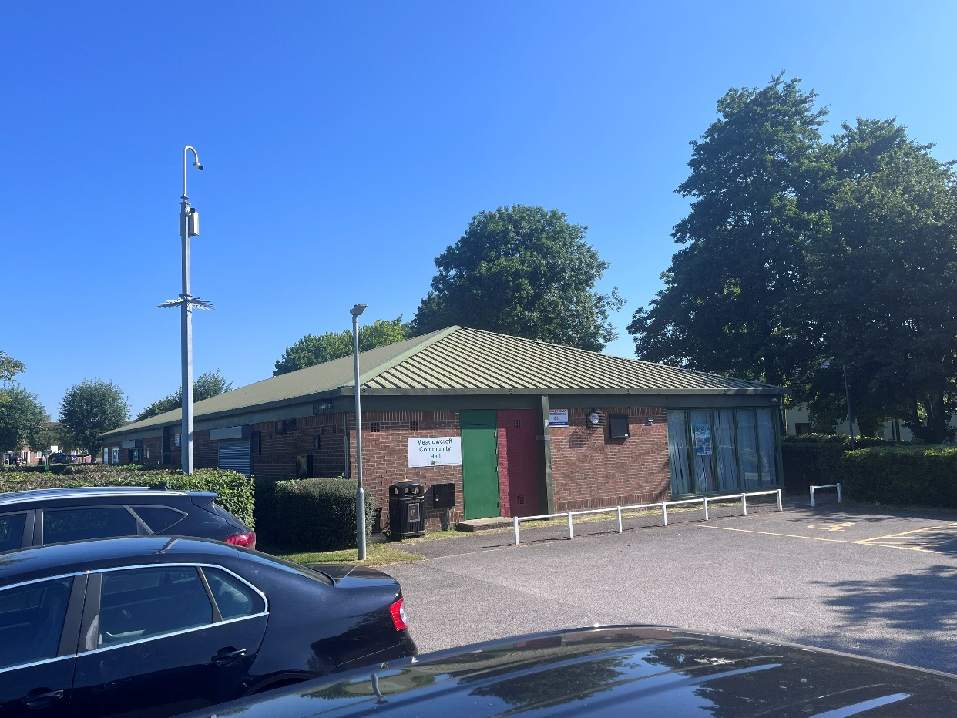West side – No obstructions

South side of building

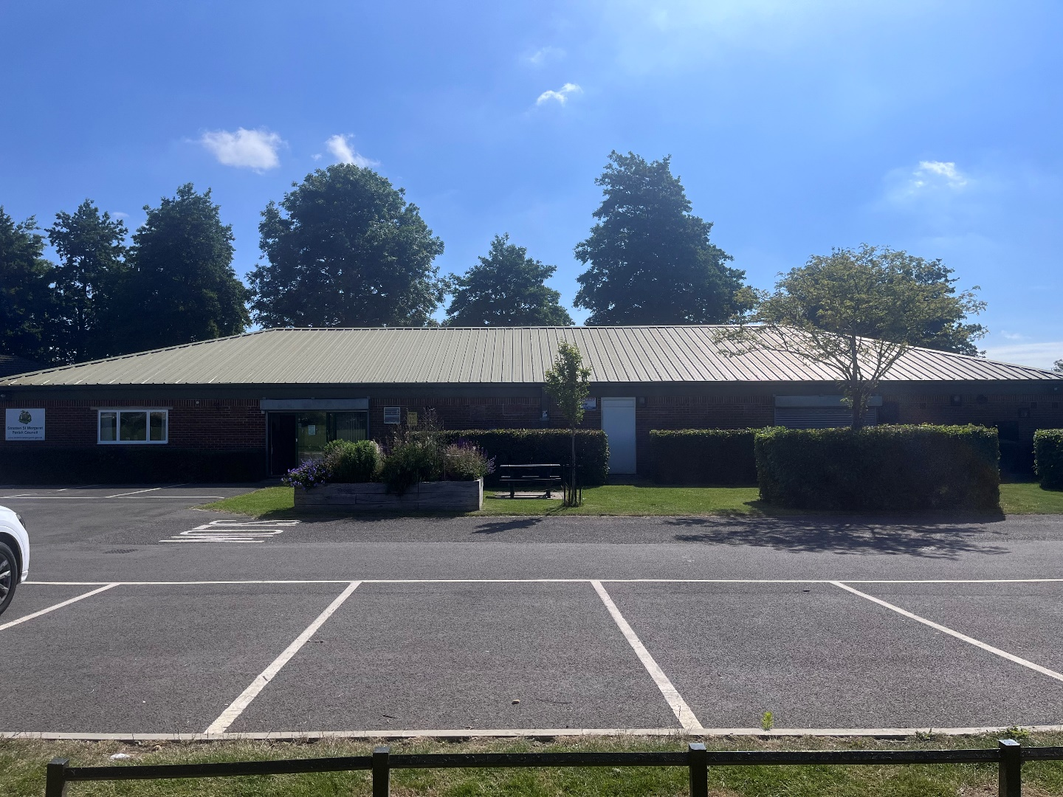

West Side of building

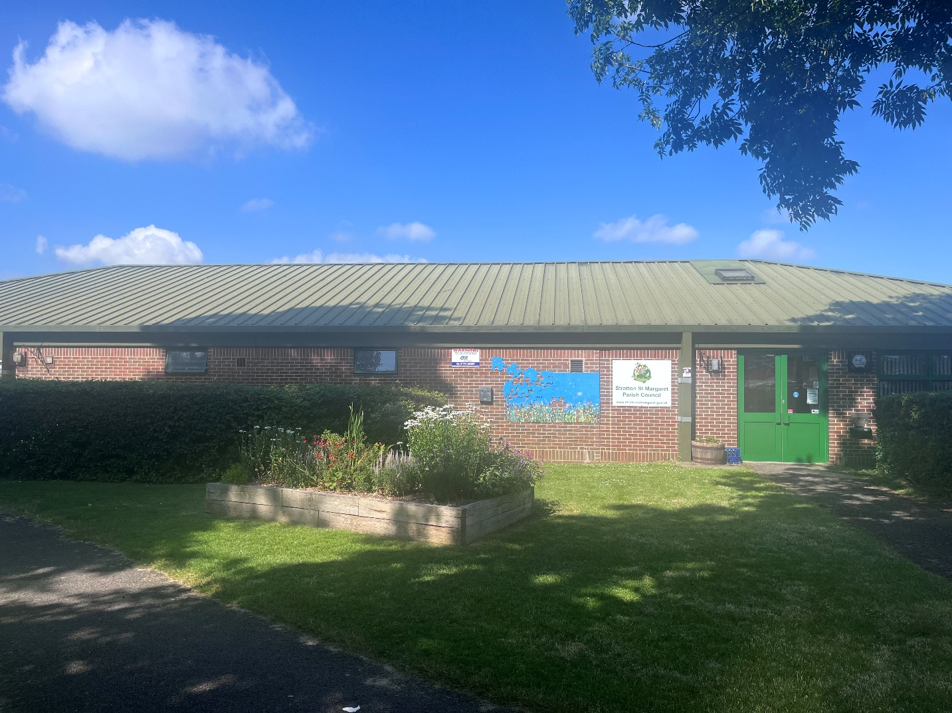

East side of building