

**06 Feb 2024**

**INVITATION TO TENDER [ITT]**

**Version 2**

**PROPOSED SERVICES – Whole site SALIX works [excluding the refurbishment of the Halls of Residence] at Shuttleworth College; Old Warden Park; Biggleswade; Bedfordshire; SG18 9DX**

**Link to contract documents**

[https://wetransfer.com/downloads/9f5f13823d1177db0f2f3933328fdcdf20240212165502/f64e838f311098014b37fda028a1ffd220240212165528/07e4a2](https://wetransfer.com/downloads/9f5f13823d1177db0f2f3933328fdcdf20240212165502/f64e838f311098014b37fda028a1ffd220240212165528/07e4a2?trk=TRN_TDL_01&utm_campaign=TRN_TDL_01&utm_medium=email&utm_source=sendgrid)

**1.0 Introduction**

Bedford College is seeking a **fixed price design & build tender** to carryout whole site SALIX related works at Shuttleworth College. The campus comprises of a series of specialist teaching facilities; support buildings and two student residential blocks [Halls of Residence (HoR)]. Much of the site is heated by oil and this project is designed to substantially decarbonise the estate.

The tender shall exclude principal contractor duties [performed by another contractor directly appointed by Bedford College] and the provision of site welfare.

Set out below are the works that form this tender.

1. Provide stage RIBA 5/6 design services
2. Supply and install new buried district heating pipework.
3. Strip out the plantroom 1 [*see plan b*]
4. Design and install a new district heating.
5. Design and supply all equipment in plantroom 1 [adjacent to the ZEC -*see note 1*]
6. Update all the internal heating in the Russell Hall.
7. Install upgrade the electrical supplies to the new plant & HoR.
8. Design, supply and install new plantroom 2 slab [*see note 2*].
9. Design; supply and install all equipment in plantroom 2 [*see note 4*].
10. Connect pipework and electrical power to the ASHP equipment adjacent to plantroom 2. [*see note 3*}

See below the packages not forming part of the tender are as follows:

Flat roofing & insulation works to the following buildings – The two hall of residence blocks; common room; Russell Hall [excluding the sports hall] & the LRC/IT block.

Internal refurbishment of two residential blocks & common room [the company carrying out these works will be appointed Principal Contractor]

It should be note that there are likely to be at least three other companies on site during these works. All companies shall submit RAMS to the principal contraor and fully comply with their H&S rules at all times.

*Note 1* – the design, supply and installation of the new plantroom adjacent to the ZEC is by others. The buffer vessel[s] for the plantroom will be free issued.

*Note 2* – Plantroom 2 will be erected on site by Totalspan/Cabin Locator.

*Note 3* – ASHP will be supplied, delivered and commissioned by Carrier [free issue].

*Note 4* – buffer vessels for plantroom 2 will be free issued for installation.

The halls of residence are scheduled to be fully completed for occupation by 30/08/24.

*Note 5 – The tender shall include for all plant; BWIC and making good, removal of waste from site and associated with the works.*

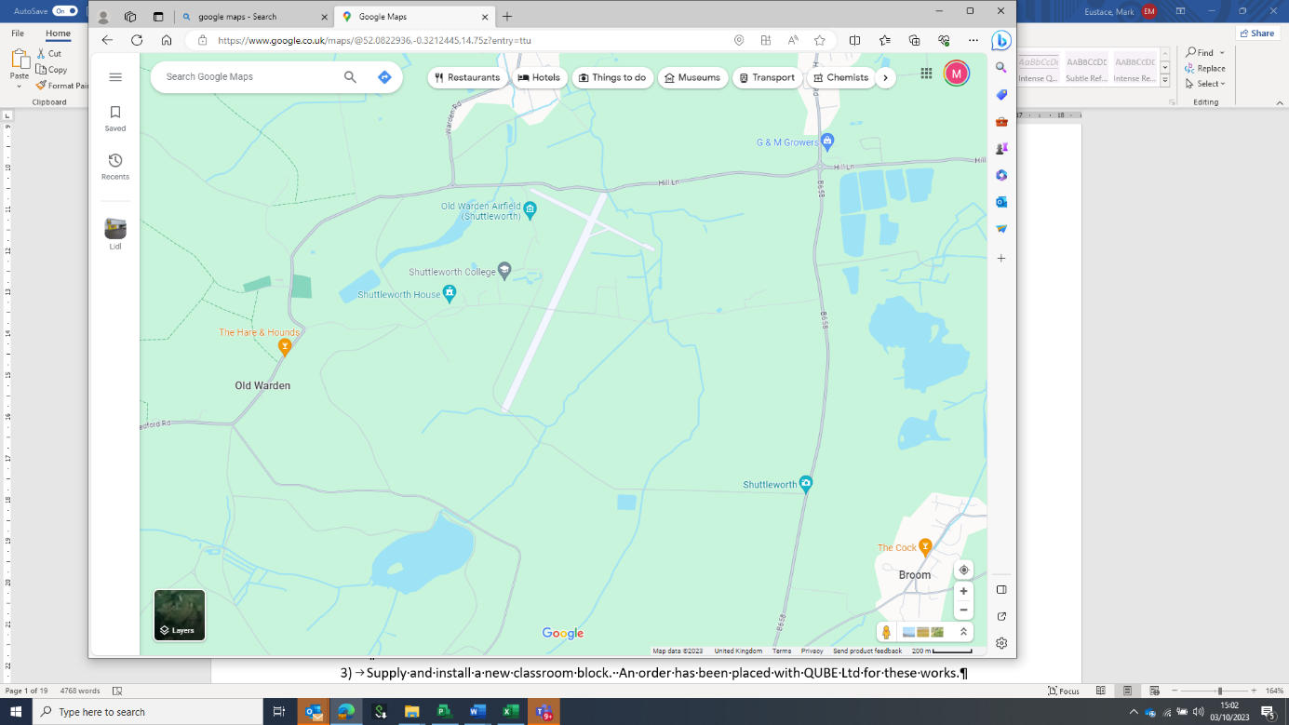

Access to Shuttleworth College from B658

Site Location

Plan A - Location of the planned works. [see note 5]

*Note 5* – all deliveries must be completed using the entrance from the B658 and not via the estate entrance from Shuttleworth village.

**2.0 Tender Information.**

The project is fully funded and supported via a government SALIX grant.

The College campus and Shuttleworth estate shall be fully operational for the entire duration of the project. Learners will be present in buildings and land adjacent to the site area during the works. Shuttleworth College is live work area that provides facilities for animal management; horticulture and agricultural studies.

Bedford College have appointed a team of consultants [see V3 PROJECT DIRECTORY 03 Oct 2023] who are delivering the project up to the handover to the turnkey contractor. The consultant team are working on the project under the employment of Bedford College.

Mark Eustace [Capital Works Project Manager - CWPM] will be the main point of contact and the sole source for answering questions and queries during the tender [**via email only** - [*meustace@bedford.ac.uk*](mailto:meustace@bedford.ac.uk)*]*

The key dates for the project are set out below in Table A.

|  |  |
| --- | --- |
| *Project Milestone* | *Key Date/Duration* |
| Release tender information – | Tuesday 13 Feb 2024. |
| Tender period | 4 weeks and 3 days |
| Return the second stage tender | *12:00 on Friday 15 Mar 2024*  ***NOTE: the tender return shall be via email only*** *to tenders@bedford.ac.uk* |
| Tender award | Friday 22 March 2024. |
| Start on site | Monday 01 April 2024 |
| Completion of the works | Friday 30 August 2024 |

Table A – *Key Project Milestones*

|  |  |  |
| --- | --- | --- |
| Task Name | Start | Finish |
| REFURBISHMENT WORKS [Halls of Residence] | TBC | Friday 30/08/24 |
| SALIX ROOF INSULATION WORKS | Fri 09/02/24 | Fri 21/06/24 |
| Whole Campus SALIX Works | Mon 01/04/24 | Mon 02/09/24 |
| Commissioning & witnessing | Mon 02/09/24 | Friday 27/09/24 |

Table B – *Key Durations and Dates*

Please note that Bedford College is seeking a project specific tender submission that takes full account of the project information and the nature of the client. Generic bid submissions that take no account of the ITT will be ruled invalid.

Any quote will be deemed to include supply; delivery of the works & commissioning in line with agree timetable [see Table A].

The specification for the tender is set out in the schedule of tender information in Table C

|  |
| --- |
| **General Information** |
| V1 Site Plan 07 Dec 2023.docx |
| V1 Tender Information Whole Site SALIX.xlsx |
| V2 ITT SALIX works excluding the refurbishment of the Halls of Residence 06 Feb 2024 - Copy.docx |
| V3 Halls of Residence Fit Out Works plus roofing & SALIX whole campus works 11 Dec 2023.pdf |
| SALIX Cost Breakdown.xlsx |
| Staff Safeguarding Leaflet - April 2022.pdf |
| V1 SALIX WORKS Whole Site CONTRACT SUM ANALYSIS Shuttleworth 07 Feb 2025.xlsx |
| **Architectural Information** |
| 02-15 M-DE-05-T00 ASHP Plant Room details.pdf |
| 02-15 M-DE-04-T00 ASHP Plant Room details.pdf |
| 02-15 M-DE-03-R00 Fabrication details.pdf |
| C02-15 M-DE-02-T00 Below ground pipework details.pdf |
| 02-15 M-CS-01-T01 Mechanical coversheet.pdf |
| BES23255_1A-4A BES GEOMATICS - Topographical & Utilities Survey.pdf |
| 2211-DA-DET-DR-A-571_T1 Bench Seating Detail.pdf |
| 2211-DA-00-EX-A-249_T1 Russel Sports Hall Existing Section A-A.pdf |
| C:2211-DA-00-EX-A-248_T1 Russel Sports Hall Existing Section B-B.pdf |
| 2211-DA-00-EX-A-246_T1 LRC Existing GF Plans (2 of 2).pdf |
| 2211-DA-00-EX-A-245_T1 LRC Existing GF Plans (1 of 2).pdf |
| 2211-DA-00-EX-A-243_T1 Russel Sports Hall Existing Elevations 3.pdf |
| 2211-DA-00-EX-A-242_T1 Russel Sports Hall Existing Elevations 2 & 4.pdf |
| 2211-DA-00-EX-A-241_T1 Russel Sports Hall Existing Elevations 1.pdf |
| 2211-DA-00-EX-A-238_T1 Russel Sports Hall Existing 1F Plans (2 of 2).pdf |
| 2211-DA-00-EX-A-237_T1 Russel Sports Hall Existing 1F Plans (1 of 2).pdf |
| 2211-DA-00-EX-A-236_T1 Russel Sports Hall Existing GF Plans (2 of 2).pdf |
| 2211-DA-00-EX-A-235_T1 Russel Sports Hall Existing GF Plans (1 of 2).pdf |
| 2211-DA-00-EX-A-201_T2 Existing Site Location Plan.pdf |
| 2211-DA-00-EX-A-200_T2 Existing Site Location Plan.pdf |
| 2211-DA-00-DR-A-700_T1 External Works Details.pdf |
| 2211-DA-00-DR-A-332_T1 Proposed Elevations 3 - Russell Sports Hall.pdf |
| 2211-DA-00-DR-A-331_T1 Proposed Elevations 2 & 4 - Russell Sports Hall.pdf |
| 2211-DA-00-DR-A-330_T1 Proposed Elevations 1 - Russell Sports Hall.pdf |
| 2211-DA-00-DR-A-321_T1 Proposed Plans - Classroom and LRC Block Plan.pdf |
| 2211-DA-00-DR-A-318_T1 Proposed 1F Plans (2 of 2) - Russell Sports Hall.pdf |
| 2211-DA-00-DR-A-317_T1 Proposed 1F Plans (1 of 2) - Russell Sports Hall.pdf |
| C2211-DA-00-DR-A-316_T1 Proposed GF Plans (2 of 2) - Russell Sports Hall.pdf |
| 2211-DA-00-DR-A-315_T1 Proposed GF Plans (1 of 2) - Russell Sports Hall.pdf |
| 2211-DA-00-DR-A-308_T1 Proposed Retaining Wall.pdf |
| 2211-DA-00-DR-A-307_T1 Proposed ASHP Fencing Details.pdf |
| 2211-DA-00-DR-A-306_T1 Proposed Elevations.pdf |
| 2211-DA-00-DR-A-305_T1 Proposed GF and Roof Plans.pdf |
| 2211-DA-00-DR-A-301_T1 Proposed Site Plan and Sub Station and ASHP.pdf |
| 2211-DA-00-DR-A-300_T1 Proposed Site Plan.pdf |
| **MES Information** |
| 02-15-M-CSA-03 Mechanical - Infrastructure.xlsx |
| 02-15-M DIN1 300121.pdf |
| 02-15-L0-23 Common Room Electrical.pdf |
| 02-15-E-SP-99 Electrical Specification.pdf |
| 02-15-E-SC-93 LV Schematics.pdf |
| 02-15-E-LX-21 HOR LV-Data Layout.pdf |
| 02-15-E-LX-21 ASHP LV-Data Layout.pdf |
| 02-15-E-L1-19 1st RH East SPD.pdf |
| 02-15-E-L1-17 1st RH West SPD.pdf |
| 02-15-E-L0-22 HOR PR Electrical.pdf |
| 02-15-E-L0-21 ASHP Electrical.pdf |
| 02-15-E-L0-20 LRC SPD.pdf |
| 02-15-E-L0-18 Grd RH East SPD.pdf |
| C02-15-E-L0-16 Grd RH West SPD.pdf |
| 02-15-E-CSA-03 Electrical - Infrastucture.xlsx |
| 02-15-E-CS-92 Genius Details.pdf |
| 02-15-E-CS-90 Elec Coversheet.pdf |
| 02-15-E DIN1 300124.pdf |
| 02-15 SPC-M-T01 Mech specification.pdf |
| C02-15 SPC-M-09-T00 ATN-XX.pdf |
| 02-15 SPC-M-08-T00 WSHP-01.pdf |
| 02-15 SPC-M-07-R00 ASHP-01.pdf |
| 02-15 SPC-M-06-T00 AH-01.pdf |
| 02-15 SPC-M-05-T00 HHB-01.pdf |
| C:02-15 SPC-M-04-T00 Mat & Equip specification - Ventilation.pdf |
| 02-15 SPC-M-03-T01 Mat & Equip specification - Plumb & Drain.pdf |
| C02-15 SPC-M-02-T01 Mat & Equip specification - Heating.pdf |
| 02-15 M-SP-01-T00 Site distribution plan .pdf |
| 02-15 M-SC-18-T00 HoR Plant Room diagram .pdf |
| 02-15 M-SC-17-T00 RH ventilation diagram .pdf |
| 02-15 M-SC-16-T00 RH heating diagram .pdf |
| 02-15 M-SC-15-T00 RH heating diagram .pdf |
| 02-15 M-SC-14-T00 LRC heating diagram .pdf |
| 02-15 M-SC-02-T00 Site distribution diagram .pdf |
| 02-15 M-SC-01-T00 Heating plant diagram.pdf |
| 02-15 M-L2-03-T00 RH BWIC plan.pdf |
| 02-15 M-L2-02-T00 RH Heating & ventilation plan.pdf |
| 02-15 M-L2-01-T00 RH Heating & ventilation plan.pdf |
| 02-15 M-L1-07-T00 RH BWIC plan.pdf |
| 02-15 M-L1-06-T00 RH Heating & ventilation plan.pdf |
| 02-15 M-L1-05-T00 RH Heating plan.pdf |
| 02-15 M-L1-04-T00 RH Heating plan.pdf |
| 02-15 M-L1-03-T00 RH Heating plan.pdf |
| 02-15 M-L1-02-T00 LRC BWIC plan.pdf |
| 02-15 M-L1-01-T00 LRC heating plan.pdf |
| 02-15 M-DE-07-T00 HoR Plant Room details & BWIC.pdf |
| 02-15 M-DE-06-T00 ASHP Plant Room details.pdf |

Table C – *Schedule of Tender Information.*

Link to Tender Information –

The quote for the works [unless agreed by Bedford College] shall be in full accordance with Table B & C.

**3.0 Site Set Up & Welfare**

The College has identified the tennis courts as a location for the temporary site and welfare area. The principal contractor will provide facilities that are sufficient for all of the works contractors who will be on site.

Site accommodation [*provided by others*] shall comprise of the following:

|  |
| --- |
| Site Office |
| Welfare/canteen |
| Changing/drying room |
| Meeting room |
| 3 + 1 Toilet |

Table D – *Schedule of Site Accommodation.* 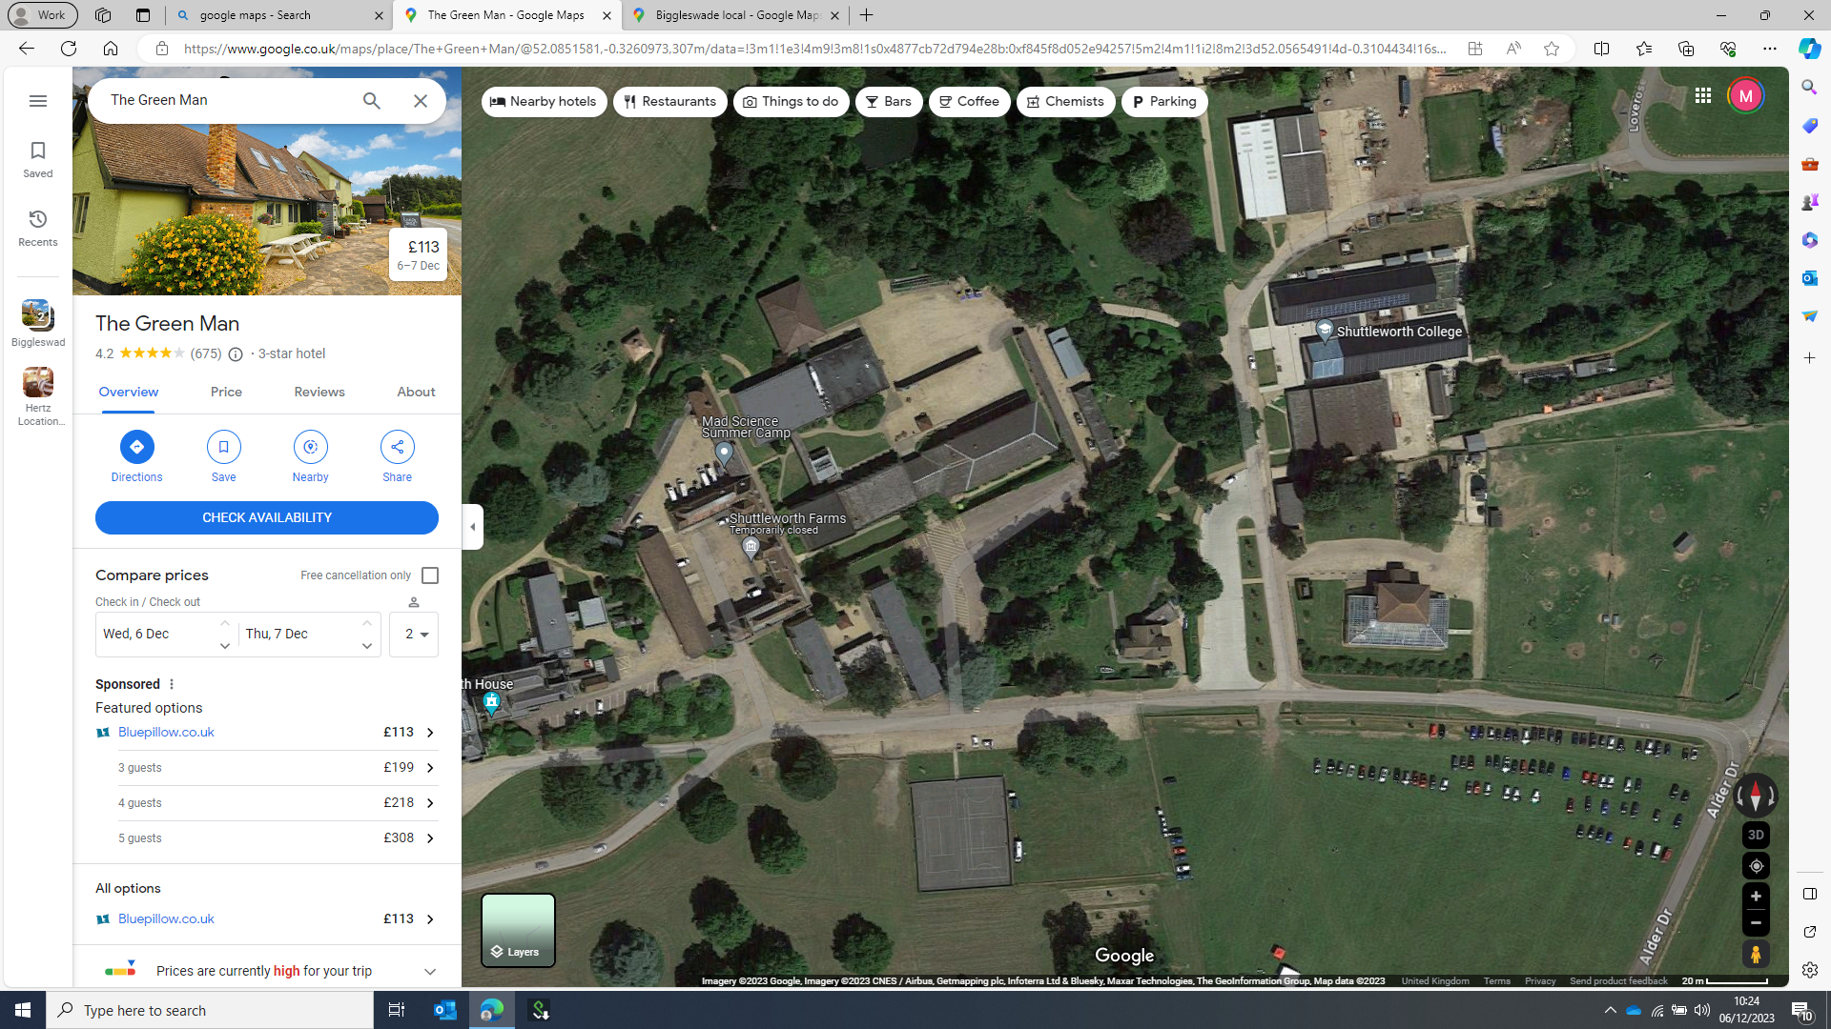

Site Compound

Plantroom 1

SALIX work LRC/IT teaching block

Refurbishment works – Halls of Residence/Common Room

AHHP/Plantroom 2

SALIX work Russell Hall

`

Plan B - Location of the Works

**4.0 Site Visits During the Tender Period.**

The College have allocated four site visit slots during the tender process. Visits will be agreed on a “first come, first served” basis. All visits shall pre agreed via email with Mark Eustace [meustace@bedford.ac.uk]

|  |  |  |
| --- | --- | --- |
|  | *Wednesday 14 Feb 2024* | *Wednesday 21 Feb 2024* |
| Slot 1 | 09:00 – 11:00 | 09:00 – 11:00 |
| Slot 2 | 13:00 – 15:00 | 13:00 – 15:00 |

Table E – *Schedule of Visit Slots*

Direct unannounced visits to site will not be permitted.

**5.0` Safeguarding and DBS Checks.**

The SALIX works are being carried on very busy college campus and inevitability the on-site team will be working near to learners and staff. Bedford College have a published safeguarding guidance for the operation of their education sites [*Staff Safeguarding Leaflet - April 2022*]. The contractor shall always execute the works in full accordance with this guidance.

The purpose of the Bedford College safeguarding guidance is to set out the “preventative and precautionary approaches to planning and procedures that are necessary to be in place to protect all students, staff and visitors and minimise risk from any potential harm.”

SALIX works are scheduled to be part carried out during term time when learners will still be present on site, as well as during holidays. Therefore, the entire construction team shall be fully Enhanced DBS checked. The cost and application for the DBS checking should be organised by the contractor. The Capital Works Project Manager can request to inspect the checks at any time. Any member of the workforce who are unable to provide an enhanced DBS will be excluded from the works.

Further information on the application of the DBS system can be obtained via the following link:

<https://www.gov.uk/dbs-check-applicant-criminal-record/get-a-standard-or-enhanced-dbs-check-for-an-employee>

Prior to starting on site the entire workforce will be required to attend a safeguarding awareness session hosted by Bedford College.

**6.0 Health and Safety & Asbestos**

Due to the nature of the works, it likely that the contractor will encounter any asbestos risk during the works. Bedford College have commissioned a R&D survey covering all of the works.

All delivery staff shall always wear steel toe cap boots or shoes and clean branded hi-vis vests/jackets. The use of site hats will be subject to the method statement and RAMS.

Smoking will only be permitted in pre-agreed areas outside of the working area. The workforce shall not interact at any time with customers; members of the public, Willow Place staff, or visitors.

**See Appendix 1**- Pre-Construction Client Information [In accordance with the CDM Regulations 2015]

**7.0 Pricing Schedule & contract.**

Please include the following information in your offer letter on headed paper.

1. Prices in accordance with the combined Contract Sum Analysis [excluding VAT].
2. Preliminaries
3. Overhead and profits
4. Percentage addition to Provisional Sums
5. 12 warranty period under seal.
6. The contract will be a standard JCT Design Build Contract [2016].
7. Liquidate and ascertained damages – £4,800/week.
8. None of the consultant team will be novated. The successful company undertaking the works will be permitted to approach any of the current professional team to provide a fee for the stage 5/6 design work.

|  |  |  |
| --- | --- | --- |
| *Company* | *Contact* | *Email Address* |
| *Devonshire Architects* | *Stuart Devonshire* | [*sdevonshire@mk40architects.com*](mailto:sdevonshire@mk40architects.com)  *07786 858221* |
| *PANDA CES Ltd* | *JP Cain* | [*jp@pandaces.co.uk*](mailto:jp@pandaces.co.uk)  *07801 556104* |
| *SOLUTION CE Ltd* | *Steve Baldwin* | [*steveb@solutionce.co.uk*](mailto:steveb@solutionce.co.uk)  *07903 162414* |

Table F – *Consultant Contact Table*

**8.0 Schedule of potential suppliers/sub-contractors.**

Set out below is a schedule of supplier/sub-contractors who can be approached to provide a quotation of the works. Please note we are nomination or naming these companies.

* Civil Engineering Works [Marsh Construction [Luton] Ltd] – *joe@civilsluton.com*

96 Marsh Road

Luton

LU3 2NL  
Telephone: 01582 491591 or 07956 562593

**9.0 Tender Instructions & validity**

1. Tenders must be returned via email to [tenders@bedford.ac.uk](mailto:tenders@bedford.ac.uk) at 12:00 on Friday 08 March 2024.
2. Tenders sent to any other email address may be excluded from consideration.
3. The tender offer shall be presented on headed paper.
4. Please ensure you allow sufficient time to submit the documents/quote/both CSA’s [in Excel format] prior to the **deadline of 12:00 on Friday 08 March 2024**.
5. Late tenders [or quotes sent to the wrong email address] shall be excluded from consideration.
6. All queries during the tender process shall be submitted in writing [via email] to Mark Eustace meustace@bedford.ac.uk
7. The proposal shall remain in force for a minimum of 30 days from the date fixed for the submission.
8. In submitting the proposal, the contractor shall undertake that, in the event of the submission being accepted by the College, within 30 days of being called upon to do so by the Principal or Authorised Officer on behalf of the College, the contractor will execute a formal contract.
9. Proposals shall only be submitted on the basis that they are bona fide competitive submissions.

a) shall have offered or given or agreed to give any officer or member of the College staff any gift or consideration of any kind as an inducement or bribe to influence its decision.

b) shall have communicated to any other person than the College the amount or approximate amount of the proposed submission other than in confidence in order to obtain quotations necessary for the preparation of the submission, or for insurance purposes, or

c) shall have entered into any agreement or arrangement with any person as to the amount of any proposed submission or that person shall refrain from submitting.

1. The College will exclude bidders at any time throughout the tender process should the grounds of exclusion pursuant to Public Contracts Regulations 2015 as amended be found to apply.

Please note that tenders should not be copied or submitted to any other email address. The College reserves the right to exclude any tenders that are not submitted in line with the ITT.

**10.0 Acceptance of Submission**

1. The College shall not be under any obligation to accept any proposal.
2. The College shall not be under any obligation to accept the lowest proposal.
3. The College reserves the right to cancel the entire or parts of the tender, without such an action conferring any right to compensation on the contractors.
4. At no time should the contractor, prior to submitting or following the bid submission, communicate with any person within the College in the first instance other than Mark Eustace. Failure to abide by this ruling could disqualify the contractor’s proposal from being considered.
5. The submission must be based upon the terms, conditions and specification(s) set out in these documents, otherwise it may be rejected because of being unsuitable and non-compliant.  The Form of Tender may not be modified in anyway.
6. Contractors will be notified of the outcome of their submission at the earliest possible time.
7. No submission will be deemed to have been accepted unless such acceptance has been notified to the contractor in writing.
8. In case a submission is abnormally low or high in relation to the services to be provided, the College will request a clarification in writing and/or explanation concerning its elements. The College reserves the right to exclude a submission, if after a verification process based on the explanations and evidence received it concludes that the submission is abnormally low or high.

**11.0 Payment Terms & SALIX Grant Draw Down**

Bedford College terms are that each month’s invoices will normally be settled within 28 days. All invoices should be submitted electronically to the finance department using the email address *finance@bedford.ac.uk* quoting a valid purchase order number. Should any offer vary from the standard College payment terms then this must be agreed in writing by the Capital Works Project Manager prior to the purchase order being issued.

On a monthly basis, to assist Bedford College to draw down the SALIX grant funding, the PC shall complete the sections in yellow on the attached spreadsheet *SALIX Cost Breakdown. XLS*. The PC shall co-operate with Bedford College present invoice in accordance with the format required by the SALIX grant offer.

**12.0 Project Team**

The core project team members are identified below.

|  |  |  |  |
| --- | --- | --- | --- |
| Diane Gamble | Bedford College | Director of Estates and Facilities | [dgamble@bedford.ac.uk](mailto:dgamble@bedford.ac.uk) |
| Mark Eustace | Project Management Solutions | Capital Works Project Manager | [meustace@bedford.ac.uk](mailto:meustace@bedford.ac.uk) |
| Stuart Devonshire | Devonshire Architects | Principal Designer; design team leader and Architect | stuart@devonshirearchitects.co.uk |
| John Paul Cain | Panda CE | Mechanical & Electrical consultant | [jp@pandaces.co.uk](mailto:jp@pandaces.co.uk) |

**13.0 Tender Scoring**

Bedford College and the project team will be applying a technical/financial evaluation to determine the tender.

The tender evaluation will determine the most compliant, comprehensive and cost-effective offer.

The consultant team will review the priced schedule to determine the basis of each tender. In some cases, this may result in the request for clarification or further information to satisfy the client team that the cost is offered on a full “like for like “basis.

**APPENDIX 1**

Pre-Construction Client Information – Shuttleworth College; Old Warden Park; Biggleswade; Bedfordshire; SG18 9DX.

Pre-Construction Client Information [In accordance with the CDM Regulations 2015]

|  |  |
| --- | --- |
| Version | 7.0 |
| Date | 08 Feb 2024 |
| Author | Mark Eustace |
| Checked By: | Diane Gamble |

|  |  |
| --- | --- |
| Description of the project | Site address – Shuttleworth College; Old Warden Park; Biggleswade; Bedfordshire; SG18 9DX  The works will involve the installation of district heating pipework; plantroom fit out; install new heat emitters; connect new ASHP; install AHU’s and connect up services to the HoR at Shuttleworth College. |
| [Key dates](http://www.designingbuildings.co.uk/wiki/Key_dates). | Works are planned to be carried out between 01/04/24 and 27/09/24. |
| Contact details [and roles] for the key college team | *College Project Manager [Primary Contact]*  Mark Eustace  [meustace@bedford.ac.uk](mailto:meustace@bedford.ac.uk)  07977 123039  *On Site Contact on behalf of Bedford College*  Chris Jones  [Cjones@bedford.ac.uk](mailto:Cjones@bedford.ac.uk)  Shuttleworth College Facilities Co-Ordinator |
| Principal Contractor; supervision and the operation of the works. | Bedford College will be fulfilling the role of Client/Employer for the project.  The contractor shall fulfil the role of Principal Contractor [PC].  The PC shall appoint a suitably experienced full-time non-working Senior Site Manger [SSM] for the duration of the site works.  The CWPM shall be the main point of contact for the College during the defect’s liability period. |
| The Project Team | Bedford College has appointed Project Management Solutions as Employers Agent.  The current project team structure is set out below.  The design team is being led and coordinated by Architect & Lead Designer – Stuart Devonshire [Devonshire Architects]  Mechanical & Electrical Design – JP Cain [PANDA CE]  M&E Clerk of the Works – Iain Hodkinson [PANDA CE]  Structural & Civil Engineering Consultant - Sanjay Dhanani [Waldeck] |
| The extent and location of existing information. | *The following information will be supplied in advance of the works:* |
| Project arrangements: | Working hours are as follows:  07:00– 17:00 [weekend working by prior agreement]  Smoking is only permitted on site in a pre-agreed location writing the contractors compound.  No access will be permitted to other parts of the college or the Shuttleworth Estate without prior agreement. |
| Planning and managing the construction work | The PC shall name and appoint a named supervisor for the works.  A full set of RAMS will be supplied to the College for comment/approval  A qualified non-working first aider will be supplied by the contractor at all times.  The movement of all site traffic outside of the site boundary will be subject to a maximum speed of 20 mph. |
| Communication and liaison | All communication during the works will be via Mark Eustace [Capital Works Project Manager].  The works contractor shall allow for meeting with the CWPM for a coordination meeting one a Wednesday [weekly] during the project. |
| Security; access and egress for other residents/tenants. | The contractor shall take all reasonable steps to protect the works.  No work shall be left over night in an unsafe state.  In co-operation with the CWPM, the contractor shall prepare and agree a Construction Management Plan [CMP] to ensure that all of the students; staff and visitors at Bletchley campus and occupiers of the adjacent properties continue have quiet and safe enjoyment of their demise all-times. |
| Site transport | Strict 20 mph rules are in place on the main service road. The supplier shall exercise extreme care when exiting the site.  Extreme care must be exercised during access; egress and manoeuvring on campus and in the circulation areas.  All deliveries shall be banked and adhere to the speed restrictions.  Any failure comply will result in the permanent explosion from site of the driver and vehicle. |
| Emergency procedures | For the duration of the works, the supplier will maintain effective communication with Bedford College Facilities Team. |
| Safety hazards and adjacent land uses | The college will be using a variety of vehicles on site. Extreme caution shall always be exercised.  For the entire duration of the project, leaners; staff and visitors will be present but not within the site works.  The site works will be very close to a working campus and machinery. |
| Temporary Works | The supplier shall exercise extreme care to prevent any collapse or damage to the sub strata. |
| Site Operative Health & Safety | PPE The supplier will provide fully serviced PPE for operatives or their supervisors.  All operatives must enter the site in full; clean and fully operational PPE.  Minimum PPE will be as follows:   * Safety hard hat conforming to BS EN 397, less than three years old and in good condition. * High visibility vest conforming to BS EN 471 * Steel protected footwear [to protect the toes and foot bed] to EN20345 S1-P SRC safety rating * Gloves - Life gear Green Latex Grip Builders Gloves [OSA]   Behaviour & dress  All site personnel are expected to conduct themselves in a professional manner at all times whilst on site, especially given that the site is within a busy shopping area. This includes the use of appropriate language and dress. Shorts, hooded garments and vests will not be allowed on site without prior permission. |
| Site Accommodation | The PC shall submit a temporary accommodation plan prior to the start of the works. |
| Restrictions on deliveries, waste collection or storage. | All deliveries shall be made via the entrance from the B658 |
| COVID Rules | Not applicable |
| Existing services. | The PC shall price for carrying out a full CAT scan below ground survey before commencing any excavation works. |
| R&D [Asbestos](http://www.designingbuildings.co.uk/wiki/Asbestos) [Survey](http://www.designingbuildings.co.uk/wiki/Contaminated_land) | Bedford College will provide a detailed intrusive asbestos survey during the tender. |
| [Client](http://www.designingbuildings.co.uk/wiki/Client)’s activities | Bedford College operates Shuttleworth College as a live teaching site.  Learners; staff and visitors who are totally unconnected with the project will be located adjacent to works site. Extreme care should be exercised to limit any contact or disturbance during the works. |
| CCS | CCS registration is not required |
| Storage of hazardous materials | The PC shall submit a plan for the storage of any hazardous waste. |

**Appendix 2 Conflict of Interest Declaration**

I/We warrant that:

* 1. There **would be no** conflict or perceived conflict of interest in relation to the personnel or type of work involved in this contract.

Signed:

Position/Status:

Company Name:

Address:

Date signed:

I / We warrant that:

* 1. There could be a possible conflict or perceived conflict of interest in relation to the personnel or type of work involved in this contract.

Please explain what the possible conflict or perceived conflict of interest may be and who it relates to and how it could have an adverse effect on this contract.

|  |
| --- |
|  |

Signed:

Position/Status:

Company Name:

Address:

Date signed: