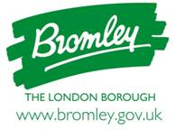

MENTAL HEALTH FLEXIBLE SUPPORT –
PROVIDER MARKET ENGAGEMENT EVENT

TUESDAY 15 JANUARY 2019 – 14:00PM to 16:30PM

APPLICATION FORM

I / we confirm that I / we will be attending Bromley Mental Heath Flexible Support, Provider Market Engagement Event on Monday 15 January 2019.

Company Name:

Company Address of

Telephone Number:

Email address:

Name of Delegate(s) attending.

CQC Registered | Yes: □ No. □

