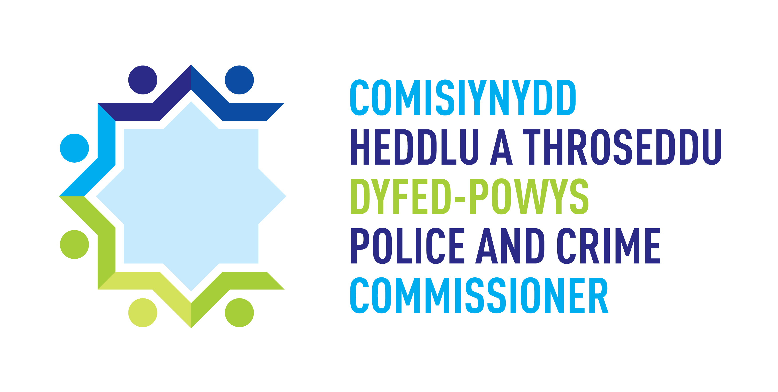 | 

Supplier Qualification Questionnaire

Supply, Implementation, Support and Maintenance of Contact Management Solution

DPP/20/21

INSTRUCTIONS FOR SUPPLIER QUALIFICATION STAGE

OBJECT OF THE CONTRACT
The Police and Crime Commissioner for Dyfed Powys is inviting tenders from suitably qualified and experienced organisations for the supply, implementation, support and maintenance of a Contact Management Solution (CMS).

BACKGROUND
Dyfed Powys Police has a history of operating a critical voice and data environment to meet the demands of front-line services to its citizens via the 999, 101 and various other services. DPP has one of the highest average speed times of answering calls for 999 across the UK.

Dyfed Powys Police are now seeking to procure an Integrated Communication Control System (ICCS) and Contact Management Solution (including telephony platform) for the Force Control Room based at Headquarters, Carmarthen. Adopting a principle of ‘cloud first’ we are looking for a cloud based, high availability, easy to maintain and effective next generation ICCS/Contact Management Solution that supports both multichannel voice and digital communications and also interfaces with the current Airwave radio network. The system must also be available within our secondary site, based at our premises in Ammanford which acts as a backup site but this site can also be used as a staff training facility, business continuity events and so on.

The corporate voice platform outside of the Force Control Room is currently Cisco Call Manager, interfacing into this would also be a requirement for the provision of call transfer etc.

Technology within Policing is changing, the legacy Airwave network will evolve into ESN and the traditional delivery of emergency 999 calls over ISDN will be replaced by the requirement for SIP therefore the system we seek must be adaptable and will deliver to the force a seamless migration into next generation technologies. Obviously being a 24x7x365 service, we require that a service management support mechanism must also be available to reflect our operational needs should the system encounter any issues.

The solution must also provide full voice recording and playback functionality across both the telephony and Airwave formats.

Some of the other features we expect include:
- Command & Control integration for multi-channel voice/digital communications and digital radio communication
- Customer Relationship Management application
- Easily customisable Interactive Voice Response attendant
- Provision of location services for the mapping and dispatch of mobile units within Command & Control
- Enhanced EISEC/EISEC 2 for BT subscriber service
- Multi-channel contact and Airwave radio recording of calls with data tagging
- Ability to dynamically adjust agent skills and call flows
- Customisable agent reporting, live time displays and ‘cradle to grave’ reporting

The control room is split into two distinct workstreams, namely Call Dispatchers and Call Takers. All users have access to Sopra Steria STORM as the on-premise Command and Control therefore the new ICCS/Contact Management Solution will have to integrate into this.

The license requirement is as follows:
- Despatchers Licences x 20 users
- Call Handling Licences x 25 users
- Voice Recording Multichannel licences x 45 users
Additional requirements (non-exhaustive):
- Operator and Technical training
- Technical Services and Integration
- Hosting costs (including voice circuits etc.)
- Implementation
- Testing (SAT’s/ UAT’s).

Dyfed Powys Police – ICT Strategy

In response to Policing Vision 2025, Dyfed Powys have developed an internal ICT strategy for 2018 – 2024. This is to ensure the key national deliverables are met along with ensuring the force is in a position to provide the best ICT systems to ensure the workforce of Dyfed Powys Police is digitally enabled and informed. It also ensures officers and staff are provided with the correct tools to safeguard and protect the public and are given a reliably quick, secure, agile and cost effective infrastructure to work on.

The strategy outlines a number of Principles to underpin the choice of ICT products, whether procured from external providers or developed in-house in order to:

- Collaborate with partners as a default
- Share, manage and rely on information confidently where appropriate
- Guarantee efficient and consistent information processing
- Make it easy for users to deliver.

ICT Principles
1. Support front line delivery by:
a. Minimise double keying and duplicate data entry of data amongst systems;
b. Avoid returning unnecessarily to base or to revert to desktop data entry.
2. Prevent and fix duplicate nominal records.
3. Apply data quality processes that will ensure standardisation.
4. Process driven data input that guides user through relevant mandated fields.
5. Ensure integration and interoperability between applications/systems.
6. Deliver a seamless user experience, ensuring an intuitive interface which has a consistent corporate look and feel across all applications, including standard navigation and page layouts.
7. “Mobile first” - Prioritising mobile data solution.
8. Provide “single sign-on” to all applications via Active Directory and integrating with the NIAM solution.
9. Support the ability to work disconnected with a robust and reliable synchronisation mechanism when in coverage.
10. Use of geocoding and mapping to intuitively populate location fields.

Police and Crime Plan 2017-2021

The Police and Crime Plan sets out the Force’s priorities and details how progress will be measured.

Priority 1: Keeping our communities safe
Priority 2: Safeguarding the vulnerable
Priority 3: Protecting our communities from serious threats
Priority 4: Connecting with communities.

GUIDANCE FOR COMPLETING THE SUPPLIER QUALIFICATION QUESTIONNAIRE

- Please read through this document before completing your return.
- The ‘Customer’ shall mean The Police and Crime Commissioner for Dyfed Powys who invites persons, firms, companies or other bodies to submit Tenders.
- NB You are required to complete the questionnaire online within the etenderwales portal. Where the question identifies a response eg Yes/No please answer as appropriate. Where we have asked for you to provide additional documentation, the file name needs to stipulate the applicable question reference number and be uploaded with your questionnaire response.
- Responses to this questionnaire will be used to help compile a shortlist of companies to be invited to tender for the proposed contract. You must therefore supply all relevant information and supporting documentation at this stage to ensure that it accurately reflects your capabilities.
- Please fully answer all of the questions, in the fields provided, even if you have previously submitted information. It will not be sufficient to refer to information previously provided.
- The completed questionnaire (together with any supporting documentation) must be completed and published within etenderwales by the closing date identified below.
- The information you provide in this document will be used to evaluate companies interested in tendering for the proposed contract. It may also be referred to during the period of the contract and will form part of any contract awarded.
- The Customer reserves the right to ask for further information in addition to and/or in support of that presented in your company’s completed document.
- Where a Tenderer has any further enquiries arising from the Tender Documentation which may have a bearing on the offer to be made these should be raised via Etenderwales message portal as soon as possible and no later than 2pm 18th March 2021.
- Please also refer to the message portal on Etenderwales for any additional information posted about this tender or to view answers to any clarification questions which may have been submitted.
- Where such an enquiry has been made, a copy of the written reply will be circulated to all Tenderers although anonymity will be preserved.

The deadline for the return of the completed questionnaire is 10am 26th March 2021.
EVALUATION APPROACH

Supplier Selection

The objective of the selection process is to assess the responses to the Supplier Qualification Questionnaire (SQQ) and select potential service providers to proceed to the next stage of the procurement.

Selection criteria will be a combination of both financial and non-financial factors and will consider:

- economic and financial standing
- technical and professional ability

Failure to provide a satisfactory response to any of the questions may result in the Customer not proceeding further with the supplier.

The information supplied will be checked for completeness and compliance before responses are evaluated.

Questions are pass or fail. Individual Question Guidance is provided within etenderwales.

A minimum of 3 will progress onto the tender stage.

Where in the opinion of the Customer the response is inadequate the supplier may be excluded from further consideration.

Evaluation of subsequent stages will be undertaken in accordance with the Award Criteria stated in the Invitation to Participate for this procurement. The Customer intends to award any contract based on the most economically advantageous offer taking in to account the Award Criteria.

Invitation to Participate in Negotiations stage

Suppliers who are successful at the supplier qualification stage will be shortlisted and will be Invited to Participate in Negotiations for this requirement.

Further and more detailed information regarding the requirement is provided at this stage for information only and is in DRAFT version. The Customer reserves the right to revise these documents prior to publication of the next stage. These documents are provided at this stage in line with Public Contracts regulations 2015 – Regulation 53 Electronic Availability of Procurement Documents.

As indicated in the Contract Notice, the Customer will conduct the procurement in successive stages in order to reduce the number of solutions and Tenderers throughout the process.

As per Regulation 29 (15), The Customer reserves the right to award the Contract on the basis of the Initial Tenders without negotiation as indicated, in the Contract Notice.

PLEASE NOTE: You are NOT required to complete the ITT requirements at this time. Please ONLY complete the Supplier Qualification Questionnaire.

- Timescales (approximate for planning purposes only)
The following table sets out a summary of the complete process and an indicative timetable. Please note that the Customer, reserves the right to change any of the dates or stages set out in the table below at its absolute discretion.

Tenderers should note that the Customer may vary the Procurement process, for example in order to support continued competition, avoid unnecessary costs associated with a Bid and adhere to technical, legal or commercial guidance issued subsequent to the ITPN.

Competition with Negotiation
Timeframe | Dates | Task | Responsible
1 day | 24.02.2021 | Advertise on Sell2Wales.co.uk/Contracts Finder  Publish Supplier Questionnaire | Procurement / Project Team
30 days (fixed) | 26.03.2021 | SQ Return date | Procurement
7 days | 29.03.2021 | SQ Evaluation  Agree Shortlist Tenderers | Evaluation Panel
25 days (fixed) | 30.03.2021 | Publish Invitation To Participate  Stage 1 | Procurement
 | w/c12.04.2021 | Supplier Day Clarifications  SUPPLIERS TO NOTE DATES | Suppliers  Procurement / Project Team
 | 27.04.2021 | Tender Return | OPCC to open tenders
14 days | 27.04 - 07.05.2021 | Evaluate responses including consensus day | Evaluation Panel  Procurement / Project Team
 | 07.05.2021 | Consensus Day | Evaluation Panel  Procurement / Project Team
2 days | 13 - 14.05.2021 | Negotiation Stage | Suppliers  Procurement / Project Team
 | w/c 17.05.201 | Evaluation and shortlist to ITCN | Evaluation Panel  Procurement / Project Team
21 days | 21.05.2021 | Issue Invitation to Continue Negotiations | Procurement
Within 21 days | 01 – 02.06.2021 | Demonstration Days  SUPPLIER TO NOTE DATES | Suppliers / Evaluation Panel  Procurement / Project Team
2 days | 08 - 09.06.2021 | Negotiations  SUPPLIER TO NOTE DATES  Actual dates will be provided in later stages | Suppliers  Procurement / Project Team
 | 10.06.2021 | Evaluation and shortlist to further stage or conclude | Evaluation Panel  Procurement / Project Team
7 days | 14.06.2021 | Conclude ITCN / Issue Invitation to Submit Final Tender (possibility of further negotiation stage) | Procurement / Project Team
 | 21.06.2021 | ISFT submission Draft | Suppliers
7 days | 21.06.2021 | Review | Evaluation Panel  Procurement / Project Team
 | 28.06.2021 | ISFT submission Final | Suppliers
7 days | 28.06.2021 | Evaluation | Evaluation Panel  Procurement / Project Team
7 days | w/c 28.06.2021 | Reporting and Sign Off / Intention to Award  Dependent on COG / PB availability | Procurement / Project Team
10 days | 02 - 13.07.2021 | Standstill period / Confirmation of Award
 | 19.07.2021 | Start-up Meeting / Contract Live | All Parties
 | 19.07.2021 - 31.07.2022 | Implementation Period
 | 01.08.2022 | Go Live | All Parties
 | 23.09.2022 | Existing Contract end
2 Confidentiality
2.1 Invitations to Tender must be treated as private and confidential. The Tenderer must not disclose the fact that they have been invited to tender or release details of these Tender Documents to any party other than the Tenderer’s professional advisers whom they may need to consult for the purpose of preparing this Tender.

2.2 The documents which constitute the Tender Documents and all copies thereof are and shall remain the property of the Customer and save for the purposes of the Tender, must not be copied or reproduced in whole or in part and must be returned to the Customer upon demand.

3 Legislation
3.1 Freedom of Information Act 2000
Police and Crime Commissioner for Dyfed Powys is committed to open government and to meeting its responsibilities under the Freedom of Information Act 2000. Accordingly, all information submitted to the Customer may need to be disclosed by the Customer in response to a request under the Act. We may also decide to include certain information in the publication scheme which we maintain under the Act. If you consider that any of the information included in your tender is commercially sensitive, please identify it and explain (in broad terms) what harm may result from disclosure if a request is received, and the time period applicable to that sensitivity. You should be aware that, even where you have indicated that information is commercially sensitive, we may be required to disclose it under the Act if a request is received. Please also note that the receipt of any material marked ‘confidential’ or equivalent by the Customer should not be taken to mean that the Customer accepts any duty of confidence by virtue of that marking. If a request is received, we may also be required to disclose details of unsuccessful tenders.
3.2 Welsh Language Standards Regulations 2016
The force has a duty to comply with the Welsh Language Standards Regulations. This duty extends in specific circumstances to Contractors.

4 Data Processing/Disclosure and Confidentiality Agreements
4.1 The successful supplier will be required to enter into relevant data processing contracts/data disclosure agreements and confidentiality agreements in respect of any information of the Customer that they will have access to as part of the contract.

