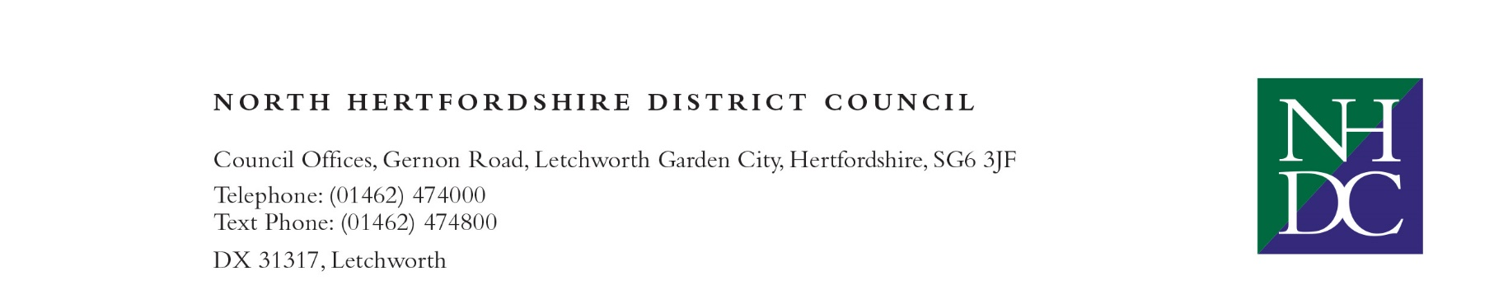

|  |  |  |
| --- | --- | --- |
| Phoenix Software Ltd  Blenheim House  York Road  Pocklington  York  YO42 1NS | Our Ref: NHDC\VG\IT  Contact Officer: Jo Dufficy  Direct Line: 01462 474555  Email Johanne.Dufficy@north-herts.gov.uk  Date: 25th March 2022 |  |

Dear Sirs,

**Re: 3 Years Microsoft Licenses – E5 Contract**

On 18th February 2022 we communicated our intention to make an award to your company for the above contract using the KCS Framework Y20011 (Mini Competition), subject to there being no legal challenges being raised during the standstill period, applied in accordance with the requirements of regulation 87 of the Public Contract Regulations 2015 and the Authority’s reserved rights as declared in the ITT.

The standstill period ended at midnight on 1st March 2022, with no challenge and I am pleased to confirm that we are now able to conclude the contractual arrangements and formally award a contract.

*The award of this contract is based on the KCS Framework Agreement incorporating the individual Call-Off contract and with any amendments to the Call-Off terms that may be agreed by both Parties.*

Once again, I would like to thank you on behalf of North Hertfordshire District Council for expressing your interest in the contract and for the time taken in the preparation of your tender documents. North Hertfordshire District Council looks forward to continuing a successful working relationship with your organisation.

Yours faithfully,

Jo Dufficy

Service Director - Customers

North Hertfordshire District Council

