Appendix 4a

21st September 2020

Project Title: Henry Dickens Court - Sports Pitch Fencing Renewal (Estate Improvement Budget)

Scope of Works | The contracted supplier will be required to: -  - Supply labour, plant, materials and temporary materials to carry out the improvement works to the MUGA Fencing at Henry Dickens Court Estate under this Contract.  - Undertake an onsite inspection of the Current MUGA fencing.  - Breakout and disposal of current MUGA mesh fencing.  - Supply and Install new MUGA fencing to site in line with specification.  - Supply and Install 2x site entrance gates in line with specification.
Project Lead | Patrick Sullivan
Department | Estate and Environmental Services
Project Team | Patrick Sullivan, Dominic Davies, John Gaffney
Estimated Project Cost | £30,000 – £35,000 Excl. VAT, based on Benchmark Cost Exercise.
Funding Route | Estate Improvement Budget (EIB)
Consultation | Consultation has been undertaken with the Residents Association and the Estate in line with the Estate Improvement Budget (EIB) processes. Letters were issued to the estate and they were consulted on the proposed works.
S.20 Required | No as through EIB and no recharge
JCT Minor Works 2016 | Yes
CDM Requirements | Not expected to exceed 30 days with more than 20 workers at any time, or, have over 500 person days on site.
Proposed Project Start Date | TBC through tender process by procurement.  If agreed, site works would need to be commenced between Monday 9th November 2020 and Friday 20th November 2020.
Proposed Project Works Period | Works to be agreed in set time frame. It is thought that works should not take more than 30 working days.  Monday 9th November 2020 – Friday 18th December 2020  No works to be undertaken on Weekends  Works to be proposed between the hours of 9am – 5pm
Project Specification | Please see attached documentation
Tender Evaluation Criteria | 60 : 40 (Quality : Cost)
Tender Questions | 1.0) Please submit a minimum of two examples of previous contracts that are similar to this Project. Submissions, which do not, in the opinion of the Council, adequately meet the requirements of this Project with regard to previous experience, will be excluded from the Technical and Price Criteria outlined below and will not be taken forward to any subsequent stages of the Tender evaluation.  2.0) Please identify the potential issues around working within a constrained site where neighbours and children are resident in close proximity, and how you would look to mitigate them. Please answer with emphasis on site specifics.  3.0) Please outline how you propose to manage site logistics i.e. welfare facilities, deliveries, parking, residents and other business access etc. with minimal disruption to neighbours. Please answer with emphasis on site specifics.  4.0) Please identify the potential Health and Safety issues specific to this particular project and how you propose to mitigate them. Please answer with emphasis on site specifics.  5.0) Please outline the environmental and sustainability principles that should be taken into consideration prior and during the works to avoid or minimise any negative impact on the environment. Please answer with emphasis on site specifics.

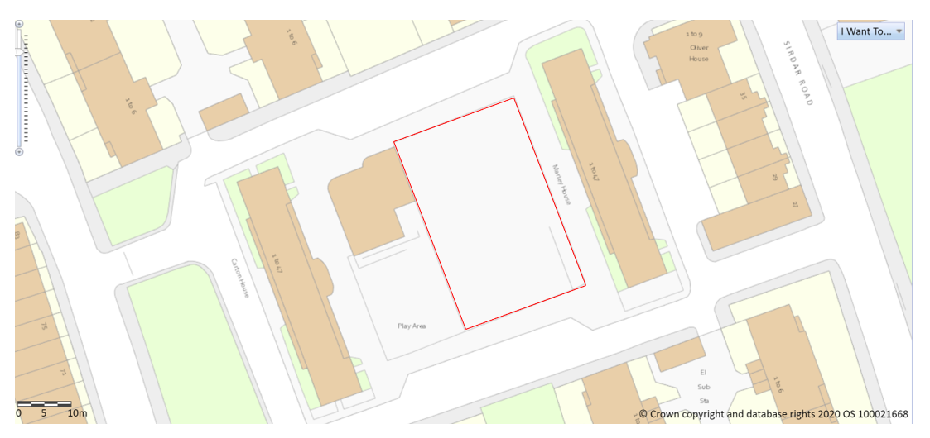

Yours faithfully

Patrick Sean Sullivan
Environmental Project Officer
Royal Borough of Kensington and Chelsea
Network Hub, 292 Kensal Road, London, W10 5BE
Our Values | Putting Communities First | Respect | Integrity | Working Together

