

Invitation to participate in a Mini Competition
Fixed Term Viability Consultancy Support

HCA / ATLAS

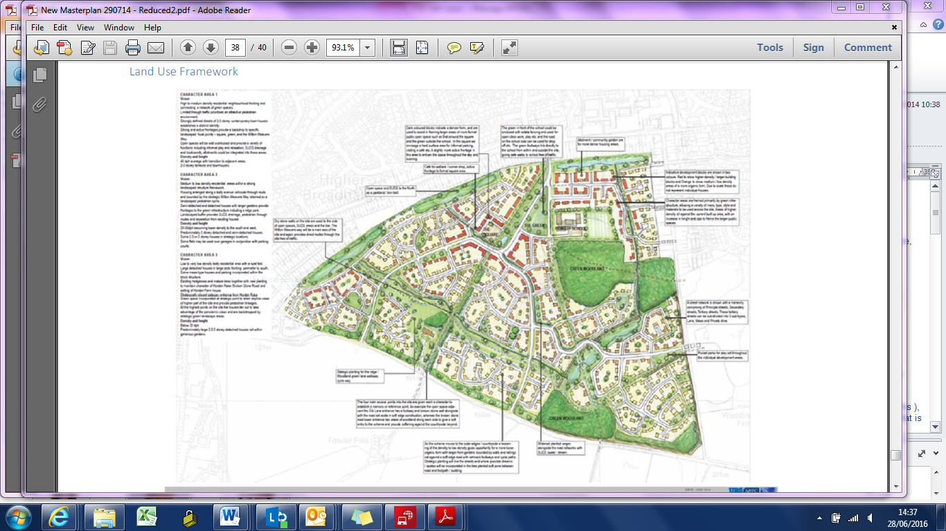

Issue date : 02/08/2016

Deadline for response (2 weeks):
5.00 pm 16/08/2016

Panel: | Property
HCA Area: | ATLAS
From: | Homes & Communities Agency
Date: | Issued 02/08/2016
Deadline for return bids: | 5pm on Tuesday 16/08/2016 (2 weeks)

- Summary
The HCA ATLAS team are seeking to procure up to two consultants to provide viability and delivery advice as part of our role to support delivery of planning certainty on large scale residential led developments including Garden Settlements and Housing Zones. This will require named, dedicated resource for 2 to 3 days per week with the aim that the individuals will be integrated into our multi-disciplinary team and adopt the ATLAS approach of impartiality and collaborative working.
- Introduction
Part of the ATLAS role is to provide an impartial advisory service to Local Planning Authorities and their delivery partners; helping to speed up progress through the planning process; and improve the quality of outcomes for large scale residential led development projects(typically around 500 units or more).ATLAS also provide advice and best practise guidance regarding the delivery of large scale, priority sites and garden settlements within the HCA and to DCLG.
ATLAS was originally set up by DCLG and now forms part of the HCA’s comprehensive offer of planning and enabling support to local places delivering large sites. We are a nationwide, multi-disciplinary matrix team located in all the main HCA offices.
Our commissions begin when we are asked to assist on a project by either the LPA or their private sector partners. This can be at any stage in the planning process; we then diagnose the key issues and scope our support to the project, get to know the project teams; provide good practise advice; facilitate/broker solutions to planning policy/applications and mediate on delivery mechanisms and planning obligations. We have a good track record established over ten years working on large sites and can demonstrate success at each of the following stages of the planning process:
- Strategic site selection
- Visioning/ objective setting
- Establishing policy
- SPG/ Masterplan
- Outline planning application
- Reserved matters/ Conditions discharge
- Implementation of the development and monitoring
Since the introduction of the NPPF; PPG and the recent Housing and Planning Act, deliverability/viability of schemes has become vital at all key stages of the planning process. On large scale schemes there is usually a need for significant new infrastructure to ensure sustainable and acceptable development; delivery of this infrastructure can have a critical impact on scheme viability, and interventions such as public sector recoverable investment can be factored in to help speed up delivery on site – emphasising the links to HCA Investment programmes and future pipelines of housing delivery.
ATLAS is committed to supporting project teams to compile the appropriate level of evidence needed to underpin planning decisions and delivery. This can be when the site is allocated within a local plan; embedding delivery into a masterplan or policy documentation; establishing infrastructure delivery plans and viable S106 terms including affordable housing; and when brokering a realistic viability baseline to support a planning application decision and future review mechanisms. As part of this support package we also provide training to council planning officers and members in order to build understanding of the importance of viability at all stages of the planning process.
- The Role
We are looking to appoint dedicated, named consultants who will be based in one of the HCA offices ( to be agreed and subject to negotiation from Birmingham, Bedford or Bristol) for 2 or 3 days per week. We are looking for a good geographic spread, and it is likely that the individuals selected will be required to travel significantly to sites across England. The consultants will be managed by one of the senior managers within the ATLAS central team, and work within the ATLAS matrix as part of the multi-disciplinary offer to specific projects. These could be traditional long term developments, growth areas, SUEs, housing zones or garden settlements at any stage of the planning process.
The consultants are expected to bring a wide range of viability and delivery expertise on large scale developments to contribute to the ATLAS offer to local planning authorities and their private sector partners. They will be expected to attend key project meetings – internal clinics, site visits, task and finish group/steering group meetings with the project teams, and help to facilitate at workshops and training events. They will be expected to build capacity within the ATLAS team, HCA wider team and our partners promoting an understanding of approach to large scale site viability and delivery.
A core value of our engagement is that the project is the client rather than simply seeking to promote the interests of either the local authority or developer. Accordingly it is important that the successful consultants can share the ATLAS approach which is strongly based upon impartiality and collaboration, and that the driver is to ensure that the project moves forward with the aim of improved outcomes of both quality and speedy delivery. In effect we are a critical friend to both the local authority and the land promoter/developer.
We expect that the consultants will have a solid understanding of the development economics of large scale developments – predominantly housing led - but with a good understanding of mixed use and commercial projects.
They will have an excellent working knowledge of viability appraisal methodology and the use of industry recognised toolkits for example an understanding of the HCA Development Appraisal Toolkit, The HCA Area wide viability model and the use of the ATLAS Garden Cities model (or other long term value capture model) would be extremely valuable.
We expect the consultants to be able to provide clear advice on the level of viability evidence that is appropriate at each stage of the planning process, and to show how to source data for suitable assumptions and local comparables. Our role is not to dictate or stipulate but to mediate between both sides of a negotiation and seek an early agreement or workable solution. Finding a solution which allows the local authority to achieve realistic benefits to mitigate the impact of the scheme, and yet sits with a commercially attractive proposition that will secure delivery is a key ATLAS objective.
A solid understanding of national guidance on planning and viability will be essential.
Whilst we do usually find that there is significant expertise on both sides of any project negotiation, it is sometimes necessary for ATLAS to pick up and complete studies or critique produced work in order to expedite planning goals – in this case it is expected that the consultants will be flexible, produce the necessary outputs required. This may require transferring data into a standard model. On occasion we are asked to write a brief to enable the appointment of consultants on behalf of the local authority or the project partners.
It is anticipated that approximately two individual Property Consultants will be appointed to undertake the services. The successful consultants could be from the same panel company, or separate consultancies. These Property Consultants will provide additional resource to the ATLAS team for a minimum of one (1) year. This could be subject to early termination or extension should there be a change in government policy, change in working arrangements between the DCLG/HCA, lack of suitable projects or expanded future pipeline. This early termination or extension would be subject to 3 months’ notice.
The appointed consultants will be managed by one of the senior managers within the ATLAS central team, and will be allocated to project leads to provide viability support and facilitate negotiations on a number of ATLAS projects based upon a variety of means (for example, either an individual, locational and/or portfolio basis), which may be affected by:
- Consideration of previous/ongoing performance (or lack thereof);
- Likely understanding of the site(s) based upon previous experience.
- Capacity at the time;
- Conflicts of interest; and/or
- Anything else pertinent.
It is ATLAS’ intention to try so much as is possible to award sites and fees approximately equally to each appointed consultant over the duration of the commission. However, if there is repeated unsatisfactory performance, ATLAS reserves the right to terminate works either on a site or programme basis with a particular consultant and another consultant may be appointed to take their place.
Although the role will predominantly be based on the ATLAS programme of support to large scale delivery as outlined within this brief, the appointed consultant(s) may be required to work on other HCA land projects from time to time.
IT and other equipment will be provided to undertake the work whilst based in HCA’s offices.
Any annual leave taken will be agreed in advance and will not be chargeable as part of this commission.
Any expenses incurred in undertaking this commission shall be reimbursed in accordance with HCA policy (see Appendix 2)

- The Individual
It is envisaged that the successful candidate(s) will meet the following criteria
- RICS qualified (Registered Valuer preferable)
- Holder of a valid driving licence
- Have the use of their own car throughout the consultancy period.
- Be prepared to travel significantly.

In order to successfully fulfil the role required, the successful candidate(s) will meet most or all of the following requirements
- Be able to adopt the impartial approach
- Familiar with working with a multi-disciplinary team.
- Self-sufficient
- Familiar with the residential development process and the residential market
- Familiarity with the economics of large scale housing development with a flexible approach to dealing with viability matters
- Experience of writing consultancy briefs and evaluation of submissions. A competent user of residual appraisal software. (Argus/DATetc)
- Experienced in the negotiations of site acquisitions and disposals
- An understanding of the National Planning Policy Framework and its implementation.
- Experience of working for/with Private/Public Sector landowners.
- An appreciation of the role of the HCA in delivering public land and the HCA’s relationship with Local Authorities and other public bodies.
- An appreciation of public sector requirements of transparency, adherence to procurement and other regulations and requirement to achieve best value for public assets.
- A background that includes commercial negotiations.

- Submission Requirements
In response to this brief, the following will be required : -
- An up to date Curriculum Vitae of the proposed dedicated consultant.
- Completion of form found at Appendix 3
- Tender Submission and Evaluation
Tenders should be submitted no later than 5pm 16/08/2016 by email to (Redacted) at the following address: (Redacted)

Please note that the HCA has a 10 meg limit for the receipt of e-mails.

All tenders for this commission will be assessed on a quality / price basis:

50% of the marks will be awarded based on candidates demonstrating a knowledge and experience of:

Large Scale Residential Phased Development | 10%
Working with local planning authorities | 10%
Sound commercial experience | 10%
Development appraisal methodology/application | 10%
Negotiation, collaboration and mediation skills | 10%

The consultants answer to each of the requirements / questions will be scored using the scoring principles below:
Score | Scoring Principles
0 | Rejected - Evidence is unacceptable or non-existent, or there is a failure to properly address any issues.
1-4 | Poor – The evidence is deficient in certain areas where the lack of detail or information requires the reviewer to make assumptions.
5-6 | Satisfactory –The evidence is acceptable, but with some minor reservations.
7-8 | Good – The standard of evidence meets expectations with some evidence provided.
9-10 | Excellent – Comprehensively meet requirements with high quality and substantial amounts of evidence and information provided.

A scoring panel will give a score out of 10 as above for each of the requirements.

The remaining 50% of marks will be awarded for price (average day rate over the period to 31st March 2017).

Please note that parties are free to propose any day rate, up to the amount provided for within the Property Panel Framework Contract.

HCA reserves the right to reject any proposal that does not meet the following criteria : -
- RICS Qualified
- Clean Driving Licence
- Demonstrated that they suitably experienced to be self-sufficient
- Able to offer at least 2 days/week over the fixed term period
- Candidates potential start date is deemed too far in advance

- Structure of Commission
The relationship will be solely with the HCA/ATLAS and funding to deliver this work has already been identified for this commission. The chosen consultant will be appointed under HCA’s panel arrangements and will have a duty of care to HCA.
- Ownership of Outputs
All data produced as a result of this commission will remain in the ownership of the HCA/ATLAS once the commission is finished.

- Follow on Work
HCA reserve the right to extend the term of the appointment and the days per week, by mutual agreement, at a rate of no more than the day rate provided within the successful candidates tender submission.

- Termination
Should performance during the period of this appointment prove unsatisfactory the HCA will exercise its right under the Panel Appointment of Consultant Guidance 2010 to give notice to terminate the arrangement without giving reasons with immediate effect.

- Confidentiality
All information supplied by the Homes and Communities Agency/ATLAS in connection with this Invitation to Tender shall be treated as confidential by prospective tenderers and shall not be revealed at any time to any person (including any Organisation) except for the purposes of the preparation and submission of this tender or the performance of any contract entered into by the Homes and Communities Agency pursuant to any such tender.

The HCA requires a clear understanding that there are no conflicts of interest in representing the HCA on this project. If there is any likelihood of potential conflicts of interest then this needs to be disclosed, and the steps to mitigate or eliminate the conflict should be explained.

- Transparency
This procurement and award is subject to the transparency arrangements being adopted by the UK Government. These arrangements include the publication of tender documentation issued by the HCA and the contract between the HCA and supplier. Bidders should highlight any areas they consider commercially sensitive in order for the HCA to be able to honour our transparency obligations without undermining the bidders commercial interests.

Appendix 1 - HCA Expenses and Disbursements

Extract from the Property Panle Framework Contract.

PART 4 - EXPENSES AND DISBURSEMENTS
14. Subject to the prior approval of the Instructing Officer or such other officer as the Agency
shall direct, the Consultant shall be entitled to reimbursement of the following expenses
and disbursements:
(a) printing, or reproduction of, drawings, plans, maps, photographs or other such documents;
(b) bulk photocopying (where the number of pages copied exceeds 200);
(c) courier or other extraordinary delivery costs;
(d) car travel at the rate of 40 pence per mile for the first 10,000; 25 pence per mile thereafter;
(e) air, sea or rail fares at economy or second class rates; and
(f) other extraordinary expenses or disbursements as may be pre-authorised in writing by the Agency.

15. Subject to this Part 4 of this Schedule 2, the Consultant shall not be entitled to claim
payment for travelling time in attending the Agency's offices or other locations during the
Consultancy Period.

16. Where the Agency deems it necessary for the Consultant to attend meetings at a location
other than the Agency's offices or the Consultant's offices, the Consultant will be entitled
to claim travelling expenses on an agreed basis.
Appendix 2 – Typical ATLAS projects

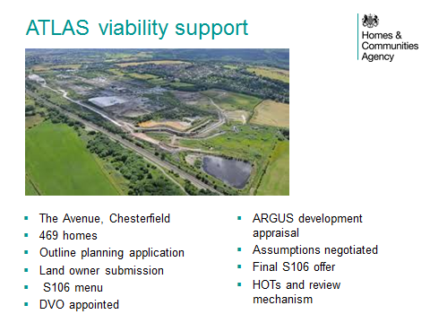

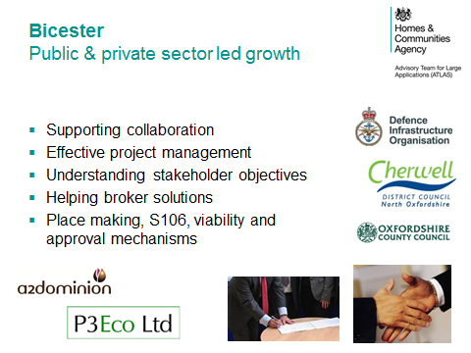
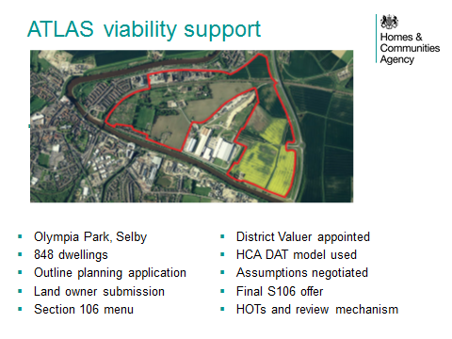

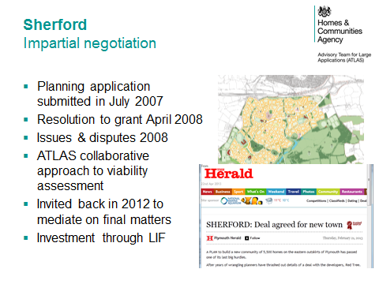

Appendix 3
Response to invitation to participate in a mini competition

Panel: | Property
Project Name: | HCA/ATLAS Planning viability support
To: | (Redacted), ATLAS
From: | <Name of contact>, <Job Title>, <Company>
Date:
Deadline: | 5pm 16/08/2016

Relevant Knowledge and Experience (50 marks)
To be no more than 4 sides of A4
50% of the marks will be awarded based on candidates demonstrating a knowledge and experience of the following:
Large Scale Residential Phased Development 10%
<candidates response>

Working with local planning authorities 10%
<candidates response>

Sound commercial experience 10%
<candidates response>

Development appraisal methodology 10%
<candidates response>

Negotiation, collaboration and mediation skills 10%

<candidates response>

Price (50 marks) based on average day rate over the period to 31st March 2018
<candidates response>

Additional Information
Candidates potential start date, number of days/week available for and term available for
<candidates response>

Potential conflicts of interest
Please supply any information regarding any potential conflicts of interest that may be apparent/relevant regarding existing workloads and overlap with HCA/ATLAS programmes and schemes.
<candidates response>

HCA reserves the right to reject any proposal that does not meet the following qualifying criteria : -
- RICS Qualified
- Clean Driving Licence
- Demonstrated that they suitably experienced to be self-sufficient
- Able to offer at least 2.5 days/week over the fixed term
- Candidates potential start date is deemed too far in advance

Information regarding qualifying criteria
<candidates response>

Tenders are to be returned with the above form completed and an up to date Curriculum Vitae.

