**Market Survey / Questionnaire**

TracER/Swab STRM Production & Supply

Contents

1. Company details 3

2. Background and context 3

3. Procurement timeline 5

4. Response instructions 5

5. Supplier capability questions 6

## Company details

Please input your details below:

|  |  |
| --- | --- |
| Name |  |
| Company |  |
| Address |  |
| Primary E-mail Address |  |
| Secondary E-mail Address (in case primary e-mail address unavailable) |  |
| Company Website URL |  |
| Phone Number |  |

## Background and context

This market survey is an information gathering exercise through which the Department for Transport (DfT) is looking to understand market appetite, capacity and capability to produce a pre-agreed number of TracER test pieces and STRM swabs on a trial basis. This market survey is not a guarantee of future long-term commercial opportunity. The number of TracER test pieces and swab STRMs required for the trial is subject to change and this market survey stage does not commit DfT to any production numbers.

Explosives trace detection (ETD) is widely deployed in aviation security. Prior to an ETD system being approved for use in aviation security, it must pass stringent performance testing against internationally agreed standards. To provide assurance that deployed systems continue to meet the detection standard they are tested and certified against there is a requirement to monitor the performance of ETD systems over time.

Quality assurance (QA) of trace detection capability is complex because it includes both equipment and human (swabbing) performance. In recent years the Department for Transport (DfT) has funded the development of tools to address both of these factors. A training aid (TracER) has been developed as a means to evaluate the human factors aspect and the utility of swab standard trace reference materials (STRMs) as a tool to monitor ETD equipment performance has been investigated.

To support the roadmap for the operational deployment of both TracER test pieces and swab STRMs DfT is planning a large-scale trial to inform the use case(s) for both tools. DfT wish to explore the appetite, capability and capacity of the market to produce a set number of TracERs and swab STRMs for this trial, anticipated volumes are as follows:

* 5,000 TracER test pieces
* 10,000 swabs STRMs, comprised of up to four different swab types

Due to the low quantities of sensitive materials required to manufacture the products, it is assumed no explosive handling or storage licenses will be required; however, significant quality assurance and quality control procedures will need to be in place to ensure individual units are fit for purpose on a commercial scale.

Procedure for the preparation of TracER test pieces and swab STRMs

This procedure describes the preparation of TracER test pieces and swab STRMs for testing of explosives trace detection equipment. This covers production of the following materials:

* TracER test pieces: trace explosives contamination on acrylonitrile butadiene styrene (ABS).
* Swab STRMs: trace explosives contamination on commercial ETD swab materials procured from the original equipment manufacturer[1].

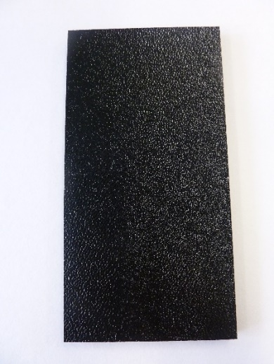 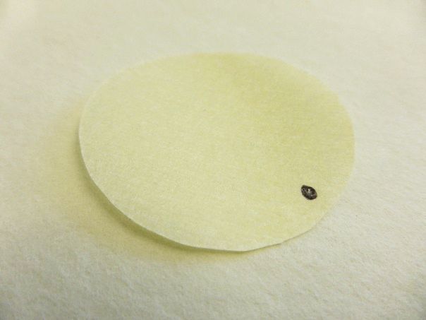

Figure 1. TracER test piece (left) and example swab STRM – Smiths Ionscan 500DT Nomex swab (right).

TracERs and swab STRMs are prepared by direct deposition (or ‘drop casting’) using a calibrated syringe to drop cast onto the surface with a dilute solution of known concentration containing the target explosive.

Preparation of explosives solutions

The explosives solutions will not exceed concentrations of 10 mg/mL. At these concentrations the solutions do not present an explosive hazard but fall under COSHH (Control of Substances Hazardous to Health) regulation due to the solvents used.

Preparation of TracER test pieces

The TracER test piece material is virgin black pinseal ABS (115 x 59 x 6 mm, Eagle Plastics Ltd). The TracER test pieces must be cleaned and dried before the explosives trace contamination is applied. Currently a two stage cleaning process is used which uses a laboratory detergent followed by rinsing with de-ionised water. The TracER test piece is prepared by depositing the explosives solution on the centre of the pinseal surface of the ABS and allowing the solvent to evaporate. Once dry, the TracER test pieces should be suitably labelled and packaged individually. The packaging should protect the TracERs during storage and transportation.

Preparation of swab STRMs

Commercially available swabs from the original equipment manufacturer are used to produce swab STRMs. Swab STRMs are prepared by depositing the explosives solution onto the swab and allowing the solvent to evaporate. The solution should be deposited onto the area of the swab exposed to the ETD thermal desorber. Since shape, size and insertion methods for swabs differ between ETDs the correct placement of the trace explosives contamination is crucial for ensuring swab STRMs perform appropriately.

Once allowed to dry, the swab STRMs should be suitably labelled, including marking to indicate which side has the trace explosives contamination, and packaged individually. The packaging should protect the swab STRMs during storage and transportation.

Quality control/quality assurance procedures

Due to the low levels of explosives trace contamination deposited onto both TracER test pieces and swab STRMs, it is essential that strict contamination control procedures are in place during preparation and storage.

Strict control over the masses deposited onto TracER test pieces and swab STRMs is essential.

Concentrations should be validated against certified reference materials and systems used to deposit the explosives solutions must be calibrated for accuracy and reproducibility.

Explosives solutions for preparing TracER test pieces and swab STRMs should fall within ±2% of the expected concentration. This should be checked when solutions are made and again before use. Any solutions which fall outside of the permitted tolerance should be discarded and re-made.

Trace contamination levels on the surfaces of the TracER test pieces and swab STRMs should fall within ±10% of the required mass loading. Any TracER test pieces or swab STRMs which fall outside of the permitted tolerance should be discarded and re-made.

It is also desirable that a percentage of each batch of TracER test pieces and swab STRMs is tested with a relevant ETD system to provide confidence that they will be detected in the operational environment.

## Procurement timeline

This market survey is an information gathering exercise only and is not a guarantee of a future long-term commercial opportunity. The number of TracER test pieces and swab STRMs required for the trial is subject to change and this market survey stage does not commit DfT to any production numbers.

## Response instructions

* The deadline for submission to this questionnaire is 5pm Friday 21st February 2025.
* Participants should complete the questions below, and submit to [**Ryan.Wake@dft.gov.uk**](mailto:Ryan.Wake@dft.gov.uk)
* Any clarification questions should also be directed to **Ryan.Wake@dft.gov.uk**
* There is no strict word limit on each question, please complete each section with as much detail as you feel necessary or attach separate documents if necessary.

## Supplier capability questions

Describe your experience and capabilities capacity in the following areas:

|  |
| --- |
| 1. Describe your capability to manufacture TracER and/or swab STRMs? Please consider:  * Do you have the capability to produce one or both of TracER and swab STRMs? * Technical skills you deem necessary for production * In-house skills and facilities currently in-place * Required skills or facilities that would be contracted to third-parties * Short-term capability to produce 5,000 TracERs and/or 10,000 swab STRM and related individual packaging. |
| [Please continue on separate pages or attach separate documents if necessary] |
| 1. **Describe your manufacturing capacity to produce and package TracER and/or swab STRMs in both the short-term (i.e. the duration of the trial period) and long-term (i.e. mass production if required by the DfT). Please consider:**  * Short-term capacity to produce 5,000 TracERs and/or 10,000 swab STRMs * Long-term capacity to produce different amounts of one or both products * Manufacturing lines’ capacity to flex with changing demand (i.e. the required number of units increases or decreases and ability to scale production as necessary). |
| [Please continue on separate pages or attach separate documents if necessary] |
| 1. **Describe existing manufacturing geographies. Please consider:**  * Production locations for similar products globally * Production locations that could be adapted to manufacture relevant quantities of TracER and/or swab STRMs   + Short-term (i.e. immediately for the trial period)   + Long-term (i.e. post-trial) * Existing supply chains. |
| [Please continue on separate pages or attach separate documents if necessary] |
| 1. **Can you provide indicative costs for both short-term and long-term production of TracER and/or swab STRMs? Please consider:**  * Sunk costs to adapt existing production lines (as necessary) * Long-term costs if the number of required units increases or decreases * Manufacturing costs based on a number of units produced |
| [Please continue on separate pages or attach separate documents if necessary] |
| 1. **Describe your existing quality assurance and quality control (QAQC) procedures. Due to the expected use cases for both TracER and swab STRMs it is essential that they meet the defined mass loading specification at point of use. Please consider:**  * Comment on product shelf life and required storage conditions * Which staff will carry out QAQC procedures and what experience and testing equipment do they have? * If you are unable to provide sufficient QAQC procedures in-house, how would you address this aspect? * How would you apply your QAQC procedures to the production of TracER and swab STRMs? |
| [Please continue on separate pages or attach separate documents if necessary] |
| 1. **Include any additional information you feel might be relevant or interesting to the DfT in relation to the production and supply of TracER and/or swab STRMs. Please consider:**    * Any limitations you may have in delivering the requirement    * Any other information that you feel may be relevant |
| [Please continue on separate pages or attach separate documents if necessary] |

END OF DOCUMENT

1. ETD equipment approved for operational use in UK airports is listed on the DfT Approved Equipment list https://www.gov.uk/government/collections/aviation-security-screening-approved-equipment-list