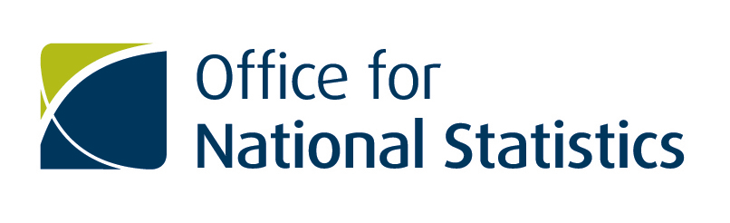

Better Data for Britain: Securing data partnerships to deliver better statistics for better decisions.
Data Partnerships – Shipping Data
About ONS
ONS is the UK's largest independent producer of official statistics and is the recognised national statistical institute for the UK. Formally, it is the executive office of the UK Statistics Authority, a non-Ministerial Department established by the Statistics and Registration Service Act 2007. It is responsible for collecting and publishing statistics related to the economy, population and society at national, regional and local levels. It also conducts the Census in England and Wales every ten years. ONS plays a leading role in national and international good practice in the production of official statistics.
Introduction
The Office for National Statistics (ONS) is looking to identify and engage with industry partners to help bring third party data and or expertise to directly support a 'shift' to accessing better more relevant data sources and to improve the aggregate official statistics about our population, society and economy that decision makers, businesses and citizens so urgently need.
The Data Science Campus (DSC) within the Office for National Statistics is planning to undertake a project looking at port traffic and cargo data. DSC want to explore UK's imports and exports based on shipping freights and investigate if this can be used as GDP indicators or nowcast (forecast) international trade. In addition DSC wants to investigate the traffic around UK's major ports, the delays happening in specific ports and situations and possible under or over utilisation.
In order to do this DSC are looking to access the following data:
- freight ships arriving at and departing from UK main ports;
- the origin and destination of the ship;
- the type of cargo the ship is carrying;
- information about the route the ship followed and frequent interval location to identify situations where the ship stayed still for a long time.

DSC have identified that information from the Automatic Identification System (AIS) would be beneficial to the project and are seeking to develop partnerships with organisations that hold the relevant information to support the project.

What can a partnership with ONS offer?
An opportunity to work with a world class statistics organisation, to deliver better and more timely statistics to be used by all for the benefit of the public good. See attached partnership agreement.

How to register
If you would like to express an interest in being part of this research process, register on the ONS e-tendering portal https://in-tendhost.co.uk/ons and use the "express an interest" function against the project title ‘Requirement for shipping data’.
When you have expressed an interest, please attach the following information to allow ONS to have an understanding of what your company can offer. Please include as a minimum:
- Organisation Name
- Contact details
- Brief description of primary activity of organisation
- Type of data you can provide and support available
Additional Information
This Exercise is NOT a pre-qualification or selection exercise and is NOT part of any pre-qualification or selection process that may apply to any future potential procurement. The exercise is intended to act as an awareness and information gathering exercise offering an opportunity for suppliers to advise the extent to which they potentially are able to provide some or all of the services that ONS may require, in order to help ONS with its future intentions.

