Hilton Scouts and Girl Guiding
Hilton Scout and Guide Hut, Peacroft Lane, Hilton, DE65 5GH
07855561787 or mattokun@gmail.com or
hiltonhut@gmail.com

Invitation to Tender

Hilton Scout and Guide Executive Committee has a requirement to extend and modify the existing Scout Hut to provide additional accommodation and storage. Bids are invited in conformance with the enclosed tender documentation. If you would like to be considered for this contract, please read through the document carefully and submit your tender in accordance with the specified procedures. Should you have any queries or require clarification on any point, please contact the undersigned on the above email address.

General Requirement

Bids are invited for the erection of an extension to the existing scout hut and the repurposing of an existing storage area into a usable space. Planning permission has previously been granted and plans with structural drawings have been completed and are attached to this document. NOTE: Existing plans identify an extension to both ends (East & West) of the scout hut and also the creation of a stage area, however at this time we are not requiring the extension to the west side of the scout hut or the stage area as this is deemed surplus to requirements.

It is expected that this tender document will be completed by bidders for this Project. The successful bidder(s) will be required to provide all the necessary labour and equipment to bring the Project to a completed fully functional condition on acceptance by the Scout Hut Executive Committee.

- Full access to the site will be provided via the car park and access gates shown in the picture below
- The successful bidder will be responsible for all planning and building regulation inspections and ensuring that all finished works meet all appropriate Health and Safety requirements
- On acceptance by the Executive Committee the successful bidder will remove all their equipment, excess material and waste and make good the wider area used during the extension of the scout hut.

[note: the Scout Hut can provide a local supply of electricity and water. The existing scout hut is surrounded by a 2 metre high fence. There is a car park adjacent to the scout hut with ample space for a skip or other equipment. See picture below]

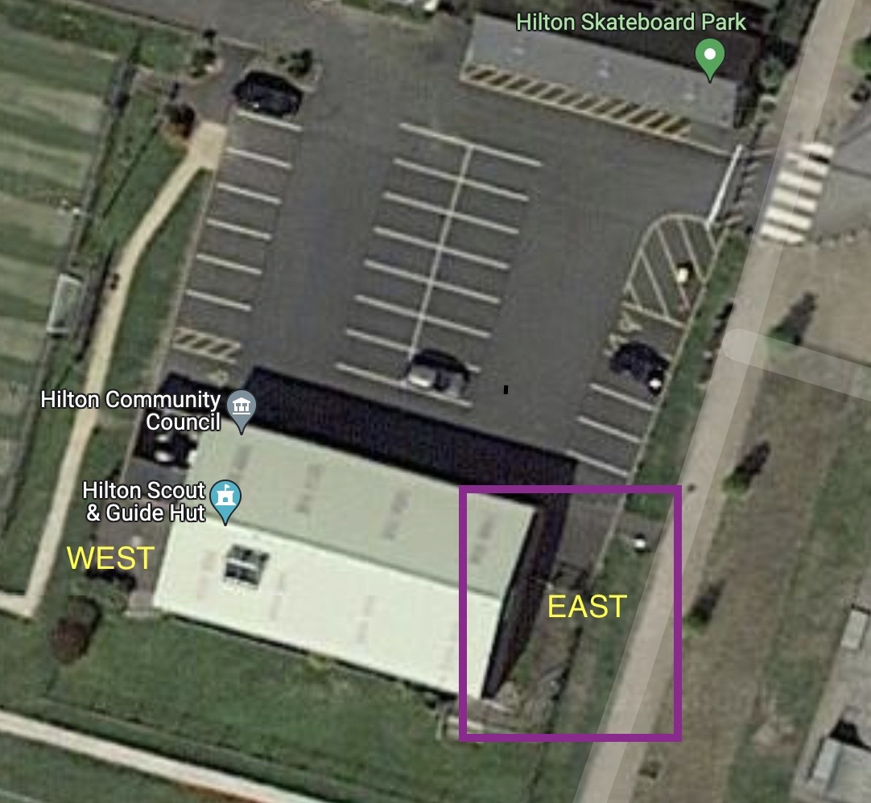

2 The bid will comprise a fixed price, timescales, guarantees/warranty for the following elements:
  - For the building of the extension to the East side of the existing Scout Hut (within the purple square in the picture above) to include moving and reinstatement of the existing fence including gates to allow access into the garden area
  - Installation of disabled access to the existing rear double doors and new extension
  - Refit of the existing upstairs storage room into a habitable and usable space.
  - The successful bidder will provide a timescale plan, preferably in GANTT chart form, showing the duration of each phase of the Project. Any dependencies on weather or other requirements beyond the control of the bidder will be highlighted
  - The successful bidder will guarantee new building works for a minimum of five years of ‘normal’ usage. If any repair or replacement becomes necessary within the guarantee period, then the successful bidder will carry out the necessary remedial work to a fully useable and safe condition at no charge to the Executive Committee
Area where extension to be built
  - The successful bidder will provide a guarantee for the workmanship ensuring compliance with all appropriate planning and building regulations and health and Safety requirements

Specific requirements for Extension to East end of the Scout Hut

- Preference to build this section first given existing storage room is in use
- Existing plans identify a stage area - THIS IS NO LONGER REQUIRED
- Full first floor provided with no supporting pillars intruding to ground floor space - to allow for future use as an additional room when required
- Stairs to allow access to the first floor compliant with current H&S legislation
- Insulation to match or exceed current building given longer term plan to utilise ground floor as habitable space
- Full electric sockets and lighting to be installed
- All doors and windows, spaces to be integrated into existing security and fire alarm systems

Internal first floor space at East end
- First floor room to be separated from ground floor and stairs with a fire door creating a separate fire zone
- Skylights to be provided as per existing building to provide additional lighting
- Full electric sockets and lighting to be installed
- First floor space to be integrated into existing security and fire alarm systems

Specific requirements for refit of existing first floor storage area to West side of Scout Hut:
- Preference to complete this section second given current use as storage area
- Extension of hut to west above patio area – NO LONGER REQUIRED
- Provision of fire escape exiting onto existing patio area - secured and only allowing access coming down the stairs for security reasons
- Enclosure of existing boiler and pipework
- Creation of enclosed storage in eaves
- Upgrade of electric sockets and lighting
- Installation of heating
- Upgrade of flooring
- Integration/upgrade into existing security and alarm systems.

Tender Documentation
All bidders are required to complete all the following sections fully and honestly.
If questions are left unanswered, this will be deemed a fail in the bidding process.
If the Executive Committee subsequently discovers any discrepancy in the bidder’s response, the bidder will be eliminated from the bidding process. If any such discrepancy is discovered after the contract is awarded, then depending on the nature of the discrepancy, the successful bidder may have the contract terminated with immediate effect and at no cost to the Executive Committee.

Information of the Bidder

- Please confirm that your company has the financial capability to take on this Project Yes/No
- Please confirm that your company has Employer’s Liability insurance, Public Liability Insurance and Professional Indemnity Cover and provide the level of such cover Yes/No
  - Employer’s Liability £XXm
  - Public Liability £XXm
  - Professional Indemnity £Xm

- Please confirm that your company or its directors has/have not been the subject of any proceedings which would automatically eliminate your company from the bidding process including bankruptcy, administration, court proceedings of a criminal nature etc. This list is not exhaustive. Yes/No

- Please confirm that your company has not been involved in any dispute with other customers for a similar contract in the last three years Yes/No

- Please confirm that your company complies with all current employment and business legislation Yes/No

- Please provide details below of your company’s experience in delivering this type of Project

- Please provide details of two contracts that your company has secured that are relevant to this Project. Please include contact details for the customers so we may contact them for a reference.

Pricing

All prices submitted are to be in Pounds Sterling and exclusive of VAT

1 Fixed price for extension of scout hut to east side, installation of disabled access and refit of existing first floor storage area £xxx

2 Please confirm that all labour and equipment necessary for the completion of the Project will be supplied by your company Yes/No

Timescales

The duration of the Project and the time of year when the Project is undertaken is important to the Executive Committee as the scout hut is in daily use. A detailed plan is required, preferably in the form of a GANTT chart, that shows the days expected for each phase of the Project with measurable milestones that the Executive Committee can use to monitor progress

1 Please confirm that a plan as specified above will be provided from Commencement date to Project completion/hand over Yes/No

2 Are there weather considerations that could disrupt the plan? Yes/No
If Yes, please state below what those considerations are….

3 Please confirm that any necessary changes to the agreed plan will be discussed and agreed with the Executive Committee before a revised plan is issued
Yes/No

Business Requirements

The Executive Committee and the successful bidder will each appoint a Project co-ordinator who will be the point of contact between the Executive Committee and the successful bidder. The Project co-ordinators will have the authority to make binding decisions on both parties under the terms of the signed contract.
The Executive Committee requires that the new extension and associated works are underwritten by meaningful guarantees/warranties

- Please confirm that appropriate guarantees/warranties will be provided. Yes/No
- Please state if access to an electricity supply is required Yes/No
- Please state if access to a water supply is required Yes/No

Conditions of Contract
The successful bidder will be required to enter into a contract covering the following items:
1. Definitions and Interpretation
2. Term
3. Supplier's Due diligence
4. Supply, Installation and Acceptance
5. Guarantees and Warranty
6. Compliance
7. Payment
8. Project Representative
9. Sub-Contracting and assignment
10. Indemnities
11. Limitation of liability
12. Insurance
13. Freedom of information
14. Confidentiality
15. Termination for breach
16. Force majeure
17. Consequences of termination
18. Waiver
19. Severability
20. Partnership or agency
21. Publicity
22. Notices
23. Jurisdiction
24. Abnormally low Tenders
25. Variations

Submission of Quotation

Quotations should be submitted by email or post by no later than 31 July 2022.

Two copies of the completed tender documentation are required.

If responding by post the envelope should be sealed and addressed to the Chairman or Matt Brown-Jackson at the address above.

Quotations received after the closing date will not be considered.

If you wish to query or have clarified any aspect of this tender documentation, then please allow sufficient time for the Executive Committee to respond before the deadline for submission and in all cases no later than five working days before the deadline.

After the receipt of the quotations, they will be reviewed by the Extension sub-committee of the Executive Committee. The extension sub-committee will ensure compliance of all bids with the tender documentation requirements. The extension sub-committee will then evaluate the bids against its award criteria. Please note that the Executive Committee does not have to select the lowest quotation.
During this evaluation, the Executive Committee may seek clarification of certain inputs.
The Executive Committee also reserves the right to seek another round of bidding from a short list of bidders.
The Executive Committee will notify the successful bidder in writing.

All pages of this tender document must be returned and will form part of the final contract for the successful bidder(s)

[The Executive Committee give this tender documentation to bidders, on the basis that they remain the Executive Committee’s property and bidders must treat the contents as confidential. If bidders are unable or unwilling to keep to this rule, they:
- must destroy this RFQ and all associated documents at once; and
- must not keep any electronic or paper copies.]

Bidders must not take part in any publicity activities with any part of the media about this tender process without getting the Executive Committe’s written agreement first. This includes the Executive Committee’s agreement on the format and content of any publicity.
This tender documentation is made available in good faith. The Executive Committee give no warranty as to the accuracy or completeness of the information contained in it. The Executive Committee also disclaim any liability for any inaccuracy or incompleteness. The Executive Committee reserve the right to cancel this tender process at any point.
The Executive Committee are not liable for any costs resulting from any cancellation of this tender process or for any other costs that bidders may incur by tendering for this contract. Bidders must obtain at their own expense all the information that they need for the preparation of their tender.
Bidders will be deemed to fully understand the processes that the Executive Committee must follow under relevant European and UK legislation, particularly The Public Contracts Regulations 2015 and Public Contracts (Amendment) Regulations 2009.

I DECLARE THAT TO THE BEST OF MY KNOWLEDGE THE ANSWERS SUBMITTED IN THE TENDER DOCUMENTATION ARE CORRECT. I UNDERSTAND THAT THE INFORMATION WILL BE USED IN THE EVALUATION PROCESS TO ASSESS MY ORGANISATION’S SUITABILITY TO TENDER FOR THE EXECUTIVE COMMITTEE’S REQUIREMENT. SHOULD THE EXECUTIVE COMMITTEE DISCOVER ANY DISCREPANCIES OR THAT I HAVE BEEN DISHONEST WITH THE ANSWERS THIS WILL RESULT IN THE ORGANISATION TO WHICH I HAVE COMPLETED THIS QUOTATION FOR, BEING REJECTED FROM THE TENDER PROCESS OR IF AWARDED A CONTRACT WILL HAVE THE CONTRACT TERMINATED WITH IMMEDIATE EFFECT AND NO COST INCURRED TO THE COUNCIL. Signature is mandatory, failure to do so will result in your bid being deemed non compliant which will result in your bid being disqualified from this tendering process.
Name:
Position (Job Title):
Date:
Telephone number:
Signature:

Signed for and on behalf of Hilton Scout and Guide Executive Committee

Name Matt Brown- Jackson

Position Extension sub committee

Date

