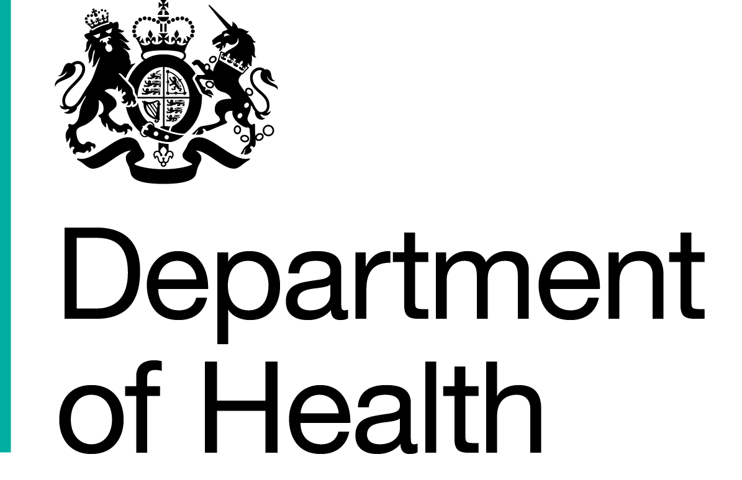

|  |  |  |
| --- | --- | --- |
|  | Commercial Medicines Unit (CMU)  Medicines, Pharmacy & Industry  2 Floor  Rutland House  Runcorn  WA7 2ES  www.dh.gov.uk  All messages regarding the Offer documentation should be sent via the Bravosolution Website |  |
|  |  |  |

13 December 2016

Dear Supplier

**Invitation to offer for NHS National Pharmaceuticals - Wave 10c**

**Offer reference number: CM/PHG/15/5466**

**Period of framework agreement: Dates detailed below with options to extend up to a maximum period of 40 months**

**Potential periods of call-offs under the framework agreement:**

**Oral Products:                           All Regions 01/07/2017 to 28/02/2019 (20 months)**

**Hospital Only Products:            LSNE 01/07/2017 to 30/06/2018 (12 months)**

**NWLN 01/07/2017 to 30/06/2018 (12 months)**

**CESW 01/07/2017 to 30/06/2018 (12 months)**

The Secretary of State for Health acting as part of the Crown through the Commercial Medicines Unit (‘Authority’) invites offers for the above mentioned goods and/or services as defined in Document No.08 Specimen framework agreement. Offers shall be made subject to the terms of:

Document No.01 This covering letter

Document No.02 Terms of offer

Document No.03 NHS conditions of contract for the purchase of goods (supplementary) May 2015

Document No.04 NHS supplementary conditions of contract for the purchase of pharmaceuticals October 2012

Document No.05 Contract technical specification

Document No.06a(i) Product listing and usage – 100% Products

Document No.06a(ii) Selectt offer schedule – **CM/PHG/15/5466/01**

Document No.06a(iii) Product listing and usage – 33% Products Only

Document No.06a(iv) Selectt offer schedule – **CM/PHG/15/5466/02**

Document No.06b Selectt offer schedule instructions

Document No.07 Form of offer

Document No.08 Specimen framework agreement

Document No.09a Quality control technical sheet

Document No.09b Guidance for performing a pharmaceutical quality assessment of licensed medicines for the NHS

Document No.10 Participating authorities

Document No.11 Commercially sensitive information schedule

all of which constitute this Invitation to offer.

If any of the documents constituting the Invitation to offer is missing please contact the undersigned immediately via the Bravosolution messaging portal.

The Authority does not bind itself to accept the lowest offer or any offer at all and reserves the right to accept an offer either in whole or in part, each item being for this purpose treated as offered separately. The Authority reserves the right to conclude a framework agreement for the supply of the goods and/or services with more than one Offeror.

I would like to draw your attention to the following important points when completing and submitting your offer:

1. All offers must be written in English.

2. All offers must be submitted subject to and in accordance with the documentation comprising the Invitation to offer. Save where the Offerors are instructed to provide information, the documentation comprising the Invitation to offer must not be amended in any way.

3. All offers must be loaded onto the Commercial Medicines Unit’s eTendering portal <https://cmu.bravosolution.co.uk/web/login.shtml>

4. Offers must be open for 90 days.

5. Offers must be fully completed and available on the designated website no later than **1300** on **17 January 2017**.

I must also draw your attention to the enclosed Form of offer where all the requirements for completing and submitting an offer can be found. Failure to comply with these instructions may result in your offer being rejected.

I hope that the above instructions are clear but please contact the undersigned via the Bravosolution messaging portal if there is anything you wish to clarify.

Yours faithfully

**Marie Thompson**

Marie Thompson

Procurement Specialist