ProofID Limited

8 Exchange Quay

Salford

Manchester

M5 3EJ

Friday 16th May2025

Dear Andy,

**Contract Title: UKRI Identity and Access Management Solution**

**Contract Reference: DDaT21551**

**Contract Variation Reference: 004**

Please find the attached contract variation reference DDaT21551; with effect from 20/06/2025

This Variation is to extend the Call Off Contract for year 4 at the value of  £133,500.00 (Excl VAT).

The cumulative contract value remains unchanged, providing room for contingencies. The total Call Off Contract Value shall not exceed £1,403,351.76 (Excl VAT).

Please ensure that you  review and satisfy yourselves with its content and the contractual

implications of this variation before signing and returning to [REDACTED](mailto:REDACTED) and DDaTProcurement@uksbs.co.uk for our records

|  |
| --- |
| Yours Sincerely,  [REDACTED](mailto:REDACTED)  Procurement Specialist – Digital, Data and Technology  UK Shared Business Services Ltd  [REDACTED](mailto:REDACTED)  For and on behalf of UK Research and Innovation |

Contract DDaT21551 is varied as follows and shall take effect on 20/06/2025 between:

|  |
| --- |
| 1. **UK Research and Innovation** Polaris House, North Star Avenue, Swindon SN2 1FF **(The Authority)**   and |
| 1. **ProofID Limited,**8 Exchange Key, Salford, Manchester, M5 3EJ**(The Contractor).** |

Collectively known as the “**Parties**”

The Parties agree the following changes to contract DDaT21551 – UKRI Identity and Access Management Solution.

This Variation is to extend the Call Off Contract for year 4. The contract value for the

additional year extension is £133,500.00 (Excl VAT).

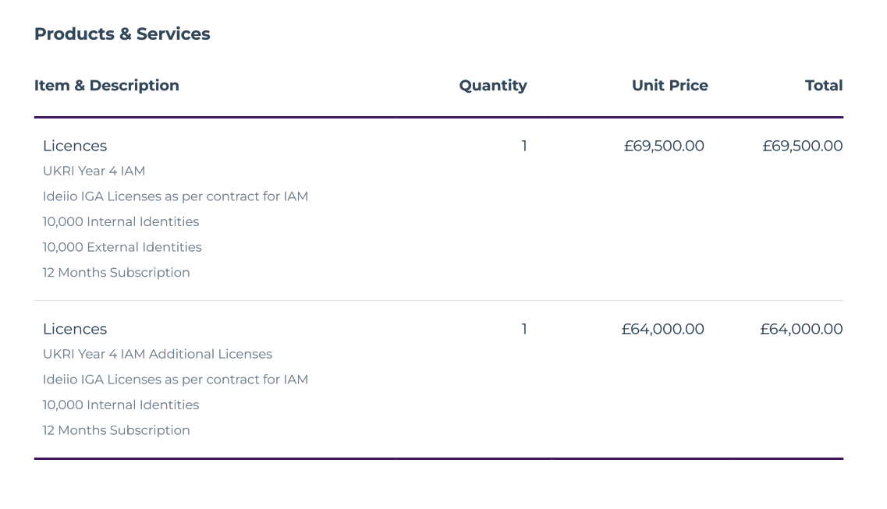

|  |  |
| --- | --- |
| For and on behalf of ProofID Limited **(The Contractor )**  Signed  Name  Position  Date | [REDACTED](mailto:REDACTED)  [REDACTED](mailto:REDACTED)  [REDACTED](mailto:REDACTED)  ………………………………………………  [REDACTED](mailto:REDACTED)  ………………………………………………  ……………………………………………… |
| For and on behalf of UK Research and  Innovation **(The Authority)**  Signed  Name  Position  Date | [REDACTED](mailto:REDACTED)  ………………………………………………  [REDACTED](mailto:REDACTED)  ………………………………………………  [REDACTED](mailto:REDACTED)  ………………………………………………  [REDACTED](mailto:REDACTED) …………………………………………… |

Words and expressions in this variation shall have the meanings given to them in Contract DDaT21551. Contract DDaT21551, including any previous variations, shall remain effective and unaltered except as amended by this variation.