Proposal for 2 Mini Tennis courts at the Windmill Centre, Hempton Road, Deddington OX15 0QH
Deddington Parish Council wishes to construct two mini-Red Tennis Courts on land immediately adjacent to an existing block of three hard tennis courts and the tennis clubhouse. The two courts to be adjacent to each other along on an E–W axis (see drawing).

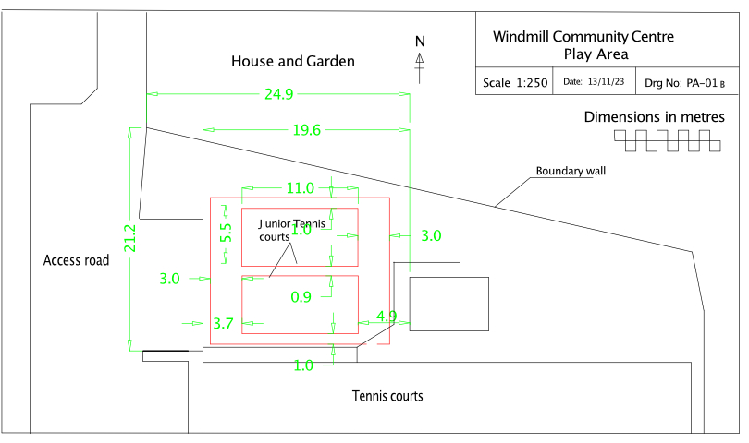

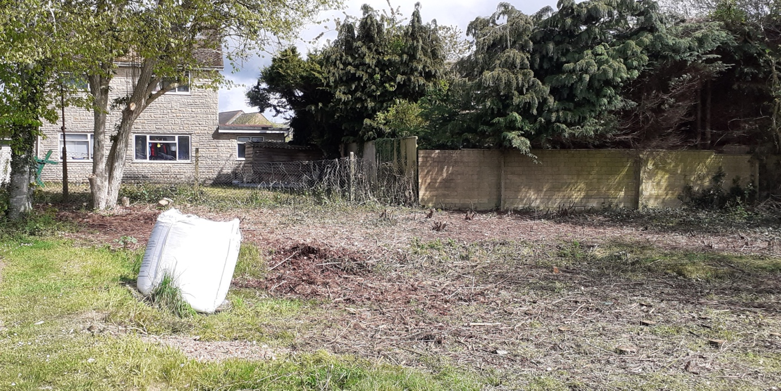

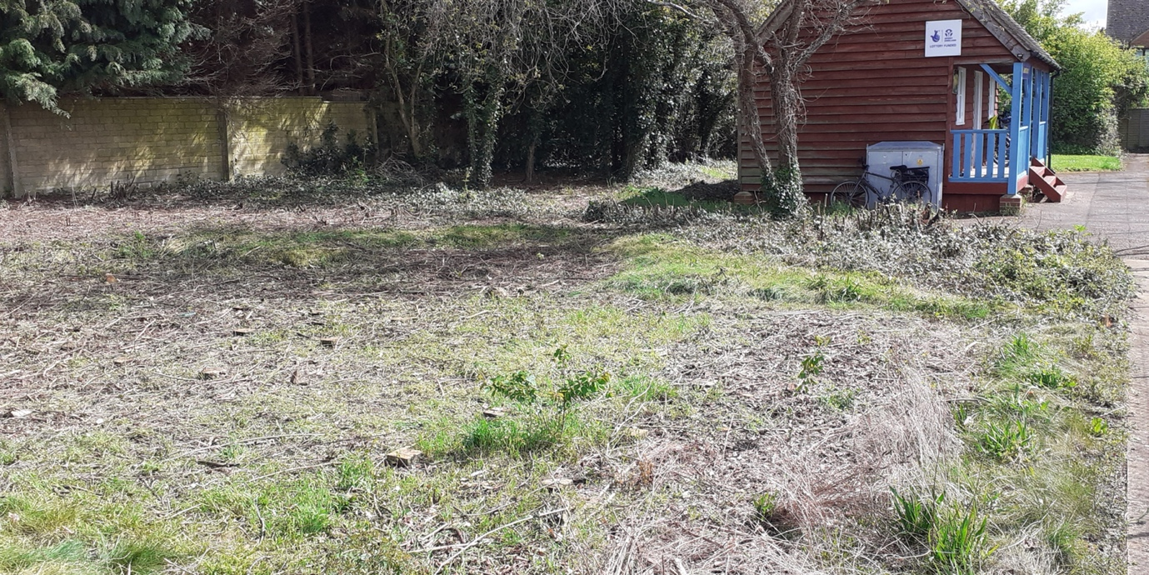

Indicative specification
The two mini courts are to be designed using the following indicative specification. Tenderers are recommended to inspect the site before quoting.

Ground level
The ground is significantly higher on the north side, so there will either be a slope down to the fenced area, or a small retaining wall.

Drain
A shallow porous drainage channel is to be formed on the north side of the fenced area to prevent rainwater run-off on to the courts.

Tarmacked area
To be 17m E–W and 13.9m N–S. Area outside this to be left to be grassed or landscaped with low maintenance shrubs. The surface level of the courts is to be the same as the tennis courts.

Tree removal
The tree on the eastern end of the site (near the pavilion) is to be removed. The trees on the northwestern corner are outside the tarmacked area and will remain.

Tree root barrier
A short length of tree root barrier to be installed at the northwest corner of the fenced area.

Foundations
A minimum of a 150mm consolidated thickness of MOT Type 3 with reduced ﬁnes crushed stone foundations laid over a geo textile membrane to the formation.

Retaining edges
900mm x 150mm x 50mm hydraulically pressed precast concrete square top edgings securely bedded on edge on a foundation of ST1 concrete to SHW Clause 2602 100mm deep and 200mm wide and shall be backed with ST1 concrete from the back of the bedding to within a minimum of 20mm from the top of the edging.

Macadam binder course
Supply and lay 40mm consolidated thickness of 20mm nominal size aggregate open graded bitumen macadam binder course, hand screeded and rolled to produce a fine tolerance.

Macadam surface course
Supply and lay 35mm as laid depth of (25mm consolidated thickness) 6mm nominal size aggregate open graded macadam surface course, hand screeded and rolled to produce a fine tolerance.

Court area
The playing surface shall be 11m x 5.5m each.

Surrounding fencing
To go around courts only, with 3m run-off at each end, and 0.75m on each side (see wider red line on drawing below).

The fence shall be of 50mm black plastic-coated galvanised core chain link of 3.55/ 2.55 gauge and polyester powder coated black.

On three sides the fence shall be 2.75 metres high, while on the fourth (south) side it shall be 900mm high with a 1.5m gap at the east end for access.

Fence on west side to be 700mm behind the parking area kerb to avoid damage from parked cars.

Line markings and colour sprayed surface
The surface shall be marked as two mini-red tennis courts using a two-tone dark green/light green colour sprayed design and white lines.

We are advised that planning permission is not required as there is no change of use from the previous children’s play area facility.

Anticipated start date: spring 2024.

