Our Ref: ENV6003627R
Your Ref:

Date:

Dear Sir/Madam,

Contract Ref: ENV6003627R
Contract Title: Inventory and tool for cost-effectiveness information for interventions for integrated environmental and flood risk management: Phase 2: Development and population of decision support inventory and tool

You are invited to quote for the above in accordance with the enclosed documents.

Instructions on what information we require you to provide is in Section 4 of the following Request for Quotation document.

Your response should be returned to the following email address by 13.00 on the 20th September2019

david.forrow.environment-agency.gov.uk

Please confirm, by email, receipt of these documents and whether you intend to submit a quote.

If you have any queries, please do not hesitate to contact me.

Yours sincerely

Dr David Forrow
Title: Senior Evidence Advisor

E-mail: david.forrow@environment-agency.gov.uk
Telephone: +442030259623 or 07775817695

The Environment Agency, Red Kite House, Howbery Park, Crowmarsh Gifford, Wallingford, Oxfordshire, OX108BD

Request for Quotation

Ref: ENV6003627R
Title: Inventory and tool for cost-effectiveness information for interventions for integrated environmental and flood risk management: Phase 2: Development and population of decision support inventory and tool

Section 1

Who is the Environment Agency?
We are an Executive Non-departmental Public Body responsible to the Secretary of State for Environment, Food and Rural Affairs. Our principal aims are to protect and improve the environment, and to promote sustainable development.

Further information on our responsibilities, Corporate Plan and how we are structured can be found on our Website.

https://www.gov.uk/government/organisations/environment-agency/about

What do we spend our money on?
We are a major procurer of goods and services within the UK, spending circa £600M per annum, our major spend areas are:

- Flood and Coastal Risk Management (design, construction and maintenance)
- ICT and Telecommunications
- Vehicles and Plant
- Environmental Consultancy and Monitoring
- Temporary Staff and Contractors
- Facilities Management, Energy and Utilities
- Flood Management and Water Related Services

What do we need from our suppliers?
Suppliers are vital in supporting the delivery of our corporate plan. We aim to support the economy and society whilst delivering more environmental outcomes for every pound we spend. In many areas we are leading the way on environmental and technical developments. It is our role to ensure that suppliers clearly understand our corporate aims and objectives and know that we are committed to delivering the best value most sustainable solutions, taking into account the whole life cost of our procurement decisions. We promote diversity and equality and treat all of our suppliers fairly.

Our procurement strategy may be of interest to you as a potential supplier. It sets out our priorities and key commitments in a range of areas such as delivering our corporate plan, Government policy, supplier management and sustainable procurement:

https://www.gov.uk/government/organisations/environment-agency/about/procurement#procurement-strategy

Government changes and collaboration
Since 1 April 2013, the Environment Agency is no longer responsible for delivering the environmental priorities of Wales. This is now the remit of Natural Resources Wales (NRW).Further information can be found here:

http://naturalresources.wales/splash?orig=/

By bidding for this requirement, you may also be approached by other members of the Defra network, NRW or other government departments that are specifically named in the tender document.

Further information
For further information and to see our commitments to Diversity and Equality, please visit our website.

https://www.gov.uk/government/organisations/environment-agency/about/procurement
https://www.gov.uk/government/organisations/environment-agency/about/equality-and-diversity

Also, are you up to date on environmental legislation? See links below for further information.

Waste and Environmental Impact - https://www.gov.uk/browse/business/waste-environment
Environmental Regulations - https://www.gov.uk/browse/business/waste-environment/environmental-regulations’

Section 2

The Customer

Summary

The customer is the Environment Agency Specially Dr David Forrow, Research Assessment and Design, Research, Analysis and Evaluation; Environment and Business.

Positon: Senior Evidence Advisor within Research and Development

Davids role is to develop research and evidence for the Environment Agency.

Contract Length

It is anticipated that this contract will be awarded to one supplier for a period of 6 months to end no later than 20/03/20. Prices will remain fixed for the duration of the contract award period. We may at our sole discretion extend this contract to include related or further work. Any extension shall be agreed in advance of any work commencing and may be subject to further competition. Any amendment to contract prices for the extensions are to be by negotiation.

The Environment Agency Conditions of Contract for Research (Appendix C) shall apply to this contract.

This contract shall be managed on behalf of the Agency by Dr David Forrow. Tel +442030259623

Contact Details and Timeline

Dr David Forrow will be your contact for any questions linked to the content of the quote pack or the process. Please submit any questions by email and note that both the question and the response will be circulated to all tenderers.

david.forrow@environment-agency.gov.uk

Key elements of the process have been reviewed. Anticipated dates for planned activities are below:

Activity | Due Date
Supplier responses for Request for Quote | 13.00 on the 20th September2019
Evaluation of Request for Quote submissions | 26th September 2019
Award of contract | 30th September 2019
Project/Contract end date | 20th March 2020

It should be noted that these timescales and activities may be subject to change.

Section 3

Evaluation Criteria

We will award this contract in line with the most economically advantageous tender (MEAT) as set out in the following award criteria:

- Price – 60%

- Quality – 40%

The following quality criteria are weighted in accordance with the importance and relevance attached to each one.

- Your key personnel who will be directly involved with this contract.
- Your understanding of the proposal
- Your proposed methodology and approach
- Your measurement of success in each of the deliverables.
- Your recent experience of carrying out similar contracts and knowledge of similar work
- Value added indicated in the expression of interest and in relation to the intent and potential use and application of the work

The criteria listed above will be assessed on a 0 to 10 basis and will reflect the following judgements:

Rating of Response  The tenderer provides a response which in the opinion of the evaluators is: | Score
Excellent: Addresses all of the requirements and provides a response with relevant supporting information which does not contain any weaknesses, giving the Agency complete confidence that the requirements will be met. | 10
Very Good: Addresses all of the requirements and provides a response with relevant supporting information, which contains very minor weaknesses, giving the Agency high confidence that the requirements will be met. | 8
Good: Addresses all of the requirements and provides a response with relevant supporting information, which contains minor weaknesses, giving the Agency reasonable confidence that the requirements will be met. | 6
Satisfactory: Substantially addresses the requirements and provides a response with relevant supporting information which may contain moderate weaknesses, but gives the Agency some confidence that the requirements will be met. | 4
Weak: Partially addresses the requirements, or provides supporting information that is of limited relevance or contains significant weaknesses, and therefore gives the Agency low confidence that the requirements will be met. | 2
Nil: No response or provides a response that gives the Agency no confidence that the requirements will be met. | 0

Section 4

Information to be returned

Please note, the following information requested must be provided. Incomplete tender submissions may be discounted.

Please complete and return the following information:
- completed Pricing Schedule (Appendix A);
- completed Prior Rights Schedule (Appendix B);
- confirmation that terms and conditions are accepted (Appendix C. Please note that the terms cannot be amended later).
- details of the personnel you are proposing to carry out the service, including CV’s of your key personnel and skills and experience in relation to tasks;
- details of how you propose to maintain continuity of personnel;
- a clear indication of your understanding of the proposals intent and requirements
- details of proposed methodology and approach in relation to each task
- any value added proposals in relation to delivering the intent and intended use and application within the scope and context of this particular contract
- details of how you measure your success in each of the deliverables.
- Details of your recent experience of carrying out similar contracts
- knowledge of similar work which would be useful to inform this work

Section 5

Specification

Overarching Project Deliverables
- Improved environmental management intervention cost-effectiveness evidence framework and database
- Report on database structure and use
- Material describing and illustrating potential further development and utility of evidence base.

- Objective

The main product will be in the form of an information management system and evidence base for environmental management interventions with associated information on the outcomes they deliver and costs. This will be part populated and act as a framework to collect, collate and systematise further information over time. The emphasis will be to ensure simple and easy population and use.

- Background

In order to the deliver environmental and flood risk management outcomes and benefits the Environment Agency and others identify and put in place interventions (instruments and actions). These interventions can be regulatory, financial, behavioural or physical and include traditional technological and compliance interventions as well as more nature based interventions.

These interventions are often selected on the basis of past experience and/or assumptions about their cost-effectiveness. However this, in reality, depends on the assumptions being correct, particularly in the context of their operational implementation.

We do not adequately test or validate these assumptions on the basis of current and best available international evidence nor do we routinely collect and systematise information on the performance of the interventions implemented through our (and our partners) management processes. Use of empirical research and systematisation of learning is an essential requirement for an ‘Evidence based organisation’.

Where cost-effectiveness information is available from either our own or others processes and studies (e.g. in the published and grey literature) it is usually disparate, not at hand, difficult to compare and therefore not used to its full potential to inform decision making. Further, there are likely to be significant gaps in the evidence that we need to identify and address.

Without an effective evidence base on interventions and their respective costs and effectiveness at addressing different environmental pressures and delivering outcomes it is difficult to identify, compare and combine options (options screening and cost-effectiveness analysis) to ensure that the most cost-effective interventions, programmes of interventions and innovative management is implemented to address real and complex environmental management contexts.

These shortcomings constrain collaborative working with key partners due to a lack of transparency on the assumptions we use in decision making. This can undermine trust with potential partners and investors in respect of the identification and implementation of interventions.

Bringing evidence on cost-effectiveness together opens up the opportunity to interrogate the information (manual and computerised) and to develop analytical functionality adding further insight and value for decision making. For instance in developing optimal programmes of interventions to deliver multiple outcomes.

- Business need

There is a need for easy access to better intervention comparative cost-effectiveness information and tools to support application into policy and operational planning and decision making. This information is needed for options appraisal (cost-effectiveness analysis, cost-benefit analysis); risk and risk reduction assessment; post-project appraisal; evaluation; reporting; optimal programme design etc; Annex 1). An NAO report (2010) identified the need for ways of capturing and reporting cost-effectiveness information.

Recent moves towards more integrated catchment planning support the need to pull intervention and cost-effectiveness information for different drivers and objectives together. This will support more integrated and coherent planning and decision making on programmes of interventions for catchments which address multiple risks and deliver multiple outcomes.

This evidence base will ensure greater consistency across the country on the assumptions that underpin selection of interventions, enhancing the Environment Agency’s reputation as being fair and proportionate in its decision making.

Further, to use this evidence base for learning and to develop functionality and visualisation of evidence for decision support. And to use the evidence base as a driver for consistent systematic collection of evidence from our own and others activities.

Population of any evidence base (transposition of information from sources to system) needs to be made as simple as possible for multiple users. Information sources are of variable quality and they report interventions and effectiveness against different outcomes in different ways (incl. qualitative description or numerical description with different units). Likewise any use of any evidence base and its functionality needs to be simple but informative.
The Environment Agency’s goal is to implement internal and external evidence synthesis and organisational learning by collating evidence and retaining valuable internal experience and knowledge of intervention cost and effectiveness. This will be achieved by storing this in a single accessible location and making it available to planners in a format that facilitates longlisting of intervention options. Ultimately to develop this is into a ‘smart’ user friendly decision support tool with functionality that makes best use of the growing evidence base.
This will include importing information from sources outside the Environment Agency and the drawing of conclusions about how effective an intervention might be in a given context to support analysis, project planning and appraisal.

- Phase 1 of the work (delivered)

A phase 1 of the project has developed a proof of concept to gather more user input for a workable system. It has produced a draft conceptual information framework which has been shown to be capable of organising and storing intervention cost and effectiveness information from numerous internal and external sources. The information framework is the conceptual structure of the information management system and exists independently of any database, spreadsheet or other data storage platform. It starts to define the information to be obtained and what format will be used.
Phase 1 provided recommendations for further development and outlines the capabilities that such a system would give the Environment Agency and its partners.
Phase 1 also developed a ‘light-duty’ Excel implementation for testing and demonstration of the practical implementation of the information framework. This was populated with a sample of cost-effectiveness evidence from a variety of sources. Although the framework was built to incorporate evidence on cost the demonstration system was not populated with cost information. The demonstration system does not represent an operational system.

A recommendation of Phase 1 was to develop the information framework into a more versatile database format. Phase 1 also demonstrated the paucity of consistent cost-effectiveness information and the heterogeneity in how cost-effectiveness is reported.
The next phase of work (Phase 2) would be to make use of the information framework developed in phase 1 to develop an interventions data management system. This would be a database (or suggested alternative) version with a user-interface. Phase 2 will further populate the inventory and improve its usability and functionality.

Phase 1 identified the lack of consistent post-project assessment and recording in the Agency and the cultural shift and financial commitment required to change this. Phase 2 is not intended to substantively address these. However the evidence data acts as an enabler to encourage this shift by providing a framework for information collection. Phase 2 will look to see how the system can be enhanced to further support this shift.

- Phase 2 summary (proposed here)

Phase 2 of the project will:
- Develop the cost-effective inventory framework structure further;
- Integrate an existing ‘cost-effectiveness’ spreadsheet (of primarily cost data) into the framework;
- Reconfigure the framework structure into a database (or suggested alternative) format;
- Develop a smart front end to allow for simple input of heterogeneous cost and effectiveness information from different sources by different users;
- Improve the way the framework handles heterogeneous cost and effectiveness information from source material converting this into ‘normalised’ comparative summary information for each outcome;
- Link the cost-effectiveness information with contextual information in the database;
- Further populate the database, using the built front end, using a variety of source information;
- Develop the front end to allow for easy user output interaction (e.g. searching) and visualisation of information;
- Consider how the database and supporting outputs can be configured to be an enabler for improved post-project appraisal;
- Propose and describe in outline (including potential technical complexity and costs) potential future enhancements and improved/increased functionality of the system relevant to application by the Agency and its partners.

Task 1: Develop cost-effectiveness inventory framework further
This would develop the framework further based on current and future user needs and developed from the available cost-effectiveness evidence. This would include:
  - Ensuring more comprehensive coverage in field content lists (e.g. sectors, pressure/risk type etc.)
  - Expanding and better structuring the categorisation, classification and breakdown of intervention types (and include field for intervention description)
  - Broadening the range of recorded outcomes including, microbial contamination, hydromorphology, flood risk; natural capital and ecosystem service outcomes and social outcomes

The framework already ensures reference/ a link to all sources of information including any internal functional planning processes and associated evidence bases on the cost –effectiveness of measures (e.g. Water Industry Price Review guidance). This would be maintained and enhanced in phase 2. The system would act as a portal to more detailed cost-effectiveness information in existing databases, websites etc.

Where possible and appropriate the system should be consistent with existing Agency data classification and standard descriptions around interventions and outcomes. These will be made known and available to contractor.

Task 2: Integrate an existing ‘cost-effectiveness’ spreadsheet
A previous ‘cost-effectiveness’ evidence spreadsheet was developed by the Environment Agency (referred here as the ‘Cost spreadsheet’). This is populated with mainly cost information for interventions. There is a need to integrate the content and functionality of this spreadsheet with the Phase 1 output from this work into a new system. A screenshot of the Cost spreadsheet is in Annex 5. The actions from guidance on the use of this Cost spreadsheet will also be required to be incorporated (e.g. requirement to update any costs to present day value by reference to bank of England inflation calculator). Improved interaction/functioning of this aspect of the evidence base will be delivered as appropriate in transitioning this work. This spreadsheet and guidance will be supplied to potential contractors during the bidding process.

Task 3: Reconfigure the framework structure into a database format
The Excel demonstration of the framework, developed in phase 1, limited the utility and potential functionality of the evidence base. The framework was designed to store the raw information needed to evaluate effectiveness according to various criteria. This is accomplished by recording the outcomes of the intervention as increases or decreases in one or more measures such as iron levels, wetland area, permit compliance, or any other measurable quantity. This was not developed in the Excel demonstration of the framework because of the difficulty of creating this functionality in a flat data structure such as a spreadsheet. A recommendation from the phase 1 work was to develop the framework in a database format. Therefore Phase 2 will deliver the product in database format in Microsoft Access. Suggestions on an alternative system to a database which performs the same or enhanced function, which is acceptable to the Agency, will also be encouraged and considered.

Task 4: Develop a front end to allow for simple input of heterogeneous cost and effectiveness information
Phase 1 of the project entered a sample number of evidence sources. This required a certain level of ‘manual’ processing to transpose the information into the information framework. Because of the heterogeneous nature of the source material there is a need for a front end that allows for quick and easy input of heterogeneous information from different source types by different users without complex manual interpretation and transformation before it is entered. This will need to link with the ‘normalisation’ processes described in task 5 below. There is the potential to process and link entered content through totally automatic or partially automatic application of machine learning and AI (or similar) approaches? For instance these could help simplify the transposition of evidence from sources and the processing of this information once entered or process it automatically (Fig 1)?
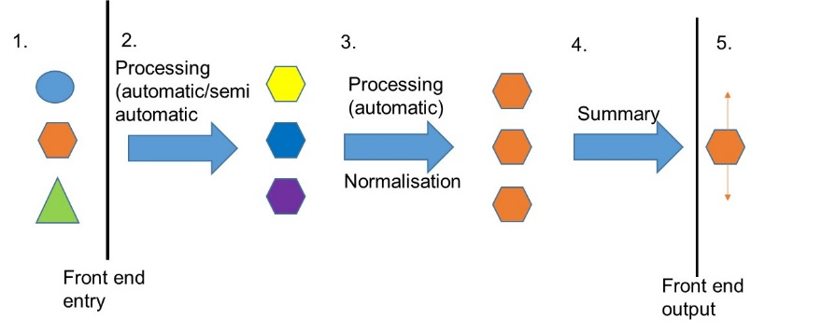
Transpose from sources
Fig 1: Transposing, processing and synthesis of heterogeneous evidence from sources through to summary information

This interface should be compatible for development into a web interface in future phases.

Task 5: Improve the way the framework handles heterogeneous cost, effectiveness and outcome information
The information and evidence available in the literature and case studies describes cost, effectiveness and outcomes in very different ways (units, qualitative/quantitative etc.). There is a need to synthesise and ‘normalise’ descriptions to allow for comparison and summary across multiple evidence sources (see fig 1; No 3.). Phase 1 did this to a limited degree. This needs to be more robust across a wider range of sources and outcomes. There is the potential to progress this using machine learning/data analytical approaches?

Further the most appropriate way of assessing and expressing uncertainty in the information needs to be explored and built into the system building on the work and recommendations in phase 1 (Phase 1 report section 2.2.4).

Aggregation and summary of cost ranges needs to be part of the system too. The ‘Cost-spreadsheet will give a lead on how this can be done.

Task 6: Link the cost-effectiveness information with contextual information in the database
The cost-effectiveness of an intervention depends on the project and location specific intent. Therefore the framework identifies, from the evidence, to what extent the interventions deliver against different outcomes. Cost-effectiveness is then a decision for a user in the context of their particular project and/or location. Therefore only limited contextual information was put into the framework structure. However it would be useful to link the cost-effectiveness information to contextual information. For instance, for the identification of ‘helping and hindering’ factors for interventions, such as topography, land use, scale, stakeholder support and so on. Also for the potential for using contextual information to identify/ model cost-effective (programmes) of interventions and to make recommendations on the most appropriate cost-effective interventions. Phase 2 will incorporate contextual information into the database and link this with the core cost-effective framework. It will structure this as to ensure the development of potential future improved functionality in future phases. This potential future functionality will be explored by the contractors.

Part of this contextual information might include information on effectiveness in the context of the particular project or location (see Annex 2).

The contextual information will be geographically-referenced to allow for mapping.

Task 7: Further populate the database using the built front end using a variety of source information
Phase 2 will populate the information base with a number of additional information sources and types. This will include material from Environment Agency area staff (working directly with these staff) and from the academic and grey literature. As this information will be of a heterogeneous nature it will be used to both help test and develop the other requirements described above.

A limited amount of literature searching and analysis should be progressed to generate some of this material.

Agency Area post-project assessment information will be used to help identify the utility of this information when collected and encourage future more robust collection and structuring of this information.

Task 8: Further develop the front end interface to allow for user interaction with outputs
Phase 2 will develop the front end to allow for easy and clear searching and application of any functionality. It will develop appropriate simple visualisation of information to allow for a pleasant and more polished user experience to support the purposes identified in Annex 1 and task 10. This interface should be compatible for development into a web interface in future phases.

Task 9: Consider how the database and supporting outputs can be configured to be an enabler for improved post-project appraisal
Phase 2 will scope (only) how the system can be enhanced to encourage and support a cultural shift towards more structured and consistent post-project appraisal and the collection and reporting of information from these types of assessments. However Phase 2 will not be required to put in place other tools, guidance, processes etc. which would be required to fully deliver this change.

Task 10: Propose and describe in outline (including technical complexity and costs) potential future enhancements and functionality of the system relevant to the Agency and its partners application.
Phase 2 will describe the potential future development of the database as an information management and decision support tool. It will describe potential future enhanced functionality and the benefits these will deliver. Phase 2 will outline (only) technical requirements and estimate potential costs to deliver these enhancements. Functionality can either be within the database or through export of information to another system. Where possible these enhancements will be demonstrated (as proof of concept only) with real or simulated information. Where this is not possible (technically or within the funding limitation of this project) these will be described through conceptual visualisation using Microsoft Powerpoint slides. Possible enhancements include:
- Modelling ecosystem services outcomes from first principles in cases where sufficient evidence is available.
- Enabling disaggregation of multiple interventions to proportion estimates of effect.
- Estimating cost-effectiveness curves over time.
- Providing enhanced visualisation of outputs.
- Delivering cost and effectiveness modelling.
- Use of evidence in risk assessments and risk reduction assessments
The database should be built as not to preclude these future enhancements.

- Products of the contract

The final outputs of the contract will be:
- A Microsoft Access database (or suggested acceptable alternative) with the properties as described above
- A Report with the following minimal content
  - Database structure and build characteristics
  - Guidance on use (input and output)
  - Potential future enhancement /limitations on future enhancement
- Demonstration (proof of concept) material for future enhancement

7. Scope

The scope of the framework will reflect the developing move towards integrated catchment management, systems-based management and the intention to manage multiple issues and deliver multiple outcomes (incl. ecosystem services). Indeed, the inventory will be a way to help promote that approach. Therefore the intention will be to continue to build the framework to cover interventions for multiple:
- issues (e.g. water quality, water quantity, natural flood risk management, species and habitat conservation, discontinuity and restoration, land quality, air quality etc.);
- pressures/risks (point and diffuse pollution; phosphate, nitrate; sediment, BOD, ammonia, non-native invasives, physical habitat modification, faecal contamination etc.);
- ecosystems/habitats (e.g. chalk streams, versus peatlands etc.) and water body types (e.g. surface water versus groundwater);
- outcomes/ecosystem assets/ ecosystem services /benefits;
- receptors;
- sectors etc.

The inventory will not only cover water but also land and air based interventions relevant to integrated catchment management. Interventions will include traditional regulatory and technological approaches as well as more nature based solutions. Outcomes will include those directed towards the water, land and aerial environment. However the focus in the first instance will be towards the water environment (water quality, physical habitat, water quality, flooding).

8. Sources of information

Development of the framework

The framework developed in phase 1 is the starting point for further development of the framework. Other framework inventories developed by the Agency (e.g. EA's Benefits Inventory, EA's NFM Evidence Directory, NE's Ecosystem Transfer Tool)) and others (What works inventories; B£ST etc.) may also represent useful background.

Population of the database

A number of existing publications, reports, databases and websites have been identified (see annex 3). These would represent a starting point to source information for developing, testing and part populating the inventory and for the inventory to act as a portal to point towards (not all of these are necessary or appropriate). There are also a number of studies in progress (Defra, UKWIR; IMPEL- https://www.impel.eu/tools/idepend-modelling-tool) collating cost-effectiveness information which may represent a potential source (subject to IPR). However some literature searching and analysis will be required. Other information will come from limited working with one or two Agency areas to mine the information they may have.

Priorities for the initial population of the inventory will be discussed and agreed at the start up meeting.

9. Programme of work

 | Task | When by | Who | Outcome
1 | Start-up meeting | 1st Oct 2019 | EA/contractor | Agreed outline scope and deliverables
2 | Scope/ conceptual development | 11th Oct 2019 | Contractor | Full scope/ concept proposal report submitted to EA for review
3 | Scope review telecom | 16th Oct 2019 | EA/contractor | Agreed scope and deliverables
4 | Proposals and demonstration of tasks | 22nd Nov 2019 | Contractor | Interim report and other material outlining proposals and demonstration of how tasks will be developed before build
5 | Review proposals | 29th Nov 2019 | EA | Steer for further development to contractor
6 | Version 0.1 of database | 22nd Dec 2020 | Contractor | Version 0.1 of functioning database for Agency review.
7 | Progress meeting | 8th Jan 2020 | EA | Agency feedback comments
8 | Version 0.2 of database | 24th Jan 2020 | Contractor | Version 0.2 of functioning database for Agency review.
9 | Draft report V0.1 | 24th Jan 2020 | Contractor | Draft report
10 | Agency feedback comments | 31st Jan 2020 | EA | Steer for further development including views of key users (Ops and key partners)
11 | Version 0.3 of database | 19th Feb 2020 | Contractor | Version 0.3 of functioning database for Agency review.
12 | Draft recommendations and demonstration material for further enhancement V0.1 | 19th Feb 2020 | Contractor | Recommendations and demonstration material for further enhancement
13 | Progress meeting | 26th Feb 2020 | EA | Agency feedback comments
14 | Version 0.4 of database | 6th March 2020 | Contractor | Version 0.4 of functioning database for Agency review.
15 | Draft report V0.2 | 6th March 2020 | Contractor | Revised draft report
16 | Recommendations and demonstration material for further enhancement V0.2 | 6th March 2020 | Contractor | Revised recommendations and demonstration material for further enhancement
17 | Agency feedback comments | 13th March | EA | Agency feedback comments
17 | Final version 1.0 of database | 20th March 2020 | Contractor | Version 1.0 of functioning database for Agency review.
18 | Final report V1.0 | 20th March 2020 | Contractor | Revised draft report
19 | Final Recommendations and demonstration material for further enhancement V1.0 | 20th March 2020 | Contractor | Revised recommendations and demonstration material for further enhancement

The Agency will be as responsive as possible in supplying information identified by the contractor which is known to exist or likely to exist within the Agency or elsewhere.

10. Timetable

1st Oct 2019 to 20th March 2020

11. Payment schedule

Payment of 50% of the total project price after completion of points 1- 10 in section 7 ‘Programme of work’. Payment of remaining 50% after all deliverables point 19 in section 7. ‘Programme of work’ completed to satisfactory standard.

12. Performance and contract management

- Start-up meeting (see section 7. ‘Programme of work’; 1st Oct 2019)
- Scope/ conceptual development (see section 7. ‘Programme of work’)
- Progress meetings (face to face 8th Jan 2020; 26th Feb 2020 see section 7. ‘Programme of work’)
- Weekly telecoms
- Draft deliverables reviews (see section 7. ‘Programme of work’)

13. Deliverables and milestones

Date | Interim/  final | Deliverable/milestone
11th Oct 19 | Interim | Scoping / concept note
22nd Nov 19 | Interim | Proposal and demonstration of tasks
22nd Dec 19 | Interim | Version 0.1 functioning database
24th Jan 20 | Interim | Version 0.2 functioning database
24th Jan 20 | Interim | Draft report V0.1
19th Feb 20 | Interim | Version 0.3 functioning database
19th Feb 20 | Interim | Recommendations and demo of enhancements V0.1
6th Mar 20 | Interim | Version 0.4 functioning database
6th Mar 20 | Interim | Draft report V0.2
6th Mar 20 | Interim | Recommendations and demo of enhancements V0.2
20th Mar 20 | Final | Version 1.0 functioning database
20th Mar 20 | Final | Draft report V1.0
20th Mar 20 | Final | Recommendations and demo of enhancements V1.0

14. Skills

Some of the likely skills and knowledge required:

- Understanding of environmental management and management interventions across wide range of disciplines
- Knowledge of (research) developments in intervention assessment and appraisal
- Knowledge and experience of using economic appraisal for environmental management
- Data/information system design and development and in particular experience of producing consistent data sets with user-friendly front ends;
- Data science and data/information manipulation
- Information sourcing and analysis
- Excellent communication and project management skills;
- Ability to present information and concepts clearly in plain English;

Specification Annex 1: Benefits and application of the inventory

The benefits of the work will include:
- Improving decision making around intervention option screening (optioneering), cost-effectiveness analysis, cost-benefit analysis, intervention selection and decision making around interventions
- Improving the cost-effectiveness of our and others integrated environmental and flood risk management
- Delivering efficiencies in planning and delivering interventions
- Improving transparency in decision making around interventions
- Helping to move towards more integrated decision making and delivery of interventions which deliver multiple benefits
- Improving effectiveness of in-place interventions
- Delivering efficiencies in planning
- More consist decision making
- Transparency and hence benefits to collaborative working and therefore leverage of funding

The evidence base will have the potential to be applied to a number of applications within the typical environmental planning and management cycle (Fig 1):

Fig 1. Application of evidence-base in the context of a typical environmental management cycle

For environmental planning: Identifying interventions
- Options screening in environmental planning (what works/ most cost-effective)
- Identifying alternative options (incl. for delivering multiple outcomes/benefits)
- Cost-effectiveness and cost-benefit analysis
- Helping to formulate integrated cost-effective programmes of interventions
- Finding case-study examples
- Improving engagement and participation of partners/investors

For in-place or planned interventions: Existing interventions
  - Extrapolating cost-effectiveness to situations where we do not have this information
  - Making recommendations to improve effectiveness of planned and in-place interventions based on best practice/lessons learnt (‘adaptive management’!)
  - Finding case study examples
  - Helping to develop an overall view of effectiveness of in-place interventions for reporting

For environmental planning: General
- Improving risk assessments
- Regulatory Impact assessment
- Building scenarios
Providing a framework to record learning

Specification Annex 2: Scoping of possible effectiveness attributes for contextual information?

Effectiveness
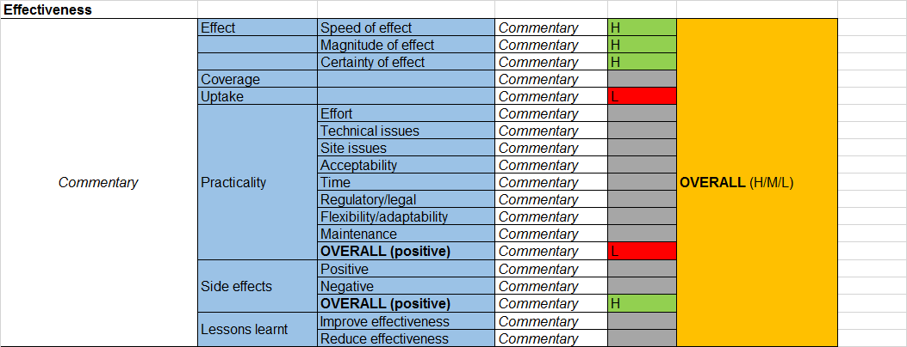

Specification Annex 3: Some known existing relevant reports, initiatives, systems etc. identified by consultees

Note – It is not known how useful these are in the context of this current proposal

AGRI INDUSTRY
  - Agri - FARMSCOPER
  - Built on CAM tool Evidence for 20 yrs Defra research etc 100+ measures & cost database Scale - farm, water mgt catchment, RBD, England Central Modelling Platform Training & awareness raising
  - Built on ADAS manual
  - Catchment change matrix Extract of farmscoper to do what-if modelling
  - JWEG Effectiveness of agri measures (5 measures)
  - JWEG wetland systems report
  - Agri evidence - DTC, CSF (
  - CSF Evaluation reports Agri-environment schemes in England 2009. Review of results and effectiveness
  - Agri evidence strategic evidence planning (
  - Effectiveness of bundles of measures in mechanisms
  - Climate adaptation agricultural measures cost-effectiveness work
  - Innovative and cost-effective technologies to reduce N losses to water from agriculture in the EU: a catalogue of farm level strategies (Newcastle University)
  - Developing a field tool kit for ecological targeting of agricultural diffuse pollution mitigation measures CEH (Defra funded)
  - New basic measures for agriculture (Defra)
  - ADAS 'SEPARATE' project (Defra project WQ0223)?
  - Evidence around Water Protection Zones
  - Potential cost and effectiveness of voluntary measures in reducing the environmental impact of pesticides (Defra)
  - Initial evaluation of effectiveness of measures to mitigate diffuse rural pollution report (ADAS)
  - The effectiveness of changing Farmer Practice on the reduction of diffuse pollution of nitrogen and phosphorus (Defra)
  - Review of agricultural water management intervention impacts at the watershed scale: a synthesis using the sustainable livelihoods framework (SEI Stockholm Environment Institute)
  - Rural sustainable drainage systems (RSUDs) Environment Agency Report
  - Agriculture and climate change: Evidence on influencing farmer behaviours
  - Defra Agr-env review WT1594
  - EU River Basin network review on Agricultural interventions

WATER INDUSTRY
  - Water Ind case studies Good practice in NEP
  - Talk to Paul Davidson

WATER QUALITY
  - WQ project - End of pipe vs catchment measures assessment (
  - Minewaters
  - Rural SUDS
  - ARUP- Benefits around SUDs and river restoration
  - Case studies on urban SUDS
  - Case studies on urban SUDs
  - Community SUDS guidance (
  - PR14
  - Metal mine improvements

WATER RESOURCES
  - Water Resource - flow augmentation
  - Low Flow measures matrix -
  - Water Resource - RSA effectiveness?
  - Effectiveness of measures to complement, or as an alternative to, abstraction reduction (UKWIR)
  - Evaluation of the effectiveness of water retention measures

HYDROMORPH
  - RESTORE - Case studies (river restoration) – Monitoring
  - Mitigation Measures Manual incl CBA & ES
  - REFORM - HM&ECOL interactions - What measures to apply & when
  - 671 case studies reviewed against objectives<http://www.reformrivers.eu/home> and outputs here <http://www.reformrivers.eu/results/deliverables>
  - River restoration centre - Mon guidance to assess measures
  - Queen Mary Uni - Citizen Science - morph assessment survey
  - WR - Eff of WR measures
  - Natural Processes - Catchment labs
  - Guidance and decision support for cost-effective river and floodplain restoration and its benefits
  - Review of River Restoration (International Union for Conservation). Publ - September Catchment scale restoration
  - Queen Mary MSc's
  - Multiple benefits of river and wetland restoration - measured from projects implemented on the ground (Alistair Driver)
  - Conservation Projects Database (CPD)
  - River Wiki case studies <https://restorerivers.eu/wiki/index.php?title=Main_Page>
  - WFD GiA- Effectiveness of river habitat rehabilitation in Humber RBD
  - See document(s): National EP Annual Reports
  - river sediment and habitats: the impacts of maintenance capital works (EA report)

LAND QUALITY
  - Royal Haskoning Appraisal of interventions (sediments)
  - Rural sustainable drainage systems. EA report scho0612buwh-e-e.pdf
  - Defra integrated modelling form case studies
  - Lessons learned from interventions and evaluations. Forest research
  - Halcrow basic measures report
  - CSF evaluation report
  - WQ0223
  - PR14 case studies (moors of the future)
  - Assessment of the effectiveness, impact and cost of measures to protect soils report (Ricardo-AEA)

CROSS CUTTING
  - Cost-effectiveness of ‘natural’ measures - Lydia BG work - Paul B natural processes email
  - Integrated WQ Modelling Forum (CEH)
  - Catchment Planning System
  - RNAG
  - EU reports on success of directives
  - Case studies folder at <O:\RBD Information\Case studies>
  - : <O:\RBD Information\Case studies\Env Prog Year in Reviews>
  - Biodiversity Actions Reporting System UKBARS (JNCC)
  - See document(s): actionmap, actionmap
  - climate adaptation agricultural cost-effectiveness work
  - Evidence and learning project
  - CABA
  - Catchment based approach data standards report
  - Comparison of Env Prog and NEP
  - Evaluation of the effectiveness of the protection and management of local sites for geodiversity and biodiversity
  - Evidence for significant water management issues: costs for improvement scenarios (AMEC)
  - Testing the effectiveness of climate change adaptation principles for biodiversity conservation
  - Effectiveness of regulation: literature review and analysis. EA report
  - Description of regulatory approaches to assessing the effectiveness of regulatory activities at low risk sites and proposed good practice framework (EA partners report)
  - Compliance Classification Scheme (CCS) Compliab

FCRM
  - Natural flood management measures case studies
  - JBA evidence base
  - Healthy catchments manual (prev. mitigation measures manual)
  - Working with nature (WWNP) project evidence base (Lydia)
  - Establishing the cost-effectiveness of property flood protection: FD2657
  - Project appraisal
  - SE Project appraisal proposal
  - River habitat rehabilitation in Humber RBD Evidence and Learning project

METHODS
- Collaborative Research Programme on Economics
- Development of methodology to determine the cost-effectiveness of measures and combinations of measures for the water framework directive RPA
  - 2a- Developing a methodology for assessing the effectiveness of measures and combinations of measures
  - 2b developing a methodology for an even-handed assessment of the costs and economic impacts of measures and led on combining the methodologies to produce a cost-effectiveness methodology
  - 2c development of a benchmark database and will produce and test guidance for the application of the cost effectiveness analysis (CEA) methodology
  - 2d requires the development and testing of tailored proformas for obtaining local specific cost information for different sectors
- What works in waste crime
- Developing an FCRM evaluation framework (report SC120013/R2)
- CDUG Universal Translator (FBA report)

EXISTING DATA PORTALS
- EA Geostore
- EA Catchment Data Explorer
- MAGIC
- SE Web
- Catchment Sensitive Farming (CSF)
- WElsh Government Geo-Portal LLE
- EIP
- EA Catchment Planning System CPS
- River wiki
- Catchment change management (CCM) hub
- Conservation projects database (form-E database)
- DTC archive

CATCHMENT/OPS EVIDENCE BASE
- Evidence for Learning project
- ACADEMIC PARTNERSHIPS
- MSc - Kings Uni Evaluate success of cycle 1 projects - June - Sept
- Better Thames Network (Dom Martyn previous - now Jenny Thomas) Link with academic partner projects, many on effectiveness
- Evidence for measures project
- WPZ - DWP plans
- Cycle 1 retrospective evaluation –
- Investigations for the first cycle
- Pilot catchments
- Catchment walkovers
- Demonstration test catchments

TRACKING & REPORTING SYSTEMS
- Measures T&F
- Elements being targeted - Money being invested - Projected monetised benefits
- CPS system improvements for measures / actions.
- Km enhanced KPI
- Conservation database
- Env prog outputs and outcomes
- IEP prioritisation tool
- WFD prioritisation 2. Second bolt-on tool based on opportunities etc. 3. Combined Area action plan (Devon and Cornwall trial
- Cost Effective Database
- Conservation database?

Specification Annex 4. Example of visualisation of effectiveness

UKWIR (2013): Effectiveness of measures to compliment, or as an alternative to abstraction reduction

Specification Annex 5

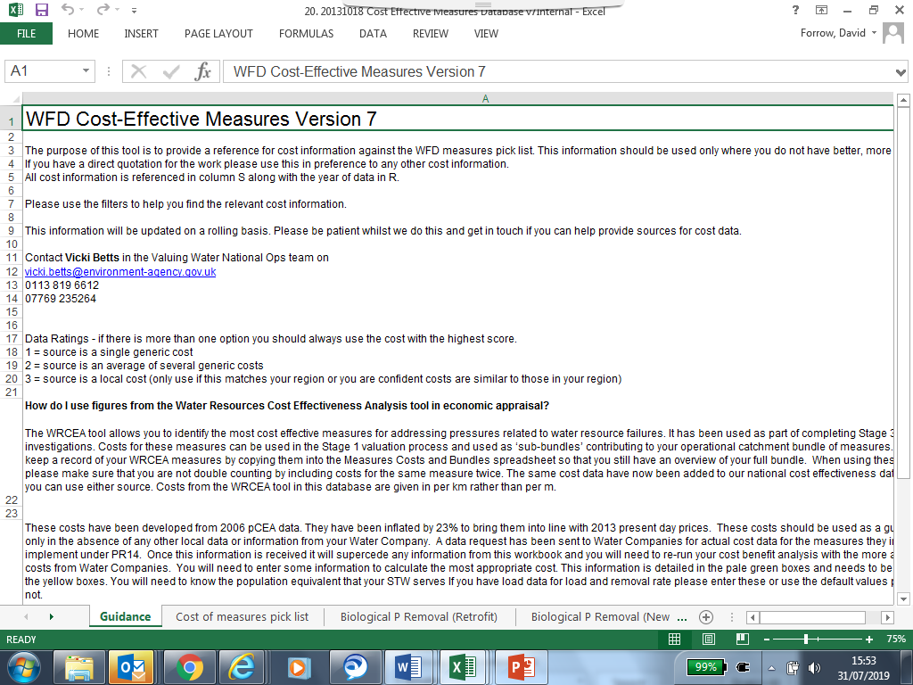

Specification Annex 6: Screen shots from benefits inventory
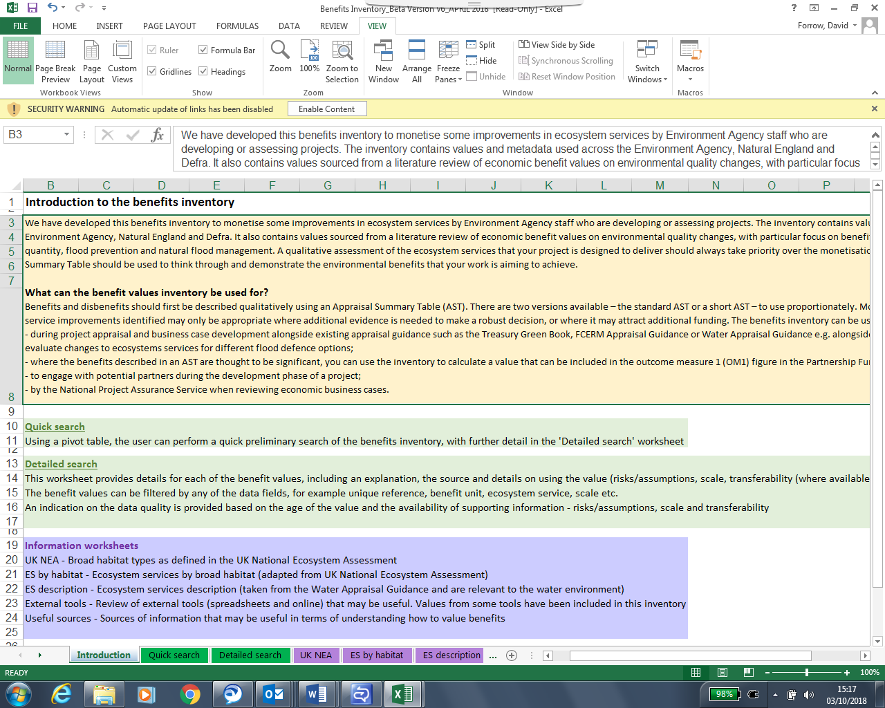

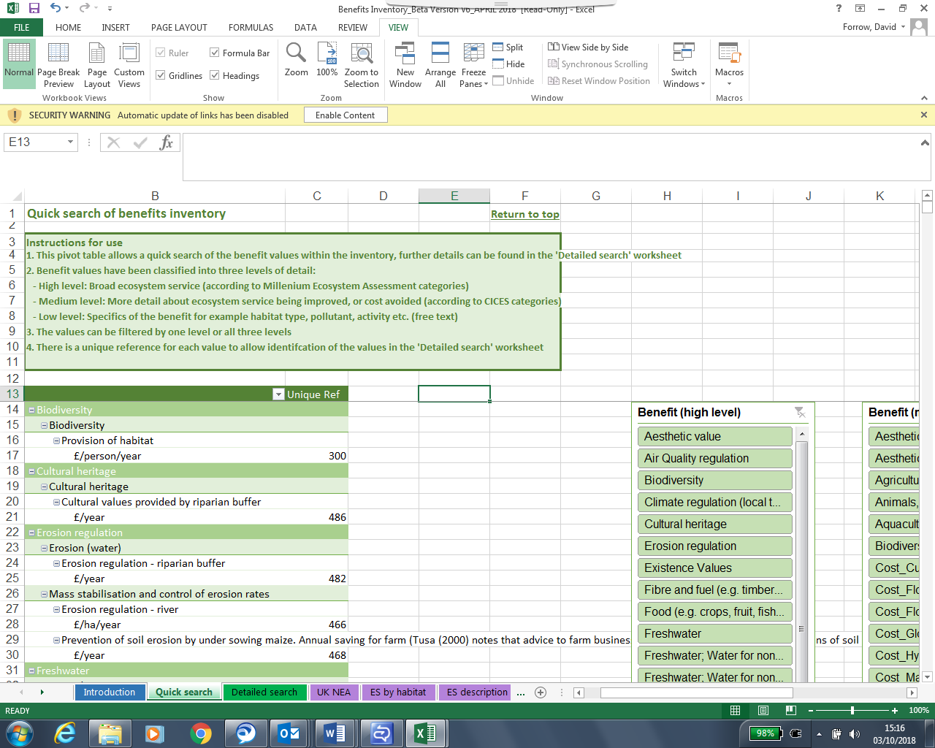

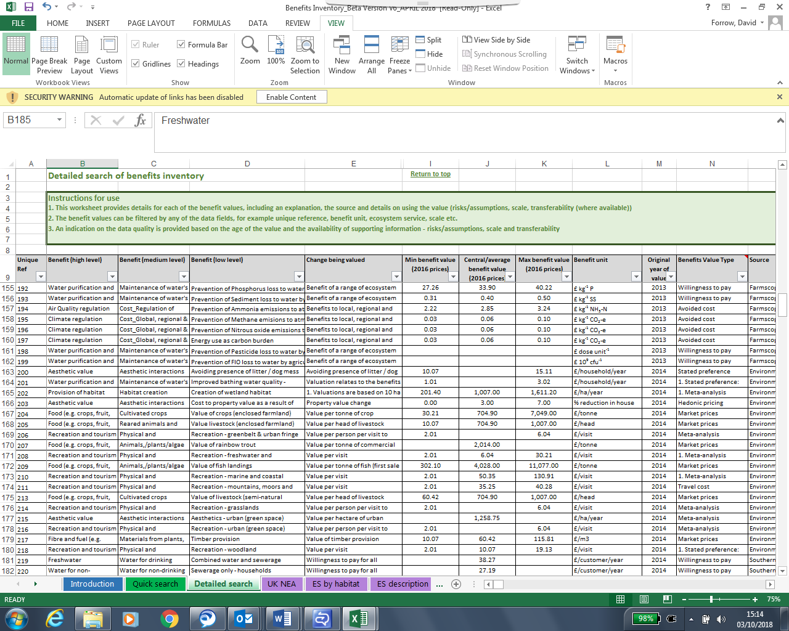

Section 6

Contract Management

This contract shall be managed on behalf of the Agency by Dr David Forrow +442030259623

The project review meetings, reports, milestones and performance meetings are displayed in sections 8, 11 and12 of the contract above.

We will raise purchase orders to cover the cost of the services and will issue to the awarded supplier following contract award.

The payment schedule is displayed in section 10 of the specification above

Before the invoice is issued, a fee note must be emailed in advance to the contract manager for approval. All invoices must quote the purchase order number in order to be processed. A file copy invoice must be provided to the contract manager, on request. The timescale for payment of invoices will be up to 30 days after we have received a valid invoice.

Section 7

Sustainability Considerations
We are committed to continually improving our sustainability performance. The Environment Agency has set itself tough objectives as a clear commitment and contribution to sustainable development throughout England. The Agency recognises that this can only be achieved through commitment from all sectors of society and it is intent on raising awareness amongst industry and commerce.

Contractors must adopt a sound proactive environmental approach, designed to minimise harm to the environment.

Environmental criteria should be considered as part of your tender submission with credit given for innovation. Factors to be considered could include areas such as:
    - Paper use: All documents and reports prepared by consultants and contractors are produced wherever possible on recycled paper containing at least 100% post consumer waste and printed double sided.
    - Travel: use of public transport, reduce face to face meetings by using email and videoconferencing. Meetings to be held in locations to minimise travel and close to public transport links.
    - Packaging: should be kept to a minimum. Re-use and disposal issues must be considered.
    - Efficient Energy and Water Use.
    - Disposal of Waste: Whilst on site the contractor is responsible for the disposal of their own waste and can only use client facilities with express permission from the on site facilities officer.
    - Whilst on site, contractors should comply with the local environmental policy statement which will be made available to you in advance or on arrival.

Diversity and Equal Opportunities
We are committed to promoting equality and diversity in all we do and valuing the diversity of our workforce, customers and communities. As a public body, we publish regular information about what our equality objectives are and how we’re meeting them.
https://www.gov.uk/government/organisations/environment-agency/about/equality-and-diversity

Health and Safety
Contractors will be responsible for making sure all required health and safety aspects including risk assessments are undertaken and required management measures are in place to protect worker exposure. This includes management of all partners, consortium members and subcontractors.

IEM2020:

Sustainability Objectives

As the Environment Agency, our overarching aim is to protect and improve the environment for people and wildlife. Over the last 10 years we have achieved significant reductions in our environmental impacts that occur through our everyday operations. This included a 40% reduction in our carbon emissions and a 37% reduction in the number of miles we travel. This year we have launched our new Internal Environmental Management strategy to take us through to 2020, building on these successes and widening our ambition.

Supply chain

Our 2020 approach will have a very strong emphasis on the indirect impacts of our supply chain.

Our supply chain accounts for over 70% of our total environmental impacts.

Working with our supply chain we want to be world class in the area of environmental management. The environmental impacts of our work and that delivered by and through our supply chain must be reduced; environmental risks must be effectively managed and opportunities for enhancements investigated.
As an organisation, our environmental management system (EMS) is accredited to ISO14001 and EMAS standards. Our procurement activities form part of this system; driving environmental performance improvements across the value chain.

Section 8

Additional Information

Copyright and confidentiality

Unless otherwise indicated, the copyright in all of the documentation belongs to the Environment Agency, and the documentation is to be returned to us with your tender. The contents of the documentation must be held in confidence by you and not disclosed to any third party other than is strictly necessary for the purposes of submitting your quote. You must also ensure that a similar obligation of confidentiality is placed upon any third party to whom you may need to disclose any of the documentation for the purposes of the tender.

Accuracy of documentation

You should check all documentation; should any part be found to be missing or unclear you should immediately contact us at the address given in the covering letter. No liability will be accepted by the Environment Agency for any omission or errors in the documentation which could have been identified by you.

Amendments to documentation

Prior to the date for return of tenders, we may clarify, amend or add to the documentation. A copy of each instruction will be issued to every Tenderer and shall form part of the documentation. No amendment shall be made to the documentation unless it is the subject of an instruction. The Tenderer shall promptly acknowledge receipt of such instructions.

Alternative Offers

Alternative offers may be considered if they constitute a fully priced alternative and are submitted in addition to a quotation complying with the requirements of the Invitation to Quote Documents. If, for any reason you wish to submit an alternative offer without a fully compliant tender please contact us in accordance with the details in the covering letter.

Continuity of personnel

The Contractor shall employ sufficient staff to ensure that the Services are provided at all times and in all respects to the Project Standard. It shall be the duty of the Contractor to ensure that a sufficient reserve of staff is available to ensure project delivery in the event of staff holidays, sickness or voluntary absence

The Environment Agency will be notified immediately of any changes to personnel associated with the project. The Contractor will ensure that every effort is made to replace outgoing staff with personnel of equal calibre and expertise. All new members of staff undertaking work for the Project will need to be agreed by the Environment Agency prior to commencement.

At all times, the Contractor shall only employ in the execution and superintendence of the Contract persons who are suitable and appropriately skilled and experienced.

Intellectual property rights

All results, including material and tools produced, developed or paid for under this contract shall be the property of the Environment Agency.

References

The Environment Agency may request recent and relevant references prior to the award of the project.

Contract award

This Request for Quote is issued in good faith but we reserve the right not to award any or all of this work.

DATA PROTECTION ACT ADDENDUM TO SPECIFICATION

Protection of personal data

In order to comply with the Data Protection Act 1998 the Contractor must agree to the following:

- You must only process the personal data in strict accordance with instructions from the Environment Agency.

- You must ensure that all the personal data that we disclose to you or you collect on our behalf under this agreement are kept confidential.

- You must take reasonable steps to ensure the reliability of employees who have access to personal data.

- Only employees who may be required to assist in meeting the obligations under this agreement may have access to the personal data.

- Any disclosure of personal data must be made in confidence and extend only so far as that which is specifically necessary for the purposes of this agreement.

- You must ensure that there are appropriate security measures in place to safeguard against any unauthorised access or unlawful processing or accidental loss, destruction or damage or disclosure of the personal data.

- On termination of this agreement, for whatever reason, the personal data must be returned to us promptly and safely, together with all copies in your possession or control.

APPENDIX A - PRICING SCHEDULE

ALL COSTS QUOTED MUST BE EXCLUSIVE OF VAT
All costs must be quoted on this schedule. Any costs not detailed will not be paid.

Staff Costs
Please detail the day rates of your proposed personnel in the table below.
(Please also advise how many hours you constitute a working day)

Name | Title/Grade | Day Rate | No of Days
Other costs if applicable (please detail)
Total |  | £

Discounts, rebates and reductions
Please detail below any discounts, rebates and other reductions you are prepared to offer and the basis of those incentives

DESCRIPTION | AMOUNT  £
TOTAL

Total Overall Cost

Please detail the total fixed cost for the project

ITEM | TOTAL AMOUNT  £
Staff Costs
Other Costs
Discounts/reductions
TOTAL Overall Cost

The following limits will be applicable to all claims for travel and subsistence under this contract:

- Travel by rail: standard class should be used at all times
- Travel by car: 45 pence/mile

Hotel bookings should be made through the Environment Agency’s corporate travel contract. Details of this contract are available from the Corporate Contracting Team.

When making reservations you should state that you are a contractor working on Environment Agency business.

Hotel charges must not exceed a maximum limit per night bed and breakfast (VAT included) of: £140 in London; £100 in Bristol; £90 in Warrington; £85 in Reading; £75 in Aberdeen, Birmingham, Belfast, Cardiff, Coventry, Edinburgh, Glasgow, Harlow, Leeds, Manchester, Middlesbrough, Newcastle, Oxford, Portsmouth, Sheffield and York; and £70 in all other destinations. Please note that these hotel ceiling rates are subject to change throughout the life of the contract.

Expenditure on dinner during an overnight stay must not exceed a maximum limit of £25, including a drink.

Receipts for all rail travel, hotel and food expenses will be required as proof of expenditure and will be reimbursed at cost. No profit or additional cost shall be applied by the contractor to such personal expenses.

APPENDIX B - PRIOR RIGHTS SCHEDULE

Details of Prior Rights held by the Parties (To be updated as Rights are introduced during the period of the Contract)
Prior Rights owned or lawfully used by a Party, whether under licence or otherwise, which it introduces to the Project for the purposes of fulfilling its obligations under the Contract

Held by the Environment Agency

Name and description of Prior Rights | Extent of proposed use in the Project | Proprietary owner of the Prior Rights
Cost-effectiveness database (costs database) | Incorporation | Environment Agency
Cost-effective framework (project phase 1) | Incorporation | Environment Agency

Held by the Contractor

Name and description of Prior Rights | Extent of proposed use in the Project | Proprietary owner of the Prior Rights

Explanation of Contractor's Prior Rights
All Intellectual Property Rights owned by or lawfully used by the Contractor, whether under licence or otherwise before the date of this Contract. It can also mean any invention and know how or other intellectual property (whether or not patentable) owned by one of the parties prior to the commencement of the Project, or devised or discovered by one of them only in the course of other projects during the Project period and not arising directly from the Project.

APPENDIX C – ACCEPTANCE OF TERMS AND CONDITIONS

APPENDIX C. Conditions of Contract - Research & Development
Ref: ENV6003627R
Title: Inventory and tool for cost-effectiveness information for interventions for integrated environmental and flood risk management: Phase 2: Development and population of decision support inventory and tool

  - Definitions and Interpretation................................................
  - Precedence........................................................................…
  - Contract Supervisor...............................................................
  - Services..............................................................................…
  - Assignment............................................................................
  - Contract Period......................................................................
  - Property..................................................................................
  - Confidential Information.........................................................
  - Security..................................................................................
  - Variations...............................................................................
  - Extensions of Time................................................................
  - Default ............................................................................
  - Termination.............................................................................
  - Determination..........................................................................
  - Indemnity.................................................................................
  - Limitation of Contractor’s Liability............................................
  - Insurance.................................................................................
  - Prevention of Fraud or Corruption...........................................
  - Monitoring and Audit................................................................
  - Contract Price ..................................................................
  - Invoicing and Payment............................................................
  - Intellectual Property Rights......................................................
  - Warranties................................................................................
  - Publication of Results...............................................................
  - Statutory Requirements............................................................
  - Environment, Sustainability and Diversity.................................
  - Law...........................................................................................
  - Waiver......................................................................................
  - Enforceability and Survivorship................................................
  - Dispute Resolution....................................…............................
  - General.......................................................…...........................
  - Freedom of Information Act......................................................
  - Data Protection…………………………………………………….

Appendix to Conditions - Research & Development..........................

All rights reserved. No part of this document may be reproduced
or transmitted in any form or by any means, including photocopying
and recording, without the written permission of the copyright holder.
Such written permission must also be obtained before any part of
this publication is stored in a retrieval system of any nature
© Environment Agency 2018
- DEFINITIONS AND INTERPRETATION

  - In the Contract, unless the context otherwise requires the following words and expressions shall have the following meanings:

    - Agency
Environment Agency, its successors and assigns.

    - Agency’s Prior Rights
All Intellectual Property Rights owned by, or lawfully used by the Agency, whether under licence or otherwise, before the date of this Contract.

    - Appendix
The Appendix to these Conditions.

    - Contractor
The person, firm, company or body that undertakes to provide the services to the Agency as set out in the Appendix.

    - Contractor’s Prior Rights
All Intellectual Property Rights owned by or lawfully used by the Contractor, whether under licence or otherwise before the date of this Contract.

    - Contract
These Conditions including the Appendix, any Special Conditions, the Specification, Pricing Schedule, Contractor’s tender, acceptance letter and any relevant documents agreeing modifications exchanged before the Contract is awarded, and any subsequent amendments or variations agreed in writing.

    - Contract Period
The time period stated in the Appendix, or otherwise in the Contract, for the performance of the Services.

    - Contractor Personnel
means all directors, officers, employees, agents, consultants and contractors of the Contractor and/or of any sub-contractor engaged in the performance of its obligations under this Contract

    - Contracting Authority
Means any contracting authorities (other than the Environment Agency) as defined in regulation 2 of the Public Contract Regulations 2015 (SI 2015/102) (as amended).

    - Contract Price
The price (exclusive of any VAT) set out in the Contract for which the Contractor has agreed to provide the services.

    - Contract Supervisor
Any duly authorised representative of the Agency, notified in writing to the Contractor for all purposes connected with the Contract. Any notice or other written communication given by or to the Contract Supervisor, shall be taken as given by or made to the Agency.

    - Data Protection Legislation
means: (i) the General Data Protection Regulation (Regulation (EU) 2016/679) or GDPR, the Law Enforcement Directive (Directive (EU) 2016/680) ("LED") and any applicable national implementing Laws as amended from time to time (ii) the Data Protection Act 1998 ("DPA 1998") and/or the Data Protection Act 2018 ("DPA 2018") to the extent that it relates to processing of personal data and privacy; (iii) all applicable Law about the processing of personal data and privacy

    - Data Protection Schedule
The Schedule attached to this Contract describing how the Parties will comply with the Data Protection Legislation.

    - Law
means any law, subordinate legislation within the meaning of Section 21(1) of the Interpretation Act 1978, bye-law, enforceable right within the meaning of Section 2 of the European Communities Act 1972, regulation, order, regulatory policy, mandatory guidance or code of practice, judgment of a relevant court of law, or directives or requirements with which the Contractor is bound to comply

    - Notice
Any written instruction or notice given to the Contractor by the Contract Supervisor, delivered by:

- fax, or hand delivery to the Contractor’s registered office or other address notified by the Contractor to the Agency for the purposes of the Contract and be deemed to have been served at the date and time of delivery; or

- first class post to the Contractor’s registered office. Such notice shall be deemed to have been served 48 hours after posting.

    - Intellectual Property Rights
All Intellectual Property Rights including without limitation, patents, patent applications, design rights, registered designs, utility models, trade and service marks and applications for same, copyright, know- how, rights in semi-conductor chip topography, and in each case whether protectable at law or not, and if protectable, whether an application has been made for such protection or not, and all similar industrial, commercial, monopoly or other intellectual property rights whether present or future, vested or contingent wherever protected.

    - Results
All things produced in performing the Services including maps, plans, photographs, drawings, tapes, statistical data, experimental results, field data, analysis of results, published and unpublished results and reports, inventions, computer programmes and user documentation.

    - Resulting Rights
All Intellectual Property Rights in the Results that are originated, conceived, written or made by the Contractor, whether alone or with others in the performance of the Services or otherwise resulting from the Contract.

    - Services
All Services detailed in the Specification including any additions or substitutions as may be requested by the Contract Supervisor.

    - PCR
Means the Public Contract Regulations 2015 (SI 2015/102) as amended.

  - Except as set out above and in the Data Protection Schedule, the Contract shall be interpreted in accordance with the Interpretation Act 1978.

  - All headings in these Conditions are for ease of reference only, and shall not affect the construction of the Contract.

  - Any reference in these Conditions to a statutory requirement this will include all subsequent modifications.

  - All undefined words and expressions are to be given their normal English meaning within the context of this Contract. Any dispute as to the interpretation of such undefined words and expressions shall be settled by reference to the definition in the Shorter Oxford English Dictionary.

- PRECEDENCE

To the extent that the following documents form the Contract, in the case of conflict of content, they shall have the following order of precedence.

    - Conditions of Contract including Appendix, Data Protection Schedule and any Special Conditions
    - Specification
    - Pricing Schedule
    - Drawings, maps or other diagrams.

- CONTRACT SUPERVISOR

The Contractor shall strictly comply with any instruction given by the Contract Supervisor concerning or about the Contract provided such instructions are reasonable and consistent with the nature, scope and value of the Contract. All such instructions shall be in writing. The Contractor is not obliged to comply with any verbal instruction from the Contract Supervisor, that is not confirmed in writing within seven working days.

- SERVICES

  - The Contractor shall provide all staff, equipment, materials and any other requirements necessary for the performance of the Contract using reasonable skill, care and diligence, and to the reasonable satisfaction of the Contract Supervisor.

  - Where the Agency has indicated in writing, at or before the date of the Contract, that there will be a need to retain certain persons crucial to the successful provision of the Services, such persons (“Key Personnel”) shall be identified from within the Contractor’s business or staff and agreed in writing, and a list made of such persons (“the Key Personnel List”).

  - The Contractor shall (subject to Condition 4.5) make Key Personnel available for the whole of the Contract Period, for the purposes of providing the Services.

  - Where the Contract Supervisor gives Notice that Key Personnel are associated with the provision of specific services, such services shall only be provided by such persons.

  - No changes of any kind shall be made to the Key Personnel List, without the prior written agreement of the Contract Supervisor.

  - The Contractor shall only employ in the execution and superintendence of the Contract, persons who are suitable, and appropriately skilled and experienced. The Contract Supervisor shall be at liberty to object to, and require the Contractor to remove any person employed in or about the Contract who is unsuitable, misconducts himself, is incompetent or negligent in the performance of his duties, or persists in conduct which could endanger the health or safety of others. Such persons shall not be employed again on the Contract without the express permission of the Contract Supervisor.

  - The Contractor shall provide the Agency with such progress reports at such intervals and in such form as is detailed in the Specification or otherwise as reasonably required by the Contract Supervisor.

  - The Contractor shall notify the Contract Supervisor immediately if any factors occur which give the Contractor reason to believe that the Contract could be completed more effectively or expeditiously by changing the programme or method of working in the Specification.

  - The Contractor shall not carry out any survey for the Agency (whether or not such survey forms part of the Services) which includes any interviews or the circulation of questionnaires or similar documents without the agreement of the Agency to the form and content of such interviews, questionnaires or other documents.

  - The Contractor shall promptly notify the Contract Supervisor, in writing of any situation, or event arising from circumstances beyond his control and which it could not have reasonably foreseen which makes it difficult for the Contractor to carry out in whole or in part the Contract in accordance with the Specification. On receipt of such notification, any revision to the Condition 6 (Contract Period) in accordance with Condition 10 (Variations) and/or Condition 11 (Extensions of Time) shall be considered by the Contract Supervisor on its merits, and the Contractor notified in writing of the decision.

- ASSIGNMENT

  - The Contractor shall not assign, transfer or sub-contract the Contract, or any part of it, without the prior written permission of Contract Supervisor.

  - Any assignment, transfer or sub-contract entered into, shall not relieve the Contractor of any of its obligations or duties under the Contract.

  - Nothing in this Contract confers or purports to confer on any third party any benefit or any right to enforce any term of the Contract

- CONTRACT PERIOD

The Contractor shall perform the Services within the time stated in the Appendix [DRAFTING NOTE – CHECK APPENDIX], subject to such amendments arising from Condition 10 (Variations), and/or Condition 11 (Extensions of Time.).

- PROPERTY

  - All property issued by the Agency to the Contractor in connection with the Contract shall remain the property of the Agency, and shall be used in the execution of the Contract, and for no other purpose whatsoever without the prior approval of the Contract Supervisor.

  - The Contractor shall keep all property issued by the Agency in safe custody and good condition, set aside and clearly marked as the property of the Agency.

  - On expiry, or earlier termination of the Contract, the Contractor shall, if so required, either surrender such property to the Agency, or otherwise dispose of it, as instructed by the Contract Supervisor.

- CONFIDENTIAL INFORMATION

  - Confidential Information shall comprise any information disclosed to, or made available to the Contractor and its agents and staff in connection with the Contract and the provision of the Services. This will include, but not be limited to the Agency’s procedures, the Contract, the Results, any Intellectual Property of the Agency, or any other information which could reasonably be regarded as confidential.

  - The Contractor shall take all necessary precautions to ensure that all Confidential Information as in Condition 8.1:

    - Is given only to the minimum number of staff and then only to the extent necessary for each member of staff’s activities in the provision of the Services;

    - Is treated as confidential and not disclosed, without the prior approval of the Contract Supervisor, to any other person.

  - Where required by the Contract Supervisor, the Contractor will ensure that its staff sign a confidentiality undertaking before commencing work on the provision of the Services, and provide copies to the Contract Supervisor.

  - The Agency’s remedies for breaches of Conditions 8.1, 8.2, and 8.3 shall not be limited to damages.

  - Nothing in this Condition shall prevent the Agency from disclosing such information relating to the outcome of the Contract procurement process as may be required to be published in the Supplement to the Official Journal of the European Communities in accordance with E.C. Directives, or elsewhere in accordance with requirements of United Kingdom law on the disclosure of information.

- SECURITY

The Contractor shall be responsible for the security of all goods and equipment (i) belonging to the Agency and used by the Contractor in the provision of the Services, and (ii) belonging to the Contractor, or Contractor’s staff, or sub-contractors whilst on Agency premises. This Condition shall not prejudice the Agency’s rights under Condition 15.

- VARIATIONS

  - The Contract Supervisor may vary the Contract by adding to, deleting or otherwise modifying the Services to be supplied, by written order to the Contractor provided such variations are reasonable and consistent with the nature, scope and value of the Contract.

  - The value of any such variation, other than any variation arising out of Condition 10.3, shall be determined by reference to the rates contained in the Pricing Schedule. Where the Services so ordered are not covered in the Pricing Schedule, they shall be valued at a fair and reasonable rate agreed between the Contract Supervisor and the Contractor.

  - Where a variation is the result of some default or breach of the Contract by the Contractor, or for some other cause for which it is solely responsible, any additional cost attributable to the variation shall be borne by the Contractor.

  - The Contractor may also propose a variation to the Services, but no such variation shall take effect unless agreed and confirmed in writing by the Contract Supervisor.

  - No variation shall have the effect of invalidating the Contract, if that variation is reasonably consistent with the nature, scope and value of the Contract. The Contractor may also propose a variation to the Goods to be supplied but no such variation shall take effect unless agreed and confirmed in writing by the Contract Supervisor.

  - No variation shall have the effect of invalidating the Contract, or placing the Contract at large, if that variation is reasonably consistent with the nature, scope and value of the Contract.

  - The Agency may vary the Contract to comply with a change in English Law. Such a change will be effected by the Contract Supervisor notifying the Contractor in writing.

  - The Agency may assign, novate or otherwise dispose of its rights and obligations under the Contract or any part thereof to:

    - any Contracting Authority; or

    - any other body established by the Crown or under statute in order substantially to perform any of the functions that had previously been performed by the Agency; or

    - any private sector body which substantially performs the functions of the Agency, provided that any such assignment, novation or other disposal shall not increase the burden of the Contractor's obligations under the Contract.

  - Any change in the legal status of the Agency such that it ceases to be a Contracting Authority shall not affect the validity of the Contract. In such circumstances the Contract shall bind and inure to the benefit of any successor body to the Agency.

- EXTENSIONS OF TIME

  - Should the performance of the Contract be delayed by any cause beyond the reasonable control of the Contractor, and provided that the Contractor shall first have given the Contract Supervisor written notice within five working days after becoming aware that such delay was likely to occur, then, the Contract Supervisor, if satisfied that this Condition applies:

    - in the case of any delay of which the Agency is not the cause, may grant the Contractor such extension of time as in his opinion, is reasonable, having regard, without limitation, to any other delays or extensions of time that may have occurred or been granted under the Contract. The Contract Price shall not increase as a result of such an extension of time.

    - in the case of any delay of which the Agency is the cause, shall grant the Contractor a reasonable extension of time to take account of the delay.

  - No extension of time shall be granted where in the opinion of the Agency, the Contractor has failed to use reasonable endeavours to avoid or reduce the cause and/or effects of the delay.

  - Any extension of time granted under this Condition shall not affect the Agency’s rights to terminate or determine the Contract under Conditions 13 and 14 respectively.

- DEFAULT

  - The Contractor shall be in default if it:

    - Fails to perform the Contract with due skill, care, diligence and timeliness; or

    - Refuses or neglects to comply with any reasonable written instruction given by the Contract Supervisor; or

    - Is otherwise in breach of Contract.

  - Where in the opinion of the Contract Supervisor, the Contractor is in default, the Contract Supervisor may serve a Notice, giving at least 5 working days in which to remedy the default.

  - If the Contractor fails to comply with such a Notice, the Contract Supervisor may without prejudice to any other rights or remedies under the Contract, take over for such a period as is necessary the performance of the relevant part of the Contract, and make other arrangements for its completion. Any extra costs arising from this action, will be paid by the Contractor or deducted from any monies owing to it.

- TERMINATION

  - The Agency may immediately, without any liability on its part and without prejudice to any of its other rights and remedies under the Contract, terminate all, or any part of the Contract by Notice to the Contractor, or the Contractor’s receiver, or the Contractor’s liquidator or to any other person in whom the Contract may become vested, if the Contractor:

    - fails in the opinion of the Contract Supervisor to comply with (or take reasonable steps to comply with) a Notice under Condition 12.2; or

    - becomes bankrupt or insolvent, or has a receiving order made against it, or makes an arrangement with its creditors, or (being a corporation) commences to be wound up, not being a voluntary winding up for the purpose of reconstruction or amalgamation, or has a receiver, administrator, or administrative receiver appointed by a Court.

'Termination under the Procurement PCR’

  - The Agency may terminate the Contract on written Notice to the Contractor if:

    - the contract has been subject to a substantial modification which requires a new procurement procedure pursuant to regulation 72(9) of the PCR;

    - the Contractor was, at the time the Contract was awarded, in one of the situations specified in regulation 57(1) of the PCR, including as a result of the application of regulation 57(2), and should therefore have been excluded from the procurement procedure which resulted in its award of the Contract; or

    - The Contract should not have been awarded to the Contractor in view of a serious infringement of the obligations under the Treaties and the PCR that has been declared by the Court of Justice of the European Union in a procedure under Article 258 of the TFEU.

- DETERMINATION

  - Without prejudice to any other rights or remedies under the Contract, the Agency reserves the right to determine the Contract at any time by giving not less than one month’s Notice, (or such other time period as may be appropriate).

  - The Agency shall pay the Contractor such amounts as may be necessary to cover his reasonable costs and outstanding and unavoidable commitments necessarily and solely incurred in properly performing the Contract prior to determination.

  - The Agency will not pay for any costs or commitments that the Contractor is able to mitigate and shall only pay those costs that the Agency has validated to its satisfaction. The Agency’s total liability under this clause shall not in any circumstances exceed the Contract Price that would have been payable for the Services if the Contract had not been determined.

- INDEMNITY

  - Subject always to Condition 15.2 without prejudice to the Agency’s remedies for breach of Contract, the Contractor shall fully indemnify the Agency and its staff against any liability, loss, costs, expenses, claims or proceedings in respect of:

    - Death or injury to any person, and/or

    - Loss or damage to any property, excluding indirect and consequential loss, and/or

    - Infringement of third party Intellectual Property Rights

which might arise as a consequence of the actions, omissions or negligence of the Contractor, its staff or agents in the execution of the Contract.

  - Nothing in this Condition 15 shall limit or exclude any liability of the Agency for personal injury or death arising from its negligence.

- LIMIT OF CONTRACTOR’S LIABILITY

  - The limit of the Contractor’s liability for each and every claim by the Agency, other than for death or personal injury, whether by way of indemnity or by reason of breach of Contract, or statutory duty, or by reason of any tort shall be-

    - The sum stated in the Appendix [DRAFTING NOTE – INSERT SUM and consider personal data risk];

    - If no sum is stated in the Appendix, ten times the Contract Price, or five million pounds whichever is the greater.

- INSURANCE

  - The Contractor shall insure, and maintain insurance against the liabilities under Condition 15 (Indemnity), in the manner, and to the values listed in the Appendix to these Conditions. [DRAFTING NOTE – CHECK SUM and consider personal data risk]. If no sum is stated, the value insured shall be £5m, (five million pounds).

  - If required by the Agency, nominated insurances shall be in the joint names of the Contractor and the Agency.

  - The Contractor shall, upon request, produce to Contract Supervisor documentary evidence that the insurances required are fully paid up and valid for the duration of the Contract.

- PREVENTION OF FRAUD AND CORRUPTION

  - The Contractor shall not offer, give, or agree to give anything, to any person an inducement or reward for doing, refraining from doing, or for having done or refrained from doing, any act in relation to the obtaining or execution of the Contract or for showing or refraining from showing favour or disfavour to any person in relation to the Contract.

  - The Contractor shall take all reasonable steps, in accordance with good industry practice, to prevent fraud by the Contractor’s staff and the Contractor (including its shareholders, members and directors) in connection with the Contract and shall notify the Agency immediately if it has reason to suspect that any fraud has occurred or is occurring or is likely to occur.

  - If the Contractor or the Contractor’s staff engages in conduct prohibited by this clause 18 or commits fraud in relation to the Contract or any other contract with the Crown (including the Agency) the Agency may:

    - terminate the Contract and recover from the Contractor the amount of any loss suffered by the Agency resulting from the termination, including the cost reasonably incurred by the Agency of making other arrangements for the supply of the Goods and any additional expenditure incurred by the Agency throughout the remainder of the Contract; or

    - recover in full from the Contractor any other loss sustained by the Agency in consequence of any breach of this clause.

  - The Contractor shall not, directly or indirectly through intermediaries commit any offence under the Bribery Act 2010 (as amended), in any of its dealings with the Agency.

- MONITORING AND AUDIT

  - The Contract Supervisor may inspect and examine the Services being carried out on the Agency’s premises or elsewhere at any reasonable time. Where the Services are being performed on other than the Agency’s premises, reasonable notice to inspect shall be given to the Contractor. The Contractor shall give all such facilities as the Contract Supervisor may reasonably require for such inspection and examination.

  - The Contractor shall keep and maintain for six years following termination of the Contract, records of all expenses and expenditure which have been or are reimbursable by the Agency, and of the hours worked and costs incurred by the Contractor and its sub-contractors in the performance of the Contract, and the Contractor shall on request afford the Agency such access to those records as may be required to carry out audit checks or for any other legitimate reason.

- CONTRACT PRICE

  - The Contract Price will be paid by the Agency to the Contractor, as amended by any variations ordered under Condition 10 (Variations).

  - Subject to receipt of a valid VAT invoice addressed to the Agency, in addition to the Contract Price, the Agency will pay to the Contractor such VAT (if any) as may properly be chargeable at rates ruling at the time of invoice.

- INVOICING AND PAYMENT

  - Invoices shall only be submitted for work already satisfactorily completed, and accompanied by such information as the Contract Supervisor may reasonably require to verify the Contractor’s entitlement to payment. Such invoices will be paid within 30 days of receipt by the Agency.

  - If any sum shall become payable under the Contract by the Contractor to the Agency, whether by deduction from the Contract Price, or otherwise, it will be deducted by the Contractor from the Contract Price and such deduction reflected in the next available invoice.

  - If the Contractor enters into a sub-contract with a supplier for the purpose of performing its obligations under the Contract, it shall ensure that a provision is included in the sub-contract which requires payment to be made of all sums due from it to the sub-contractor within 30 days from the receipt of a valid invoice.

- INTELLECTUAL PROPERTY RIGHTS

  - All Prior Rights used in connection with the Services shall remain the property of the party introducing them. Details of each party’s Prior Rights are set out in the Prior Rights Schedule to this contract.

  - All Results shall be the property of the Agency.

  - The Resulting Rights in any Results, and any interim results shall, from the time they arise, be the property of the Agency and the Agency shall be free, should it so wish, to apply at its own expense for patent or other protection in respect of the Results or any interim results. The Agency’s intention to apply for such patent or other protection shall be notified to the Contractor. Such applications for patents or other registered intellectual property rights shall be filed in the name of the Agency.

  - Unless otherwise agreed in writing between the Contractor and the Agency, the Contractor hereby:

    - assigns to the Agency all Resulting Rights

    - grants the Agency a non-exclusive, non transferable (save for the purposes of sub-licensing, reorganisation or transfer to a successor body, for the purposes of all the successor body's normal business use), irrevocable, royalty free, perpetual licence to the Agency in respect of all the Contractor's Prior Rights necessary in order for the Agency to use or exploit the Resulting Rights.

  - The Contractor undertakes to the Agency not to use, exploit or deal with any of the Agency's Prior Rights, other than in the performance of the Contract unless the Contractor has first obtained a written licence from the Agency, in specific terms to do so.

  - The Agency undertakes to the Contractor not to use or exploit the Contractor's Prior Rights, save as provided in Condition 22.3.

  - The Contractor warrants to the Agency that the performance of the Services, the Contractor’s Prior Rights and the Results shall not in any way infringe any Intellectual Property Rights of any third party.

  - If the Contractor is prevented from carrying out his obligations under the Contract due to any infringement or alleged infringement of any Intellectual Property Rights, the Agency may without prejudice to any other rights and remedies under the Contract, exercise the powers and remedies available to it under Conditions 13 and 14, Termination and Determination respectively.

  - The Contractor shall not be liable if such infringement arises from the use of any design, technique or method of working provided by or specified by the Agency.

  - The Contractor waives in favour of the Agency its rights to object to derogatory treatment of the Results and the Contractor also agrees that it will not assert or seek to enforce against the Agency and/or any other person, firm or company any of its moral rights as defined in the Copyright Designs and Patents Act 1988 without the prior agreement of the Agency.

  - The Contractor shall not be liable for any consequential losses, damage or injuries arising from third party misuse of the Results, of which the Contractor is not aware.

- WARRANTIES

The Contractor warrants that the Services supplied by him will be discharged with reasonable skill, care and diligence.

- PUBLICATION OF RESULTS

  - Without prejudice to the generality of Condition 22, the Contractor shall not, without the prior written agreement of Contract Supervisor, use, disclose or permit any person or organisation to use or disclose the Results or Confidential Information for any thesis, degree, research or other educational purpose. Any such use or disclosure may only be made subject to such terms as the Agency shall require.

  - The Contractor shall not publish any other information related to the Contract without agreeing the text to be published, and the publication or transmission service in or on which it is to appear with Contract Supervisor. Such agreement shall not be unreasonably withheld or delayed.

  - Any agreed publication shall contain an acknowledgement that the Services were carried out under contract to the Agency, and is published with the Agency's agreement.

  - Any publication by the Contractor shall be entirely at the Contractor's own cost and the Contractor shall, within ten days of publication, supply the Agency free of charge with a reasonable number of copies of any publication.

- STATUTORY REQUIREMENTS

The Contractor shall at all times comply with (i) all relevant legislation and all applicable codes of practice and other similar codes or recommendations and (ii) the Health and Safety at Work etc. Act 1974 (as amended) and any other acts, orders, regulations and codes of practice relating to health and safety, which may apply to employees and other persons working directly or indirectly in the provision of the Services.

- ENVIRONMENT, SUSTAINABILITY AND DIVERSITY

  - The Contractor in the performance of this Contract should adopt a sound proactive environmental approach, designed to minimise harm to the environment, to conserve energy, water, wood, paper and other resources, reduce waste and phase out the use of single-use plastic, ozone depleting substances and minimise the release of greenhouse gases, volatile organic compounds and other substances damaging to health and/or the environment, and be able to provide proof of so doing to the Agency on demand.

  - The Agency is committed to ensuring that workers employed within its supply chains are treated fairly, humanely and equitably. The Agency expects the Contractor to share this commitment and to understand any areas of risk associated with this and work to ensure they are meeting International Labour Standards. The Contractor ensures that it and its sub-contractors and its supply chain:

    - comply with the provisions of the Modern Slavery Act 2015;

    - pay staff fair wages (and pays its staff in the UK not less than the Foundation Living Wage Rate ); and

    - implement fair shift arrangements, providing sufficient gaps between shifts, adequate rest breaks and reasonable shift length, and other best practices for staff welfare and performance.

  - The Contractor should support the Agency to achieve its Public Sector Equality Duty by complying with the Agency's policies (as amended from time to time) on Equality, Diversity and Inclusion (EDI). This includes ensuring that the Contractor (and their sub-contractors) in the delivery of its obligations under this Contract:

    - eliminates discrimination, harassment, victimisation and any other conduct that is prohibited by or under the Equality Act 2010;

    - advances equality of opportunity between people who share a protected characteristic and those who do not; and

    - fosters good relations between people who share a protected characteristic and those who do not.

- LAW

This Contract shall be governed and construed in accordance with the Law, and subject to the exclusive jurisdiction of the courts of England.

- WAIVER

  - No delay, neglect or forbearance by the Agency in enforcing any provision of the Contract shall be deemed to be a waiver, or in any other way prejudice the rights of the Agency under the Contract.

  - No waiver by the Agency shall be effective unless made in writing.

  - No waiver by the Agency of a breach of Contract shall constitute a waiver of any subsequent breach of Contract.

- ENFORCEABILITY AND SURVIVORSHIP

  - If any part of the Contract is found by a court of competent jurisdiction or other competent authority to be invalid or legally unenforceable, then that part will be severed from the remainder of the Contract which will continue to be valid and enforceable to the fullest extent permitted by law.

  - The following clauses shall survive termination of the Contract, howsoever caused: 8, 13, 14, 15, 22, 23, 24, 25, 27, 29, 30, 31, 32 and 33.

- DISPUTE RESOLUTION

  - All disputes under or in connection with this Contract shall be referred first to negotiators nominated at a suitable and appropriate working level by the Agency and the Contractor.

  - If the parties’ negotiators are unable to resolve the dispute within a period of forty five days from its being referred to them, the dispute shall be referred at the instance of either party to the parties respective senior managers or directors (supported as necessary by their advisors)

  - If the parties respective senior managers or directors are unable to resolve the dispute within forty five days, the dispute shall be referred to the Centre for Dispute Resolution who shall appoint a mediator and the parties shall then submit to the mediators supervision of the resolution of the dispute.

  - Recourse to this dispute resolution procedure shall be binding on the parties as to submission to the medium but not as to its outcome. Accordingly all negotiations connected with the dispute shall be conducted in strict confidence and without prejudice to the rights of the parties in any future legal proceedings. Except for any party’s right to seek interlocutory relief in the courts, no party may commence other legal proceedings under the jurisdiction of the courts, or any other form of arbitration until forty five days after the appointment of the mediator.

  - If, with the assistance of the mediator, the parties reach a settlement, such settlement shall be put in writing and, once signed by a duly authorised representative of each of the parties, shall remain binding on the parties.

  - The parties shall bear their own legal costs of this dispute resolution procedure, but the costs and expenses of mediation shall be borne by the parties equally.

  - Any of the time limits in Condition 30 may be extended by mutual agreement between the parties. Such agreed extension shall not prejudice the right of either party to proceed to the next stage of resolution.

- GENERAL

  - Neither party to the Contract will be liable to the other for any delay in performing or failing to perform its obligations under the Contract because of any cause outside its reasonable control. Such delay or failure will not constitute a breach of the Contract and the time for performance of the affected obligation will be extended by a reasonable period.

  - The Contract contains the whole agreement between the parties and supersedes all previous communications, representations and arrangements, written or oral. It is accepted that the Contract has not been entered into on the basis of any representations that are not expressly contained in the Contract.

- FREEDOM OF INFORMATION ACT

  - The Agency is committed to open government and to meeting its responsibilities under the Freedom of Information Act 2000 (as amended) (‘Act’) and the Environmental Information Regulations 2004 (as amended) (Regulations’).

  - The Contractor agrees that:

    - All information submitted to the Agency may need to be disclosed by the Agency in response to a request under the Act or the Regulations; and

    - The Agency may include information submitted (in whole or in part) in the publication scheme which it maintains under the Act or publish the Contract, including from time to time agreed changes to the Contract, to the public.

  - If the Contractor considers that any of the information included in its tender, or that it has submitted to the Agency or that is otherwise contained in the Contract, is commercially sensitive, it shall identify and explain (in broad terms) what harm may result from disclosure if a request is received, and the time period applicable to that sensitivity. The Contractor acknowledges that if it has indicated that information is commercially sensitive, such information may still be required to be disclosed by the Agency under the Act or the Regulations. The receipt of any material stated to be or marked ‘confidential’ or equivalent by the Agency shall not be deemed to infer that the Agency agrees any duty of confidentiality by virtue of that marking.

- Data Protection

  - In the event that the Contract requires data to be processed within the meaning of the Data Protection Legislation the Data Protection Schedule shall be completed by the Parties and provisions and definitions therein shall apply and bind the Parties as part of this Contract.

Appendix to Conditions Research and Development

Ref: ENV6003627R
Title: Inventory and tool for cost-effectiveness information for interventions for integrated environmental and flood risk management: Phase 2: Development and population of decision support inventory and tool

Condition

1 Contract Supervisor 3
Contact Supervisor

Address:-
Address
City
Postcode

- Contractor
«Company_Name»
Address:
«SUPPLIER_ADDRESS»
«TOWN_CITY»
«COUNTY»
«ZIP»

3 Completion 6

Contract Start Date «Contract_Start_Date»

Contract End Date «Contract_End_Date»
4 Delivery 11

Address:-
Insert delivery address if different to above

5 Insurance 17

Professional Indemnity Min. Cover £x million
Third Party Minimum Cover £x million
Public Liability Min. Cover £x million

6 Limit on Liability 16

Limit on Contractors Liability £x million

I/We accept in full the terms and conditions named in Section 2 and appended to this Request for Quote document.

Company ____________________________________________________
Name

Signature ____________________________________________________

Print Name ____________________________________________________

Position ____________________________________________________

Date ____________________________________________________

