The Education and Skills Funding Agency (ESFA) currently uses the Student Bursary Support Service (SBSS) to administer the student financial support schemes. The SBSS is currently provided through an outsourced contract. The contract expires on 31 August 2019 and a fully operational service is required from 1 September 2019, with the capability to process new Professional and Career Development Loan and Care to Learn applications from May 2019 for those studying in the 2019 to 2020 academic year.

The new service will cover the following support schemes

* Care to Learn (C2L)
* 16 to 19 Bursary Fund for vulnerable students (VB)
* Professional and Career Development Loans (PCDL)

Information regarding the service and schemes can be found at the following links:

[SBSS](https://www.gov.uk/guidance/student-bursary-support-service) [C2L](https://www.gov.uk/care-to-learn) [PCDL](https://www.gov.uk/career-development-loans)

[VB (student)](https://www.gov.uk/1619-bursary-fund) [VB (education institution)](https://www.gov.uk/guidance/16-to-19-bursary-fund-guide-2017-to-2018-academic-year)

Note: only the vulnerable bursary element of the 16 to 19 Bursary Fund is administered by the service.

The service will cover the processing of application forms, the recording of data onto secure systems and the payments made to educational institutions and childcare providers. The ESFA provides funds on a weekly basis to make these payments.

For the replacement service we intend to procure a service that will cover the following periods:

* Set-up – May 2018 to August 2019
* Operation for 3 academic years – September 2019 to August 2022
* Optional Closure – September 2022 to December 2022. Rescheduled if optional extensions taken up.
* Optional extension – September 2022 to August 2023
* Optional extension – September 2023 to August 2024

To ensure continuity of financial support for students from 1 September 2019 and those requiring summer retainers from May 2019, we require the initial phase of the service to be operational by 1 May 2019 with the service fully operational by 1 September 2019.

Currently SBSS is provided by Capita as Software as a Service (SaaS) using the following packages:

* **Advantage Digital** platform for case management
* **Connect** for the secure portal

**Main Features of SBSS**

**Professional and Career Development Loan (PCDL)**

The activities marked with * are carried out using a PCDL portal operated and maintained by the ESFA. The ESFA will provide the contractor with user accounts to access the PCDL portal to manage the administration and reconciliation of loans.

* SBSS Portal to capture loan applications submitted by the students
* SBSS Portal to capture loan adjustments submitted by the students
* Back office processes to send and receive details from the commercial bank
* Verification and maintenance of course details *
* Verification and maintenance of learning providers *
* Upload of loan application data, loan recoveries, loan adjustments, loan enquiries to PCDL portal using XML format files *
* Extract course information from PCDL portal for use on SBSS portal*
* Manage follow-up questionnaires *
* Management and reconciliation of loans and bank charges *

**VB claims 16 to 19 Bursary Fund for vulnerable students (VB)**

* SBSS Portal to capture claim information, comprising the education institution submitting the claim, the amount of bursary for each student, the vulnerable category of the student and the unique references for the student
* Payments to the education institutions

**Care to Learn (C2L)**

* SBSS Portal to capture
  + young parent application
  + education institution details and student attendance monitoring
  + childcare provider details and child attendance monitoring
* Payments to education institutions, childcare providers, agencies
* Case work to assess non-standard eligibility and application issues
* Verification of Ofsted registrations for childcare providers

**User support**

* Support and application queries – telephone, email, issue reporting (portal enquiry form), webchat, text messaging (using GOV.UK Notify)
* Resolution of data, postcode/address, process and payment issues
* Handle application appeals and complaints (C2L and PCDL)

**IT services**

* SBSS Portal to manage user accounts and capture data
* Point of entry data validation, eligibility checking and notifications
* Case management system to support eligibility checks, queries etc
* Account documentation – correspondence (email), payments, user notifications, attendance returns
* System customisation/developments
* Hosting/Cloud services
* System security to meet industry and government standards

**General**

* Secure accommodation to house and protect departmental data to meet government standards
* System design that meets Government Digital Services (GDS) – Service Toolkit
* A range of MI reports to cover service performance and service activity
* Access to the service, data and systems by government staff and nominated auditors to verify service performance, compliance with scheme policy and the appropriate use of public funds

Link to support videos on YouTube to assist users. These videos contain images of the input screens.

<https://www.gov.uk/guidance/student-bursary-support-service-demonstration-videos-for-students>

Screenshots from SBSS portal screen

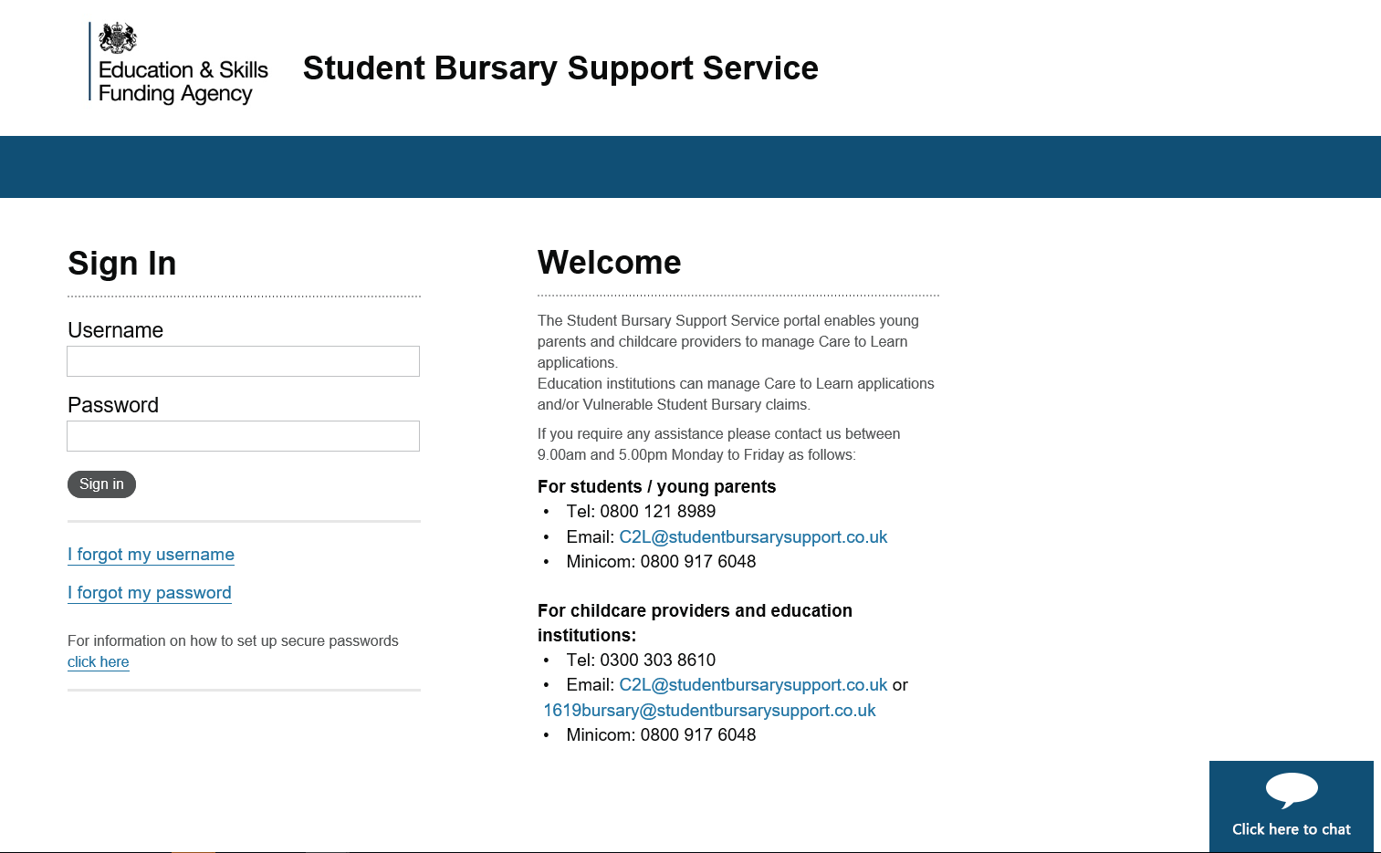

Screenshot for PCDL loan application screen

