**Business Continuity Planning System Prospectus**

**Introduction**

1. The purpose of this prospectus (and any associated published procurement notices) is for the Environment Agency (the “EA”) to make known its intention of a planned procurement and to commence the market engagement process (in advance of commencing any formal procurement process) for the development of a Business Continuity Planning Tool which will facilitate undertaking a Business Impact Analysis (BIA) to collect the data to generate dynamic Business Continuity Plans (BCPs). The tool will provide the capability to report on the continuity status of activities during an incident as well as provide high level reports on the Business Continuity Management System (BCMS) to support the day-to-day programme management. The Business Continuity Tool will be used by the EA and other organisations in the Defra group.
2. As part of the market engagement process, the EA is keen to hear from Suppliers who are able to meet our requirements set out in Annex B through either COTS business continuity planning software, or a solution built using a low code platform (e.g. Microsoft Power Platform).
3. Prospective tenderers are requested to read this prospectus, and to complete both Annex B and Annex D and email a PDF to louise.pawlowska@environment-agency.gov.uk. The EA may then contact prospective tenderers to discuss their responses in further detail. Within Annex B, complete column F ‘Vendor Response to Requirement’, with details of how the requirement is met. Annex D is a market engagement questionnaire to be completed.

**Disclaimer**

1. This prospectus is written and provided in good faith; EA reserves the right to alter any aspect of this document, or to not proceed with the procurement in any way. This prospectus summarises certain aspects of the procurement but does not purport to contain complete descriptions of it, nor to be all inclusive or contain all the information that a prospective tenderer may require when determining whether to take part in this market engagement process. No representation or warranty, express or implied, is or will be made, and no responsibility or liability is or will be accepted by EA or any of its advisors as to the accuracy, adequacy, or completeness of the information within this prospectus. This prospectus is not intended to form the basis of any investment decision or other evaluation by the recipient(s) and does not constitute and should not be considered as a recommendation by any person. EA shall not be liable for any costs or expenses of any prospective tenderer in relation to any matter in connection with this market engagement process, howsoever incurred.

**Background**

1. Defra is the UK government department which is responsible for improving and protecting the environment. Defra aims to grow a green economy and sustain thriving rural communities, and support the UK’s world-leading food, farming and fishing industries. Defra works with 33 agencies (including the EA) and public bodies, collectively referred to as “Defra Group”.
2. The Environment Agency works to create better places for people and wildlife and support sustainable development. Within England, the Environment Agency’s responsibilities include:
   * regulating major industry and waste
   * treatment of contaminated land
   * water quality and resources
   * fisheries
   * inland river, estuary, and harbour navigations
   * conservation and ecology
   * managing flood risk
3. Cabinet Office Minimum Requirements state that all public sector organisations require an annual Business Impact Analysis (BIA) and annual updates of their Business Continuity Plans. As a Category 1 responder there are additional duties on the EA, under the Civil Contingencies Act 2004 to have business continuity arrangements in place. In order to meet our Category 1 responder responsibilities, the EA has developed mature processes and procedures for incident response, supported by embedded IT systems for all phases of incident management. The organisation is not looking for systems that facilitate incident response activities such as warning and reporting and staff communications.
4. The EA organisation consists of 14 operational Areas and four national Directorates (Chief Operating Officer’s Directorate, Environment and Business Directorate, Flood and Coastal Risk Management Directorate and Local Operations Directorate). Currently there is a Business Continuity Plan for each Directorate and for each operational Area, as well as an overarching National Plan.
5. At present, in the EA, business continuity data is gathered through a BIA process, to identify what business activities are undertaken by the different teams and to analyse and collate relevant information for each business activity (e.g., how quickly the activity needs to be resumed in the event of a business continuity incident, how many staff are required to deliver the activity, location of the activity, any dependencies or seasonality of the activity, etc). For many Area activities, and some Directorate activities relevant teams will need to reach agreement on a consistent way of describing their activity, so that the activity is referenced in the same way, wherever it takes place.
6. All this data on business activities is currently put into an Excel spreadsheet, known as the Central Activity List (or CAL). A Business Continuity Plan template (a Word document) is annually updated for Areas and Directorates, and then populated with the relevant data from the CAL Excel spreadsheet. These Business Continuity Plans provide a checklist for the Strategic Manager who finds themselves having to deal with a business continuity incident. The Business Continuity Plans also provide data on business activities by location, showing the priority order for activities to be resumed.
7. There are numerous problems with the current approach – the principal one being that it is very time consuming to review all activities in such a large organisation on an annual basis (resulting in information not being kept up to date). Due to the time taken to update information, there is no flexibility to review data more frequently, when business needs change. The current approach does not have any data analysis capability and it involves manual data input, with much tedious cutting and pasting to spreadsheets and documents.
8. The BC Planning Improvement Project’s vision is to deliver a user-friendly IT tool which will enhance both the preparedness and response to business continuity incidents for the EA and some of the Defra group organisations. This will be achieved by improving the approach to capturing, analysing and reporting critical business information using an online BIA tool. This improved approach to business continuity planning, using this tool, will assist to make peace time and incident decisions in a more dynamic way.
9. To be successful this tool will allow:

* EA and Defra group organisations to follow the BIA process and populate the relevant business continuity plan templates. The BIA process we follow is as set out in the Business Continuity Institute (BCI) Good Practice Guidelines and ISO 22301 Standard.
* To be replicated so it can be used in different “instances” by the EA and other Defra group organisations (currently six additional organisations are considering use of the tool).
* To have the capability for approximately 1500 managers to provide information on their business activities (using an online form) which will relieve the burden on a small community of Business Continuity Planners having to manually input all the information.
* For approximately 50-100 Business Continuity Planners and Organisational Resilience Team members across the organisation to have “user access” to the tool, so they can use the data to produce Business Continuity Plans, reports, and dashboards.
* Business activities can be linked to agreed strategic priorities, and business plan objectives.
* Reports to be produced showing business activities ordered by time sensitivity, as well as location, strategic priorities, and business plan objectives.
* An automated link between the information captured and Business Continuity Plan templates, so that plans are updated immediately and without the burden of input on planners as above.
* A live dashboard showing the resilience status of different aspects of the business continuity management service, allowing improved assurance of the service.
* The ability to query the data during an incident (including whether a business activity is continuing, has slowed or stopped), enabling improved decision making.
* GDPR and data security compliance.
* The new Business Continuity Planning process documented in guidance which sets out how the BIA will be undertaken, and business continuity plans produced using the new tool.

1. The Project Team has identified the following key benefits:

* By creating a simple, user-friendly online form, we can capture the activities directly from senior management teams, reducing the need for business continuity planners to gather the data and manually input it into the existing spreadsheet.
* By capturing data in this way, it can be updated regularly as changes occur, so the information will always be up to date.
* By automating the link between the data repository and new online plans, we can keep our plans up to date without the need to use business continuity planners to manually update the plans.
* By storing the data in a database with processing capability, we can analyse the data in many ways and create dashboards of useful information to show where there are gaps in our service and preparedness and how well we are performing – to enable senior managers to make informed decisions about our resilience.
* By being able to analyse data quickly, we can make quick real time decisions during incident response that align with the current situation, removing the need to have complex pre-written plans that don’t necessarily cover the range of scenarios we face, and reducing the time taken during the early stages of planning our response and responding.

**Annex A: Critical Success Factors**

The critical success factors we have identified are outlined below.

|  |
| --- |
| **Critical Success Factor** |
| Efficient, user friendly online Business Impact Analysis (BIA) process that captures and analyses critical and other business activities – ensuring that this information is kept up to date to assist response to business continuity incidents. |
| Produces business continuity plans – auto-populating agreed plan templates using the data captured during the BIA process. |
| A risk and threat assessment undertaken for business activities |
| Aligns business activities to an agreed list of EA Strategic Priorities / Critical Functions and the “EA 2025” business plan priorities |
| Tool lifespan to be no less than 5 years. Initial development will be minimum viable product based on high level user requirements with the ability for incremental improvements as required. |
| Meets required data protection standards |
| During an incident, the capability to update business activities to show their “continuity status” - Stopped/Slowed/Continuing - using RAG status indicators to enable managers to quickly understand the extent of business impacts. |
| Produces reports on the overall Business Continuity Management System and organisational resilience, and during an incident, provides reports with up-to-date information on business impacts - for responders and decision makers to use when prioritising recovery resources. |
| The tool has the ability to be adapted to meet the user requirements of the Defra Group organisations who have shown an interest in utilising the tool for their business continuity management going forward. This will allow for consistent reports across the Defra Group to inform key enablers (Defra Facilities Management & IT Department) on priorities and requirements for their services to enable business continuity – and to provide more consistent reporting on impacts during a widespread incident to the Defra Executive Team. |

**Annex B: High Level Requirements**

Please see attached spreadsheet with the high-level requirements:

‘Annex B – Requirements Catalogue for RFI – Business Continuity Planning Project – v0.3’

Suppliers are required to complete column F on the spreadsheet ‘Vendor Response to Requirement’, with details of how the requirement is met.

Suppliers should set their expected support model including any immediate post implementation support and training as well as the BAU support covered as part of their standard support arrangements.

*Security*

Applications and associated platform services are expected to follow government security guidelines. [Government Functional Standard GovS 007: Security (publishing.service.gov.uk)](https://assets.publishing.service.gov.uk/government/uploads/system/uploads/attachment_data/file/1016424/GovS_007-_Security.pdf)

*Configurability vs Customisation*

It is important that any system can be easily configured by suitably trained support staff, a solution that can only be maintained via code changes and updates to the system by the supplier is not desirable.

*Accessibility*

The system needs to be designed to be accessible in line with government guidelines, the target audience is internal and public facing.

*Access Channels*

The primary access device will be laptop or PCs running Windows 10.

**Annex C: Current Baseline and Target Solution Architecture Views**

**Current Baseline**

To provide context, the diagram below shows a high-level view of the current process and tools used. The ArchiMate modelling language is used for the diagrams in this section.

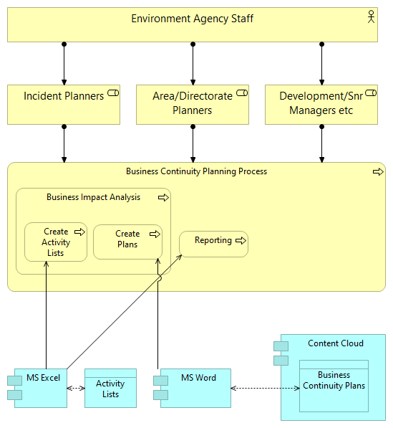

Figure 1 - Current Baseline

There are two steps to the Business Impact Analysis (BIA):

1. Capture and collate information on all the organisation’s business activities, their resources and other critical aspects that deliver the organisations objectives.
2. For each business activity, analyse the impacts over time, of a disruption to delivery to ascertain the recovery requirements such as, the time to be recovered by (recovery time objective) and the level of resources required to ensure that there is an acceptable level of delivery until such time as the organisation can recover to business as usual.

Currently, in the EA, the information from a BIA is collated on a spreadsheet: the Central Activity List (CAL). The CAL comprises two tabs: for Time Critical Business Activities (which have a Recovery Time Objective of 2 days or less) and Other Business Activities (which have a longer recovery time objective).

Additional data is collected for Time Critical Business Activities as these activities are the immediate priority for recovery during a business continuity incident, and they are included in the Business Continuity Plans.

A For the “time critical” business activities, the following key data attributes are recorded on the spreadsheet:

1. Location, e.g., National/Area, site
2. Continuity solutions; preferred option for scenario of loss of site, IT system, site or key supplier
3. Number of staff required to resume the activity
4. Primary staff contact

Recovery Time Objective (RTO); e.g., 1 hour, 0.5 day, 1 day, etc up to 28 days and beyond. The CAL data is held as a MS Excel spreadsheet, with email used for review and approval.

The EA Business Continuity Plans are generated at National (x1), Area (x14), and Directorate (x4) level. They contain:

1. General business continuity incident response process
2. Checklists and templates; e.g., for safety/wellbeing, reporting, communications
3. A copy of the time critical business activities from the CAL spreadsheet
4. Summary details for this plan level; e.g., number of sites and staff (derived from the CAL spreadsheet)
5. Roles, responsibilities and contact details

The Business Continuity Plans are manually compiled Microsoft Word documents, published to the Defra Content Cloud platform.

Defra group organisations will have different approaches to undertaking the BIA and preparing Business Continuity Plans. However, all are reliant upon Excel spreadsheets and Word documents.

**Target Solution**

The diagram below shows a simple high-level view of the new application services and data (in blue) and integration points with other Defra systems.

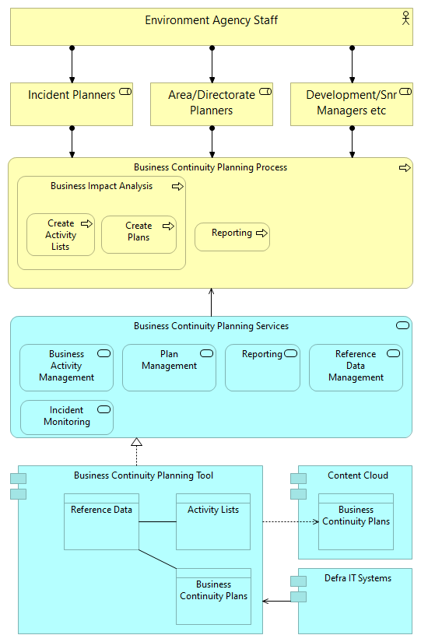

Figure 2 - Target Solution

**Annex D: Market Engagement Questionnaire**

|  |  |  |
| --- | --- | --- |
| **No** | **Question** | **Response Type** |
| 1 | Organisation details | Free text for:   * Organisation * Contact details |
| 2 | Are you happy to be contacted by EA for any follow up on questions? | Yes/No |
| 3 | What software and services do you offer which meets any or all of the proposed High-Level Requirements for the Business Continuity Planning project?  If your solution relies on underlying software from another vendor (e.g. Microsoft), please describe this. | Free text |
| 4 | Do you provide Software as a Service (SaaS)? | Free text |
| 5 | What route(s) to market (e.g., CCS Framework, “OJEU” as was) should EA be considering? | Free text |