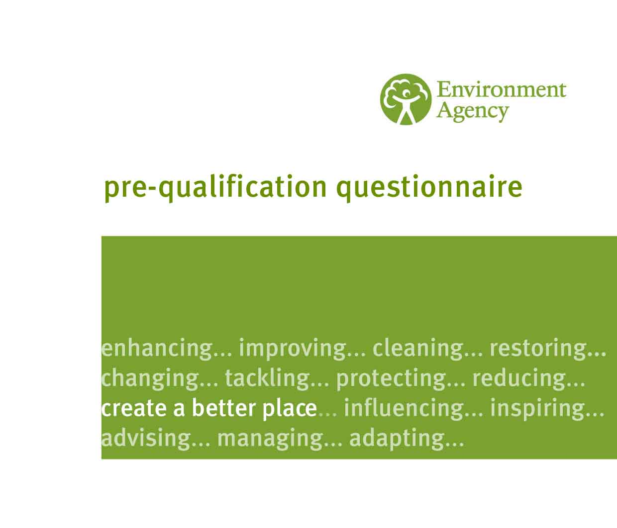

**Commercial-in-Confidence**

**Contract ID:** Project_32321

**SSC ID**: pqq_3001

**Contract Title:** Stakeholder Engagement Advice and Facilitation Services (SEAFS) and Training Framework

Supplier Selection Criteria Information & Guidance Document



**CONTENTS**

PART 1 – INSTRUCTIONS

PART 2 – ENVIRONMENT AGENCY BACKGROUND INFORMATION

PART 3 – PROCUREMENT STRATEGY

**Appendices to this Supplier Selection Criteria guidance document**

|  |  |
| --- | --- |
| Appendix 1 | SSC Response Template |
| Appendix E | Working with Others (WWO) |

**PART 1 – INSTRUCTIONS**

Introduction

This questionnaire is issued to all parties who have responded to the notice placed in the on Find a Tender Service or Contracts Finder.

The document provides further information on the goods/services required. Organisations wishing to pursue this opportunity should respond to the questions within the e-sourcing system. The information you provide will enable us to select suppliers who are eligible for the next stage in the procurement process.

The contract term will be for an initial 2 years with two opportunities to extend for 12 additional months (4 years in total). The anticipated framework value is £500,000 per annum, as this is a Framework Agreement, there is no guaranteed level of work.

Please note that we will not be liable for any costs incurred by potential tenderers in responding to this.

**Instructions for completing the Questionnaire**

1. Complete all fields within the qualification tab on bravo and any missing information may result in a further clarification or failure to participate in the evaluation process.
2. Please complete all relevant parts of this questionnaire (questions 1-3) and attach your response within the technical envelope on bravo.
3. No additional attachments are permitted as part of the responses.
4. Use the Supplier Selection Criteria response template to submit your final response. No attempt should be made to alter the template in any way. Minimise the use of diagrams and images, all words will be counted towards the final word count. Please submit in word or PDF only, no other format will be accepted.
5. No pricing is required at this stage. A Pricing Schedule will be required at stage 2; Invitation to Tender, to the highest 8 scoring potential Delivery Partners.
6. Statements of facts, proposals, and details submitted may be audited and further evidence may be requested in future stages of the process. Inconsistencies, ambiguities and untruths will count against the applicant.
7. The questionnaire should be returned via the Bravo portal (https://defra.bravosolution.co.uk) and as requested.
8. The response date and time is detailed within the Supplier Selection Criteria Information area of Bravo and part 3 of this document.
9. All queries regarding this supplier selection exercise should be sent through the ‘Messages’ area within Bravo. Clarification messages will only be responded to if they are submitted before the clarification deadline set out in the Timetable. The Authority will aim to respond to all clarifications within 3 working days. The responses will be sent to all Delivery Partners, unless requested as confidential and this will be assessed on an independent basis.
10. Should you have any queries regarding Bravo itself, please use the contact details on the Bravo homepage to contact the Bravo support desk. (Phone: 0800 069 8630, Email: [help@bravosolution.co.uk](mailto:help@bravosolution.co.uk)).

**PART 2 – ENVIRONMENT AGENCY BACKGROUND INFORMATION**

**Who is the Environment Agency?**

We are an Executive Non-departmental Public Body responsible to the Secretary of State for Environment, Food and Rural Affairs. Our principal aims are to protect and improve the environment, and to promote sustainable development.

Further information on our responsibilities, Corporate Plan and how we are structured can be found on our [Website](https://www.gov.uk/government/organisations/environment-agency).

**What do we spend our money on?**

We are a major procurer of goods and services within the UK, spending circa £600M per annum, our major spend areas are:

* Flood and Coastal Risk Management (design, construction and maintenance)
* ICT and Telecommunications
* Vehicles and Plant
* Environmental Consultancy and Monitoring
* Temporary Staff and Contractors
* Facilities Management, Energy and Utilities
* Flood Management and Water Related Services

The Environment Agency’s Vision is to create a better place for **people, wildlife and the environment**.

This plan, [EA2025](https://www.gov.uk/government/publications/environment-agency-ea2025-creating-a-better-place), translates our vision for the future into action. The plan sets out 3 long term goals:

* **by 2025 we will have created more climate resilient places and infrastructure, by ensuring the nation is prepared for flooding, coastal change and drought**
* **by 2025 we will be a stronger leader on climate adaptation and resilience, encouraging others to act now on the climate emergency and invest in adaptation**
* **by 2025 we will be ready for bigger, more frequent incidents and will support those at risk to be more resilient**

**What do we need from our suppliers?**

Suppliers are vital in supporting the delivery of our corporate plan. We aim to support the economy and society whilst delivering more environmental outcomes for every pound we spend.

In many areas we are at the leading the way on environmental and technical developments. It is our role to ensure that suppliers clearly understand our corporate aims and objectives and know that we are committed to delivering the best value most sustainable solutions, taking into account the whole life cost of our procurement decisions. We promote diversity and equality and treat all of our suppliers fairly. Our [Procurement Plan](https://www.gov.uk/government/organisations/environment-agency/about/procurement#our-procurement-commitment) may be of interest to you as a potential supplier. It sets out our priorities and key commitments in a range of areas such as delivering our corporate plan, Government policy, supplier management and sustainable procurement.

**Government changes and collaboration**

Some recent changes have taken place meaning that from 1st April 2013 the Environment Agency is no longer be responsible for delivering the environmental priorities of Wales as this is now the responsibility of Natural Resources Wales (NRW).

By bidding for this requirement, you may also be approached by other members of the [Defra network](https://www.gov.uk/government/organisations).

**Further information**

For further information and to see our commitments to [Diversity and Equality](https://www.gov.uk/government/publications/environment-agency-equality-and-diversity-benchmarking/environment-agency-equality-and-diversity-benchmarking).

Also, are you up to date on environmental legislation?  See links below for further information

[Waste and Environmental Impact](https://www.gov.uk/browse/business/waste-environment)

[Environmental Regulations](https://www.gov.uk/topic/environmental-management)

**PART 3 - PROCUREMENT STRATEGY**

* 1. Our requirement

Our SEAFS Framework contract is around 15 years old. We want to appoint Delivery Partners on a framework to help support our work with stakeholders over the next 2 to 4 years. These framework Delivery Partners will help Environment Agency staff plan, facilitate and evaluate effective stakeholder engagement processes to achieve our current corporate strategy, [EA2025](https://www.gov.uk/government/publications/environment-agency-ea2025-creating-a-better-place) creating a better place, as well as lay the foundations for creating an ‘engagement capable’ workforce.

Environmental change has a significant impact on people's lives. We work with others to reduce the risks to people and properties from flooding; make sure there is enough water for people and wildlife; protect and improve air, land and water quality and apply the environmental standards within which industry can operate. Acting to reduce climate change and helping people and wildlife adapt to its consequences are at the heart of all that we do.

We cannot do this alone. We need to work closely with a wide range of partners including government, business, local authorities, other agencies, civil society groups and the communities we serve. How we work with others is critical to our success. We need to listen to them, understand their views, concerns and priorities to help us make the best decision for the environment and people. We also need to motivate them to take action to improve the environment or protect them from flooding. And we increasingly need to collaborate and develop partnership arrangements to meet shared goals. Helping our staff to do this is essential.

The Environment Agency already has extensive engagement support for staff through its Working with Others (WWO) programme (Appendix E).

This includes:

* guidance
* training, coaching and mentoring
* digital engagement tools
* an in-house network of trained facilitators
* an in-house network of engagement professionals who support, advise, coach, mentor and train our people.

The work carried out under this framework contract is another essential strand of this WWO programme. The SEAFS framework plays a critical role in giving our workforce access to external specialists who:

1. **are leaders in the fields of engagement and facilitation:** bringing with them engagement and facilitation knowledge, experience and contacts from a range of sectors, including industry, charities and academia**,** tohelp us continuously improve our WWO programme. Our Delivery Partners must also have the learning and development capabilities to coach, train and mentor our people to learn and apply new approaches. Delivery Partners must be committed to evaluating engagement and transferring learning back into our Working with Others Engagement Advisor network, in-house Facilitation network and Stakeholder Engagement and Comms Community of Practice (SEC CoP).
2. **provide us with** **more advanced engagement capabilities, including independent facilitation**: helping us do increasingly complex and sensitive engagement through the design and delivery of participative and deliberative engagement processes. Our SEAFS Delivery Partners must be able to act as highly competent independent facilitators and successfully facilitate in high conflict situations.
3. **provide us with extra engagement capacity:** to enable us to support, advise, coach, mentor and train more of our people to plan, deliver and evaluate engagement to at least the same standard as our in-house engagement advisors.

The contract is to secure experienced engagement professionals to provide support to Environment Agency employees involved in working with stakeholders. In some cases we will want our Delivery Partners to fulfil the role of independent facilitator. The specific activities will include:

* designing and managing large engagement programmes that include planning, delivery and evaluation
* designing stakeholder engagement processes for our staff to manage
* facilitate events either on our behalf of, or with, our staff
* coaching staff to plan and facilitate stakeholder engagement work
* quality assuring Environment Agency produced engagement plans to help assist in the development of staff
* reviewing work and supporting staff doing stakeholder engagement to assist in their development through remote or face-to-face support
* promoting and developing the WWO ethos and approach
* developing the content of suitable information materials to support our work with stakeholders
* evaluation and capturing of lessons learned during work done under this contract
* provide feedback and transfer knowledge to our staff to improve their expertise in facilitation and engagement
* identifying good practice from within the organisation and sharing it with the wider business
* providing advice about how to evaluate a stakeholder engagement process
* developing and delivering new learning solutions to address the needs of the business.
  1. Procurement process

Key elements of the process have been reviewed and the planned activities and timescales are:

|  |  |  |
| --- | --- | --- |
| **No.** | **Activity** | **Date** |
|  | Supplier Selection Criteria (SSC) issued | 25 May 2021 |
|  | Clarification deadline | 8 June 2021 |
| 15:00 |
|  | Return of SSC | 22 June 2021 |
| 15:00 |
|  | Supplier Selection Outcome | 07 July 2021 |
|  | Issue/ Invite to Final Tender | 07 July 2021 |
|  | Return of Tenders | 06 August 2021 |
|  | Contract commence | 01 October 2021 |

It should be noted that these timescales might be subject to change.

Please ensure you complete all of the supplier selection questions in Bravo.

We are happy to accept consortium tenders. Where you have formed a consortium you should appoint a lead organisation to submit all required documentation. The lead organisation will be the single point of contact for the tender and if successful any resulting award. Please note any other consortium members will be required to complete the mandatory Supplier Selection Stage Questions in Bravo.

We will invite up to 8 top scoring Delivery Partners from the Supplier Selection Stage to Tender. Potential Delivery Partners not being invited to tender will be informed of their scores with supporting information through Bravo.

We are obligated under the Public Contract Regulations to provide you with all tender documentation at this time however only providers invited through from the Supplier Selection Stage may submit a tender response.

All of the providers submitting a tender will be invited to attend a presentation. Further details regarding presentations are given in the Invitation to Tender document.

* 1. Criteria for assessment of submissions

The following issues will be assessed by the Agency when considering the suitability of potential tenderers for short-listing. The evaluation will include an assessment of a potential tenderers ability to satisfy the Agency’s needs in terms of business objectives, contractual arrangements and supplier fit. The assessment will specifically cover:

1. Previous experience

2. Supplier suitability

3. Business Continuity

Tenderers should be aware that where we have requested customer details, we may utilise this information for taking up references.

* 1. Evaluation methodology

|  |  |
| --- | --- |
| **Descriptor** | **Score** |
| **Very good** - Addresses all the Authority’s requirements with all the relevant supporting information set out in the Bidder Pack. There are no weaknesses and therefore the tender response gives the Authority complete confidence that all the requirements will be met to a high standard. | 100 |
| |  | | --- | | **Good** - Addresses all the Authority’s requirements with all the relevant supporting information set out in the Bidder Pack. The response contains minor weaknesses and therefore the tender response gives the Authority confidence that all the requirements will be met to a good standard. | | 70 |
| |  | | --- | | **Moderate** - Addresses most of the requirements with most of the relevant supporting information set out in the Bidder Pack. The response contains moderate weaknesses and therefore the tender response gives the Authority confidence that most of the requirements will be met to a suitable standard. | | 50 |
| |  | | --- | | **Weak** - Substantially addresses the requirements but not all and provides supporting information that is of limited or no relevance or a methodology containing significant weaknesses and therefore raises concerns for the Authority that the requirements may not all be met. | | 20 |
| |  | | --- | | **Unacceptable** - No response or provides a response that gives the Authority no confidence that the requirement will be met. | | 0 |

All Supplier Selection Questions will be scored against the above evaluation methodology and the maximum score of 100 is possible. The minimum acceptable score is 50 and any responses below may be disqualified from tender process. The top 8 scoring tenders will be invited to the Invitation to Tender stage. All responses will be evaluated individually and a consensus score will be agreed by the panel prior to notification of the Supplier Selection Outcome.

* 1. Supplier Selection Questions

Please ensure you answer each question in full. When responding please use the SSC response template (Appendix 1) provided within the attachments and submit as a Word or PDF format only using Arial font size 11. Any responses not using this template may be disqualified. Word counts should not be exceeded, additional wording may not be considered.

We will assess your response to the following questions when considering the suitability of potential tenderers for short-listing. As a result of this Supplier Selection process a maximum of eight (8) Delivery Partners will be taken through to ITT stage. Should two bidders receive the same score, then it may be possible that more than 8 Delivery Partners will be shortlisted; but only in this circumstance.

|  |  |  |  |  |
| --- | --- | --- | --- | --- |
| **Criteria** | **Question** | **Word Count** | **Weight** | **Evaluation guidance** |
| **Previous experience** | 1. Please provide us with your 3 most recent examples from across both the public and private sectors of where you've delivered a service that is relevant to this contract. And that show a strong emphasis on quality of service in respect to appropriate planning, delivery and evaluation of engagement, facilitation, and skills development.  Please summarise your engagement with these clients including project titles, approach and outcome. | Max 500 words per example  (1,500 in total) | 50% | The panel will assess on the merit of strong and highly relevant examples given, which show an emphasis on quality of service and appropriate engagement in working with an organisation with a similar make up and diversity of the EA.  The panel will also be looking for evidence of working with stakeholder groups which could include:   * MPs and ministers; * Evidence of working on complex collaborations; * Evidence of working on controversial issues.   And looking for evidence of:   * Your approach to planning and evaluating, and how this helped delivery of your relevant examples as well as enable you to continuously improve; * Developing people's engagement skills through designing and delivering high quality learning interventions. |
| **Supplier suitability** | 2. Please provide us with 3 Person Specifications for the facilitators and engagement specialists who work for your organisation and who would look to work on this contract.  Please do not submit full CV's. Please include recent and relevant examples of the work they have carried out. | Max 500 words per person  (1,500 in total) | 30% | The panel are looking at the merit of the people you have put forward. You should provide evidence that your engagement professionals, facilitators and/or trainers are experts in their field, have significant knowledge and experience and evidence of working with organisations of similar structure and role to the Environment Agency. |
| **Business continuity** | 3. What is your organisation’s business continuity approach to enable continued delivery on projects throughout the duration of the framework? | Max 500 words | 20% | Please include how you would manage an unplanned disruption in your organisation. For example, but not limited to, changes to availability to project personnel and loss of IT systems/ access to data, which would affect your ability to meet the requirements of a project brief. Please detail any policies, procedures and accreditation standards which support your approach.  The panel will assess your ability to demonstrate that your organisation has a robust mechanism in place in order to carry on delivering agreed services for projects that are equal to, or better than, the original standard during times of unplanned disruption. |

**End of** **document**