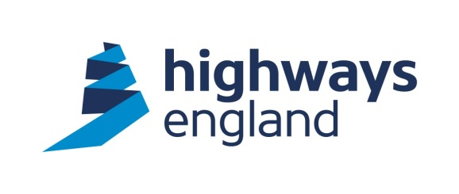  Our ref: OLM/6L/LH  Your ref: HREMW16251  Amco Rail  Amalgamated Construction  Whaley Road  Barugh  Barnsley  S75 1HT  For the attention of: Redacted,  Redacted  Dear Sirs, | Highways England  Procurement  Lateral  8 City Walk  Leeds  LS11 9AT  Direct Line: Redacted  7 August 2018  http://highwaysengland.co.uk
CLOSED BRANCH LINES MINOR WORKS – OLM/6L CUTTING AT GREENFIELD – TREE FELLING

Further to your quotation for the above works I am pleased to advise you that your price of £16,074.43 has been accepted.

You should note that we will not pay for any works unless it has been specifically authorised in writing within the terms of the agreement.

Please note the works are to be undertaken under the Works Framework Contract 2016-2020 and the conditions of contract for these works are the “NEC3 Engineering and Construction Short Contract.”

Invoices should be sent to Financial Services Payments at Highways England, The Cube, 199 Wharfside Street, Birmingham B1 1RN, quoting the Blanket Purchase Agreement number, Release number and Receipt number. These details will be provided to you by the Historical Railways Estate team as works are certified.

I trust the above is acceptable. The Start Date is 13 August 2018. The Completion Date is 14 September 2018. Should you wish to discuss the matter further please contact Redacted, the Project Manager, Historical Railways Estate on 07740 418150.

Please acknowledge receipt and acceptance of this letter by return.

Yours faithfully

Redacted

Redacted
Procurement Officer for Historical Railways Estate
Email: Redacted @highwaysengland.co.uk

