**Appendix A**

**Select for Local Councils Policy Schedule**

Business Parish / Town Council

Period of Insurance

From 01st October 2023

To 30th September 2024

and any other period for which cover has been agreed.

Additional Information:

* Overall salary figure excluding NI and Pension = £635,000
* Number of staff = 26
* Number of Councillors = 15

Lines of Cover applying

**Part A – Material Damage**

**Table Headings**

Contents (a) Furniture, fixtures, fittings and tenants’ improvements

Contents (b) Other contents and consumable stock not specified below including printed books and

unused stationery

Contents (c) Computer equipment, other office equipment and sports equipment

Contents (d) Televisions, audio-visual and photographic equipment (excluding videos), beer, wine,

spirits, tools and gardening equipment

Contents (e) Tobacco

Contents (f) Camcorders, videos and gaming machines

Contents (g) Civic Regalia

**Sums Insured**

**For Premises:** 1, 2, 3

**Insured Perils applicable to Material Damage: 1-16**

**Excesses Applicable to Premises 1, 2 & 3**

The following Excesses apply to each and every loss arising in respect of each and every separate premises:

Accidental Damage £250

Theft £250

Riot civil commotion and Malicious Persons £250

Storm or Flood £250

Escape of Water £250

Falling Trees or Branches £250

Subsidence £1,000

Variable contents excess active:

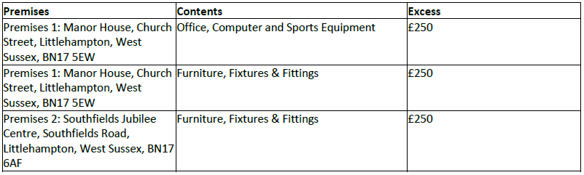

**Operative Endorsements:** 1, 2, 3, 5, 6, 7, 8 & 9 (please refer to the Endorsement section of the policy wording)

**Part B – Business Interruption**

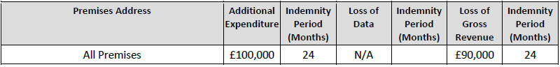

**For Premises:** 1, 2, 3

**Insured Perils applicable to Business Interruption: 1-16**

**Operative Endorsements:**

None

**Part C – All Risks**

**Table Headings**

Contents (a) Furniture, fixtures, fittings and tenant’s improvements

Contents (b) Other Contents and consumable stock not specified below including printed books and

unused stationery

Contents (c) Computer Equipment, other office equipment and sports equipment

Contents (d) Televisions, audio-visual and photographic equipment (excluding videos), beer, wine,

spirits, tools and gardening equipment

Contents (e) Tobacco

Contents (f) Camcorders, videos and gaming machines

Contents (g) Civic Regalia

**Additional Items:**

Where no premises address is shown, the item is not based at one location and cover is provided anywhere within

the **territorial limits**.

**(*Please note an updated and required insurance figure has been supplied for the war memorial listed below which is in the region of £235,000 - £260,000*)

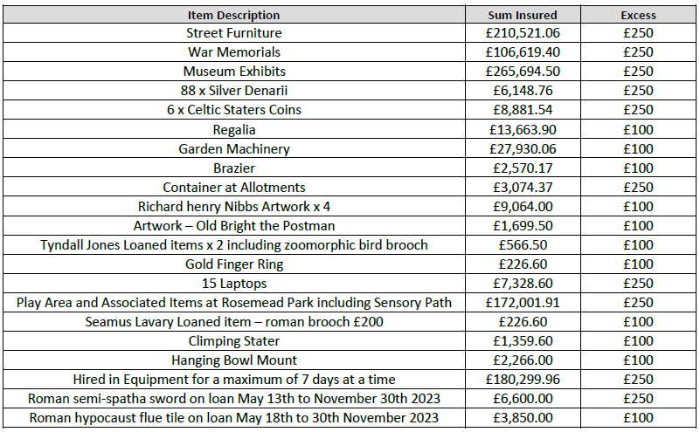

The excess stated applies to each and every loss.

**Operative Endorsements:** 1, 2, 3 & 7 (please refer to the Endorsement section of the policy wording)

**Part D – Money**

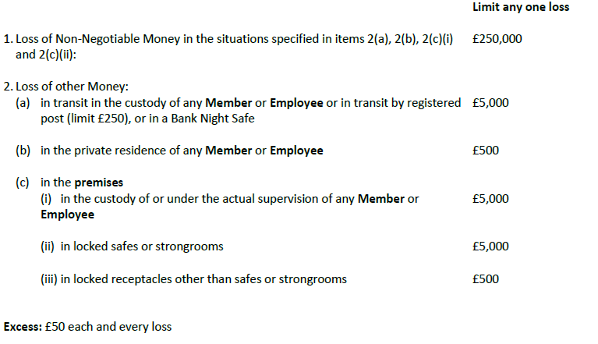

**Personal Accident Assault Limits:** Stated in Section 3(c) of the policy wording

**Operative Endorsements:**

1.In respect of **Section 1 – Special Definitions**, the definition of Person Insured is extended to include any person

between the ages of 16 and 90.

**Part E – Public Liability**

**Limit of Indemnity:** £15,000,000

**Excess:** £100 each and every claim in respect of Section 2(d)(ii)

**Operative Endorsements:**

1. Environmental Clean Up Costs. The following Special Definitions are added to Section 1:

**Clean Up Costs**

a) Testing for or monitoring of Pollution or Contamination

b) the costs of Remediation required by any Enforcing Authority to a standard reasonably achievable

by the methods available at the time that such Remediation commences.

**Remediation**

Remedying the effects of Pollution or Contamination including primary, complementary and compensatory actions

as specified in the Environmental Damage (Prevention and Remediation) Regulations 2009.

**Enforcing Authority**

Any government or statutory authority or body implementing or enforcing environmental protection legislation within the territorial limits.

**Cover**

With effect from 01 July 2009 or the inception of the policy if later, the **insurer** will indemnify the **insured** in respect

of all sums including statutory debts that the **insured** is legally liable to pay in respect of Clean Up Costs arising from

environmental damage caused by Pollution or Contamination where such liability arises under an environmental

directive, statute or statutory instrument.

Provided always that:

a) liability arises from Pollution or Contamination caused by a sudden, identifiable, unintended and

unexpected incident which takes place in its entirety at a specific time and place during the Period of

Insurance. All Pollution or Contamination which arises out of one incident shall be deemed to have

occurred at the same time such incident takes place

b) the **insurer**’s liability under this Extension shall not exceed £1,000,000 for any one occurrence and in

the aggregate in any one Period of Insurance and will be the maximum the insurer will pay inclusive

all costs and expenses. This limit will form part of and not be in addition to the Limit of Indemnity

stated in the Schedule

c) immediate loss prevention or salvage action is taken and the appropriate authorities are notified

**Exclusions**

The **insurer** shall be under no liability:

1. in respect of Clean up Costs for **damage** to the **Insured’s** land, premises, watercourse or body of

water whether owned, leased, hired, tenanted or otherwise in the **insured’s** care, custody or control

2. for **damage** connected with pre-existing contaminated property

3. for **damage** caused by a succession of several events where such individual event would not warrant

immediate action

4. in respect of removal of any risk of an adverse effect on human health on the Insured’s land,

premises, watercourse or body of water whether owned, leased, hired, tenanted or otherwise in the

**insured’s** care, custody or control

5. in respect of costs in achieving an improvement or alteration in the condition of the land,

atmosphere or any watercourse or body of water beyond that required under any relevant and

applicable law or statutory enactment at the time Remediation commences

6. in respect of costs for prevention of imminent threat of environmental damage where such costs are

incurred without there being Pollution or Contamination caused by a sudden, identifiable,

unintended and unexpected incident

7. for **damage** resulting from an alteration to subterranean stores of groundwater or to flow patterns

8. in respect of costs for the reinstatement or reintroduction of flora or fauna

9. for **damage** caused deliberately or intentionally by the **insured** or where they have knowingly

deviated from environmental protection rulings or where the **insured** has knowingly omitted to

inspect, maintain or perform necessary repairs to plant or machinery for which they are responsible

10. in respect of fines or penalties of any kind

11. for **damage** caused by the ownership or operation on behalf of the **insured** of any mining operations

or storage, treatment or disposal of waste or waste products other than caused by composting,

purification or pre-treatment of waste water

12. for **damage** which is covered by a more specific insurance policy

13. for **damage** caused by persons aware of the defectiveness or harmfulness of products they have

placed on the market or works or other services they have performed

14. for **damage** caused by disease in animals belonging to or kept or sold by the **insured**.

**Part F – Hirers' Liability**

**Limit of Indemnity:** £2,000,000

**Excess:** £100 each and every claim for damage to the premises or contents caused other than by fire or explosion

**Operative Endorsements**

None

**Part G – Employers Liability**

**Limit of Indemnity:** £10,000,000

**Operative Endorsements:**

None

**Part H – Libel and Slander**

**Sum Insured** £250,000

**Excess:** 10% each and every claim or £1,000 whichever is the lower

**Operative Endorsements**

None

**Part N – Fidelity Guarantee**

**Persons Guaranteed: Sum Guaranteed**

All **members** and **employees** £1,000,000

**Excess:** £100 each and every loss

**Operative Endorsements:**

None

**Part O – Personal Accident**

Cover is limited to £500,000 any one person and £2,000,000 any one incident.

**Persons Insured:**

**Employees**

Capital Sum

£50,000.00

Weekly Sum

£500.00

Cover Sections 2 and 3 - Accident and Assault Cover

**Volunteers**

Capital Sum

£50,000.00

Weekly Sum

£500.00

Cover Sections 2 and 3 - Accident and Assault Cover

**Directors/Councillors**

Capital Sum

£50,000.00

Weekly Sum

£500.00

Cover Sections 2 and 3 - Accident and Assault Cover

Operative Endorsement:

1) Special Condition 4 of Section 5 is inoperative provided always that the **insurer** will not make any payment of any

benefit or in respect of any expense or loss arising from any Person Insured who has attained the age of 90 years

unless such expense or loss arises during the period of insurance during which the Person Insured attains the age of

90

**Part P – Legal Expenses**

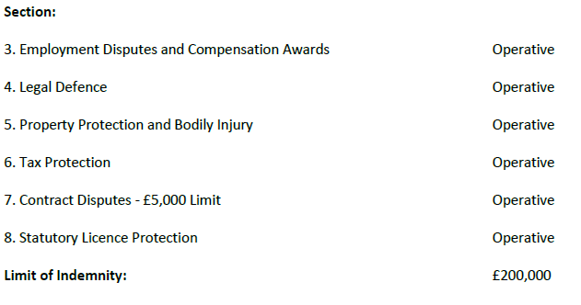

**Operative Endorsements**

The following is also operative: Debt Recovery

**Insured Incident**

The **insurer** will negotiate for the **insured’s** legal rights including enforcement of judgment to recover money and

interest due from the sale or provision of goods or of services, provided always that:

a) the amount of the debt exceeds £250 (incl VAT)

b) the claim under this Part is made within 90 days of the money becoming due and payable

c) the **insurer** has the right to select the method of enforcement, or to forego enforcing judgment if the **insurer** is

not satisfied that there are, or will be, sufficient assets available to satisfy judgment.

Exceptions

We will not provide indemnity in respect of or arising from or relating to:

a) any debt arising from an agreement entered into prior to the inception date of the indemnity

provided by this section if the debt is due within the first 90 days of the indemnity provided by this

section

b) the recovery of money and interest due from another party where the other party intimates that a defence

exists

c) any claim relating to:

i) any settlement payable under an insurance policy

ii) any lease, licence or tenancy of land or buildings

iii) any motor vehicle owned by, or hired or leased to you other than agreements relating to the sale of motor

vehicles where you are engaged in the business of selling motor vehicles

d) any dispute which arises out of the purchase, hire, sale or provision of computer hardware, software, systems or

services.

**Part R – Terrorism**