LONDON BOROUGHS OF LAMBETH & WANDSWORTH – PROJECT SPECIFICATION:

Extending the Low Line to Vauxhall, Nine Elms and Battersea
A Vision for Activation and Delivery

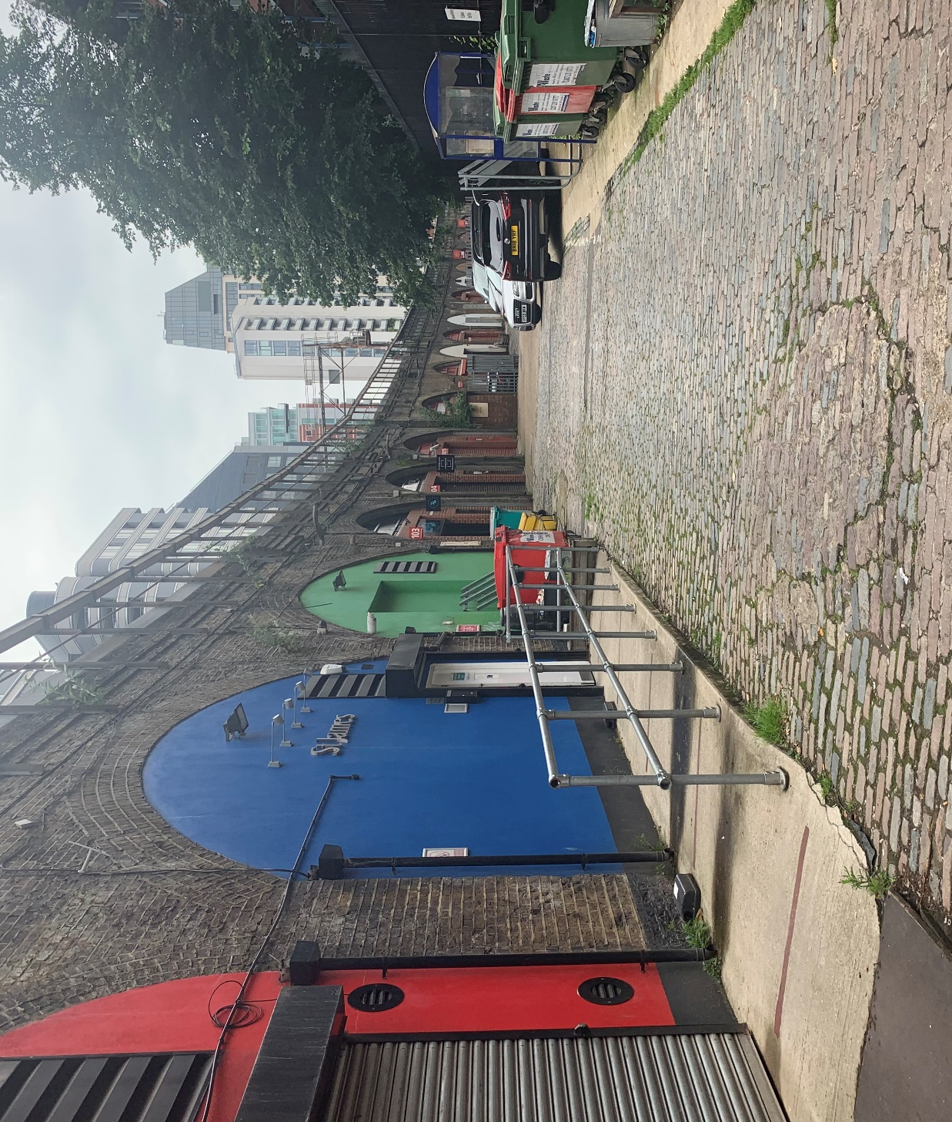

Client: LB Lambeth & LB Wandsworth
Indicative Budget: Up to £80,000 (Including expenses, excluding VAT)
Deadline for submission: 5pm, Monday 24th January 2022

Contents

- Introduction Page 4
2. Background and Context Page 5
3. Strategic and Policy Objectives Page 6
4. Project Objectives Page 8
5. Project Stages and Key Deliverables Page 10
6. Project Management and Project Programme Page 14

7. Expertise and Experience Required Page 15
8. Budget, Required Outputs and Payment Schedule Page 15
9. Achieving Social Value Page 15

APPENDIX 1 - LIST OF RELEVANT BACKGROUND DOCUMENTS Page 17

COMMISSION PURPOSE

This specification describes the requirement for a multi-disciplinary practice or consortium to develop a vision document, highlighting the potential for extending the Low Line to Vauxhall, Nine Elms and Battersea Power Station, establishing how the viaduct can become an opportunity for the area, rather than a barrier between neighbourhoods.

The aspiration for this work is to demonstrate how a continuous route tying into the area’s historic and cultural context can be created and delivered on, and how the spaces inside the viaduct can support the further growth and post-pandemic recovery of the area, by offering an alternative form of accommodation for commercial and community activity.

The vision document will form the basis of further engagement and project formulation and must present the potential of the new strategic link, as well as reveal the more local opportunities along the route, in a way that stimulates interest and galvanises action amongst partners. Project proposals should give consideration to, and be aligned with, the high-quality design principles and ethos of the existing Low Line in the London Borough of Southwark.

The Study Area

The study area for this commission corresponds to the boundary of the Vauxhall Nine Elms Battersea (VNEB) Opportunity Area:

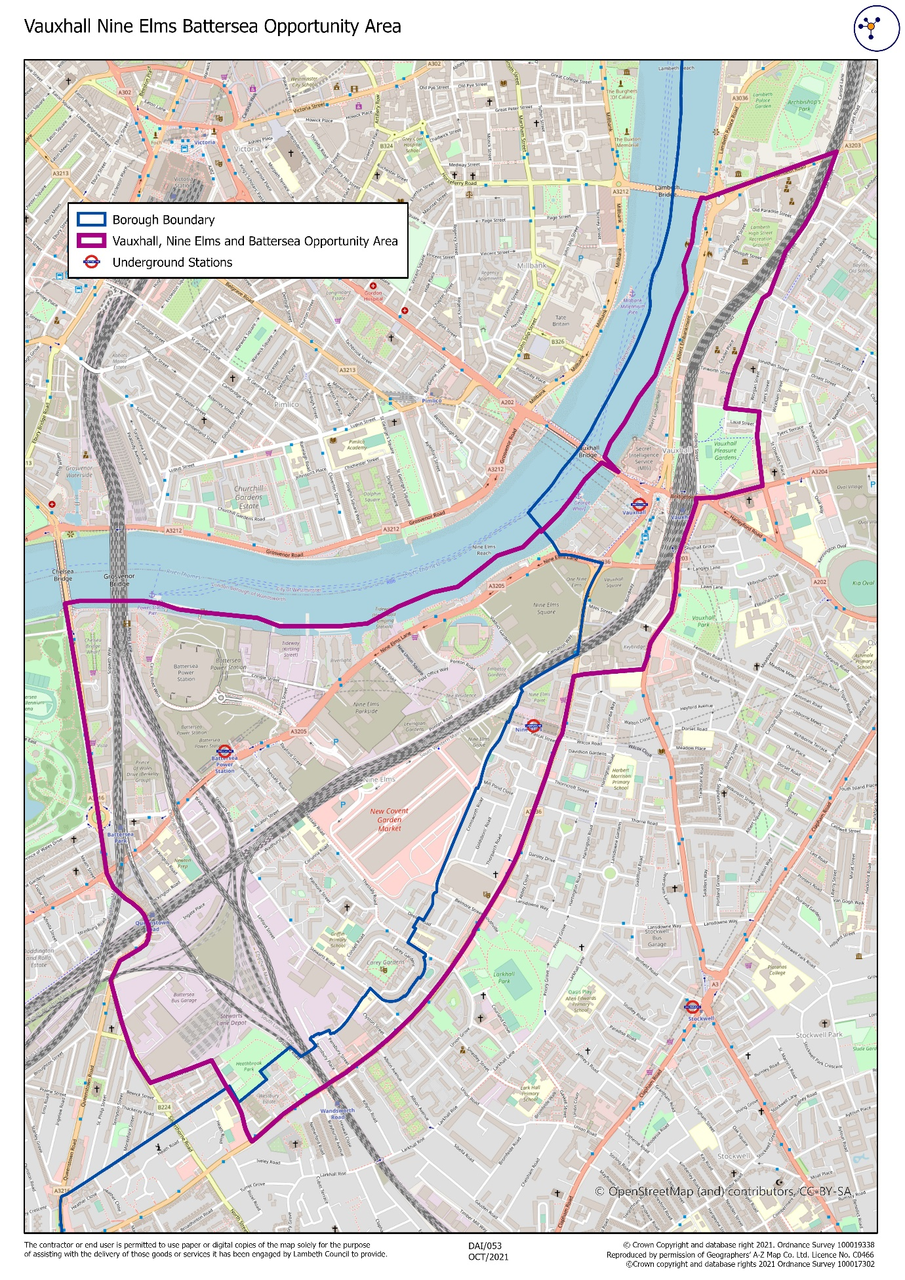
Figure 1: Map showing indicative study area boundary

Introduction

  - After the initial Low Line concept was conceived by local resident and architect David Stephens in 2012, Southwark Council and the Business Improvement Districts in the north of LB Southwark have embraced the concept, delivering a number of exciting interventions that have brought the vision to life over recent years, with notable projects completed, and sections of arches activated in Bankside, London Bridge and Bermondsey - including Flat Iron Square, Union Street Yard and Maltby Street Market.

  - The overarching vision for this commission is to extend the creation of this strategic walking route further along the southside of the Thames, linking Battersea to London Bridge – the Power Station to the Shard - via the South Bank and Waterloo – reinforcing the connection to these neighbouring areas of Waterloo, the South Bank and into LB Southwark using the same infrastructure and route. The London Borough of Lambeth and London Borough of Wandsworth (the Councils) are keen to build on recent investment and growth in the Vauxhall Nine Elms Battersea Opportunity Area (VNEB OA), and the continuation of the Low Line into the VNEB will also bring a complementary dimension to the area, establishing alternative spaces and routes at a smaller and more intimate scale.

  - The Covid pandemic has forced a re-assessment of place and a concerted effort across London to come together to drive London’s economic recovery, focussing on the role our neighbourhoods play in enhancing our everyday lives, as well as seeking to maximise the role the Central Activities Zone plays as part of Global London. This project seeks to operate at both scales; the strategic and the local neighbourhood level, bringing together strands of design and placemaking, economic activation, community activity and involvement.

  - This commission invites a creative practice or consortium, with the ability to focus on the strategic potential of the infrastructure and route, as well as uncover opportunities at a micro neighbourhood scale, to tender for the production of a vision document, highlighting the potential of the 250 viaduct arches in the VNEB Opportunity Area, and the space and routing alongside these.

  - From a public realm perspective, the commission should investigate and establish the potential for a continuous route for pedestrians, and as appropriate, cyclists, alongside the viaduct. In addition, opportunities for improving connections, both physical and visual, outward from the viaduct, particularly to existing public and green space, and key attractors in the vicinity, should be highlighted. The commission should also highlight existing and potential connections through, and opportunities to break through the ‘barrier’ of the viaduct, as has successfully been achieved at Arch 42. Identifying possibilities for the creation of new spaces alongside the viaduct, especially where these can support economic activation is also important, as is identifying opportunities for the incorporation of green infrastructure – contributing toward the creation of a ‘green spine’.

  - In terms of the arch space within the viaduct, the commission should establish current occupation and uses, future potential, and identify delivery and funding opportunities and mechanisms that could be employed to allow existing businesses to stay and grow in the space, yet balance this against an introduction and intensification, curation and clustering of complementary uses as appropriate. The work needs to consider realisation and delivery; determining prioritisation and potential phasing of areas of focus, corresponding to the phasing of planned adjacent development – and highlighting some easily deliverable small or meanwhile projects that could be used to demonstrate the partners’ intent and ambition.

  - These outputs should be brought together in a compelling and visual document that the boroughs can use as a springboard towards change and an unlocking of the potential of the infrastructure and the surrounding area. The expectation is that the creation of this document will bring key stakeholders together towards a shared vision, and act as a catalyst for real transformation of the arches and surrounding area. The aim is not to set out to deliver the concept as one piece, but instead to establish the potential and put in place the right underlying conditions to allow the vision to be realised incrementally and organically, over a longer period.

  - Both Councils are committed to ensuring that all their neighbourhoods and communities are connected to the transformative investment and growth happening across the VNEB Opportunity Area. Consideration of community connections to activity in and around the viaduct, and of the project as a means of supporting an economic recovery rooted in localism, will also be essential.

Background and Context
Area overview – Recent Investment and Growth

  - The VNEB Opportunity Area was designated in 2012 and has since delivered unprecedented growth and investment in this part of London, across both Lambeth and Wandsworth. It is one of the largest and most dynamic regeneration programmes ever undertaken in the UK and the London Plan sets out an expected delivery of up to 18,5000 new homes and 18,500 new jobs across the Opportunity Area.

  - By the end of 2020, 7,000 new homes had already been completed, with significant new commercial, retail and leisure space also being delivered, or in the pipeline to come forward in the coming years; which will ensure the area will be recognised as an internationally significant business district, and a new centre for arts and culture. A new town centre is being built around the redeveloped and iconic Battersea Power Station and New Covent Garden Market is being revitalised and reimagined. There has also been extensive development along Albert Embankment, as well as to the south of Vauxhall gyratory within Lambeth, with a number of pipeline schemes consented including the Vauxhall Island development and Vauxhall Square, as well as completed schemes such as Keybridge House and Storybox.

  - More than £1 billion is being invested in new infrastructure across the Opportunity Area, including the recently opened extension of the Northern Line in September 2021, and the first new tube stations in London this century at Nine Elms and Battersea Power Station.

  - The delivery of green infrastructure and new public realm has also been prioritised and planned for by both boroughs and is seen as crucial to knit the area together, offering the additional amenity to attract residents, investors and commercial operators to the Vauxhall Nine Elms Battersea area. In Nine Elms there are several key high-quality public realm projects, linking all the development sites, that have been integral to the build out of the area and to the creation of a successful place. These include a new linear park sweeping through the district from east to west and a focus on projects to improve movement and connections across the area, including the Arch 42, Thessaly Road and Wilcox Road key gateways projects, as well as the remodelling of Nine Elms Lane.

2.5 In Vauxhall, a high level of public investment has been allocated in recent years for improvements to public realm, parks and infrastructure; with recent investment in Vauxhall Pleasure Gardens, Vauxhall Park and the creation of a new gateway, the Missing Link route from the Pleasure Gardens along Vauxhall Walk, and new cycle grid and Quietway routes running through and beyond the area.

2.6 The scale of development activity through the district, as well as the emerging cultural offer, means the potential for significantly more journeys on foot through Vauxhall, Nine Elms and Battersea. This potential footfall increase (e.g., residents moving towards the tube and rail stations or visitors meandering north towards the South Bank) is there to be capitalised upon to support and grow the existing and emerging cultural and commercial offer and activate currently quiet or underused spaces and routes that offer alternative traffic free paths to the main thoroughfares.

  - The 250 railway arches in the VNEB Opportunity Area, as a continuous existing piece of historic infrastructure, also present a major opportunity for increased economic, cultural and community activity in the VNEB. The arch units in total represent 776,000 sq. ft of floor space, and with each arch on average 2,400 sq. ft, they are configured in a way that offers opportunities to complement some of the commercial space being built out in new developments. Current uses are varied, from retail and leisure to industrial and office and the viaduct runs through a number of different neighbourhood types, from a Key Industrial Business Area in the north of the OA, alongside green spaces including the Pleasure Gardens, through the New Covent Garden Market site up to the Power Station itself, taking in old and new and emerging residential communities. Whilst a large amount of delivery has taken place in Vauxhall Nine Elms Battersea, there are large-scale development sites still to come forward, that could contribute to the Low Line realisation.

Strategic and Policy Objectives

  - Both strategic and local policies and objectives are in place that establish the broad framework for this commission, supported by substantial local strategy and visioning work for the VNEB area. Key aspects are drawn out here, with a full list of all relevant background documents that should inform the commission provided at Appendix 1.

  - In 2012 the Mayor of London published the Vauxhall Nine Elms Battersea Opportunity Area Planning Framework (OAPF) identifying the area as capable of contributing to the Capital’s growth by providing 20,000 new homes and 25,000 new jobs (revised down in the current London Plan). The Framework noted the huge potential of the area to make a significant contribution to London’s economy.

  - The Lambeth Local Plan (2021), the Wandsworth Local Plan (2016), and planning policy within the London Plan (2021) set the policy context informing this commission.

Borough of Lambeth
  - Lambeth’s Borough Plan promotes working through partnerships, creative ideas and collaboration to improve the lives of people who live and work in the borough. It is constructed around four ambitions for Lambeth:

- Sustainable growth: a growing economy that everyone benefits from
- Communities that are thriving and connected
- Lambeth is a place people want to live, work and invest
- People have support to live as well and independently as they can

  - In terms of Vauxhall, the Lambeth Local Plan (2021) states the importance of ensuring that Vauxhall's unique identity and character is both retained and enhanced, and that its existing communities have access to those benefits. It identifies improvements to public realm as a key factor in supporting growth and states measures to increase green infrastructure across the area will be supported. It also notes that there is a Key Industrial Business Area within the study area, that constitutes one of Lambeth’s ‘Locally Significant Industrial Sites’ as defined in the London Plan and serves to accommodate the borough’s strategic reservoir of land for industrial and business use.

  - Policy ED6 Railway Arches states “Where necessary to make a development proposal acceptable in planning terms, applications affecting railway arches will be required to improve the immediate environment around the arches, including the public realm. This will include accessibility, safety, servicing and lighting appropriate to the location and the opening up of routes that contribute to the ‘Low Line’ project.”

  - Particularly relevant to this commission is Policy PN2 Vauxhall and PN2 D, I and L3 reference the railway arches or Low Line specifically and set out an aspiration for:

- Encouraging and facilitating the use of the railway arches as an active spine, a focus for employment and business, as well as a mix of uses that could include cultural, artistic and community uses in appropriate locations, along with routes for pedestrians and cyclists as part of the Low Line project.

  - The Vauxhall SPD (2013) promotes a vision for the wider Vauxhall area. It establishes the improvement of the pedestrian and cyclist experience, the enhancement of open space, and the re-connection of neighbourhoods as some of the guiding principles for development and promotes a vision of an active, connected neighbourhood, with the railway arches brought to life, with “opportunities to create a range of interesting spaces and uses alongside and within the viaduct whilst supporting north-south pedestrian movement”. Strong connections to the river are also prioritised as well as a network of journeys connecting Waterloo and the South Bank through the Linear Park to Battersea in the south.

  - The commission will also need to give consideration to Lambeth Council’s Transport Strategy (2019) and to the Mayor’s Transport Strategy (2017) and the principles set out therein, particularly to the concepts of accessibility and Healthy Streets. Lambeth continues to subscribe to a road user hierarchy that rebalances priorities for action away from the car and towards pedestrians and cyclists. The Lambeth Transport Strategy sets as strategic outcomes the improvement of air quality and greening of streets, the reduction of vehicular traffic, with neighbourhoods connected through healthy routes to encourage walking and cycling, and a guiding principle of enabling of people to live healthier, more enjoyable lives.

  - Finally, Lambeth Council published its Economic Resilience Strategy in 2020, which sets out its ambition to create an inclusive and resilient economy in Lambeth post-pandemic. The strategy puts forward a series of specific objectives and workstreams under strategic goals for People, Business and Place and is focussed on connecting local people to growth and opportunity in the borough.

Borough of Wandsworth
  - Wandsworth’s Local Plan sets out the vision for Wandsworth. The Core Strategy aims to make provision to meet the needs for housing, business, community services and infrastructure, in a sustainable way, protecting and improving both the built and the natural environments while mitigating climate change. The Council's spatial vision for the borough is for a borough of attractive and distinctive neighbourhoods, with a good range of local services with the main areas of change and development being the Thames riverside, Nine Elms Vauxhall, including the development of a new town centre at Battersea Power Station.

  - It will include a range of opportunities for local business activity, including start up and small enterprises, in mixed-use developments and an enhanced local environment including cleaner air and less traffic congestion, with protected and improved habitat and biodiversity and will have good access to the wider opportunities outside the borough for jobs and services, particularly in central London.

  - To achieve this vision the Council has set strategic objectives in three key areas – Environmental, Social and Economic Objectives.

  - The aim through these three key areas is to secure sustainable development to help tackle climate change, protect and enhance the quality of life and improve environmental, social and economic opportunities while protecting and repairing the existing distinctive character of the borough, placing full value on the heritage and amenity of each different district and create safer, healthier and more secure communities.

  - It also aims to increase the viability and vitality of the town centres and local centres, including the proposed centres at Battersea Power Station and Vauxhall, as the focus for shopping, employment, leisure and other community activities. The Council will promote the provision of flexible business space to meet the needs of the small and medium enterprises which comprise the overwhelming number of businesses in the borough.

  - The Employment and Industry Document (December 2018), updates and replaces the strategy, policies, and site-specific allocations relating to employment and industrial land and makes specific reference to Vauxhall and Nine Elms and Battersea Power Station and the protection of railway arches.

  - Particularly relevant to this commission is Policy EI3 of the Wandsworth Local Plan which seeks to protect employment land and premises, and includes specific references to railway arches, due to the limited supply of land in economic use. Railway arches and viaducts provide a range of uses and make a significant contribution to industrial and other economic floorspace within the borough. In appropriate locations, railway arches also have the potential to contribute to the vitality and viability of town and local centres and the CAZ.

  - In the CAZ and in town and local centres, railway arches have the potential to provide a broader mix of uses that support the vitality and viability of the area. Railway arches along the north-western boundary of the main New Covent Garden Market site should continue to be used to support the wholesale function of the market, including for access requirements and to provide storage, distribution, and operational space for wholesale businesses. It may be appropriate to introduce some wider town centre uses within the arches toward the north-eastern tip of the market, to contribute to the vibrancy and vitality of this part of the reconfigured wholesale market.

  - In some instances, the opening up of railway arches and surrounding land to facilitate new public access and improve permeability may be required. Railway arches that already provide public access must maintain this access.

  - The commission will also need to consider Wandsworth’s transport policies, particularly the Local Implementation Plan and the Cycling Strategy both of which set out Wandsworth Council’s vision for transport in the borough to 2041 and how the Council proposes to deliver the Mayor’s Transport Strategy (MTS) goals in Wandsworth of healthy streets and healthy people by increasing walking and cycling across the borough.

Project Objectives

The project objectives for this commission and associated project work – development of the Low Line - are as follows:

Placemaking: Creating intimate places and spaces complementing and contrasting with busier areas of Vauxhall and Nine Elms, contributing to the improved environment and amenity offer that local businesses and local communities, commercial developers and occupiers, tell us they want to see.

Consideration should be given to opportunities for connections between the viaduct arches and green spaces that are often in close proximity to each other, giving thought to how better physical or visual connections can strengthen the use and performance of both.

Movement: Improving permeability; strengthening existing connections through the Opportunity Area and opening up new ones to provide alternative routing away from more heavily vehicular trafficked routes for pedestrians, and where appropriate cyclists; for both local journeys, and journeys to and from the South Bank and beyond.

Responding to the aspirations of London and borough transport and climate/air pollution mitigation strategies to reduce vehicular traffic movements and support more sustainable and active forms of transport; the Low Line will form part of a coherent and high-quality network of cycling and pedestrian routes through the area. At the same time, the viaduct also contributes to spaces where perceptions of personal safety are problematic, where increased footfall and natural surveillance would help to address community safety concerns and bring life and activity.

Local Economy: Aiding local economic recovery by supporting a range of accessible, useful and dynamic space for small and medium sized businesses and start-ups, and for local businesses to grow into, helping to create and support local supply chains and routes into work and entrepreneurship for local people.

Supporting the emergence of sector clustering where similar and associated businesses and activities can benefit from proximity and reinforcing and supporting neighbourhood centres and existing local businesses through increased footfall and improved connections and wayfinding. Specific sectors that are already prominent in the Opportunity Area include publishing and creative and digital.

Environment: Responding to both boroughs’ declaration of a climate emergency and the recent recommendations of Lambeth’s Citizen’s Assembly on Climate, by introducing mitigating measures and considering interventions aimed at future climate change adaptability, specifically the introduction of green infrastructure, enabling the creation of a green spine.

Greater London Authority mapping identifies the area as being vulnerable to the impacts of climate change and Vauxhall is designated as having high levels of pollution and human exposure to pollution resulting from its central London location exacerbated by the dominance of vehicular traffic, particularly large amounts of freight and bus traffic, as well as the recent high amount of construction activity.

Culture: Drawing out the significant cultural heritage and history of the area and manifesting and celebrating this in the rehabilitation of the viaduct; using public art, lighting and other cultural interventions to connect different parts of the route; whilst creating interest to draw people along its connections. Using the Low Line concept to bring attention to existing assets and attractors along the route, better sign-posting cultural facilities, such as new galleries and theatres, artist workspace and workshops, and print and music studios, within the study area whilst also considering how cultural activities and interventions can be supported by and linked to activity in and along the viaduct.

Promoting and supporting the VNEB OA’s cultural offer is important. Measures to encourage movement through the area should be integral to the vision, with increased pedestrian and cycle journeys drawn in by existing cultural facilities and spaces, enhancing permeability, way finding and signage as part of this approach. Consideration of an imaginative wayfinding vision that links all objectives together showcasing the character, hidden gems and strengths of the emerging Low Line and surrounding area will be essential.

Community: Promoting the Low Line as a community connector and as a means of further connecting communities to growth. Ensuring a clear link between proposed interventions and the wellbeing, needs and desires of existing residential and employment communities, ensuring that attention is given to creating inclusive, safe and accessible environments.

The VNEB Low Line must work on a number of levels; on a strategic level, drawing visitors to and through the area but it must also bring positive benefits for those communities living and working in proximity to the route. Consideration should be given as to how proposed measures relate to improved health, social and economic outcomes for residents and measures should adhere to principles of inclusivity and accessibility for all communities, with thought given to the particular demographics of the area, and to different age groups.

Project Stages and Key Deliverables

5.1 The purpose of this commission is to deliver:

A vision document, scoping and highlighting the potential for extending the Low Line down through Vauxhall and Nine Elms to Battersea Power Station, demonstrating how the viaduct can become an opportunity for the area, rather than a barrier between neighbourhoods; showing how a continuous route tying into the area’s historic and cultural context can be created, and how the space inside the viaduct can support the area’s further growth and recovery post-pandemic, by offering an alternative form of space for commercial and community activity.

Below are some suggested work stages linked to expected project deliverables:

Project Stages:
- Project Inception
B. Information Gathering
C. Establishing a Baseline
D. Developing the Vision
E. Identification of Delivery Opportunities, Mechanisms & Phasing
F. Identification of Priority Projects
G. Final Report – A Vision for Activation and Delivery

Detail of Project Stages:

- Project Inception
Aim: To establish a common understanding of the project governance and collectively rehearse and confirm the project objectives and specification before work proper commences. Specifically, to:

  - Confirm and understand key project objectives
  - Discuss and refine the study area and project boundaries, extent of Low Line, project scope and proposed methodology
  - Agree the project programme, including how slippages will be dealt with
  - Discuss and agree how project ‘success’ will be defined, continuously monitored and evaluated
  - Discuss and agree approach to engaging with stakeholders and community members
  - Agree expectations around attendance and diarising of governance and project meetings
  - Agree a reasonable expectation for design iterations and report revisions throughout the commission
  - Discuss and agree payment schedule
  - Undertake a joint walkabout/site visit

- Information Gathering

Aim: To review and collate key policy, background information, available data, and linked studies and analysis.

- Review relevant background documentation from the Councils, GLA and key stakeholders (see list of background documents in Appendix 1) including previous studies and design work relevant to this commission.
- Identify and meet with key stakeholders to understand key priorities and emerging and future projects. This will ensure the progress of the commission is informed and improved by the contribution of local knowledge and experience and the process of active engagement should also help to build consensus and a sense of ownership around the final vision.
- We expect some engagement with the wider local community, including young people and those from diverse backgrounds, as well as selected stakeholders.
- We would envisage around six meetings or small workshops spread across the information gathering, baseline and/or vision development stages of the project, as deemed most useful, with key stakeholders and community groups or organisations, and attendance at two further engagement events as the project develops.

The Councils will undertake stakeholder mapping as preparation for the start of this commission.

- Establishing a Baseline

Aim: To provide an overview of current conditions within and along the viaduct inside the study area, an assessment of the quality of the public realm including accessibility and opportunities for the realisation of a continuous walking and cycling route, as well as an audit of current use of commercial space (with type of occupier identified) inside the arches.

Arch Spaces
- Map ownership of arches and adjacent spaces/routing and development sites (based on information from the Council and key stakeholders).
- Provide high-level mapping of completed and emerging development projects (based on information from the Council and key stakeholders) adjacent to the route; with detail of new connections and public realm if impactful on the potential for delivering the Low Line in particular locations.
- Map occupied and vacant arches and present this mapping visually, identifying types of occupation and any existing or emerging clusters, taking into account adjacent activities.
- Collate any available information on expected rental levels, lease terms and general overhead costs which can help to determine what types of businesses might be suitable occupiers in particular locations.

Public Realm
- Consider the changing nature of the areas the viaduct runs through and as appropriate differentiate these neighbourhoods or micro-neighbourhoods in terms of their relationship to the viaduct.
- Map and categorise what currently exists in terms of ease of movement alongside the viaduct including imagery, a brief description and an evaluation of the quality of the route in particular sections.
- The audit should identify the scope for improvement of individual spaces along the route. Consideration should also be given to borough and GLA climate vulnerability mapping and how improvements align with appropriate mitigation measures.
- Undertake high-level movement analysis to accompany the audit – to focus on understanding current and potential for increased pedestrian and cycle movement with an understanding of desire lines, and way-finding patterns. This could include a Healthy Streets Check (https://tfl.gov.uk/corporate/about-tfl/how-we-work/planning-for-the-future/healthy-streets) for key locations, to identify how the public realm could be improved for pedestrians and cyclists.
- There will be a need to consider how to accommodate identification of the viaduct as a key segregated cycling route in Opportunity Area policy documents and balance this with the potential conflict with pedestrian movement and space activation. In some areas, cyclist movement alongside the viaduct will be appropriate; in other areas this will not be the case because of space restrictions or because of existing cyclist routes in the vicinity and this analysis will need to be brought out in the baseline.
- Although the scope of this commission is the VNEB Opportunity Area, the connection into Waterloo and beyond over the boundary into LB Southwark needs to be considered and Lambeth Council will ensure that the consultant team are brought up to speed with relevant development activity along the viaduct around Waterloo, as well as the emerging Waterloo masterplan and We Are Waterloo’s emerging Placemaking Strategy.

- Developing the Vision

Aim: To develop an overarching vision or framework for the realisation of a VNEB Low Line in the study area, based on the project objectives, and accompanied by a collection of activation proposals (of varying scales, levels of intervention and responsive to the changing neighbourhoods along the route). More specifically the vision or framework should bring together the following elements:

Arch Spaces
- Quantify the potential economic value of an intensification of uses – existing and potential number of jobs, square footage value etc - and articulation of this in an engaging, immediate way.
- Set out a vision for the type of users and uses that could be attracted to the arch spaces with attention given to opportunities for curating similar or complementary uses, building on existing activity, and establishing a diverse offer that caters to both residents and visitors to the area.

Public Realm
- Highlight opportunities to maintain or reveal access when development sites come forward as well as existing plans for activity at the ‘backs’ of developments where an active ground floor frontage onto arches is planned.
- Building on the Baseline, provide an overview of the accessibility and potential of spaces, routes and links along the viaduct, with opportunities for public realm improvement and the creation of a continuous route drawn out, and with thought given as to how these spaces could be (re)configured.
- Consider accessibility and inclusiveness both at key points/nodes (junctions, pedestrian crossings – controlled and uncontrolled) and across the whole route generally.
- Consider the daytime and night-time functioning and appearance of the area and the spaces around the viaduct and the issue of personal safety.
- Lighting and illumination of the streetscape should be considered as part of any public realm proposals, particularly the relationship between standard lighting and other feature lighting or illumination proposed and the overall effect on the route. A consistent approach across the area is preferred but advice should be sought from both boroughs on their approach to lighting.
- Identify opportunities for the creation of new spaces alongside the viaduct, especially where these can support economic activity.
- Identify opportunities for improving connections outward from, through and alongside the viaduct, particularly to existing public and green space, and key attractors in the vicinity.
- Consider whether any of the arches can be usefully opened up to improve connectivity in the local area, specifically the improvement of east/west links.
- Provide recommendations for a wayfinding strategy for this section of the Low Line with consideration given to the project objectives and integration with existing Low Line routes.
- Identify opportunities for the incorporation of green infrastructure – to enable the creation of a ‘green spine’ for the area.

Community
- Consider how development of the Low Line enables equitable growth – consider the interface with residential communities and explore the potential for connections between activities in the viaduct and local communities and businesses, as well as the wider public and social value contributions the project could make.
- Consider the potential for delivering community space inside and alongside the viaduct and for community amenities and activities to be housed in the viaduct.
- Consider the potential for a unifying set of principles, charter or agenda for the VNEB Low Line, focussed on social and climate responsibility, that businesses and landowners could engage with and would provide unity across the whole project and route.

- Delivery Opportunities, Mechanisms & Phasing

Aim: To provide parameters for a long-term funding and delivery plan, identifying opportunities and mechanisms for curating and clustering uses, considering priority and emerging growth sectors, and establishing a coherent plan for project delivery phasing, related to the timing of development sites coming forward along the route.

- Provide strategic direction for attracting diverse and desirable users, uses and activations; highlighting practical and proven mechanisms, model options and incentives for achieving an appealing and sustainable mix of activities i.e., innovative leasing arrangements, meanwhile uses, collectives within a unit, empty arch grants.
- Make reference to successful and innovative arch occupation and arch project precedents elsewhere in London and in other cities.
- Provide a project delivery phasing plan; identifying sections of the route or areas to come forward in a phased manner, particularly where sections of the route are dependent on adjacent development site delivery, as well as identifying opportunities for meanwhile uses or interventions, in or alongside the viaduct, particularly where these might support existing activity in the area such as the art and cultural offer.
- Suggest potential funding sources/mechanisms to support non-commercial uses in the arches i.e., community/cultural uses.
- This can be brought together in the form of a high-level action plan, summarising short, medium and long term delivery.

- Priority Projects
Aim: To provide the project partners with a small number of easily achievable small/meanwhile interventions or projects that can be delivered to demonstrate ambition and intent, as well as the potential of the VNEB Low Line to deliver against the project objectives.
- Suggested projects or interventions can have a public realm or space activation focus or can be ‘small change, big impact’ in terms of walking and cycling. These interventions could include pavement widening/improvements or opportunities for cycle infrastructure or road closures.
- This project deliverable could take the form of three or four initial/concept designs or alternatively a toolkit of appropriate small activation and green interventions that could be enacted on a meanwhile basis or could be implemented quickly and with ease at various points along the route.

- Final Report – A Vision for Activation

Aim: To collate all completed work into one highly visual and accessible final report.

The report will bring together:
- The audit of existing conditions along and within the viaduct.
- An overview of stakeholder/partner aspirations.
- The overriding vision to deliver the Low Line based on the project objectives, with principles linked to promoting community activity, celebrating local character, culture and local recovery.
- Phasing and delivery strategy.
- Identification of a small number of easily achievable permanent or meanwhile projects.

Project Management and Project Programme

6.1 Below is the programme timetable providing indicative milestones; to be further discussed with the successful team upon appointment.

Milestone | Date
Contract Award and Inception Meeting | February 2022
Presentation of project methodology/initial findings to NEV Strategy Board | March 2022
Baseline analysis and information gathering complete | March/April 2022
Emerging vision sign-off | April/May 2022
Draft Report Sign Off | June/July 2022
Final Report Sign Off | July/August 2022

  - This project is being jointly commissioned by the London Boroughs of Lambeth and Wandsworth. Both boroughs have shaped this commission and will work equally with the consultant team upon appointment. The London Borough of Lambeth is leading on the procurement process on behalf of both boroughs, and for ease, contractual arrangements will be managed between the London Borough of Lambeth and the appointed lead consultant.

  - Officers from the London Borough of Lambeth will take responsibility for all day-to-day correspondence and liaison with the appointed supplier on routine matters. All decisions relating to project direction, approval of project outputs, instructions to the consultant team, stakeholder engagement, and decisions which have a financial implication will be taken jointly by the two boroughs, with the consultant team; primarily through the mechanism of a project working group.

6.4 A small project working group will be established including council officer representation from both boroughs. It is envisaged that this group will meet fortnightly and at key gateways in the commission to sign off proposals before they move to the next stage and relevant members of the appointed consultant team will be expected to attend these meetings. In addition to these meetings the consultant team/representatives of the consultant team will also be required to attend:

- Six information gathering/engagement meetings with key stakeholders and community groups or organisations
- Attendance at two engagement events
- Attendance at NEV Strategy Board to present project methodology/interim findings
- Attendance at meeting/workshop with stakeholders to present final report

Expertise and Experience Required

  - The consultant, or consortium of consultants, is expected to assemble a multidisciplinary team including the following knowledge and skills:

- Architecture, urban design, and masterplanning expertise
- Economic/commercial development expertise
- Town planning and regeneration experience
- Landscape design, public realm, and landscape architecture expertise
- Sustainability expertise
- Transport planning/movement analysis
- Experience of planning for cultural, community or similar facilities

  - The assembling of a consortium team is encouraged, given the scope of the work; however, any consortium must have a lead consultant taking on all contractual and project management responsibilities.

Budget, Required Outputs and Payment Schedule

8.1 The budget ceiling for this commission is £80,000 excluding VAT. Tender submissions will be expected to price competitively for this commission.

8.2 The fixed fee should include all expenses, consultation costs, production and printing.

8.3 Requirements of outputs and documents are as follows:

- All outputs should be made available in electronic PDF format, with drawings and any other technical outputs made available as CAD files or in other relevant electronic formats, as agreed at project inception.
- Eight printed bound copies of the final report will be required.
- The copyright will belong jointly to London Borough of Lambeth and London Borough of Wandsworth.

8.4 If required, the London Borough of Wandsworth will be able to supply OS base mapping covering the whole of the project area. Note: the appointed consultant will be required to sign a contractor’s licence to obtain a copy of the data and will be restricted to use the data for the specific purpose of the Low Line commission and for a limited amount of time.

8.5 A payment schedule will be agreed with the appointed lead consultant. Payment will only be made following satisfactory delivery of pre-agreed certified products and deliverables in line with this agreed payment schedule.

8.6 Before payment can be considered, each invoice must include the corresponding purchase order number with a detailed elemental breakdown of work completed and the associated costs.

Achieving Social Value

9.1 Under the Public Services (Social Value) Act 2012 Councils have a responsibility to consider Social Value in commissioning goods and services and it requires all public sector organisations to consider how the services they commission and procure might improve the economic, social and environmental well-being of the area the contract will support.

9.2 Lambeth are using the definition of social value as created by The Sustainable Procurement Task Force and widely used in Scotland, Wales, and England. This explains social value as, ‘a process whereby organisations meet their needs for goods, services, works and utilities in a way that achieves value for money on a whole life basis in terms of generating benefits to society and the economy, whilst minimising damage to the environment’. LB Wandsworth has adopted the National Social Value Task Force “Themes Outcomes Measures (TOMs)” Social Value Framework and developed Local; Council specific TOMs aligned to Council priorities.

9.3 The delivery of social value is of upmost importance to both boroughs and within this project will form part of the evaluation that tenderers should respond to. For the purposes of this submission, potential providers should refer to Lambeth’s policy in demonstrating how they will integrate social value priorities within social, economic and environmental capacities throughout the commission; details of the policy are set out here .

APPENDIX 1 - LIST OF RELEVANT BACKGROUND DOCUMENTS

London-Wide Policy/Guidance

- The London Plan (2021)

- Mayor’s Transport Strategy (2018)

- Transport for London Healthy Streets for London

- Transport for London Walking Action Plan

- Transport for London Better Streets Delivered 2

- Transport for London Small Change, Big Impact

Vauxhall Nine Elms Battersea Opportunity Area

- VNEB Opportunity Area Planning Framework 2012

- Public Realm Surface Materials Code: Nine Elms on the South Bank

- Nine Elms on the South Bank Public Realm Design Guide 2015

- Cycling in Nine Elms on the South Bank - Projects Manual January 2016 – Commissioned by TfL

Borough of Lambeth

- Lambeth’s Borough Plan

- Lambeth Local Plan (2021)

- Lambeth Transport Strategy (2019)

- Lambeth Transport Strategy Implementation Plan 2019

- Lambeth’s Economic Resilience Strategy

- Lambeth’s Citizens’ Assembly on Climate Change – Final Recommendations (2021)

- Lambeth’s Air Quality Action Plan 2017 – 2022

- Lambeth Green Infrastructure Strategy (2018)

- Lambeth Skills and Employment Strategy 2020 - 2023

- Vauxhall Supplementary Planning Document (2013)

- Visioning Vauxhall 2016

- Draft Kennington Oval Vauxhall Neighbourhood Plan

- Waterloo and South Bank Public Realm Framework (2020)

- What Goding Street Businesses Want – Vauxhall One 2018

- Conservation Area Profiles

Borough of Wandsworth

- London Borough of Wandsworth Adopted Local Plan March 2016

- London Borough of Wandsworth Employment and Industry Document Adopted version December 2018

- London Borough of Wandsworth – Draft Local Plan: Full Review

- Cultural Strategy for Nine Elms and Battersea

- Wandsworth Council’s Third Local Implementation Plan Approved Version April 2019

- A cycling strategy for Wandsworth to 2020

Other Useful Links

- The Low Line

- Strategies for the Low Line – Low Line Commons, Low Line – Movement, Connectivity, Accessibility and Low Line – Horizon Scan

- nineelmslondon.com

- Lambeth’s Investment & Growth website https://lambethnow.co.uk

