Contracts Finder: Opportunity
Horley Recreation Ground:
Drainage remediation around access pathway in playground

The Town Council seeks to improve the improve the drainage at the playground area at the Horley Recreation Ground. The purpose of the works is to alleviate the issue of site flooding and accumulation of surface water around certain parts of the playground. Please refer attached photos of flooding earlier this year.

The Town Council has set a guideline estimate of £10,000 ex vat for alleviation works. The location of the playground is at the Horley Recreation Ground, Brighton Road, Horley RH6 8SS as depicted on map below.

Following earlier assessments of the site, quotations for the following works are invited:

Topsoil & raise the areas of ponding in the central area of playground & along with the edge of the tarmacadam path with topsoil finished with seed & temporarily fenced in.
Break up tarmacadam path entirely along with base & remove.
Form a new porous sub base finish with a porous tarmacadam finish.
Leave area clean & tidy.

Contractors interested in submitting quotations are advised to make a site visit to fully assess the requirements. Please submit estimates by 5 January 2024 to:

Town Clerk
Horley Town Council
92 Albert Road
Horley
RH6 7HZ

Please refer any questions by email to town.clerk@horleytown.com or by telephone 01293 784765.

This contract opportunity is being procured in line with the Public Contracts Regulations 2015 and its own Financial Regulations (refer link)

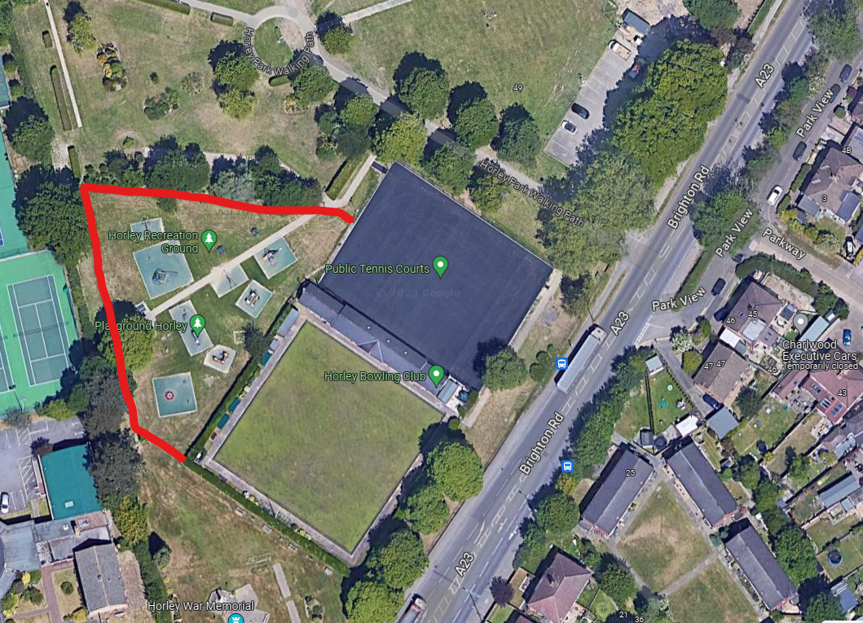
Map of playground
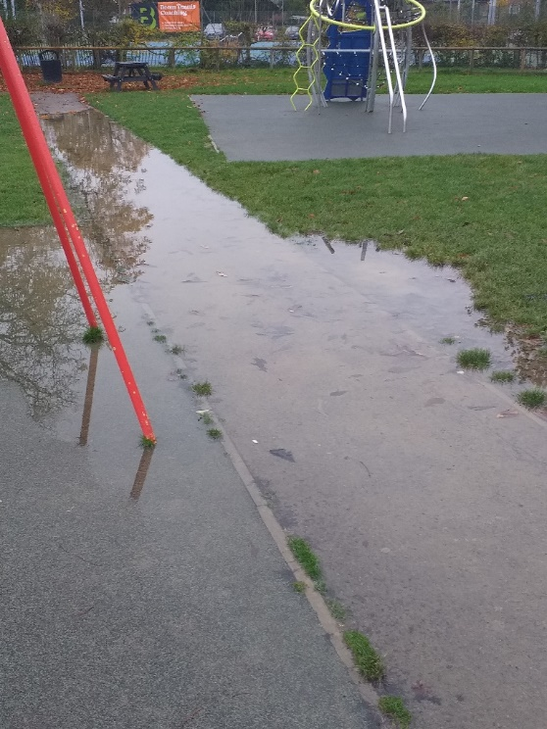 | 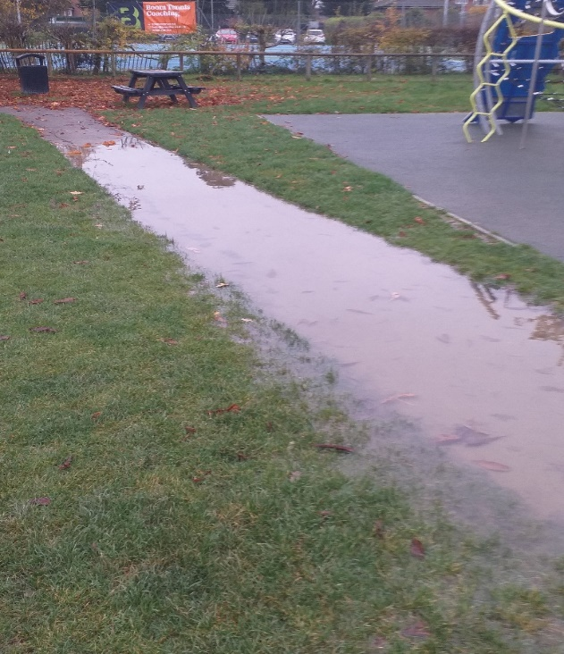
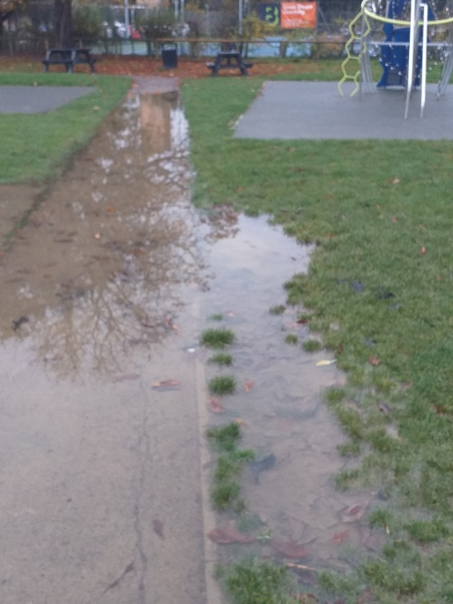 | 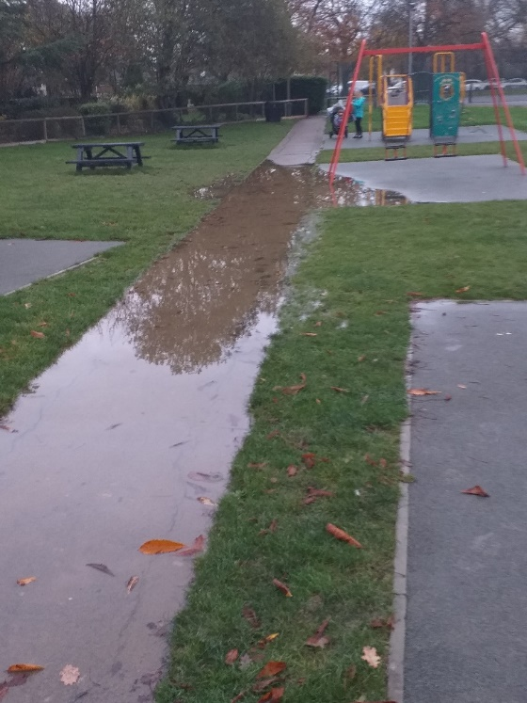

Flooded playground at Horley Recreation Ground after incessant rainfall

