Brief for South Essex Cycling and Walking Network Review

- SUMMARY

South Essex Active Travel (SEAT) is seeking to commission a cycling and walking network review of Southend-on-Sea, Thurrock, Rochford and Castle Point districts. This review must assess the suitability of the road and path network in each area for pedestrians and cyclists of varying skills levels. The cycling skills must be in line with the Bikeability skill levels www.Bikeability.org.uk or the national standard for cycle training https://www.gov.uk/government/publications/national-standard-for-cycle-training

- CONTEXT

SEAT is a joint project between Southend-on-Sea Borough Council, Essex County Council and Thurrock Council and the campaign associated with it is called ForwardMotion. SEAT is funded by the Department for Transport’s Access Fund. Southend-on-Sea Borough Council is the lead authority for delivering SEAT.

The aim of SEAT is to provide jobseekers, employees and students with travel advice and incentives to connect them with jobs, education, and training opportunities in south Essex.

SEAT is commissioning a cycling and walking network review of the boroughs of Southend-on-Sea, Thurrock, Castle Point and Rochford in order to produce maps for each area. The map below shows the areas to be covered by the network review. Each map should go slightly beyond borough boundaries.

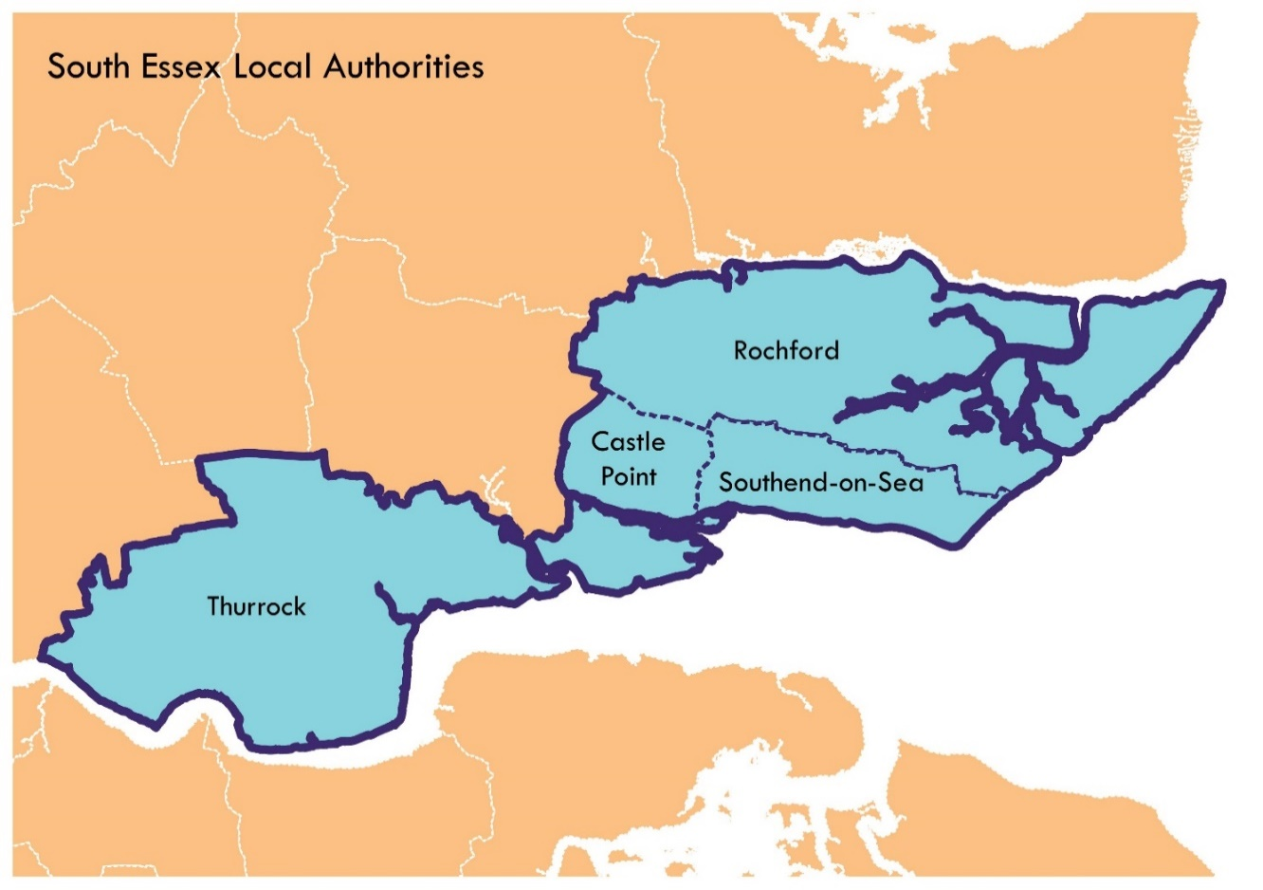

SS0, SS1, SS2, SS3, SS4, SS5, SS6, SS7, SS8, SS9, SS11, SS12, SS13, SS14, SS15, SS16, SS17, RM16, RM17, RM18, RM19, RM20, CM11, CM12

Cycle network assessments have previously been undertaken in Southend-on-Sea and Thurrock. The data from these assessments will be made available to the successful bidder. No network assessments are known to have been carried out in Rochford or Castle Point, however a Cycling Action Plan for Rochford District will be available to the successful bidder. Walking assessments in some areas are also required but there is no previous data available, these areas will be agreed with the supplier. Walking assessment templates are required to enable the assessments to continue in house in the future.

We require GIS data for all four areas. This needs to be the OSGB data vector files that the Council owns and can declare as open data. The GIS format should preferably be ESRI Shapefile. It should come with full attribution. All licences must be paid for by the funding given to the successful bidder but be owned by Southend Council who will then pass on to Thurrock and Essex Councils. All Councils will own the data and must be able to update it in-house.

The data will be used to create online and paper copy of the maps of Southend-on-Sea, Rochford, Castle Point and Thurrock. We will be going out to tender for a separate contract with a cartographer to produce these maps in the future.

- REQUIREMENTS

The requirements for the cycle and walking network review of Southend-on-Sea, Thurrock, Rochford and Castle Point are listed below and need to be completed within three months after the contract has been awarded.

- Network audit – mainly site based
  - Assembling data on road and path network (including schools and workplaces)
  - CSNA (Cycle Skills Network Audit) central – audit of road / path network and crossings / any legal restrictions/requirements
  - CSNA outer – audit of road / path network and crossings / any legal restrictions/requirements
  - GIS output
  - Draft and final report

- Cycle review and analysis
  - Mesh density and permeability analysis, including key barriers
  - Identification of tope local interventions for the four areas
  - Review of signage and cycle parking in the four areas, e.g. missing, new, good, needs replacing.
  - Data presentation and reporting of findings
  - Draft and final repot

- Walking review for key areas – The key areas will be agreed with the supplier but are likely to be a mixture of main town shopping areas to smaller shopping parades. The walking templates developed will enable each authority to continue with these assessments in the future.

  - Mesh density and permeability analysis, including key barriers
  - Identification of tope local interventions for the four areas
  - Review of signage in the four areas
  - Data presentation and reporting of findings
  - GIS Output
  - A format for walking assessments/audits that can be used in the future for other areas

Draft and final report. The Council reserves the right to instruct the supplier to make reasonable changes at any stage.

- Mapping The authorities already have the appropriate GIS layers but we need confirm of where on the map meets certain suitability criteria for cycling – therefore we won’t need to create additional mapping, just create the marked layers
  - In the format stated in section 2 so it can be viewed or downloaded as required and used by Thurrock, Essex and Southend Councils
  - Mapping of railways stations, schools, parks, places of interest, cycle parking, NCN routes, alleyways and bike friendly cafes/cake escape cafes
  - Producing GIS data for cartographer
  - Liaison with cartographer and internal GIS mapping team

- METHODOLOGY

The cycle and walking network review must include a Cycle Skills Network Assessment audit of each area using Southend-on-Sea Borough Council's approach to assessment of the road and path network. This review must assess the cycle skill levels needed to use all roads and paths in each area. All crossings of busier roads must also be assessed.

- Off road routes/cycle track/bridleway/byway/ suitable for new cyclists and children who have completed level one Bikeability
- The same as no.1 routes but cyclists and pedestrians share the route (priority to pedestrians?)
- Residential streets/moderate speeds/few lorries/suitable for less confident cyclists or child who has completed Bikeability level 2
- Busy routes with higher speeds and more lorries and large vehicles/big complex junctions/suitable for more confident cyclists or a child who has completed Bikeability level 3

Relevant existing data sets such as cycling action plans, where available, will be made available by SEAT and must be used by the supplier, where considered relevant and appropriate, and in agreement with the client.

SEAT will make available data on current and temporary/pop up routes implemented due to COVID-19 and interventions as well as earlier work classifying roads in the four areas by Bikeability skill or national standard for cycle training levels and information on growth areas and wider strategies.

The successful bidder must be able analyse outputs from the network audit using a structured and established approach to network analysis. This approach can be defined by the successful bidder and shared with the SEAT team.

Requirement for data presentation and reporting of findings.

- DELIVERABLES
- All deliverables are required three months after the award of contract
- Full report including executive summary
- Cycle Network Review
- Walking review in key areas and templates for future use
- GIS layers of mapping data
- Copies of all photographs taken during the course of the work

- CONTRACT MANAGEMENT

The successful bidder must designate a senior manager as the Contract Manager to oversee the running of this Contract. They will undertake a minimum of fortnightly update meetings to start with but could be scaled back as agreed.
The successful bidder is required to proactively partake in review meetings / conference calls with the Council. These will form part of the monthly review meetings as required. The purpose of these reviews meetings / conference calls is to ensure compliance to the contract and to discuss any issues regarding the Contract.
Responsibilities of the successful bidder’s Contract Manager will include but will not be limited to:
- Ensuring that all work is carried out in accordance with the requirements of the Contract
- Discuss financial aspects relating to the Contract
- Monitoring and reporting to the Council on the Consultants provisioning of the contract when required by the Council.
- The successful bidder must at all times consult fully with the Council and keep the Council fully informed of all issues immediately in writing which could have a negative effect on the running of the contract. In addition, as and when requested by the Council, the successful bidder shall liaise with and provide all such information as the Council may reasonably require and which is in the successful bidder’s possession and control.
The Point of Contact for the Council is: Collettekemp@southend.gov.uk
The Council’s Contract Manager reserves the reasonable right to convene a meeting with the successful bidder’S designated Contract Manager at any time.
The Council reserves the right to change its own Contract Manager without notice to the successful bidder.
The successful bidder will ensure that it resolves all queries raised by the Council’s Contract Manager within 48 hours.
The relationship between the successful bidder and the Council must be established as a working partnership with close liaison and discussion being a regular feature of the Contract.

- Contract Length and Budget
This contract will be in place from 29th October 2020 to 31st March 2021 with an option to extend for up to 12 months or any part thereof.
The value of this contract will be up to £35,000.
- Enquiries and Quotation Submissions
Bidders should note that all clarification questions must be made in writing (including email). The Council at their discretion reserves the right to circulate any response to all providers. All clarification questions must be clearly marked CLARIFICATION with the question and Provider details clearly set out. Any clarification questions from the Provider to the Council should be sent to Collettekemp@southend.gov.uk
To allow information to be circulated in time, the deadline for receiving clarification questions is 14:00hrs on Friday 18th September 2020.
The quotation return date is 14:00hrs on 29th September 2020. Quotations should be submitted by email to collettekemp@southend.gov.uk (you are recommended to request confirmation of receipt) Please use the title ‘SEAT Cycle Network Review’ when submitting your response.

- Evaluation of Quotations
All quotations will be subjected to a thorough evaluation. The Council will examine quotations for completeness and may seek clarification where necessary. A quotation determined to be incomplete or not substantially fulfilling the conditions in this document will be rejected.
- Technical (Quality) evaluations will be conducted, based on the information submitted in Section A. in writing, as part of this quotation submission.
- Commercial (Price) evaluations will be conducted, based on the information submitted in Section B, in writing, as part of this quotation submission.

- AWARD CRITERIA
The Council does not bind itself to accept the lowest priced quotation, or any quotation for this service. The Council will have no obligation to Providers arising from this quotation unless and until it enters into a formal contract with the successful Provider for the provision of the goods and/or services that are subject to this Quotation document. Any contract awarded will be to the Provider whose proposal is determined to be the most economically advantageous.
40% PRICE ALLOCATION: To be detailed within this written quotation submission, by the Provider. It is the requirement of the Council to maximise the budget available for this project. The Quotation is accepted on a “Fixed Price” basis and the Provider will not be entitled to claim any additional payments or expenses including but not limited to any increase in the price of the service and / or cost of, or incidental to, the employment of labour. The prices included in the Quotation shall be the maximum payable by the Council for the duration of the contract.
Pricing Evaluation (40%) – Using the Prices submitted by Providers a percentage will be allocated to the total cost as follows:
- Score = (Lowest Price Quotation / Your Price) * 40%
- The Table below gives an example of how the methodology works when applied to contract prices. The prices used here are examples of the pricing methodology and do not reflect any expectation of this contract in relation to any aspect of the pricing.
 | Bid A | Bid B | Bid C | Bid D
Programme Price | £250 | £500 | £300 | £250
Points Score | 40% | 20% | 33.33% | 40%
The scores awarded in the example table to Bid A and Bid D is calculated as follows:
- Bid A and Bid D with the lowest contract price in relation to the other bids are awarded the score of 40. The applied methodology gives a calculation as follows: (£250 / £250) x 40% = 40.00%
- Bid B with the highest contract price in relation to the other bids is therefore the lowest scoring bid in the pricing section, awarded 20%. The applied methodology arrives at this score through a calculation as follows: (£250 / £500) x 40% = 20%.

60% QUALITY ALLOCATION: To be detailed within this written quotation submission, by the Provider, in Section A (Technical Questionnaire).

Evaluation of Responses will be carried out on an individual question basis. Grade labels and definitions are as follows:
SCORING MATRIX |  | SCORE
Unacceptable / not answered | Question not answered – and / or – Response to the question significantly deficient – and / or - raises fundamental concerns regarding the organisation’s ability to successfully deliver the Contract. Answer does not provide satisfactory evidence as to the organisation’s capability to deliver the contract successfully. | 0
Poor | A response that is inadequate or only partially addresses the question. Response provides only limited evidence as to the organisation’s capabilities to deliver the contract successfully. Raises a large number of concerns and/or includes a large number of informational deficiencies. Does not raise any fundamental concerns regarding the organisation’s ability. | 1
Acceptable | An acceptable response submitted in terms of the level of detail, accuracy and relevance. Answer provides an average level of evidence as to the organisation’s capability. The response raises some concerns and/or includes a significant number of informational deficiencies. Does not raise any fundamental concerns regarding the organisation’s ability. | 2
Good | A good response in terms of the level of detail, accuracy and relevance. The information provides good evidence of the ability of the organisation to deliver the Contract successfully; but does raise minor concerns and/or includes deficiencies around some of the information provided in the response. Does not raise any fundamental concerns regarding the organisation’s ability. | 3
Very Good | A very good response in terms of the level of detail, accuracy and relevance. The information submitted provides significant evidence of the ability of the organisation to deliver the Contract successfully. However, the response lacks a level of detail needed for full marks. The response raises no fundamental concerns regarding the organisation’s ability. | 4
Excellent | An excellent response in terms of the level of detail, accuracy and relevance. The level of information provided is comprehensive and evidences strongly an assurance as to the organisation’s capability to deliver the contract successfully. The response raises no concerns and has no information deficiencies. | 5

PROSPECTIVE PROVIDER RESPONSE FORM
TECHNICAL QUESTIONNAIRE
Please note that page limits are on the basis of font Arial 11 and also include charts, diagrams, tables etc. Additional appendices are not permitted.
1. Demonstrable understanding of the brief & subject area

Please confirm the approach that your organisation will employ to the Council to deliver this contract.
Your response should include but not be limited to
- Examples of outputs from similar work for other local authorities and how you will use your leanings to benefit this contract
- Experience of using GIS to provide clear plans showing Bikeability-based assessments of a town, district or city and how you will use your learnings to benefit this contract
- A clear, structured methodology with reference to the latest techniques and approaches to cycle planning.

The Page Limit in response to Question 1 is 4 Pages (inclusive of visuals).

(Weighting = 60%)

PROSPECTIVE PROVIDER RESPONSE FORM
B – COMMERCIAL QUESTIONNAIRE

Please provide a quote for the full cost of delivering this project- please provide a breakdown of the full costs. Including all travel expenses, project fees, management fees, resource allocation, other expenses exclusive of VAT (if applicable).
(Weighting = 40%)

