

Resurfacing of Shopping Parade Car Parks

Document Two

Specification

CONTENTS

- Definitions Page 3
- Introduction Page 4
- Background Page 4
- Scope Page 4
- Service Conditions and Environmental Factors Page 4
- Statement of Requirements Page 4
- Construction Charter Page 12
- Quality Requirements Page 12
- Whole of Life Support Page 12
- Security Page 12
- Implementation Criteria Page 12
- Monitoring Arrangements and Project Management Page 13
- Risk Management Page 13
- Other Relevant Details Page 13
- Corporate Social Responsibility Page 14
- Appendices Page 16

- Definitions

  - The definitions of terms and/or acronyms used within this procurement are set out in the Table of Definitions, below.

Table of Definitions
CDM | Construction (Design and Management) Regulations 2015
Contract | The legal agreement between the Contractor and the Council, which details the Council’s requirements, terms and conditions
Month | A calendar month
Progress Meeting | a meeting between the Council’s Representative and the Contractor’s Authorised Representative
Progress Meeting Frequency | the frequency at which the Contractor shall conduct a Progress Meeting with the Council
Progress Report | a report provided by the Contractor indicating the steps taken to achieve Milestones or delivery dates
Prohibited Act | The following constitute Prohibited Acts:  - to directly or indirectly offer, promise or give any person working for or engaged by the Authority a financial or other advantage to: (i) induce the person to perform improperly a relevant function or activity; or (ii) reward that person for improper performance of a relevant function or activity;  - to directly or indirectly request, agree to receive or accept any financial or other advantage as an inducement or a reward for improper performance of a relevant function or activity in connection with this agreement;  - committing any offence: (i) under the Bribery Act; (ii) under legislation or common law concerning fraudulent acts; or (iii) defrauding, attempting to defraud or conspiring to defraud the Authority;  - any activity, practice or conduct which would constitute one of the offences listed under (a) to (c), if such activity, practice or conduct had been carried out in the UK.
Representative | Means, in relation to a party, its employees, officers, representatives and advisors
Site | any premises (including the Council’s Premises, the Contractor’s premises or third party premises) from, to or at which:  - the Service is (or is to be) provided; or  - the Contractor manages, organises or otherwise directs the provision or the use of the Service.
The Council | Corby Borough Council
The Contractor | The company who wins the contract, following evaluation of all bids received by the Council

- Introduction

  - The Council is seeking a suitably qualified and experienced Contractor to carry out tarmac resurfacing works and lay thermoplastic line markings across a number of car parks adjacent to Shopping Parades across Corby Borough, which have been identified to require remedial works to mitigate potholes, surface degradation and renew line markings.

- Background

  - Following a procurement for remediation works to shopping parades across Corby, which took place in 2019, the Council has identified car parks associated with some of these parades, which have benefitted from numerous patch repairs are showing signs of general wear and tear, where patch repairing is no longer appropriate.

- Scope

  - This document should be read in conjunction with the Preliminaries and General Conditions, which can be accessed by, double clicking on the document icon, below.

- Service Conditions and Environmental Factors

  - Bidders should visit the sites to quantify the areas concerned and confirm the extent of any constraints that may impact on their Bid.

  - The Contractor shall comply with all current Health and Safety regulations, including the Health and Safety at Work Act 1974 and the Construction (Design & Management) Regulations 2015 (CDM).

- Statement of Requirements

  - The details for each car park are identified on the accompanying pages.
    - Please ensure that prices include for the removal of any arisings from site and disposal;
    - Contractors should visit the site to quantify the areas concerned and confirm the extent of any constraints that may impact on their Bid;
    - The Contractor shall comply with all current Health and Safety regulations, including the Health and Safety at Work Act 1974 and the Construction (Design & Management) Regulations 2015 (CDM);
    - This document should be read in conjunction with the Preliminaries and General Conditions, attached at Appendix 3; and
    - All areas are to be left clean and tidy on completion of works.

  - Parking Bays

    - The recommended size of general purpose parking bay is 2.4 x 4.8m.

    - The recommended size of a disabled parking bay is 2.8 x 4.8 x 1.2m.

  - Location and Access

    - All sites, listed below, are located adjacent to current shopping parades and are easily accessible:
- Farmstead Road;
- Greenhill Rise;
- Danesholme Close (car park off Motala Close);
- Rockingham Road;
- Pytchley Court; and
- Boden Close.

  - Timeframe

    - The Council would like these works completed as soon as possible, but no later than mid May 2020.

*** Statement of Requirements continues on next page for continuity ***

  - Works will Include

    - Farmstead Road
              - The shaded blue area does not require any works but a seam will be required where the two areas meet;
              - The area Marked A – Plane off surface, lay wearing course resurface, clear gullies;
              - The area Marked B – Plane off surface, lay wearing course resurface, clear gullies and white lining for 24 parking spaces; and
              - Do not include concrete fillet near pub in Area B.

Table A
Requirement |  | Size or No. Required
 | Plane off surface | 1,120m2
 | Wearing course resurface | 1,120m2
 | White lining | 1 item
 | Clear gullies | 1 item

Image A
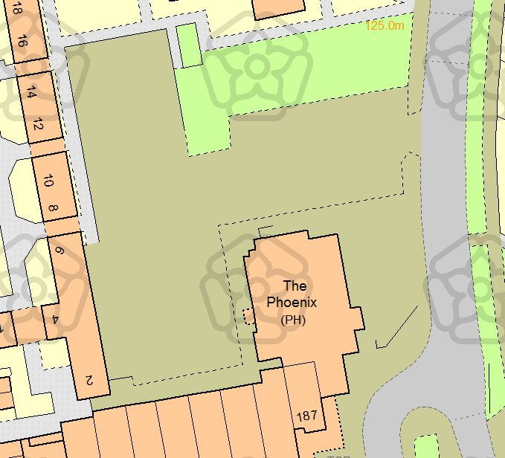
B
A
18.3
35.7
23.4
18.5

    - Greenhill Rise
- Plane off surface, base coat and lay wearing course and white lining to Area A only.

Table B
Requirement |  | Size or No. Required
 | Plane off surface | 740m2
 | Base coat and wearing course | 740m2
 | White lining | 1 item
 | Clear gullies | 1 item

Image B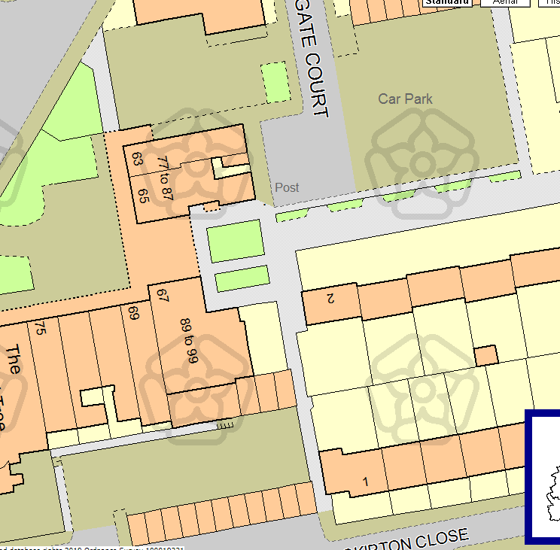
B

A
26.8
27.3
B
40.1
11.0
A
26.8
27.3

    - Danesholme Close (car park off Motala Close)
- The car park is accessed via Motala Close;
- Localised pot holes repairs, plane off surface, lay wearing course and white lining;
- The area highlighted A will be disabled parking only with two other disabled spaces, location to be agreed
- Breakdown of parking spaces
                - Disabled = 7
                - General parking = 32

Table C
Requirement |  | Size or No. Required
 | Localised pot hole repairs | 10m2
 | Plane off surface | 1,270m2
 | Wearing course | 1,270m2
 | White lining | 1 item
 | Clear gullies | 1 item

Image C
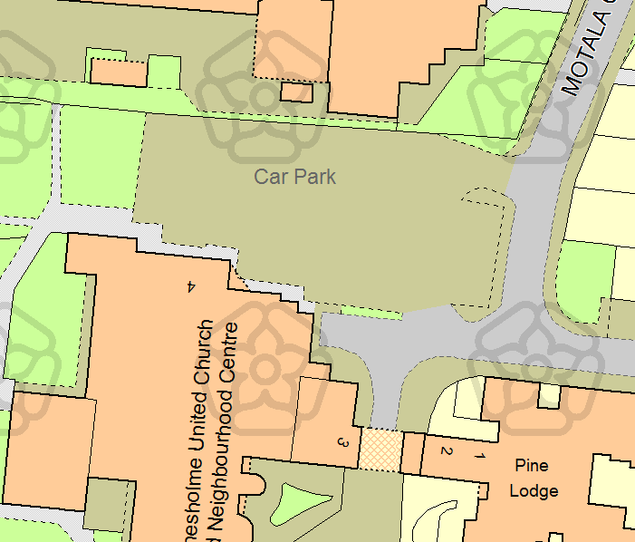
A
24.3
52.5

    - Rockingham Road
- Plane off surface, lay base coat and wearing coat and white lining; and
- The area between the two parades (highlighted in yellow) needs to have yellow hatching and signage advising no parking at any time. This is vehicle access for deliveries etc.

Table D
Requirement |  | Size or No. Required
 | Plane off surface | 140m2
 | Base coat and wearing course | 140m2
 | White lining | 1 item
 | Clear gullies | 1 item
 | Hatching area | 1 item

Image D
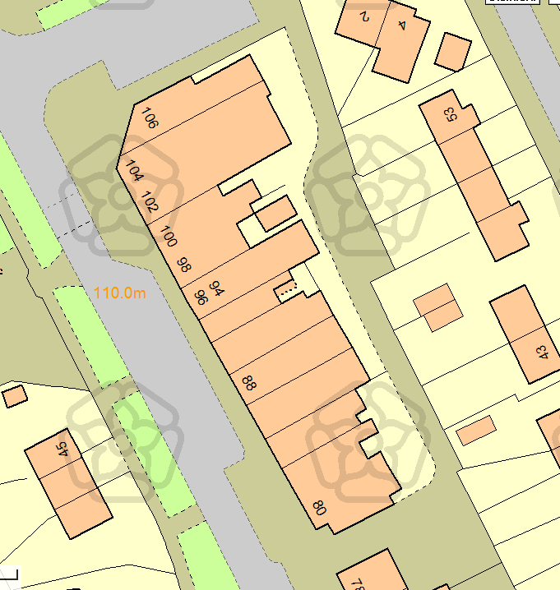
19.3 x 5.7

24.8 x 5.6

    - Pytchley Court
- Localised pot hole repairs, plane off surface, lay wearing course and white lining.
- Breakdown of parking spaces
- Disabled = 3
- General parking = 43

Table E
Requirement |  | Size or No. Required
 | Localised pot hole repairs | 20m2
 | Plane off surface | 1,195m2
 | Wearing course | 1,195m2
 | White lining | 1 item
 | Clear gullies | 1 item

Image E
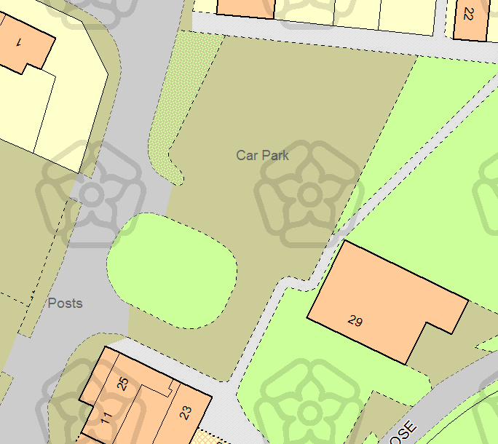
31.7
31.3

    - Boden Close
- Plane off top and lay wearing course. No white lining.
Table F
Requirement |  | Size or No. Required
 | Plane off surface | 590m2
 | Base course and wearing course | 590m2
 | Clear gullies | 1 item

Image F
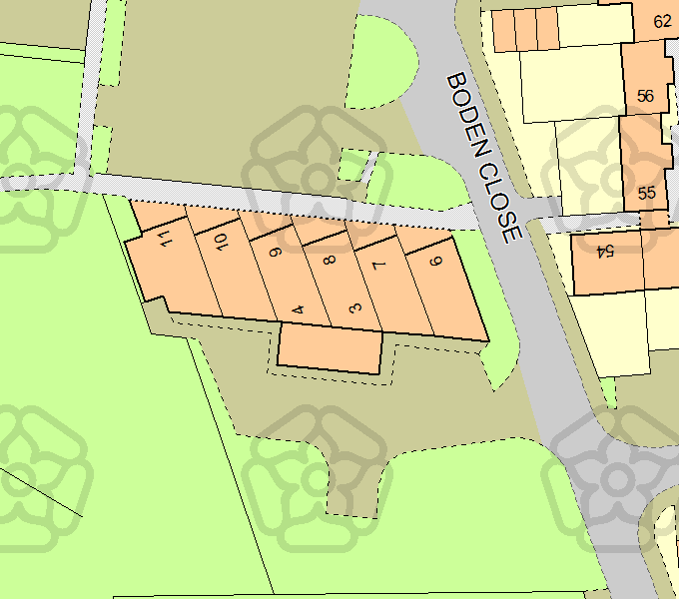
36.7
12.1
8.0 x 8.6

- Construction Charter

  - Corby Borough Council signed up to the Construction Charter on Monday, 12th November 2018 and adopted, in full, the provisions of the Charter and publically affirmed our commitment to work with Unite and other appropriate trade unions to ensure the provisions of the Charter are applied in all construction projects we are involved with.

  - The Charter states that the Council, as a responsible client, enter into this agreement and commit to working with the appropriate trade unions, in order to achieve the highest standards in respect of; direct employment status, Health & Safety, standard of work, apprenticeship training and the implementation of appropriate nationally agreed terms and conditions of employment.

  - In order to be considered for this project, the successful bidder(s) must agree to adhere to the provisions of the Charter, which can be accessed by double clicking on the link below.

- Quality Requirements

  - Quality Requirements are as defined in the Preliminaries, attached at Appendix 1.

- Whole of Life Support

  - The Contract includes a twelve (12) month Defects Period.

  - In any case, the Contractor shall also be liable for any latent defects for a period of six years.

- Security

  - All site security including equipment, fencing, machinery etc. is the responsibility of the Contractor, until an official handover has been concluded.

- Implementation Criteria

  - Following Contract Award the Council will convene a Pre-Contract Meeting with the Contractor to finalise the Contractual Arrangements.

  - The Council shall also notify the Contractor when the associated Works are scheduled and completed and convene a subsequent Pre-Start Meeting, prior to commencement on-site to finalise logistical arrangements.

  - The Contractor shall provide a minimum of one week’s notice of their intention to start on-site.

  - Prior to commencement, the Contractor shall submit an appropriately detailed Construction Management / Health and Safety Plan for the Works.

  - The Contractor shall appoint a Representative who shall be responsible for the management of the Works, to ensure they are planned and resourced adequately and who will act as a point of contact for the Council;

- Monitoring Arrangements and Project management

  - The Contractor shall at all times provide the Works to meet or exceed the requirements set out in this Specification and any associated documents.

  - The Contractor and the Council shall ensure that appropriate resource is made available on a regular basis such that the aims, objectives and specific provisions of these Works can be fully realised.

  - A Contract Administrator / Clerk of Works will be appointed by the Council, who will manage the day-to-day administration of the Contract and oversee the Works in compliance with this Specification and the terms of the Contract, as detailed within the Preliminaries and General Conditions.

  - The Contractor’s Representative will be required to attend Progress Meetings chaired by the Contract Administrator (the frequency of which shall be determined at the Pre-Contract Meeting), where they will present a Progress Report.

  - The Contact Administrator shall prepare an Agenda for such meetings and circulate the agreed Minutes.

- Risk Management

  - The Contractor and the Council shall pro-actively manage risks attributed to them under the terms of this Contract.

  - The Contractor shall develop, operate, maintain and amend, as agreed with the Council, processes for:
    - the identification and management of risks;
    - the identification and management of issues; and
    - monitoring and controlling project plans.

  - The Contractor will allow the Council to inspect, at any time within working hours, the accounts and records which the Contractor is required to keep.

  - The Contractor will maintain a risk register of the risks relating to the Service, which the Council and the Contractor have identified.

- Other Relevant Details

  - In order for Contractors to ensure their submissions reflect as accurately as possible the Council’s specification and requirements, the Council strongly recommends that Contractors undertake a site visit in order for each Contractor to satisfy itself so far as is possible that its proposed tendered price to be submitted in its bid is correct, realistic and sustainable. Such site visits may be undertaken without prior arrangement, as the site is open and publically accessible.

  - Site visits will not be scored or evaluated, but the Council makes available this opportunity to Contractors in accordance with the principles of openness, fairness, transparency and non-discrimination so as to enable each Contractor so far as is reasonable to submit its most competitive bid.

  - For the avoidance of doubt please be aware that following award of contract should the successful Contractor subsequently find that its proposed solution is not accurate and sustainable then the successful Contractor will be not be permitted to amend their pricing bid so as to request any further monies associated with the full provision of this service.

- Corporate Social Responsibility

  - Requirements
    - In September 2017, HM Government published a Contractor Code of Conduct setting out the standards and behaviours expected of Contractors who work with government. (https://www.gov.uk/government/uploads/system/uploads/attachment_data/fi le/646497/2017-09- 13_Official_Sensitive_Contractor_Code_of_Conduct_September_2017.pdf)
    - The Council expects its Contractors and Sub-Contractors to meet the standards set out in that Code. In addition, the Council expects its Contractors and Sub-Contractors to comply with the standards set out in this Section.
    - The Contractor acknowledges that the Council may have additional requirements in relation to corporate social responsibility. The Council expects that the Contractor and its Sub-Contractors will comply with such corporate social responsibility requirements as the Council may notify to the Contractor from time to time.

  - Equality and Accessibility
    - In addition to legal obligations, the Contractor shall support the Council in fulfilling its Public Sector Equality duty under S149 of the Equality Act 2010 by ensuring that it fulfils its obligations under each Contract in a way that seeks to:
- eliminate discrimination, harassment or victimisation of any kind; and
- advance equality of opportunity and good relations between those with a protected characteristic (age, disability, gender reassignment, pregnancy and maternity, race, religion or belief, sex, sexual orientation, and marriage and civil partnership) and those who do not share it.

  - Modern Slavery, Child Labour and Inhumane Treatment
    - Modern Slavery Helpline - means the mechanism for reporting suspicion, seeking help or advice and information on the subject of modern slavery available online at https://www.modernslaveryhelpline.org/report or by telephone on 08000 121 700.
    - The Contractor:
- shall not use, nor allow its Sub-Contractors to use forced, bonded or involuntary prison labour;
- shall not require any Contractor Staff or Sub-Contractor Staff to lodge deposits or identify papers with the Employer and shall be free to leave their employer after reasonable notice;
- warrants and represents that it has not been convicted of any slavery or human tracking offenses anywhere around the world;
- warrants that to the best of its knowledge it is not currently under investigation, inquiry or enforcement proceedings in relation to any allegation of slavery or human tracking offenses anywhere around the world;
- shall make reasonable enquires to ensure that its officers, employees and Sub-Contractors have not been convicted of slavery or human tracking offenses anywhere around the world;
- shall have and maintain throughout the term of any of its Contracts, its own policies and procedures to ensure its compliance with the Modern Slavery Act and include in its contracts with its Sub-Contractors anti-slavery and human trafficking provisions;
- shall implement due diligence procedures to ensure that there is no slavery or human trafficking in any part of its supply chain performing obligations under any of its Contract;
- shall prepare and deliver to the Council, upon request, a slavery and human trafficking report, setting out the steps it has taken to ensure that slavery and human trafficking is not taking place in any of its supply chains or in any part of its business with an annual certification of compliance;
- shall not use, nor allow its employees or Sub-Contractors to use physical abuse or discipline, the threat of physical abuse, sexual or other harassment and verbal abuse or other forms of intimidation of its employees or Sub-Contractors;
- shall not use or allow child or slave labour to be used by its Sub-Contractors;
- shall report the discovery or suspicion of any slavery or trafficking by it or its Sub-Contractors to the Council and Modern Slavery Helpline.

  - Income Security
    - The Contractor shall:
- ensure that that all wages and benefits paid for a standard working week meet, at a minimum, national legal standards in the country of employment;
- ensure that all Contractor Staff are provided with written and understandable Information about their employment conditions in respect to wages before they enter employment and about the particulars of their wages for the pay period concerned each time that they are paid;
- All workers shall be provided with written and understandable Information about their employment conditions in respect to wages before they enter employment and about the particulars of their wages for the pay period concerned each time that they are paid;
- not make deductions from wages:
  - as a disciplinary measure;
  - except where permitted by law; or
  - without expressed permission of the worker concerned.
- record all disciplinary measures taken against Contractor Staff; and
- ensure that Contractor Staff are engaged under a recognised employment relationship established through national law and practice.

  - Working Hours
    - The Contractor shall:
- ensure that the working hours of Contractor Staff comply with national laws, and any collective agreements;
- that the working hours of Contractor Staff, excluding overtime, shall be defined by contract, and shall not exceed 48 hours per week unless the individual has agreed in writing;
- ensure that use of overtime used responsibly, taking into account:
- the extent;
- frequency; and
- hours worked; by individuals and by the Contractor Staff as a whole.
    - The total hours worked in any seven day period shall not exceed 60 hours, except where covered by Paragraph 5.3 below.
    - Working hours may exceed 60 hours in any seven day period only in exceptional circumstances where all of the following are met:
- this is allowed by national law;
- this is allowed by a collective agreement freely negotiated with a workers’ organisation representing a significant portion of the workforce; appropriate safeguards are taken to protect the workers’ health and safety; and
- the employer can demonstrate that exceptional circumstances apply such as unexpected production peaks, accidents or emergencies.
    - All Contractor Staff shall be provided with at least one (1) day off in every seven (7) day period or, where allowed by national law, two (2) days off in every fourteen (14) day period.

  - Sustainability
    - The Contractor shall meet the applicable Government Buying Standards, which can be found online at: https://www.gov.uk/government/collections/sustainable-procurement-thegovernment-buying-standards-gbs

- Appendices

  - To open the embedded appendices, double click on the document icon.

    - Appendix 1 – Preliminaries

    - Appendix 2 – Construction Charter

