**INVITATION TO BID**

**Mill Lane Selsey, New Storage Unit – Superstructure**

**Reference MILL180918**

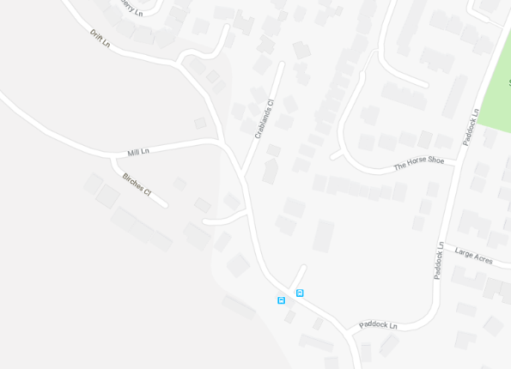

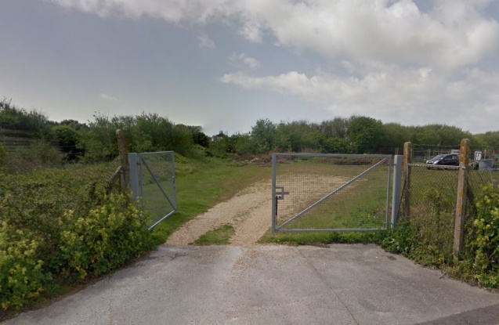

Selsey Town Council invite you to submit a Tender for the Proposed New Storage Unit at Mill Lane, Selsey. Details of the works are set out in the following tender documents:

1. Preliminaries,
2. Drawings No’s 28252/ 1A, 2, 3, 4A, 5, E1, GA1, GA2, S1 & STD.01.65c.

Your tender should comprise the fully priced Activity schedule and Form of Tender, indicative programme and any other supporting documents you feel may be useful; **and must be returned as hard copy only in a sealed envelope marked for the attention of The Clerk REF: MILL/102018, Selsey Town Council, 55 High Street, Selsey, West Sussex, PO20 0RB.**

No marks are to be made on the envelope that could identify the name of the tenderer. Any such marks may lead to rejection of the tender.

Tenders are to be returned to this office not later than 12.00 noon on 1st October 2018. Tenders received after this time will not be opened or considered.

Arrangements for visiting the site at should be made via Jenny Ririe, Deputy Clerk - [jenny.ririe@selseytowncouncil.gov.uk](mailto:jenny.ririe@selseytowncouncil.gov.uk), 01243 605803

Selsey Town Council does not bind itself to accept the lowest or any bid.