­

**Smart Motorways Programme (SMP)**

**Programme Management Office (PMO) Work Package Scope**

**Managed Service for Reporting, Data & Integrated System Controls**

**- Specification -**

1. **Introduction**
   1. The Smart Motorways Programme (SMP) forms part of the Highways England (HE) Delivery Plan and Roads Investment Strategy (RIS). The SMP Programme Management Office (PMO) actively supports the SMP PMO Director and the SMP PMO Senior Leadership Team (SLT) to achieve the required Smart Motorways Programme & Project outcomes and milestones and work to the Highways England business imperatives of:
      1. Safety
      2. Customer; and
      3. Delivery.
   2. This is also aligned with achieving the strategic outcomes set in the HE Delivery Plan, namely: supporting Economic Growth, providing a Safe, Servicable, Accessible & Integrated Network, a More Free flowing and; Improved Environment.
   3. To deliver our strategic outcomes the SMP use four key enablers:
      1. Delivering Performance & Efficiency;
      2. Managing Risk & Uncertainty;
      3. Providing Capable Employees and rewarding excellence; and
      4. Collaborative Relationships with all key stakeholders.
   4. Since April 2017 SMP has been establishing an integrated programme management team. Focus remains on developing and maturing its governance framework to drive a best-in-class PMO service harnessing and absorbing advances in data and performance reporting methodologies and expertise. This is aligned to Major Projects imperatives and HE Major Projects Directorate Change Programme: to embed and benefit from improved fit for purpose consistent project and programmme management systems, controls, capabilties and processes.
   5. The work package set out in this ‘Request For Proposal’ (RFP) will enable SMP to continue the process of stabilising and maintaining project and programmme performance reporting whilst allowing capacity and capability to improve performance management systems and reporting overall.
   6. The aim of this RFP is to set out SMP service requirements in establishing a managed service for provision of data improvement and performance reporting services.
   7. The service will comprise but not be limited to the integration of statistical analysis, computing and technology platforms, information-dashboard-reports, visualisation/ infographics and provision of any additional technology requirements such as real time collaboration platforms within the programme and project controls environment to support and enable effective decision making, visibility and control over the programme and its constituent activities, dependencies and scope of influence.
   8. The overall objective: to develop, maintain and improve upon a fit for purpose performance reporting regime by developing an SMP Data Reporting Framework. This will enable SMP to make informed strategic decisions about how best to plan and deliver the organisational objectives. By providing a clear and informative articulation defining out how the SMP PMO will provide a programme and project controls reporting structure to best support delivery of RIS Period 1 and transition into RIS Period 2.
2. **Background**
   1. The Highways England SMP PMO provides support to the Programme and its constituent projects. It provides a governance framework to drive successful programme delivery and is accountable to the SMP PMO Director.
   2. The structure of the SMP PMO Senior Leadership Team that supports and enables the delivery of programme performance objectives is outlined below in *Figure 1.0.*

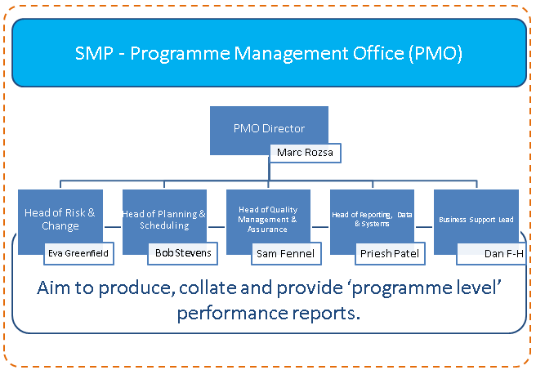

*Figure 1.0 SMP PMO Senior Leadership*

* 1. Within the structure of the SMP PMO Senior Leadership Team sits the Head of Reporting, Data & Integrated System Controls role. Figure 2.0 below sets out how the current reporting team is structured.

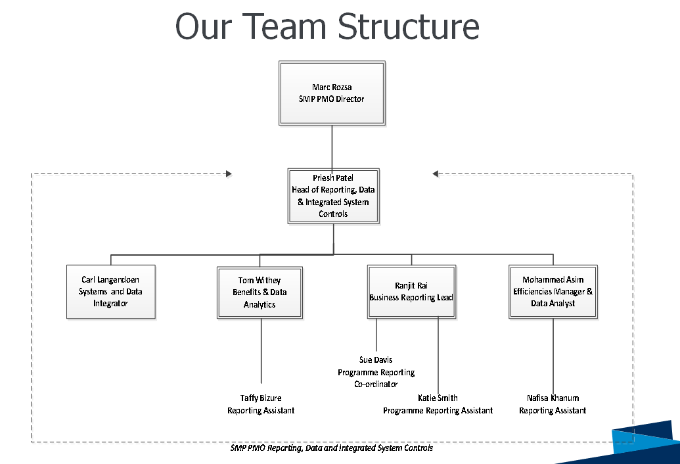

*Figure 2.0 SMP Head of Reporting, Data & Integrated System Controls Team Structure*

* 1. Since April 2017 the SMP PMO team started a journey from providing a ‘standardised’ PMO service moving to a PMO that is equipped to providing the highest level of; best practice across risk, issue & opportunities management, planning & scheduling, quality assurance, qualitative and quantitative reporting, strategic advice and better more timely informed interventions to support delivery confidence of the programme.
  2. The SMP PMO team aims to establish a fit for purpose performance reporting regime using latest approaches, techniques and platforms to develop a Data Reporting Framework, which details the development of project information from source, through its analysis, review, verification and aggregation by the programme team into a series of standardised operational and strategic reports from a multitude project control systems and other data sources.
  3. Using the latest data visualisation and representational techniques this managed service is to provide key programme-level meetings with valuable insight via information dashboards and or reports in a rapid and agile manner. These performance reports need to ensure that they are timely and have the integrity to provide interventions supporting improved delivery confidence.
  4. The programme practices a “single source” of the truth methodology. All data collected throughout the month is aggregated and consolidated to provide a position on the performance of the programme. The importance of accurate up to date information is a critical activity to ensure timely decision making.
  5. Some of this improvement work has included developing and providing an integrated client/consultant approach to draw upon best practice resources, both in terms of people, tools, software and process knowledge whilst addressing the skills gap within Highways England.
  6. We have drawn upon the consultant support network, through a managed service, and been able to flex resources and upskill HE staff. Whilst this service has stabilised the service, there are a number of areas of improvement required to build on the progress made so far with data and performance reporting processes and platforms.

1. Current State
   1. The SMP PMO team use the Office of Government Commerce’s (OGC) Portfolio, Programme and Project Management Maturity Model (P3M3®) as a framework under which to consider the SMP’s approach and arrangements for delivering its project and programme obligations. See Figure 3.0: OGC P3M3 Maturity Framework.

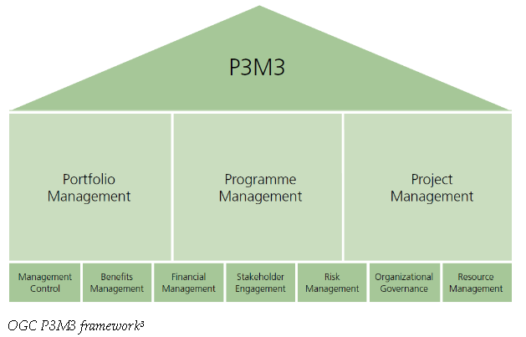

Figure 3.0: OCG P3M3 Framework

* 1. The P3M3® framework considers the full range of ‘people, system and process’ characteristics which provide a basis for assessing maturity over five levels (Level 5 being the highest level of maturity)
     1. Awareness of process;
     2. Repeatable process;
     3. Defined process;
     4. Managed process;
     5. Optimised process.
  2. We consider that Level 3 – SMP’s stated P3M3® target – is achievable subject to certain matters being addressed. Part of this is to achieve a governance framework to drive a best-in-class PMO service using advances in data and performance reporting methodologies and expertise. Thereby delivering better, fit for purpose reporting regime in an agile manner.
  3. The Service Provider is to provide confidence to the Smart Motorways Programme SLT and the PMO team by developing and undertaking a clear plan of activities to deliver a step change in the quality of our performance reporting enabling the achievement of the P3M3® target.
  4. Some of the issues identified with the current reports and process are:
     1. They are too long and not focused on what is relevant in explaining the current state of play;
     2. They do not always focus on key issues identified and decisions required;
     3. RAG status and narrative in explaining the current state of performance is too subjective, or inconsistent, with little to respond to the ‘so what?’ challenge;
     4. We need a more coherent process for circulating feedback from all stakeholders;
     5. Project reporting is not always aligned to the programme report (and vice versa). We need to enter data once and allow our various systems to automatically check data, reconcile and verify our performance reports;
     6. The report needs to take a more risks based approach as some KPIs do not move each reporting period, and therefore the lack of leading indicators makes it difficult to monitor against performance each month;
     7. The current suite of information on the KPIs may not be the best indicators to use or is not clear on explaining why they may be relevant;
     8. We are not always using the latest appropriate visualisation techniques to highlight areas of interest for senior stakeholders;
     9. Further work is required to achieve an integrated approach to reporting. This does always exist for the all of the segmental parts of project and programme controls data (Safety, Customer, Finance, Risk, Schedule, Quality etc.).
  5. In order to build on the work to improve our performance reporting capability, SMP have outlined some key deliverables; which once these are developed we should be able to deliver our key objective to provide an automated, configurable and flexible performance reporting regime. The key aims we are looking to deliver are:
     1. To improve the quality of performance reporting by using the latest data mapping, presentational and visualisation techniques; and
     2. To build upon and develop a Data Reporting Framework to support and provide a foundation for project and programme reporting.

1. **The Managed Service**
   1. In order to achieve our key objective to provide an automated performance reporting regime by developing a Data Reporting Framework.
   2. We are seeking a Service Provider to plan, execute and deliver a quality, managed service which will provide suitable experienced and capable staff who will work seamlessly with our existing stakeholders to provide support to the following work packages.
   3. Service Provider Managed Service requirements are within the scope of Performance Reporting, Data Analytics & Data Development and again within the specific scope of Project and Programme Controls for pricing and for the purposes of comparison we envisage a team that consists of the following to achieve the desired outcomes:
      1. Reporting Data Developer (1 position, Birmingham)
      2. Reporting Data Analyst (1 position, Birmingham)
      3. Performance Reporting Manager (1 position, Birmingham)
      4. Performance Reporting Analysts (2 positions, Birmingham)
   4. Each function will ultimately report to SMP PMO the Head of Reporting, Data & Integrated System Controls role, as outlined below in *Figure 5.0 Planned SMP PMO Org Structure*. All Service Provider personnel are to be based from the SMP Offices at: 2 Colmore Square, 38 Colmore Circus, Queensway, Birmingham, B4 6BN.

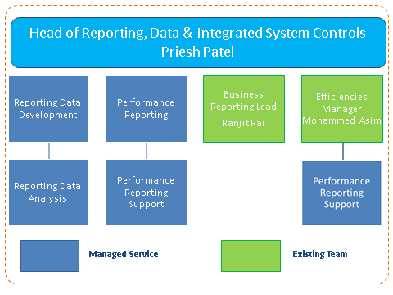

*Figure 5.0 Planned SMP PMO Reporting Team Org Structure*

* 1. The numbers of positions shown above are given for indicative purposes and reflect the current anticipated need to meet desires outcomes but are subject to adjustment to suit the actual volume of project work being undertaken at any one time.
  2. The individuals provided by the Service Provider will comply with all infrastructure industry best practices including demonstrating any key knowledge gained from previous experience of working with HE or a similar transport sector infrastructure development project controls environments. They will work collaboratively with all other involved parties within the integrated SMP team, and supply chain, database owners and data owners, sharing information as required by the PMO Director or of their management team.
  3. HE intend awarding this Work Package based on the Service Provider being able to clearly demonstrate their ability to provide a professional serviced proposition, deploying motivated, innovative, qualified experienced professionals and that they identify how they will measure their own month on month continued improvement, and provide value and performance to SMP and Highways England.
  4. Each Service Provider offer must clearly articulate a process of demonstrating some Key Performance Indicators (KPI’s) (no more than 4 in total) in SMART format (Specific, Measurable, Agreed, Realistic, Timebound) the Consultant can bring to measure their own continued performance. The Service Provider shall provide a monthly report to show their progress against agreed KPI’s.

1. **Requirements, Roles and Responsibilities** 
   1. The Service Provider will be accountable for working in a safe, timely and efficient manner, meeting contractual and reporting deadlines including availability during core month end working days and as required by the relevant project & /or programme as otherwise specified by the PMO Director and or his / her management team.
   2. The Service Provider will actively promote a health & safety culture within its organisation, the Programme and embrace and contribute to HE Health Safety and wellbeing initiatives.
   3. In respect to Health, Safety and wellbeing the Service Provider shall confirm in writing that;
      1. Staff understand and comply with their duty of care for self, colleagues and others
      2. Staff wellbeing is appropriately managed including “work/life balance”, reasonable working hours and travel distances
      3. Staff have a full understanding of roles and responsibilities of the various parties and have appropriate knowledge, training, experience and capability to fulfil their role
      4. Staff have suitable visibility and fulfil required actions in respect HS&W matters (e.g. Highways England 5 Year H&S Plan, Programme H&S Policy / Strategy, Safety Alerts, etc.)
      5. Staff are clear about the PMO teams role in adding value and supporting the team without conflict within the HS&W environment
   4. **Reporting Data Developer**

It is anticipated that Reporting Data Developer function will be responsible for providing high quality outcomes, configurable compatible, adequately maintained and protected accessible resilient data environment by reviewing and analysing data requirements, integrated systems and project reporting needs. Key outcomes will include:

* + 1. Define, Develop and Embed the Smart Motorways Programme strategy for Reporting, Data Management & Analysis and Systems Integration.
    2. Output, maintain and improve a Programme Data Reporting Framework that is fit for purpose;
    3. Delivery of a governance framework to provide advances in data reporting methodologies and expertise. Support the establishment of an automated performance reporting regime intelligently, using appropriate approaches and methodologies.
    4. Assure and gather data for each project & / or programme from various sources, collating the data in agreed formats and publish reports as required by the PMO Director and Smart Motorways Programme as per reporting timetable and SMP agreed reporting platforms.
    5. Develop, maintain and document data collection processes, and validation and validation mechanisms.
    6. Software and data assurance across the programme reporting environment. Outlining the tactical options to develop any bespoke tracking systems / access databases where necessary. Creation of local databases to meet the programme reporting requirements existing Business Intelligence (BI) capabilities to include reconciliation with HE corporate databases.
    7. Designing, documenting and building the staging area database structure to accommodate images and metadata.
    8. Testing of the image and metadata migration. Responsible for documenting the extraction and loading of the images and metadata files to a staging area database.
    9. Demonstrating required behaviours, in particular, collaboration safety and customer awareness.
    10. Develop data frameworks and connected information architectures across SMP information ecosystems that can be used to solve business issues and evaluate solutions.
    11. Develop solutions at programme and project operational levels.
    12. Respond with agility with options and plans in a changing reporting and business landscape. Advise and provide IT platforms for fill gaps identified by detailed in depth analysis of the current system landscape and capability.
    13. Relevant industry experience of programme controls reporting and data management.
  1. **Reporting Data Analysis**

The Data & Analytics function shall report and support Reporting Data Development in providing an effective data management and reporting system for SMP. Key outcomes will include:

* + 1. Day to day data management.
    2. Embed new systems, analyse and present data across the Smart Motorways Programme.
    3. Support the Reporting Data Development function in identifying data metrics and other data opportunities to generate insights, improvements, and inform Senior Stakeholders using best of breed data techniques and methods.
    4. Develop, implement and validate appropriate data analytics tools against identified performance measurement frameworks.
    5. Produce reports and dashboards on a regular and ad-hoc basis as required by SMP.
    6. Resolve data queries and data process queries.
    7. Identify and improve the quality and accuracy of our data source and flows to destination using a variety of qualitative and quantitative data analysis techniques. Ensure the integrity and accuracy of all data used for producing reports.
    8. Data analysis & interrogation e.g. Design & Construction Production Metrics, Quality Metrics, Project & Programme key data (Earned Value, SPI, CPI, KPI’s etc.).
    9. Identify good and poor project & programme practices and procedures. Conduct bespoke data searches with the others systems and tools when required.
    10. Carry out detailed in depth analysis of the data, identifying and analysing trends and providing leading indicators of improving or worsening performance. Provide advice and recommendations for interventions and actions to be taken. Undertake, implement, monitor and track effectiveness agreed actions and undertake corrective actions.
    11. Manage the internal business expectations around data change. Provide subject matter expertise sharing knowledge, experience and implementation of data visualisation techniques.
    12. In depth data analysis and provision of the latest infographics techniques used in the infrastructure construction within project controls sector. Providing a hands-on approach with all aspects of standing up the data and system to be connected programme wide.
    13. Support the Reporting Data Development function in implementing any additional IT platforms required filling any gaps identified by an analysis of the current system landscape and capability in a secure controlled governed way, protecting SMP and HE interests.
  1. **Performance Reporting**

The Performance Reporting function shall achieve the following outcomes:

* + 1. Embed and comply with the Smart Motorways Programme Strategy for Reporting, Data Management & Analysis and Systems Integration.
    2. Provide agile availability and accuracy of performance reporting elements of the development and implementation of the Data Reporting Framework.
    3. Deliver a governance framework to provide support realisation of advances in performance reporting methodologies and expertise. Support the enhancement of an automated performance reporting process.
    4. Develop and integrate cross functional performance reporting capabilities using existing project controls databases.
    5. Provide monthly updates for internal performance reporting requirements.
    6. Ensure consistency of reporting, metrics and reporting methods across the programme. Ensure that the performance reporting process adopts and adheres to the Programme & Project early warnings and change request process.
    7. Establish a requirements management approach for the programme to ensure that the programme baseline is clearly controlled, understood and documented.
    8. Establish a system for managing performance reporting issues across the programme and ensuring that potential impact of issues are properly understood.
    9. Identify explanation for the underlying drivers of performance and to improve processes to track control and analyse KPIs and business drivers.
    10. Deliver innovative reporting analysis thereby adding value and improving SMP reporting capability.
    11. Engage with SMP Strategy & Sponsorship, wider HE Benefits Working Group and Economics functions to develop improve and own a Benefit tracking process & system, monitoring and reporting Benefits Realisation of SMP and constituent projects.
    12. Analyse performance data to ensure consistency of reporting and to identify causes where performance is significantly different compared with agreed metrics, targets and baselines.
    13. Provide regular management reports, identifying issues and risks and tracking performance against KPIs, to inform management decision making.
    14. Provide advice and guidance on finance Reporting and the use of insights, and to resolve queries and issues.
    15. Preparation and production of the SMP Finance Summary Reports.
    16. Prepare ad-hoc reports, analysis, provide advice. Produce finance reports, finance data and analysis to a high level of accuracy, confidence and quality. Respond to requests coming from Major Project Programme Hub, PMO and wider SMP (various teams), and SMP Finance Business Partner in a timely way.
  1. **Performance Reporting Support**

The Programme Reporting Support function will provide support to the performance reporting process and SMP reporting service by collating and aggregating performance information. The function will achieve the following outcomes:

* + 1. Compliance with the Smart Motorways Programme Data Reporting Framework covering performance reporting, performance management, and performance integration.
    2. Co-ordination and collation programme & project reporting including the timely submissions in accordance with HE, SMP and MPPH reporting cycle and maintain accuracy of data processed and submitted.
    3. Provision budget management reporting and tracking; controlled against authorised project budgets; fiscal year budgets and overall funding envelopes.
    4. Develop, implement and administer the programme & project reporting processes.
    5. Production of reports in both electronic and paper formats (as required).
    6. Support the reporting of projects and the programme specific to performance KPI’s and Efficiency registers.
    7. Manage all reporting against schedule KPIs working closely with the HE performance team.
    8. Demonstrate required behaviours, in particular, collaboration and safety.
    9. Co-ordinate regular reports which include monthly variance, trends and informative explanations.
    10. Programme reporting of budgets (to operate at project, programme and portfolio levels).
    11. Programme reporting financial position (to operate at project, programme and portfolio levels).
    12. Performance reporting, specifically including earned value metrics (to operate at project, programme and portfolio levels).

1. **Skills/Experience**
   1. The Service Provider must be able to work collaboratively in a multi-disciplined; complex HE led project and programme team.
   2. The Service Provider shall bring industry best practice systems, procedures, tools and methods to the programme and project teams and be able to demonstrate the ability to apply them to the function.
   3. The Service Providerwill be expected to support the upskilling of project and programme staff on the programme, aiding the development of the organisation in reaching a self-sustainable P3M3 level 3 maturity at a Programme Level and will be expected to develop and execute plans to advance reporting maturity to support this key initiative.
   4. `In addition:
      1. Senior Service personnel should have professionally recognised qualifications for the expertise provided (e.g. degree/diploma/professional membership/ accreditations/ certifications).
      2. The Service Provider personnel must evidence skills and experience should be appropriate to meet the services required by HE.
      3. Junior and graduate Service Provider personnel shall have appropriate training programmes in place with the appropriate supervision and mentoring.
      4. CVs for replacement Service Provider personnel should be of an equivalent or higher standard to the incumbent resource and approved by HE prior to appointment and subject to a one month notice period.
      5. In addition, the Service Provider is to confirm how long the prospective candidate has been employed by them on a freelance or permanent basis prior to on-boarding to HE.
2. **Supplementary Services**
   1. HE may from time to time require supplementary services from the Service Provider. The procurement of such services shall be at the sole discretion of HE and if procured, HE shall be under no obligation to procure such services from the Service Provider.
   2. These supplementary services may include but not be limited to:
      1. Specialist/expert support to analyse/understand the root causes behind specific identified trends in the project data and to propose remedial action.
      2. Experienced project management, delivery expert support either on an interim basis or to support more complex projects through to completion.
      3. Additional personnel on an interim basis, as and when required.
      4. Coaching, training or other learning interventions.
      5. Systems and process either on an interim basis or for the longer term to supplement the systems procured and operated by HE.
3. **Assumptions** 
   1. The Service Provider is to confirm that the proposed personnel are available to commence their functions in line with the proposed start dates. The individuals selected for these functions will be required to have completed BPSS security screening, before their start date.
   2. Unescorted access to Highways England buildings and consultant access to HE IT systems will be provided.
   3. HE will provide:
      1. Access to HE’s Business Collaborator system
      2. Access to any other HE systems should it be an identified need for the managed service to be delivered
   4. HE will not provide, but assumes the service provider includes their own provision of equipment to meet with the service needs:
      1. IT hardware (e.g. a laptop)
      2. Mobile phones
      3. PPE
   5. The Service Provider shall work in compliance with the Government’s Strategy for Building Information Modelling (BIM).
   6. To the extent that they apply, all work is to be undertaken in compliance with or aligned to:
      1. Manual of Contract Documents for Highway Works
      2. Highways England Major Projects – Project Control Framework
      3. Industry best-practice guidelines (e.g. ISO standards)
   7. All deliverables shall be HE branded and must meet HE’s Visual Identity Guidelines for Consultants.
   8. The Service Provider personnel will be required to support the PMO Director and his management team in the operation of accepted proprietary software systems used by the programme in connection with commercial and project delivery.
   9. The Service Provider personnel will be required to provide and use their own proprietary software until such time that HE can provide its own in-house software and licences.
   10. The Service Provider personnel will use Business Collaborator, which is provided by HE, to enable a collaborative common data environment.
4. **Delivery Requirements**
   1. Duration of this package contract is 18 months from the start date.
   2. The estimated budget is £810,000.