CHANGE CONTROL NOTICE (CCN)

Contract Title: | Contract for the Provision of SRS Transition and Exit Services (The Contract)
Contract Reference: | CCSO22A04 | Contract Change Number: | -1
Date CCN issued: | 16/02/2023 | Date Change Effective from: | 07/03/2023
Between: The REDACTED TEXT under FOIA Section 40, Personal (The Customer) and REDACTED TEXT under FOIA Section 40, Personal (The Supplier)

- The Contract is varied as follows:

  - Further to the current contract expiry date of 6th March 2023, the customer wishes to take up the option of a one (1) year extension to 6th March 2024 as per the call off agreement.
  - The total contract value is now increased by an additional £46,000.00 (ex VAT) bringing the new total contract value to £328,942.00 (ex VAT).
- Words and expressions in this Change Control Notice shall have the meanings given to them in the Contract.
- The Contract, including any previous Contract changes, authorised in writing by both Parties, shall remain effective and unaltered except as amended by this Change Control Notice.

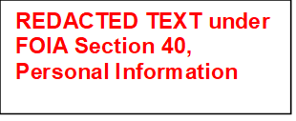
Change authorised to proceed by: (Customer’s representative):
23/02/23

Signature Print Name and Job Title Date
Authorised for and on behalf of the Supplier:

23/02/2023

Signature Print Name and Job Title Date
Authorised for and on behalf of the Customer:
27/02/2023

Signature Print Name and Job Title Date

