**Tendring District Council**

**Specification**

**TDC Sports Facilities-**

**Air Conditioning Compliance**

**07/2022**



**Our Vision**

***To put community leadership at the heart of everything we do through delivery of high quality, affordable services and working positively with others.***

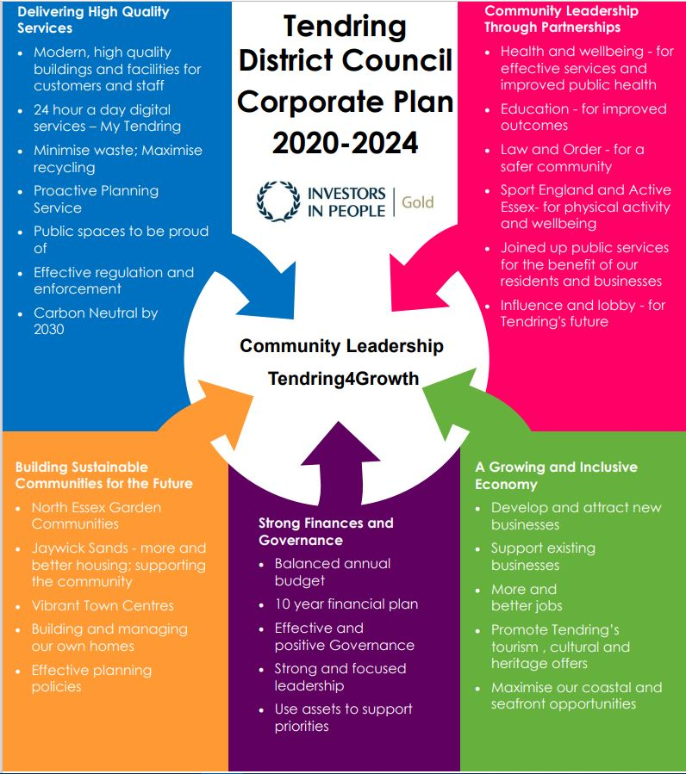

**Our Values**

♦ Councillors and staff uphold **personal integrity, honesty** and **respect** for others

♦ **Innovative, flexible, professional** staff **committed** to delivering excellence

♦ Recognising the diversity and equality of individuals

♦ Working **Collaboratively**

1. **Executive summary**

Tendring District Council operates 3 Sports Facilities within the Tendring peninsula. Each site is a thriving facility & based at the heart of the community. We pride ourselves on offering safe, hygienic, friendly & customer focussed facilities within an ever evolving environment. We endeavour to find the best value for the services that we provide & the products that we use within our facilities. The following facilities will be included within the contract;

1. Clacton Leisure Centre, Vista Road, Clacton-on-Sea , Essex CO15 6DB
2. Walton-on-the-Naze Lifestyles, Princes Esplanade, Walton on the Naze, EssexCO14 8PZ
3. Dovercourt Bay Lifestyles, Low Road, Dovercourt, Essex CO12 3TA

Bi-annual Planned Preventative Maintenance- Schedule of Plant

1. Service visits per site over 3 year contract term).

The works comprise of the following schedule of plant within Clacton Leisure Centre.

Air Conditioning Schedule of Plant at Clacton Leisure Centre

Reception 1x Mitsubishi Wall Mount AC

Meeting Room 1x Mitsubishi Cassette

Gym 4x Mitsubishi Cassette

Dance Studio 2x Mitsubishi Cassette

Dance Studio 2, 2x Mitsubishi Cassette

Small Admin Office 2x Mitsubishi Cassette AC

Main Office 1x Toshiba Wall Mount AC

Air Conditioning Schedule of Plant at Walton-on-the-Naze Lifestyles

Gym 2x Mitsubishi Cassette

Managers Office 1x Hitachi Wall Mount AC

Air Conditioning Schedule of Plant at Dovercourt Bay Lifestyles

Three heat pump type outdoor units and one cooling only outdoor unit, which are connected to their respective indoor terminal units via a 2-pipe refrigerant system. The installed units comprise of two Mitsubishi Electric and one Fujitsu single split units and one Mitsubishi Heavy Industries multi split unit. The outdoor units are connected to four indoor terminal units. The indoor terminal units have dedicated remote or wall mounted controllers.

Ventilation is provided by four supply and extract Air Handling Units (AHU's) of which only one serves the gym/fitness suite which has cooling installed. The other AHU's provide heating only to the pool area, changing rooms and foyer, which does not have cooling installed.

Compliance/ Maintenance & Servicing Schedule, Air Conditioning, as stated above.

Major Service (Bi-Annual)

Planned preventative maintenance to be carried out to scope of plant as described above, in accordance with manufacturer recommendations.

Condenser Units

* Chemically clean/ check coils
* Straighten coil fins as required
* Check coils for corrosion
* Clean/ check Electrical Panel
* Check/ tighten Electrical connections
* Check/ test compressor Amp’s per phase
* Test/ check liquid & suction filter, td to be checked
* Check/ test pipework for chaffing
* Check/ test pipework for Gas Leaks
* Check/ clean bodywork (rust & corrosion)
* Check/ test all safety devices
* Check/ test condenser fan motor direction
* Check/ test fan motor Amp’s
* Check/ tighten condenser fan motor blade
* Check/ test operation of unit
* Check interconnecting wiring & pipework
* Visually inspect fixings & hangers
* Check/ clean plant room/ areas as required

Fan Coil Units

* Check & Clean evaporator coil & filter
* Check coil for damage
* Check/ clean drip pan
* Check/ clean & test drain
* Check/ clean evaporator fan
* Check/ clean/ test & tighten Electrical Panel
* Check/ test & tighten Electrical connections
* Supply Air Diffusers, check & clean
* Check/ clean return Air Grilles
* Check/ clean/ test condensate water pump
* Check pipework for Gas Leaks
* Check/ clean/ test ON/OFF Air Temperature Check & Log
* Check/ clean/ test Air Flow, Check & Log
* Check/ clean/ test Valve & Actuator Operation
* Check/ test Operation of Unit
* Check/ tighten Interconnecting Wiring
* Check Interconnecting Pipework & Insulation
* Check/ tighten Fixings & Hangers
* Check/ clean Plant Room areas as required

F-Gas Regulations- Annual test

As part of the regulations to control the emission of ‘Greenhouse Gases’, the UK brought in strict guidelines on the containment of these gases, which became mandatory on 4th July 2007. Engineers must have ‘F’ Gas Certification. A mandatory refrigerant leak test to be carried out annually.

1. **Requirements for proposal**

All Contractors will need to ensure that the following insurance levels are in place throughout the duration of the Contract. Evidence will be required prior to the confirmation of a contract with any relevant renewal information subsequently relayed to the Operations Manager.

* + Employer’s Liability Insurance  = £5m
  + Public Liability Insurance = £5m
  + Professional Indemnity Insurance = £5m

Copies of Staff Qualifications will be required ensuring that Staff who complete works hold the relevant qualifications/ experience to ensure they are competent to complete the works in line with the relevant governing body & industry standards.

Where companies are unable to provide evidence of a Safeguarding Policy we would require them to sign up to Tendring District Council’s Safeguarding Policy. Information can be requested from the Operations Manager as applicable.

All Contractors working on site must be aware of Asbestos within the building & must have read the Asbestos Management Plan prior to the commencement of any works. Any Contractors working within these environments will be required to complete a Permit to Work, see section 5(v) & sign/comply with the Asbestos Management Plan taking all necessary precautions.

Permits to Work will be required to be completed on each visit on site where applicable. Please report to the Duty Officer at Reception who will organise a Permit. This must be displayed within your work area whilst on site.

Technical Requirements

Copies of Staff Qualifications will be required ensuring that Staff who complete works hold the relevant qualifications/ experience to ensure they are competent to complete the works in line with the relevant governing body & industry standards.

1. **Timescales**

The key dates for this RfQ are:

RfQ Response Deadline: 08/08/2022

Contract Duration: 3 years + 1 + 1

To organise Site visits please contact Daniel Kerridge at [dkerridge@tendringdc.gov.uk](mailto:dkerridge@tendringdc.gov.uk) and CC [Michael.banahene@essex.gov.uk](mailto:Michael.banahene@essex.gov.uk)

|  |  |
| --- | --- |
| **Project Milestone** | **Date** |
| Site visits finish | 29th July 2022 |
| Clarifications close | 29th July 2022 5pm |
| Tender close | 8th August 2022 12 noon |

1. **The** **Authority’s Policies** **& Statements**

The bidder will need to adhere with the below policies and statements.

* Data Protection (please see Appendix D)
* Freedom of Information (please see Appendix F.

**Modern Slavery**

The bidder self-certifies that they are taking steps to ensure that there is no modern slavery or human trafficking (as defined in the Modern Slavery Act 2015) in their organisation or supply chain relating to the requested services/supplies requirements.

Here is a link to the Act: <http://www.legislation.gov.uk/ukpga/2015/30/contents/enacted>

**Health and Safety**

The bidder self-certifies that they adhere to the Health & Safety at work Act. Any Here is a link to the Act: <http://www.hse.gov.uk/legislation/hswa.htm>

**Environment**

The bidder confirms that they are aware of Tendring District Council’s Environmental Statement, and should they be successful, they are committed to working with the Council fulfil the vision outlined in the Statement.

<https://www.tendringdc.gov.uk/environment>

1. **E-procurement requirements**

Tendring District Council has an fully automated Purchase to Pay (P2P) system.

The successful bidder will be able to:

* View their orders online;
* Update their status;
* Notify delivery; and
* Submit and monitor the status of electronic invoices, once they have been submitted.

Orders will be sent electronically to the successful bidder’s central e-mail address from the contract start date.

The successful bidder will be expected to submit electronic invoices from the contract start date. On approval of the electronic invoice an automatic payment will be made via BACS, direct to the successful bidder’s bank account supported by an e-mailed remittance advice, in line with Tendring District Council’s contracted payment terms.