SUPPLY & INSTALLATION OF PLAY and ANCILLARY EQUIPMENT
AT
HOWARD ROAD PLAY AREA
OX16 4QY

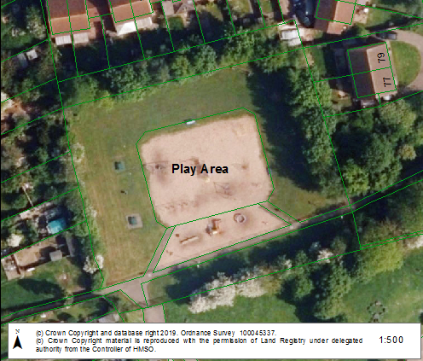

SITE DESCRIPTION & BRIEF

General Access
As can be identified from the aerial photograph at 1:200 scale the site (Appendix 1) has restricted vehicle access via Winchester Close. There is a larger opening via the private road/ driveway for Nos 77 – 85 Winchester Close but this is (as mentioned) private land along with the grass strip at the side of it, therefore there is no vehicle access along this route.
Access for vehicles to the site is along the public footpath leading off Winchester Close but contractors must be aware that any damage to the soft landscaping alongside the footpath or the footpath itself would require reinstating to the satisfaction of Banbury Town Council at the contractors own expense.

Site Layout – (see Appendix 2)
- The site consists of:-
- a bark loosefill safer surface, which has a surface area of 788m².
- 1,250m² of grass
- 64m² of bitmac surfaces (footpaths and vehicle access)
- there is also roughly 10m² of hard surfacing under one of the picnic tables

- Some of the play equipment will will be removed prior to a contractor starting work on the site including:-
- Kompan Supanova
- Eibe seesaw

- The remaining play equipment is to be removed by the contractor to his own tip including:-
- 4 seat cradle swing unit
- Basket swing unit (basket & chains to be retained)
- 2 seat flat
- Tube climber
- Timber climber
- <5 climbing frame
- >5 climbing frame
- 3 x springers
- Timber trim trail (on grass area) – grass area to be reinstated after items have been removed as required by the specification and satisfaction of Banbury Town Council

- The ancillary play equipment such as the benches and picnic tables are to be retained and included in the new design. The litter bin to the west of the site (damaged by fire) is to be replaced along with the bin on the east side with covered bins having a roof.

- The site is fenced off along the main pedestrian footpath with approximately 55 lin m of bowtop fencing that may be replaced along with 2 x pedestrian gates and a 2.9m wide vehicle access gate. The timber post and rail fencing to the rear of the siteis to be retained.

Proposals
- To remove all the loosefill safer surfacing and replace this with a bitmac surface in which the new equipment (and safer surfacing) will be located. Not only will this reduce the amount of safer surfacing needed but it will help improve drainage and make the site more DDA compliant and therefore accessible for all abilities.

- To remove the remaining play equipment to contractors own tip as indicated above, to enable the supply and installation of new play equipment onto the site. The whole area is available for new equipment and it is up to the contractor to design the new layout within the site indicated to the best possible use and purpose, (which may require the retained items to be moved with new anti-erosion (hard) surfaces intalled).

- The safer surfacing required can be either wet pour or ecoscape but the Town Council’s preference is for ecoscape.

  - All works, whether it is play equipment or safer surfacing, must comply with current standards and be followed up by an RPII Certified Inspector’s Post Installation Report (external to the company supplying and installing the new items) confirming this is the case. With any identified snagging items rectified to bring items up to the required standard prior to the submission of the final invoice.

  - If the contractor chooses to use the grass area for new equipment and safer surfacing it should be made accessible to comply with DDA requirements.

- To incorporate where possible the wishes of local children as identified in the specification and also where possible ensure that any new equipment is available for users of all physical and mental abilities.

- To produce a play area with maximum play value for all abilities and for children up to the age of 12.

- To be exciting, providing initiative and adventure for children of all ages but separating the equipment to cater for the different age groups.

- Banbury Town Council would also like to see the fencing and gates replaced, which are due for replacement but this will depend upon cost of proposals being put forward and whether it impacts on the play value of the site.

- Drainage is a problem with this area and Banbury Town Council would seek the new facility to have alleviated this within the design to ensure the facility is available for use all year round.

- The winning design to be chosen will be based upon the the proposals being offered for the budget of £100,000. The contract will be awarded following consultation with local councillors. Price and the quality of the design will factor in the final analysis.

- The equipment to be installed is to be galvanised and powder-coated metal with minimal items that can be damaged by fire, anti-social behaviour or vandalism. No timber equipment will be considered unless it is fitted to steel anchours (feet) into the ground. All equipment must be guaranteed for at least 15 years and preferably more.

- The signage is to be replaced to the same size as existing with artwork conforming the the standard playground sign shown below.

- The work is to be completed by the end of October 2019 at the very latest.

- A retention of 5% will be held back upon completion of the contract until 12 months maintenance has been accomplished.

