Overview

As a response to the Montgomery ruling (https://www.rcog.org.uk/globalassets/documents/members/membership-news/og-magazine/december-2016/montgomery.pdf)
‘iDecide’ was developed by NHSE&I and NHSX in collaboration with Royal College of Obstetricians and Gynaecologists , Royal College of Midwives and Birthrights, to support staff in improving communication and intrapartum safety and personalisation through informed decision-making and consent during labour.
Immediacy (how urgent is the situation?)
Details of the situation (what’s happening?)
Exchange of information (including the PCSP)
Choices (options available and access to information, including BRAIN)
I confirm I understand (opportunity to ask questions)
Decision (and consent)
Evaluation* (during the postnatal period)

*E - Evaluation to ensure a robust and proactive feedback mechanism for the person giving birth and for the clinician/trust/NHS to contribute to continued improvement of outcomes and experience.

In 2020/21 a digital prototype of ‘iDecide’ was developed and the concept has been feasibility tested in 3 maternity units. Further development of the digital tool and wider piloting is now required to further evaluate the initial findings:

Where ‘iDecide’ has been feasibility tested, testing suggests:

- staff are better equipped for intrapartum conversations, so delay in time sensitive interventions by protracted discussion at that point is avoided, therefore preventing brain injury/neonatal mortality/morbidity

- those giving birth are more prepared, and have improved experience, having received information and had personalised conversations antenatally, so that informed-decision making and consent is facilitated

Background

The iDecide team, comprised of NHSE&I and NHSX colleagues, commenced a collaborative Discovery and Alphas phase in March 2020. The aims initially were to test the validity of both the iDecide acronym structure and a digital tool being used to stimulate the discussion of informed decision-making and consent. This was followed by an Alpha phase developing the digital iDecide tool and Feasibility testing to ensure clinician input at local level.

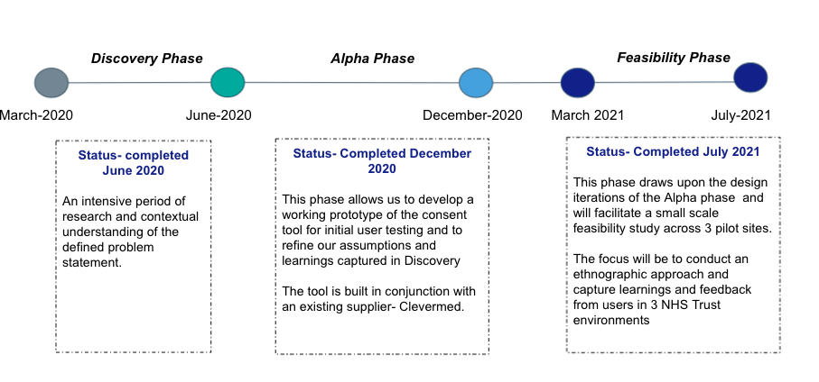
Next Steps
Following the feasibility study, there is now a need to ensure that any future solution can meet the needs of the service and that commercially it is the right solution.

When we started this original programme we went out to the digital ecosystem. To understand and engage with all potential suppliers that may be able to support the feasibility study phase. At the time only one supplier was able to engage on the known parameters at the time.

Whilst the parameters remain broadly the same the landscape is different and we have more understanding of the potential need, therefore we would like to undertake a new market engagement exercise to test the outputs from the feasibility study, and understand who in the market could potentially support us as a programme to take this forward. Whilst we have the feasibility study, based on one model we believe there may be other innovative solutions to deliver this programme hence our request for the market to re-engage with us.

Next steps would be to develop a specification that we can take to market and establish if there is a new appetite to offer solutions. Before we engage in a formal procurement, we would like to understand further whether there is renewed interest in our programme given the tangible data now available. Therefore we would like to seek expressions of interest from the market and whether organisations would be happy to attend a webinar of 3rd March 2022 (further details to follow)

To express an interest in potentially engaging in future dialogue for this programme and to receive an invite to the webinar please contact us via email at england.digitalmaternitynhsx@nhs.net with the following information

Organisation Name

Contact person
Contact details Phone & Email.
1-2 sentences on what your organisation delivers.

Please note by expressing an interest in potentially engaging with this programme you are not committing to actively engaging nor to participate in any future dialogue.

Any questions please contact at the email above.

