

Integrated Homeless Service- proposed contracting and reimbursement approach- Discussion paper

Executive Summary
This discussion paper illustrates that providing some kind of gainshare arrangement between the CCG and the service provider for the proposed Integrated Homeless Service is a feasible way of incentivising the delivery of integrated primary care for the homeless population of Tower Hamlets. After reviewing various options and approaches, the following approach to contracting and reimbursement is recommended, within the basis of a standard NHS contract with an APMS service schedule:
- An agreed contract value for delivery of the service
- A Local Incentive Scheme with the provider to be eligible for payment for performance against agreed thresholds. These to be paid quarterly, in-year and to comprise a small percentage of the agreed contract value (e.g. between 1-5%)
- Should LIS performance targets be met, the provider to be eligible for ‘gainsharing’ payments. These to be calculated as notional savings delivered against a forecast spend based on an estimated per capita spend. Pending further analysis, this per capita spend is forecast to be £841. Therefore any ‘savings’ realised to the CCG by a reduction in per capita spend from this £841 forecast should be shared with the service provider. It is recommended that this payment be equivalent to 60% of any savings realised (i.e. if per capita spend is £741 per patient, then £60 of that ‘saving’ will be paid to the service provider, and £40 of that ‘saving’ will be retained by the CCG’.) This payment to be made retrospectively, once Year End data has been validated.
Next steps:
- This discussion paper to be shared with potential providers of the Integrated Homeless Service for review and discussion.
- Further analysis to be conducted by the CCG to identify:
  - The actual amount of CCG spend on acute care that is delivered in the Royal London as opposed to other acute settings (for 2012/13 onwards)
  - A longer retrospective analysis of acute spend from 2012/13 onwards to develop a more accurate forecast of likely spend in Year 1 of the contract (19/20).
  - More detailed analysis of historic list size data at Health E1 and other primary care practices, and further analysis of demographic and socio-economic data regarding housing and homelessness in the borough to enable the CCG to develop a more accurate forecast of likely future list size.
  - If data are available, further analysis to identify how spend on acute mental health care could be included in future contracting arrangements. If data are not available, the data requirement could be included in the new contract’s Minimum Dataset requirements.
- Further work with the Healthy London Partnership clinical advisor and other stakeholders to develop a local incentive scheme for this population, including indicators, measurement approaches and proposed targets

Options for Contracting and Reimbursement for the Integrated Homeless Service
The Health E1 primary care service is a specialist primary care service for the homeless population of Tower Hamlets. People who are homeless traditionally experience poorer health outcomes and experience worse health states than the majority of the population. While a lack of suitable accommodation constrains the ability of health and care services to influence patient outcomes, there are still improvements to how delivery of primary and secondary preventative mental and physical health care, care coordination and case management could be improved that could significantly influence both patient experience and individual and population health outcomes. It is also possible (although not proven) that by delivering these improvements in care, it could impact on the population’s use of acute care services –including accident and emergency, inpatient care (both planned and elective) outpatient and secondary mental health inpatient care. A reduction in inappropriate or avoidable use of these services could potentially reduce the amount that the CCG spends on acute care services. A non-traditional contracting and reimbursement model could enable some of these CCG savings to be re-invested in further service transformation.
The CCG’s intention to recommission a number of homeless health services, including the Health E1 contract as an Integrated Homeless Service offers an opportunity to test the hypothesis that a more integrated service will deliver improvements in care, and outcomes, and result in system savings. The purpose of this paper is to explore some of the questions that will need to be considered when designing a contracting and reimbursement model that can drive system transformation. The analysis presented below is crude at this stage, and uses a limited range of data, but both the assumptions underpinning the analysis and the data used to model potential approaches can be refined over time to inform the accuracy of the analysis.
The CCG is proposing a 10 year contract. In a pre-procurement engagement event held on 23rd May, potential providers of the service were asked their views on a risk/share arrangement. Taking into account the responses from that event, this paper is intended to provide further information on the CCG’s views as to how this could work. In principle, we would like to propose something that includes:
- a fixed level of income guaranteed within the contract which is sufficient to deliver the core service
- A Local Incentive Scheme within which the provider is to be eligible for payment for performance against agreed thresholds. These to be paid quarterly, in-year and to comprise a small percentage of the agreed contract value (e.g. between 1-5%)
- Should Local Incentive Scheme performance targets be met, the provider to be eligible for ‘gainsharing’ payments. These to be calculated as notional savings delivered against a forecast spend. This payment to be made retrospectively, once Year End data has been validated.
In order to do this, the CCG needs to be sufficiently confident in its prediction of what the likely spend on acute services for this population would be over the next ten years (or for each forthcoming year over a ten year period) in the absence of any savings realised from an improved model of care. This requires a sufficiently reliable forecast of:
- Total population: i.e. how many people are likely to be registered with the HealthE1 practice OR be registered at ANY primary care practice in Tower Hamlets and meet an agreed definition of ‘homeless’.
- What is the average and/or total spend on this population in acute settings likely to be in the next 10 years, or for each forthcoming year over a ten-year period.
A: Population
Crisis, a homeless charity, forecasts that with no change in government policy, Greater London is likely to see an increase in ‘core’ homelessness (i.e. rough sleeping, sofa surfing, hostel accommodation etc.) in future years. Their definition of ‘homeless’ doesn’t directly align to definitions used in Tower Hamlets JSNA, but if we assume an increase in the HealthE1 practice list similar to the likely forecast increase in homelessness across London, then the practice list size could increase by approximately 40% over the next ten years. Policies which could impact on this rate of increase include housing policy, policies to alleviate poverty, and policies to improve social care services to reduce the number of people who are at risk of homelessness. The most conservative estimates of a likely population increase would see the list size increase from 1264 in 2016 to an estimated 1336 in 2026, an increase of only 6%. A crude adaptation of the Crisis forecast to the HealthE1 list size is detailed below:
Table 3: Crude modelling of various scenarios impacting on E1 practice list size
E1 practice | 2016 | 2017 | 2018 | 2019 | 2020 | 2021 | 2022 | 2023 | 2024 | 2025 | 2026
Static list size | 1264 | 1264 | 1264 | 1264 | 1264 | 1264 | 1264 | 1264 | 1264 | 1264 | 1264
Crisis forecast | 1264 | 1320 | 1376 | 1432 | 1488 | 1545 | 1601 | 1657 | 1713 | 1769 | 1825
Static poverty | 1264 | 1282 | 1300 | 1318 | 1337 | 1355 | 1373 | 1391 | 1409 | 1427 | 1445
60% increase in housing supply | 1264 | 1304 | 1343 | 1383 | 1422 | 1462 | 1501 | 1541 | 1580 | 1620 | 1659
maximal prevention | 1264 | 1271 | 1278 | 1286 | 1293 | 1300 | 1307 | 1314 | 1322 | 1329 | 1336

Obviously, an increase in population size, without any concurrent reduction in per capita health spend on this population would mean that the overall CCG spend on acute care for this population would increase.
Another way that the population could increase is if the definition of the ‘population’ is expanded from solely the HealthE1 practice population to anyone whose housing status is registered as ‘homeless’ at any Tower Hamlets GP practice. It is a new requirement of the Homelessness (Reduction) Act 2017 for Primary Care practices (and other health services) to record housing status, and it will be some time before the records are ready to be used to inform population estimates or identify spend on acute services for these patients. One proxy indicator that does currently exist is the Pathway service activity data. The Pathway service provides discharge support to homeless patients leaving hospital. Between November 2015 and July 2017, of the 629 patients the service saw, 7% were registered at E1, 27% were registered elsewhere in Tower Hamlets, and the remainder were registered elsewhere in London and the UK. This suggests that inclusion of a broader definition of the ‘homeless’ population could have a significant impact on the CCG’s estimate of potential savings from potential spend on acute care. However, given the quality of data at this stage, it is recommended that the CCG keep a narrow definition of the population as only those who are registered at HealthE1 practice for the first five years of the contract.
Factors within the provider’s control that can influence the list size are the extent to which the service proactively works with other service providers and directly with the homeless population within Tower Hamlets to ensure that they are registered with a primary care practice, and the extent to which the HealthE1 practice is working to support the practice population to appropriately access mainstream health services and move on to mainstream GP services once they are safely housed. It may be that the Local Incentive Scheme can be used as a lever to drive these behaviours.
Recommendations: Use ‘registered at HealthE1 practice’ as population definition. Further analysis to more accurately forecast likely list size for Y1 of the contract, and evaluate whether the Local Incentive Scheme should be used to facilitate outreach to unregistered patients or move on to mainstream services for patients that are safely housed.
B: Average or total spend on this population
The analysis presented below is based on 23 months of data on the cost to the CCG of providing acute care to the Health E1 population, including all acute service providers both in and outside of London. At this point, this does not include CCG spend on inpatient mental health care. Further iterations of this analysis could isolate the spend of the CCG on healthcare for this population solely as delivered within Tower Hamlets (i.e. at the Royal London), or across London generally as opposed to elsewhere in the country. Further analysis may be able to identify current and historic CCG spend on inpatient mental health care, but this is traditionally funded on a block contract basis and is therefore harder to analyse on a per capita basis.
Table 4: Analysis of 2 years of acute data for the HealthE1 practice population
Acute Spend on E1 Population (Barts and others) | 16/17 | 17/18 M11 | 17/18 YE forecast | monthly average | annual total of monthly average | 16/17 per capita | 17/18 per capita | annualised average per capita
A&E | £ 208,299 | £ 217,441.00 | £ 237,208 | £ 18,510 | £ 222,125 | £ 164 | £ 173 | £ 162.
Non-elective admissions | £ 680,101 | £ 574,316 | £ 626,527 | £ 54,539 | £ 654,478 | £ 537 | £ 458 | £ 479
ALL inpatient | £ 922,237 | £ 812,968 | £ 886,874 | £ 75,443 | £ 905,324 | £ 729 | £ 649 | £ 662
ALL outpatient | £ 152,372 | £ 162,626 | £ 177,410 | £ 13,695 | £ 164,347 | £ 120 | £ 129 | £ 120
All acute costs | £ 1,282,908 | £ 1,193,035 | £ 1,301,493 | £ 107,649 | £ 1,291,796 | £ 1,014 | £ 952 | £ 945
all emergency and non-elective costs | £ 888,400 | £ 791,757 | £ 863,735 | £ 73,050 | £ 876,604 | £ 702 | £ 632 | £ 641

What this table illustrates is that with just a two year dataset it is difficult to forecast future spend: from these two years it looks like the spend on some points of delivery is decreasing year-on-year without any change in the model of care or the contracting and reimbursement model. For some points of delivery the year-on-year ‘trend’ indicates that spend is increasing. However neither of these years might be ‘typical’ and drawing conclusions from just two years of spend data may lead to an inaccurate forecast of the ‘counterfactual’, i.e. the amount that the CCG has ‘saved’ by not spending as it would if it had continued with business as usual.
Some illustrations of how the interplay of possible changes to the size of the population and interpretations of ‘trends’ in spending could influence the CCG’s assessment of the potential ‘savings’ available over a 5 year period are presented below:
Table 5: Forecast spend on acute care for Health E1 practice population based on 'trend' in total spend in two year period
 |  |  |  | Y1 | Y2 | Y3 | Y4 | Y5
Acute Spend on E1 Population (Barts and others) | 16/17 | 17/18 Forecast YE | 18/19 Forecast | 19/20 forecast | 20/21 | 21/22 | 22/23 | 23/24
A&E | £ 208,299 | £ 237,208 | £ 270,130 | £ 307,621 | £ 350,315 | £ 398,934 | £ 454,301 | £ 517,353
Non-elective admissions | £ 680,101 | £ 626,527 | £ 577,172 | £ 531,706 | £ 489,821 | £ 451,236 | £ 415,690 | £ 382,945
ALL inpatient | £ 922,237 | £ 886,874 | £ 852,867 | £ 820,164 | £ 788,716 | £ 758,473 | £ 729,389 | £ 701,421
ALL outpatient | £ 152,372 | £ 177,410 | £ 206,563 | £ 240,506 | £ 280,026 | £ 326,041 | £ 379,617 | £ 441,996
All acute costs | £ 1,282,908 | £ 1,301,493 | £ 1,320,347 | £ 1,339,474 | £ 1,358,878 | £ 1,378,563 | £ 1,398,534 | £ 1,418,793
all emergency and non-elective costs | £ 888,400 | £ 863,735 | £ 839,755 | £ 816,440 | £ 793,773 | £ 771,735 | £ 750,309 | £ 729,478

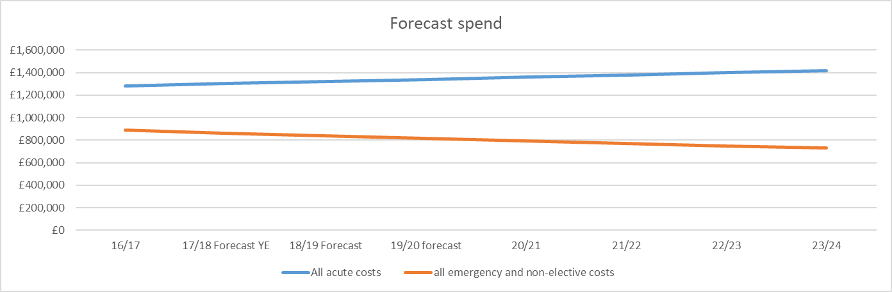
Figure 1: Forecast spend on acute care (excluding inpatient mental health care) for Health E1 practice population based on 'trend' in total spend in two year period

What this analysis illustrates is that if you assume that total spend on each POD will continue trend from 16/17 then the conclusion is total CCG spend on acute care for Health E1 patients will increase, but total spend on all emergency and non-electives will decrease (with no change to care model)

Table 6: Forecast per capita acute care spend on population, (excluding inpatient mental health care), based on two year 'trend'
 |  |  |  | Y1 | Y2 | Y3 | Y4 | Y5
 | 2016/17 per capita | 2017/18 per capita | 2018/19 | 2019/20 | 2020/21 | 2021/22 | 2022/23 | 2023/24
A&E | £ 165 | £ 174 | £ 183 | £ 193 | £ 204 | £ 215 | £ 226 | £ 239
Non-elective admissions | £ 538 | £ 459 | £ 391 | £ 334 | £ 285 | £ 243 | £ 207 | £ 177
ALL inpatient | £ 729 | £ 649 | £ 578 | £ 515 | £ 458 | £ 408 | £ 363 | £ 323
ALL outpatient | £ 120 | £ 130 | £ 140 | £ 151 | £ 163 | £ 175 | £ 189 | £ 204
All acute costs | £ 1,014 | £ 953 | £ 895 | £ 841 | £ 790 | £ 742 | £ 697 | £ 654
all emergency and non-elective costs | £ 702 | £ 632 | £ 569 | £ 512 | £ 461 | £ 415 | £ 374 | £ 336

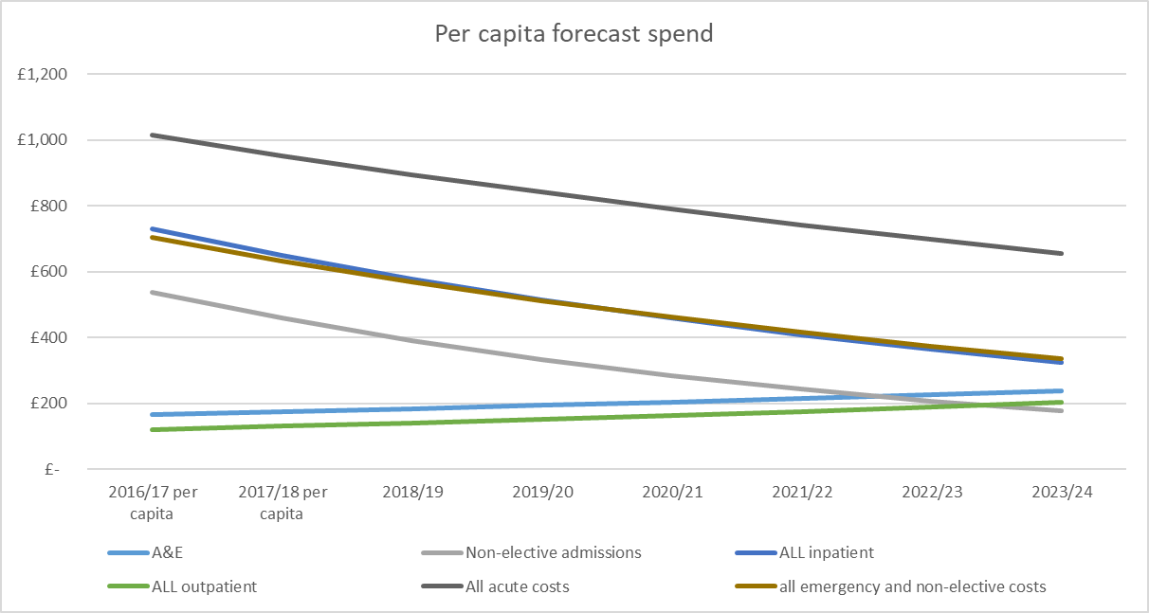
Figure 2: Forecast per capita acute care spend on population (excluding inpatient mental health care), based on two year 'trend'and estimated list size

If you assume per capita costs will follow trend of 16/17-17/18, then per capita costs will decrease for all POD care except outpatient and A&E, and decrease for the total spend within acute (‘all acute costs’) with no change to care model.

Table 7:: Total per capita spend on acute services (excluding inpatient mental health care) under various housing policy scenarios
 |  |  |  |  | Y1 | Y2 | Y3 | Y4 | Y5
 |  | 16/17 | 17/18 Forecast YE | 18/19 Forecast | 19/20 forecast | 20/21 | 21/22 | 22/23 | 23/24
Per capita forecast spend | All acute costs |  | £ 1,204,310 | £ 1,131,197 | £ 1,062,524 | £ 998,019 | £ 937,430 | £ 880,520 | £ 827,065
all emergency and non-elective costs |  | £ 887,873 | £ 799,239 | £ 719,454 | £ 647,633 | £ 582,981 | £ 524,784 | £ 472,396 | £ 425,238
list size Crisis forecast | All acute costs | £ 1,282,147 | £ 1,257,771 | £ 1,231,629 | £ 1,204,025 | £ 1,175,234 | £ 1,145,501 | £ 1,115,047 | £ 1,084,069
all emergency and non-elective costs |  | £ 887,873 | £ 834,719 | £ 783,329 | £ 733,881 | £ 686,500 | £ 641,264 | £ 598,219 | £ 557,378
list size maximal prevention | All acute costs | £ 1,282,147 | £ 1,211,168 | £ 1,144,081 | £ 1,080,676 | £ 1,020,753 | £ 964,123 | £ 910,606 | £ 860,034
all emergency and non-elective costs |  | £ 887,873 | £ 803,791 | £ 727,648 | £ 658,697 | £ 596,261 | £ 539,727 | £ 488,537 | £ 442,190

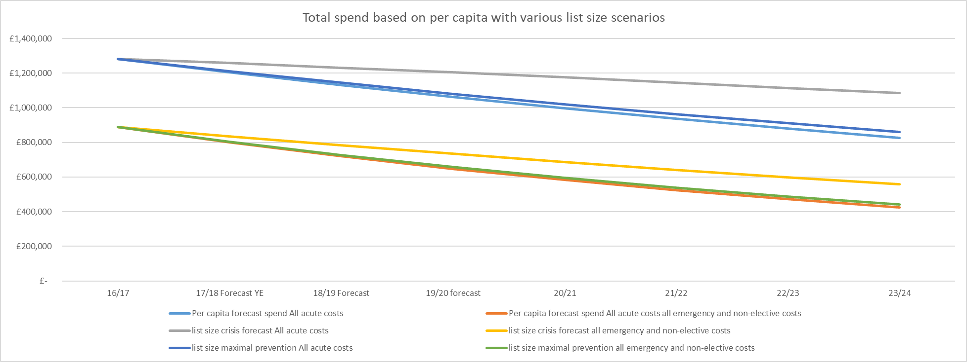
Figure 3: Total spend based on per capita assumptions with various list size scenarios
This chart shows the impact of housing policy on potential CCG spend (by increasing list size) without changes to the model of care. Because of the ‘trend’ of decreasing per capita spend on non-elective costs, this analysis suggests that over a five year period, the CCG’s total spend on non-elective and emergency care will decrease, regardless of list size. Changes to the population will only impact on the rate of decrease. However, the ‘trend’ for spend on A&E attendances in this data suggests an increase, resulting in a difference of approximately £100,000 at the five year point in terms of A&E total per capita spend on this population between maximal and minimal list size estimates:
 |  |  |  | Y1 | Y2 | Y3 | Y4 | Y5
 | 2016/17 per capita | 2017/18 per capita | 2018/19 | 2019/20 | 2020/21 | 2021/22 | 2022/23 | 2023/24
Total Spend A&E: Static | £ 208,175 | £ 219,496 | £ 231,432 | £ 244,017 | £ 257,286 | £ 271,277 | £ 286,029 | £ 301,583
Total Spend A&E: Crisis | £ 208,175 | £ 229,240 | £ 251,979 | £ 276,514 | £ 302,972 | £ 331,490 | £ 362,213 | £ 395,298
Total Spend A&E: Maximal prevention | £ 208,175 | £ 220,746 | £ 234,068 | £ 248,186 | £ 263,147 | £ 279,002 | £ 295,802 | £ 313,605
Figure 4: Total spend on A&E attendances based on various list size scenarios
To reflect the vagaries of the data, the recommended approach is to adopt a ‘per capita’ approach to estimate future spend, and take a year-on-year approach to forecasting the potential savings ‘pool’. This minimises the CCG’s risk of overestimating potential savings and allows for the analysis to become more reliable over the lifetime of the contract. If the potential savings pool is calculated using ‘all acute costs’ rather than just non-elective and/or A&E attendances, this reduces the distortion effect of trends within one part of the acute budget forecasting a decrease while other parts of the acute budget are forecast to increase.
Therefore the total estimate of ‘all acute spend’ forecast for the Health E1 population in 2019/20 (the first year of the contract) could be between £1,062,524 and £1,339,474 based on currently available data. Of this total, we must assume the following:
- Not all of the spend is at the Royal London Hospital
- The majority of the spend is ‘appropriate’ – i.e. the acute setting is the right setting for the care to have been delivered.
- Not all patients registered at HealthE1 are in contact with the practice and clinicians may not be able to influence their health behaviours, health status, health outcomes, or the likelihood of them requiring care within an acute setting in 2019/20.
With these assumptions, possible scenarios in Y1 of the contract are as follows:
Scenario 1: Decrease per capita cost but above forecast increase in list size |  | Scenario 2: Increase in per capita cost but list size below forecast |  | Scenario 3: Decrease in per capita cost and list size as forecast
Y1 (2019/20) |  | Y1 (2019/20) |  | Y1 (2019/20)
List Size estimate | 1264 | List Size estimate | 1500 | List Size estimate | 1264
Per capita estimate (no change to care model) | £ 841 | Per capita estimate (no change to care model) | £ 841 | Per capita estimate (no change to care model) | £ 841
Total forecast spend | £ 1,063,024 | Total forecast spend | £ 1,261,500 | Total forecast spend | £ 1,063,024
List size actual | 1456 | List size actual | 1456 | List size actual | 1264
Expected per capita total spend | £ 1,224,496 | Expected per capita total spend | £ 1,224,496 | Expected per capita total spend | £ 1,063,024
Per capita actual | £ 800 | Per capita actual | £ 845 | Per capita actual | £ 800
Total actual spend | £ 1,164,800 | Total actual spend | £ 1,230,320 | Total actual spend | £ 1,011,200
Notional 'savings' | £ 59,696 | Notional 'savings' | -£ 5,824 | Notional 'savings' | £ 51,824
Actual 'savings' against CCG forecast | -£ 101,776 | Actual ‘savings’ against CCG forecast | £ 31,180 | actual ‘savings’ against CCG forecast | £ 51,824
Figure 5: Illustration of various gainshare scenarios
Within these examples, the provider would be paid a percentage of the notional ‘savings’ in both Scenarios 1 &3, where a reduction in per-capita cost had been realised, even though in scenario 1 the total spend on acute services for this population was above the CCG’s forecasts, because it had assumed a smaller population size. This illustrates the need for accurate estimates of the list size to minimise the CCG’s risk.
The CCG will also need to decide what proportion of the notional ‘savings’ it makes eligible for the provider, and whether the provider should be exposed to downside risk- i.e. should the provider be prepared to assume the notional ‘loss’ made in Scenario 2, where the per capita cost has increased?.
Ensuring quality within this contracting and reimbursement model
Obviously, the easiest way for this approach to contracting and reimbursement to be ‘gamed’ would be for the service providers to ‘collude’ to inappropriately deny acute care to the population, thereby reducing per capita spend at the expense of patient care. It is therefore essential to ensure that there is no denial of care, and to take reasonable steps to attribute any reduction in spend to the delivery of better quality care, including primary and secondary prevention, care coordination and case management.
Data from the Primary Care Indicators tool (https://www.primarycare.nhs.uk/ ) illustrates some of the areas where the Practice performs worse than the borough or London on core quality metrics:
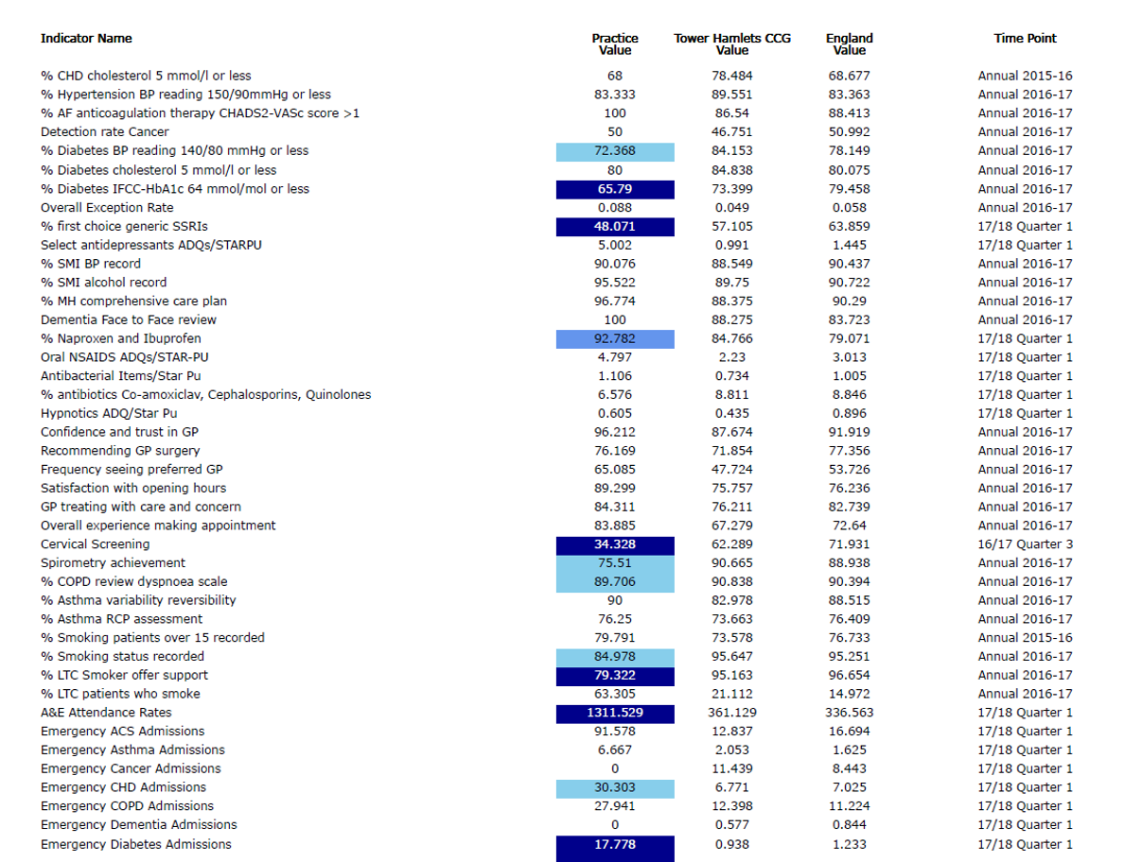
Figure 6: Health E1 performance against various General Practice Indicators
As discussed previously, interpretation of this data needs to take into account not only the basic health state of the practice population but also their vulnerable housing status, making adherence to any health and care plan significantly more challenging than it would be for an average Tower Hamlets resident. However, there are examples of good practice in how primary and secondary preventative care can be delivered to this population, and effective care management techniques for long term conditions. It therefore seems feasible to assemble some kind of ‘homeless care’ local incentive scheme which incorporates various aspects of the primary and community care pathway (as illustrated below).

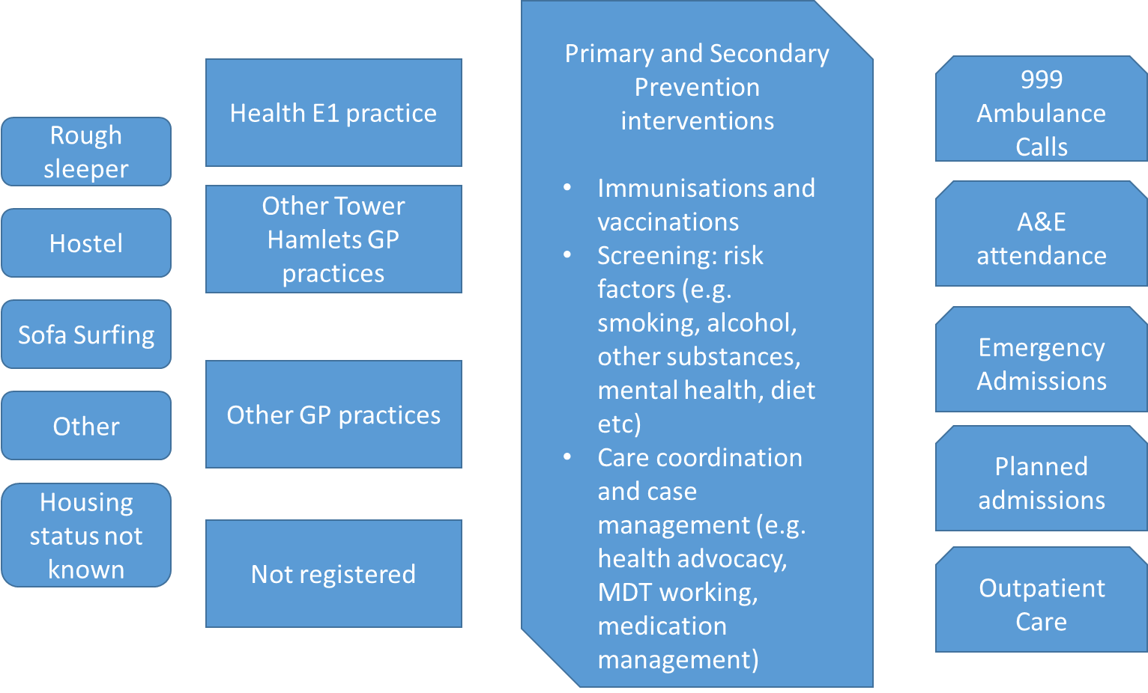
Figure 7: Basic Homeless Care Pathway
Ways in which an Integrated Homeless Service could influence this pathway to improve care delivery, and potentially patient outcomes and associated spend in the acute sector, are highlighted in the diagram below:
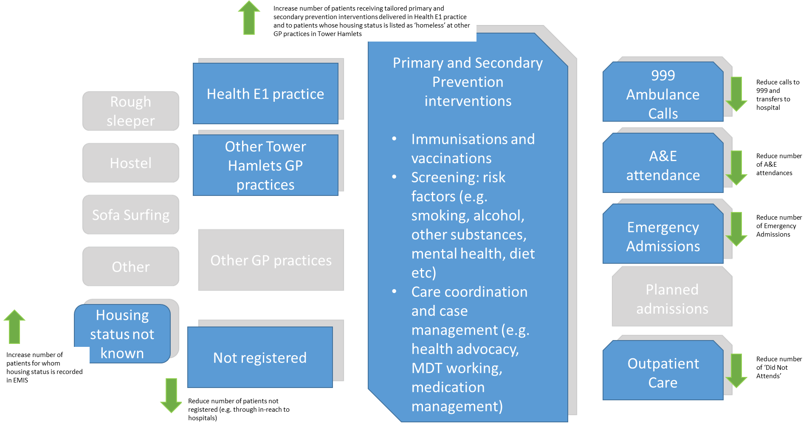
Figure 8: Opportunities for the Integrated Homeless Service provider to influence the homeless health care pathway

As has been noted elsewhere in the paper, there is also potential to impact on inpatient mental health spend for this population. However, there are additional primary and secondary mental health services outside of the scope of the Integrated Homeless Service model that also influence these outcomes, and the data on spend on these services is less readily available, therefore it may not be feasible to include this in the gainshare arrangement at this time. This is illustrated in figure 9, below:
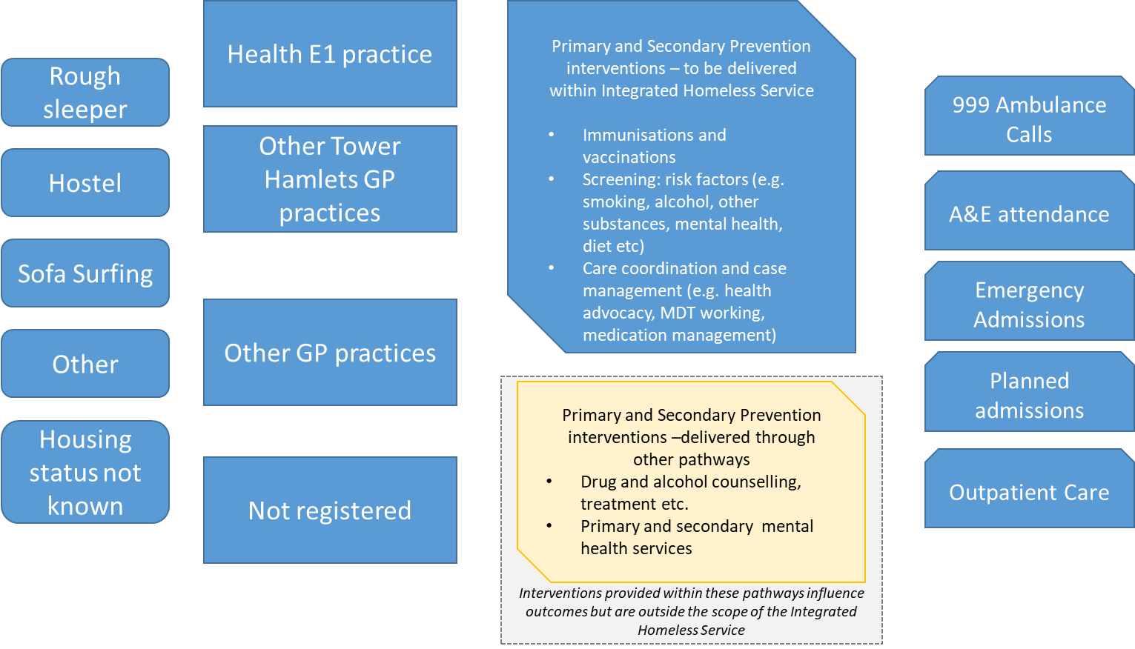
Figure 9: interventions outside of the scope of the Integrated Homeless Service that impact on inpatient mental health service utilisation

Proposal for a Local Incentive Scheme
A final consideration is the interplay between the ‘local incentive scheme’ or ‘LIS’ and the ‘gainshare’ arrangement. The CCG could require some form of minimum level of performance within the LIS in order to be eligible for the gainshare arrangement. Equally, the CCG could require the service provider to be eligible for some element of downside risk if a minimum level of performance against the LIS is not achieved. A summary of possible scenarios is illustrated below:
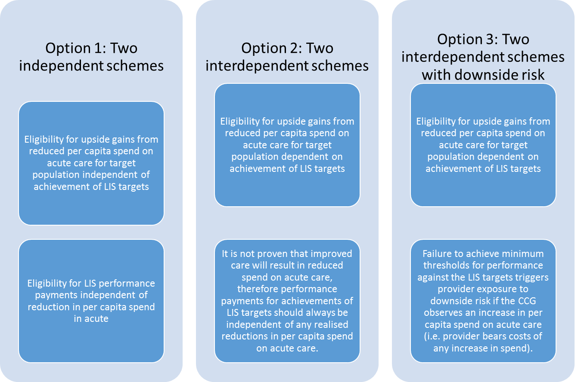
Option 2 is the recommended approach at this point in time. Reaching an appropriate level of performance against agreed LIS targets provides some evidence to the CCG that it is the actions of the provider that have influenced any observed reductions in per capita spend. Option 3: exposing the provider to some downside risk, is not recommended at this time because a) it is likely to be difficult to implement and enforce and b) because the data are not robust enough to determine that any increase in per capita spend above forecast levels is the result of poor quality care in primary care, and not the result of inaccurate forecasting of likely per capita spend. Option 3 may be worth revisiting at a later point in the contract.

Gainsharing
The final question with regards to contracting and reimbursement design is how much of the ‘gain’ should be shared. It is recommended that at this stage the CCG retain 40% of any ‘savings’ realised. This is to allow for further incentivisation for the service provider later in the contract, with the possibility of, for example 75-100% of any ‘savings’ being awarded to the service provider in exchange for agreeing to accept downside risk should per capita costs increase above forecast.
Conclusion
This discussion paper illustrates that providing some kind of gainshare arrangement between the CCG and the service provider for the proposed Integrated Homeless Service is a feasible way of incentivising the delivery of integrated primary care for either the homeless population of Tower Hamlets or the registered E1 practice population. After reviewing various options and approaches, the following approach to contracting and reimbursement is recommended:
- An agreed contract value for delivery of the service
- A Local Incentive Scheme with the provider to be eligible for payment for performance against agreed thresholds. These to be paid quarterly, in-year and to comprise a small percentage of the agreed contract value (e.g. between 1-5%)
- Should LIS performance targets be met, the provider to be eligible for ‘gainsharing’ payments. These to be calculated as notional savings delivered against a forecast spend based on an estimated per capita spend. Pending further analysis, this per capita spend is forecast to be £841. Therefore any ‘savings’ realised to the CCG by a reduction in per capita spend from this £841 forecast should be shared with the service provider. It is recommended that this payment be equivalent to 60% of any savings realised (i.e. if per capita spend is £741 per patient, then £60 of that ‘saving’ will be paid to the service provider, and £40 of that ‘saving’ will be retained by the CCG’.) This payment to be made retrospectively, once Year End data has been validated.
  - A longer retrospective analysis of acute spend from 2012/13 onwards to develop a more accurate forecast of likely spend in Year 1 of the contract (19/20).
  - More detailed analysis of historic list size data at Health E1 and other primary care practices, and further analysis of demographic and socio-economic data regarding housing and homelessness in the borough to enable the CCG to develop a more accurate forecast of likely future list size.
  - Further work with the Healthy London Partnership clinical advisor and stakeholders (including potential bidders) to develop a local incentive scheme for this population, including indicators, measurement approaches and proposed targets.

Discussion questions for potential bidders

- Do you agree with the recommendation to pursue the following contracting and reimbursement approach:
  - An agreed ‘core’ contract value for a 10 year period, with fixed annual payments
  - A Local Incentive Scheme with the provider to be eligible for payment for performance against agreed thresholds. These to be paid quarterly, in-year and to comprise a percentage of the agreed contract value
  - An opportunity for the service provider to be eligible for gainsharing payments, should agreed performance targets be met.
If you do not agree, what are the reasons for your concern, and do you have any alternative proposals?
- Do you agree that the Local Incentive Scheme should comprise a small percentage (1-5%) of the agreed contract value? What is the appropriate level of risk?
- Do you agree that achievement of LIS targets should be a ‘gateway’ condition for eligibility for gainsharing arrangements?
If you do not agree, what are the reasons for your concern and do you have any alternative proposals?
- Do you agree that the definition of patients to be included within this population should, at this stage, include only patients registered at the HealthE1 practice?
If you do not agree, what the reasons for your concerns and do you have any alternative proposals?
- Do you agree that gainsharing payments should be calculated as notional savings against forecast spend on all acute services?
If you do not agree, what the reasons for your concerns and do you have any alternative proposals?
- Do you agree that gainsharing payments should, at this stage, exclude any notional savings against inpatient mental health spend?
If you do not agree, what the reasons for your concerns and do you have any alternative proposals?
- Do you agree that gainsharing payments should be calculated on an average per capita spend on all acute services
If you do not agree, what the reasons for your concerns and do you have any alternative proposals?
- Do you agree that, at this stage, gainsharing arrangements should include upside risk only?
If you do not agree, what the reasons for your concerns and do you have any alternative proposals?

- Do you agree that, at this stage, the CCG should retain 40% of any notional savings?
If you do not agree, what the reasons for your concerns and do you have any alternative proposals?
- Do you agree with the proposed timing of the LIS and gainsharing payments (i.e. LIS payments to be made quarterly, in year, gainsharing payments to be made retrospectively at Year End)?
If you do not agree, what the reasons for your concerns and do you have any alternative proposals?
- Do you have any other recommendations, questions or concerns regarding the proposed payment scheme that you would like to discuss with the commissioners prior to the procurement?

https://www.crisis.org.uk/ending-homelessness/homelessness-knowledge-hub/types-of-homelessness/homelessness-projections-core-homelessness-in-great-britain-2017/
Add link to Homelessness JSNA

