SPECIFICATION OF REQUIREMENTS
NHS England

Cube System
Support and Maintenance

Revision Date | Summary of Changes | New Version No
06/03/17 | Final Revision | 1.0
28/03/17 | Minor update | 1.1
28/03/17 | Presentation Amends prior to ITT issue | 1.2
29/03/17 | Final Version | 2.0
30/03/17 | Final Version Amended | 3.0

TABLE OF CONTENTS

1. Background to the requirements 3

2. Scope of the Procurement 5

3. Requirements 6

4. Appendices 19

Specification of Requirements

Background to the requirements

Current Arrangements / Context

NHS England has responsibility for the Business Intelligence (BI) system called the ‘Cube’. The Cube functions as a data warehouse and a suite of reporting/presentation tools have been designed to support analysts in national and sub-regional teams. It has been identified as the main system for use by NHS England which allows operational reporting on assurance and delivery.

The Cube has been recognised as a key business asset, and in order to ensure that it performs well it has been significantly redeveloped. The Cube is now provided through Microsoft’s Cloud (Azure), applications have been upgraded to SQL Server 2016, SharePoint 2013, improved Remote Desktop Services (RDS) and new separate environments set up so allow improved software lifecycle management.

The Cube has approx. 600 users accessing the system through SharePoint reporting and approx. 30 users through RDS for specialist reporting.

The current support and maintenance contract for the Cube with the incumbent provider expires on 30th June 2017 and as such NHS England wishes to test the market to ensure we retain have the best available service and value for money.

It is expected that the new contract will at least maintain the current level of service delivery should be maintained, ideally additional value should be provided.

The Support & Maintenance agreement is needed for the Cube system is required to cover the following areas:
Service Desk
- Incident Management
- Request Fulfilment
- Access Management
- Problem Management

Change, Configuration and Release Management

Network Operations Centre (NOC)

Service Delivery Management
- Service Review Meetings
- Service Level Reporting
- 3rd Party Contract Maintenance
- Access Customer Experience Reviews
- Service Improvement Planning

SharePoint Extended Support

15 Hours of Microsoft Premier Support

Microsoft Azure Cloud Management Service
- Global Administration management
- Subscription Management
- Support of configuration of primary Azure connection and first VNet.
- Configuration of Azure endpoints (Firewall)
- Billing advice
- Troubleshooting of Azure components within customer solution.
- Managed Server
- Azure Networking

Scope of the Procurement

Aims & Objectives:

Confirm a support and maintenance service provider for the Cube for a 3 year period. Test the market to confirm we have the best available service and value for money.

Procure a service to provide support and maintenance of the Cube system. This service should include the following elements:

Change, Configuration and Release Management

Network Operations Centre (NOC)

Service Delivery Management

SharePoint Extended Support

15 Hours of Microsoft Premier Support

Microsoft Azure Cloud Management Service

Constraints and Dependencies:

The diagram and information provided in Appendix A of this specification, provides an overview of the Phase 2 Server design.

The Cube has approx. 600 users accessing the system through SharePoint reporting and approx. 30 users through RDS for specialist reporting.

The Cube service is based in the Microsoft Azure Cloud.

We have NHS England staff based in Leeds and in Reading. These locations should be used where face to face meetings are held, e.g. monthly service reviews, project review meetings and general supplier meetings.

The supplier would have to fully take on the service ready for 01/07/2017.

The strategic direction for the Cube is to move towards consuming more Platform As A Service (PAAS) Software As A Service (SAAS) in the form of Azure managed services, e.g. Azure SQL and Azure Data Factory. It would be expected that the supplier would be able to support consumption of these and similar services.

Requirements

Mandatory and Minimum Requirements
Service Desk Management

The Service Desk is the central point of contact for logging and updating of all tickets that occur within the Cube environment relating to IT Services and facilitates the restoration of normal operational service with minimal business impact.

This Service Desk will be available to users during the hours specified below.

This specification requires services supported for the items below:

- The Supplier will provide extended support for SharePoint 2013 Application.
- Remote Desktop Service
- Webroot EndPoint Protection
- Azure Backup
- SQL Server 2016
- Microsoft Office 2012
- Visual Studio 2015
- Silverlight
- R
- Java
- Notepad ++
- Power BI Desktop
- 3rd party application support where documentation has been provided.
- Reasonable endeavours to support applications that are non-Microsoft and there is no 3rd party support provider.
- A dedicated telephone number to NHS England which will give a direct connection to Supplier service desk.

Functions of the Service Desk:

- Central point of contact for logging and updating tickets via telephone, email or web portal
- First and second line support for incidents and service requests for supported users
- Ownership of incidents throughout their lifecycle
- An interface for other activities such as a change requests, third party escalations and vendor management
- Manage escalation to Supplier support teams and third party suppliers
- User verification that resolution meets their satisfaction before closing a ticket.
- Escalation to onsite engineer for local incident resolution management

Incidents are managed and escalated through to resolution, in line with the Incident Management Process and Escalation Policy. Where technical escalation and/or third party suppliers need to be involved in order to diagnose and fix an incident, the Service Desk will manage this process. The contact will be updated with progress throughout the incident.

Services Covered by Service Desk Support:

- Incident Management
- Request Fulfilment
- Access Management
- Problem Management
- Update & Maintain Knowledge Base for support on NHS England environment

Service Desk Escalation Process

The purpose of the escalation procedure is to ensure that NHS England business and users do not suffer excessive downtime and fix times detailed in this SLA are met.

The escalation procedure is designed to ensure that all incidents are passed to the appropriate team to resolve any intermittent or protracted equipment failures in the minimum time. Every outstanding ticket will be escalated as soon as it becomes apparent to the incident owner that assistance is required.

In order to progress incidents through to resolution within the SLA timescales, automatic system alerts are triggered from the incident logging system at 50%, 75% and 95% of SLA time elapsed.

Where further information or testing is required by the end user and they are not available, an email will be sent to the user regarding the query and the call will be placed on-hold. The incident clock will stop for the duration of the delay.

Where there is a mutually agreed planned response, the call will be placed on-hold and the incident clock will stop until the agreed date and time.

If there is a requirement for a 3rd party to investigate the issue and this 3rd party supported application or hardware falls outside of the supplier this will be managed with the vendor but the ticket placed On Hold and the incident clock will stop for the duration of the response.

Automated Escalation Alerts

Escalation level 1: 50% of SLA
When an incident reaches 50% of its total fix time, an alert will be sent to the Service Desk Team Leader.

Escalation level 2: 75% of SLA
When an incident reaches 75% of its total fix time, an alert will be sent to the Service Desk Team Leader, Service Desk Manager and the Service Delivery Manager.

Escalation level 3: 90% of SLA
When an incident reaches 90% of its total fix time, an alert will be sent to the same people as for 75%, and the Director of Managed Services.

Escalation levels specified in this procedure are the minimum required levels. When the person to whom a problem should be escalated, or their nominated deputy, is not available the escalation is raised to the next level.

Hours of Service:

UK (GMT) | Service Desk  Management | Cloud Management Services | SharePoint Extended Support | Change Management | Service Delivery Manager
Day of service | Hours of Service | Hours of Service | Hours of Service | Hours of Service | Hours of Service
Monday | 24x7x365 | 24x7x365 | 09:00-17:30 | 08:30-17:00 | 09:00-17:30
Tuesday | 24x7x365 | 24x7x365 | 09:00-17:30 | 08:30-17:00 | 09:00-17:30
Wednesday | 24x7x365 | 24x7x365 | 09:00-17:30 | 08:30-17:00 | 09:00-17:30
Thursday | 24x7x365 | 24x7x365 | 09:00-17:30 | 08:30-17:00 | 09:00-17:30
Friday | 24x7x365 | 24x7x365 | 09:00-17:30 | 08:30-17:00 | 09:00-17:30
Saturday | 24x7x365 | 24x7x365 | 09:00-17:30 | None | None
Sunday | 24x7x365 | 24x7x365 | 09:00-17:30 | None | None
UK Public Holidays | 24x7x365 | 24x7x365 | 09:00-17:30 | None | None

Incident logging Procedures

Incidents should be logged through by phone (automatic call distribution) directing the call straight through to an available Service Desk Analyst, email and a web portal.

3.2 Supplier Responsibilities

- Provide comprehensive service desk facilities to enable NHS England customers to log incidents associated with this service as detailed in the purchased items from the proposal.
- Provide a dedicated telephone number and for the sole use of NHS England customers
- Manage all incidents in line with SLA performance criteria below
- Not place any limit to the number of calls received by the Service Desk
- The Supplier should provide recommendations where best practices should be adopted. NHS England and the Supplier will work together to agree on the recommendations to mitigate any risk caused by any security breach.

Network Operations Centre:

Managed Servers:
The Supplier will provide a hosted managed Server service based on hosting using Azure Infrastructure Virtual Machines. These Servers will be used to host core infrastructure services as well as SharePoint application hosting.

Server Support:
The service will be the management and maintenance of the Cube Server estate in Azure. All administrative tasks relating to the management of Servers are the responsibility of the supplier and will be undertaken in accordance with the agreed maintenance windows.

Hardware / Azure Hosting:
The Supplier will ensure the hardware or virtual machines deployed are fit for purpose (based on provided business requirements where it is not an infrastructure service) and maintained.

Patching:
The Supplier will assess NHS England supported server infrastructure on a monthly basis and provide a patch status report of deficient patches. Assessment will be made on Microsoft Windows Operating Systems. Please note; this service relies on the appropriate level of vendor support being in place.

The Supplier will take the assessment reports and create a role out plan in line with NHS England requirements to ensure all supported Server OS, are upgraded to the latest levels (Critical and Security patches only).

This Schedule will be submitted to change control and reviewed with NHS England in the CAB. Provision can be made for non-critical patches, version upgrades and firmware updates on an ad-hoc basis, utilising the time bank days purchased or an additional purchase order.

Desktop Central:

Desktop Central is a tool that provides asset management, patch management, software and configuration deployment, remote control of end users desktop/laptop, system tools and mobile device management.

The Supplier should utilise Desktop Central to deploy the required Critical and Security Patches in line with the agreed patch schedule. The Supplier can schedule the activity based on criteria like network resource utilization, availability of Roaming/Mobile users and also address peak-hour productivity loss concerns in an efficient way. Desktop Central offers a flexible Reboot Policy that allows administrators to customise reboot after patch deployment to ensure it meets the NHS England’s requirements to reduce any impact of service delivery.

Refresh / Updates:
No service pricing currently covers regular refresh of Servers operating systems and applications.

Anti-Virus:
The Supplier will ensure all Servers are deployed with suitable Anti-Virus and Anti Malware software and that this software is centrally managed and regularly updated.

Monitoring:
The Supplier should utilise the Service Centre to proactively monitor and manage services in Cloud infrastructures. The Service Desk will follow processes and procedures to troubleshoot, identify and resolve issues where possible prior to escalation to the relevant resolver group.

The Supplier should be able to install an Application Management Server into the Microsoft Azure environment and will monitor and manage servers 24 x 7 x 365 within the Azure platform.

Application Management Server is a web-enabled, ITIL compliant system monitoring toolset. Configured to use generic protocols to monitor the end-to-end service not just the server, including servers, switches and routers. Using a traffic light based approach, an alert is automatically triggered, based upon the threshold set per device. The product operates using secure HTTPS protocol. No physical or logical connectivity is required into the site.

Some key features of this tool are detailed below:

- Application Discovery & Dependency Mapping
- Comprehensive Performance Management
- Distributed Monitoring for High Scalability
- Fault Management
- Root Cause Analysis
- Powerful Reporting
- Intuitive Web Client
- Multi-User Access

The Supplier should configure the toolset as part of the on boarding process in line with NHS England requirements for management of the infrastructure and applications within. Any further requirements from the toolset in terms of monitoring and alerting will be raised through change control.

The Supplier should monitor agreed devices and services on a 24x365 basis, agree thresholds and alerting procedures

Vendor management will be agreed as service transition as part of the alert, response procedures which will be agreed. A typical example would be an alert for WAN device failure. We would receipt the alert, validate and then log incident with the appropriate carrier on behalf of NHS England and manage through to resolution.

Housekeeping:
In order to help the NHS England manage Azure costs and to keep the infrastructure working optimally, the Supplier will undertake regular routine housekeeping tasks such as:

- The Supplier will ensure that Server disks are appropriately sized for the requirements.

- The Supplier will ensure that unused and/or unneeded virtual machines are removed from the Azure subscription.

Geo-Replication and Managed Backups:
The Supplier to provide a backup solution to enable a point in time restore of running Server system state and data.

This backup will cover:
- System State (Server backup)
- File System Data

Servers running in IaaS in Azure will be backed up with a centralised backup solution to Azure BLOB storage following a backup schedule such as the following:

Type | Schedule | Restore
Incremental | Daily | 4 rolling sets
Full System | Weekly | 4 rolling sets
Full System | Monthly | 12 rolling sets

Restore tests will be completed on a quarterly basis to ensure the integrity of the backup and reported at the next service review meeting.

Capacity Management:
The Supplier will proactively monitor in-scope services for capacity issues and will address them as needed. The Supplier will proactively forecast growth trends, establish ways to utilise more cost effective capacity and provide recommendations back to the NHS England.

Any additional capacity required from the Microsoft Azure platform may incur further subscription charges. The Supplier will keep the NHS England informed of these changes and will seek authorisation of any changes that will incur additional costs.

Managed Network:
The NHS England IP based network provides connectivity to devices and core services around the environment. This IP based network is normally delivered over both fixed and wireless technologies.

The Supplier is not providing any direct support for LAN, WAN and wireless networking services to the NHS England as part of this service description.

The Supplier will maintain the virtual networks in Azure and the Azure endpoint connectivity to those networks. The Supplier will be allocated an IP address range for the exclusive use of the customer and will allocate addresses from this range.

IP Address Allocation:
NHS England will design and manage the internal and external IP address scheme with the exception of those services residing in Azure.

Identity Managements:

The Supplier will be responsible for the user account management for the areas below.

- Active Directory account creation and maintenance, which relates to the authentication of users for logging into the Cube/Power BI environment.
- Active Directory Group membership, which will map onto permissions in the Cube environment (data access, file access, application functionality).
- Client Access Licenses (CALs) which is licensing associated with some of the software installed in the Cube system, for example, Remote Desktop Services, Power BI, MSDN, and Team Foundation Services.

Microsoft Premier Support:
The Supplier should be a Microsoft Gold Certified Partner whereby an existing Premier Support contract with Microsoft should be in place to supplement the 24x365 Managed Service solution.

This will enable the Supplier to provide a seamless end to end support experience by taking complete ownership, management and escalation of Microsoft issues.

The Supplier will:

- Monitor agreed devices and services on a 24x365 basis, agree thresholds and alerting procedures
- Vendor management will be agreed as service transition as part of the alert, response procedures which will be agreed. A typical example would be an alert for WAN device failure. We would receipt the alert, validate and then log incident with the appropriate carrier on behalf of NHS England and manage through to resolution.

Timescales & Implementation:

The supplier would have to fully take on the service ready for 01/07/2017.

The supplier should be able commence the mobilisation and start on-boarding of the service two weeks prior to the Go Live date of 01/07/2017.

Location

The Cube service is based in the Microsoft Azure Cloud. We have NHS England staff based in Leeds and in Reading. These locations should be used where face to face meetings are held e.g. monthly service reviews.

Roles and Responsibilities

NHS England will be responsible for commissioning the Cube support and Maintenance service.

The supplier will be responsible for delivery of the commissioned service in line with this specification and the key performance indicators which are stated at 3.6.

The Service Delivery Manager (SDM) will ensure that the contract is being delivered in full from the commencement of the contract to ensure a smooth commencement to the Managed Service.

For the duration of the Managed Service, the SDM will create a report on a monthly basis and attend a regular monthly service review meetings at NHS England’s office location to review the report and the services provided. The SDM will take the actions of the meeting and distribute to all attendees. The SDM will be the management point of contact for NHS England and will deal with any issues that are not technical incident related.

The SDM will ensure that any 3rd party contracts that have been created are maintained when renewal is required. They will involve the 3rd party in the Managed Service and where necessary, ensure that information on the service provided by the 3rd parties is passed on NHS England.

Management Information & Governance

The Supplier will be responsible for establishing onsite service review meetings, agreement reviews and forward planning meetings as required by NHS England. Where appropriate, representation from other organisations, third parties and/or vendors may be required. The SDM will coordinate their invitation/attendance.

Monthly Service Management meetings should be held to present a report providing a Service Summary which should be broken down by ticket types Events / Alerts, Incident, Service Requests, Problems and Project. Service Performance should be shown where it falls in relation to its SLAs. A detailed analysis will be required for any major incidents. A service improvement plan should be produced to highlight how the service will be improved for the next period.

Service levels will be measured and reported on against the criteria shown in the Incident Priority table which forms part of the service delivery. Where this is not possible, measurements will be made against criteria unique to this service.

The service will be measured using reports from Service Centre, which will be produced monthly in a format to be agreed between SDM and NHS England. The results of this report will be discussed in the monthly service review meeting.

In addition to the standard reports the supplier and NHS England will work together to identify other reports that may be required in support of Managed Service Performance.

Reports will be submitted to NHS England (OIC Systems) via email.

Performance and Measurement

Service Level Agreement Priority Matrix:
Severity | Response | Resolution | SLA | Definition
Severity 1 | 30 minutes | Within 4 Hours (working Hours) | 95% of cases | When the Service is completely unavailable. Impacts all the users  Examples:  a) Network Failure  b) Service affecting Virus, based upon there being a known fix.  c) None of the users can login to the Virtual Desktop Pool
Severity 2 | 30 minutes | Within 8 hours (working Hours) | 95% of cases | When the Service is partially unavailable. Impacts some of the users, but doesn't impact all users.  Examples:  a) When a number of users cannot access a single application  b) Any Server has issues and needs to be restarted.  c) When a user cannot access a File repository.
Severity 3 | 1 hour | Within 24 hours (working Hours) | 90% of cases | Incidents that do not cause  business outage & doesn't  Affect User key functionalities.  Examples:  A) Processing of data is slow or some performance issues  while saving data.  B) Queues build up on Mail Bridgehead Servers.  C) Updating Services or restoring User data.
Severity 4  Service Request | 1 hour | Within 48 Hours (working Hours) | 90% of cases | Request for an IT service that is not an Incident or impacting any business function;  Examples:  A) New User Account Setup  B) Request for access or change of network, mailbox permissions.  C) New hardware or software request

The supplier will manage any Microsoft Azure Cloud services issues maintaining availability

As part of the execution of Microsoft Azure Cloud services there may be a need to log a call with the Microsoft service desk in event of any service issues. In the event this occurs the details of the service ticket will be shared with the NHS England but the Supplier SLA will be suspended for the duration of the open ticket at Microsoft.

Contract Term:

The duration of the service contract will be for three years from 01/07/2017 – 31/06/2020.

Payment:

Payment will be made quarterly in arrears, upon receipt of an invoice.

Key elements of the required service
The table below summarises the key elements required in the service (details above):

Number | Description
1 | Service Desk  - Incident Management  - Request Fulfilment  - Access Management  - Problem Management
2 | Change, Configuration and Release Management
3 | Service Delivery Management  - Service Review Meetings  - Service Level Reporting  - 3rd Party Contract Maintenance  - Access Customer Experience Reviews  - Service Improvement Planning
4 | SharePoint Extended Support
5 | 15 Hours of Microsoft Premier Support
6 | Microsoft Azure Cloud Management Service  - Global Administration management  - Subscription Management  - Support of configuration of primary Azure connection and first VNet.  - Configuration of Azure endpoints (Firewall)  - Billing advice  - Troubleshooting of Azure components within customer solution.  - Managed Server  - Azure Networking

Ad Hoc Project Work:

It is important that the supplier should be able to respond to requests for ad hoc project work to enhance the Cube System during the term of the contract.

For work which falls out of scope of the BAU support and maintenance of the Cube System; the supplier should provide costs for up to 15 days ad hoc project work per year.

The costs for the potential 15 days should remain fixed during the three year term of the contract and will be subject to an agreed rate card. The skill level / resource profile for this work are given in the Commercial Envelope within the Invitation To Tender

The cost for project work will be in addition to those for the three year Support and Maintenance cost.

Appendices
Appendix A: Phase 2 Server Design:

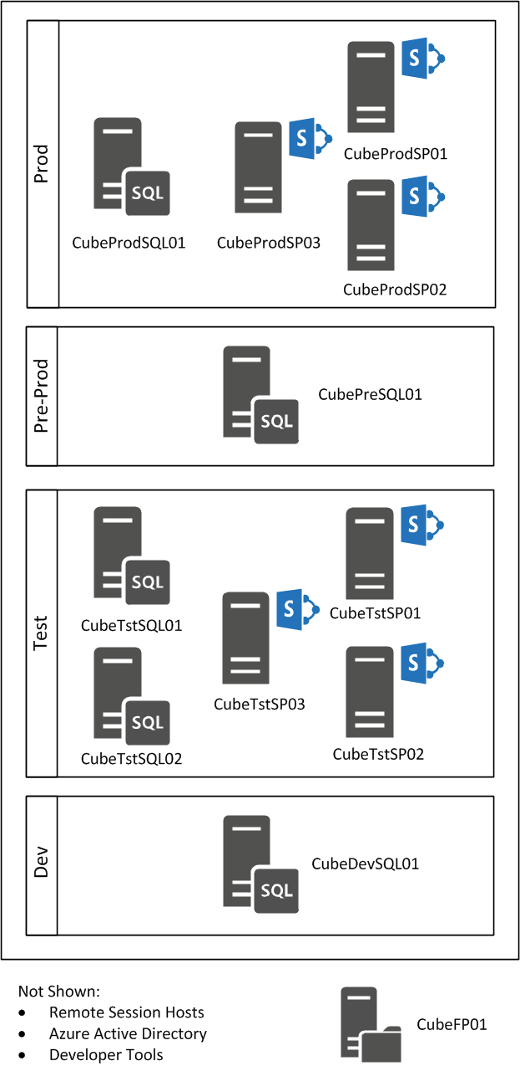

Phase 2 Servers
Name | Role | Notes
CubeProdSP01 | Production and Pre Instances SharePoint Server 2013 for Web Services | Web front end for KIS.
CubeProdSP02 | Production and Pre Instances SharePoint Server 2013 for Web Services | Web front end for KIS (Load balanced)
CubeProdSP03 | Production and Pre Instances SharePoint Server 2013 for Application Services | SharePoint application, PerformancePoint, SSRS engine running in integrated mode.
CubeProdSQL01 | Production Instance of SQL Server 2016
CubePreSQL01 | Pre-Production Instance of SQL Server 2016
CubeTstSP01 | Production and Pre Instances SharePoint Server 2013 for Web Services | Test version of CubeProdSP01
CubeTstSP02 | Production and Pre Instances SharePoint Server 2013 for Web Services | Test version of CubeProdSP02
CubeTstSP03 | Production and Pre Instances SharePoint Server 2013 for Application Services | Test version of CubeProdSP03
CubeTstSQL01 | Production Instance of SQL Server 2016 | Test version of CubeProdSQL01
CubeDEVSQL01 | Development Instance of SQL Server 2016
CubeFP01 | File Services Server, for KIS Shares and Desktop Profiles

Remote Desktop Design
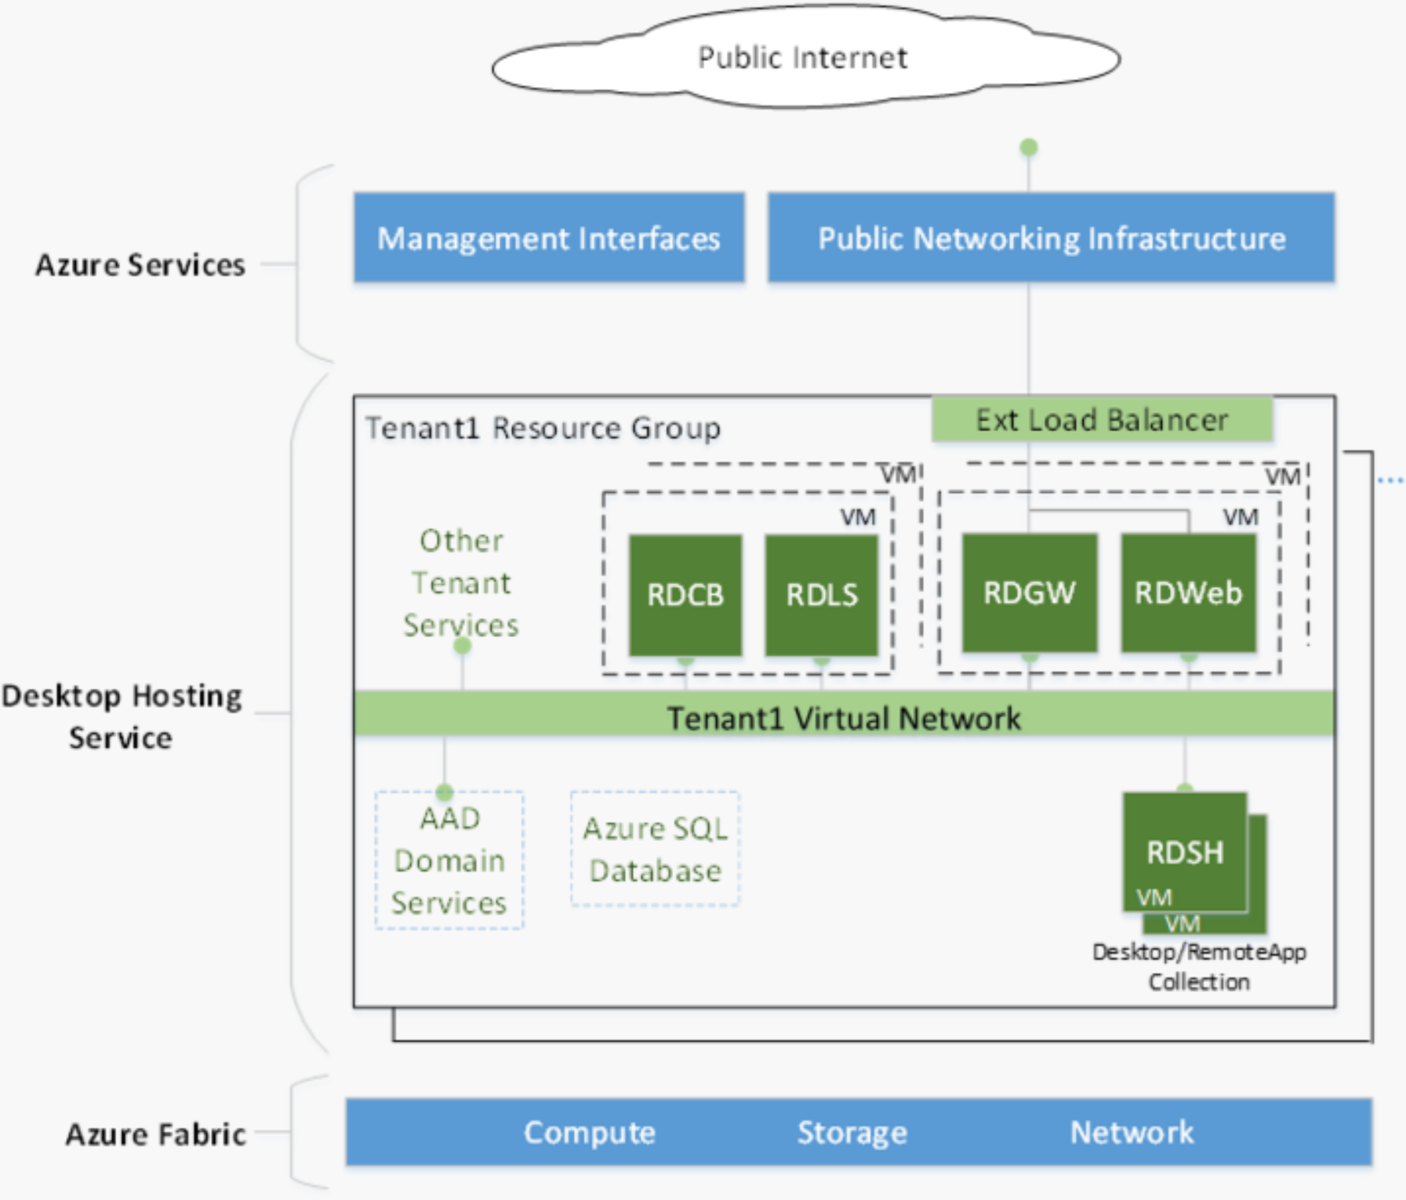

Build configuration details:
1 * Server with RDCB & RDLS
1 * Server with RDGW & RDWeb
2 * Server with RDSH for core user (30 user max)
2 * Server with RDSH for Analysts (10 user max)

The definitions for these components are:
  - RDCB – Remote Desktop Connection Broker – Provides connection load balancing between RDSH servers.
  - RDLS – Remote desktop Licensing service – Licensing for RDS connections
  - RDGW – Remote desktop gateway service – Routes RDP traffic between the public facing & internal networks
  - RDSH – Remote Desktop Session Hosts – User’s desktop and applications execute on these servers.
  - RDWeb – Provides User Logon and selection (Publishing) of desktop & applications

