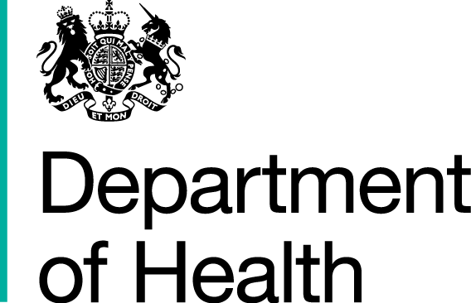

DH Procurement Services
Skipton House
80 London Road
London
SE1 6LH

2nd November, 2016

Dear Sir/Ma

NHS Jobs Alpha and Beta Market engagement Invitation

You are cordially invited to the supplier’s engagement session for the delivery of alpha and beta phase of the NHS Jobs 3 project.

Date: Tuesday, 29th November, 2016
Time: 11:00 -13:00
Venue: Department of Health, Quarry House, Leeds, LS2 7UE

There will also be a 1-1 session with interested supplier on the day.
Kindly confirm your interest and number of delegates attending the event via a return of email to: Taiwo.gbadebo@dh.gsi.gov.uk

We look forward to meeting your team.

Kind regards,

TGbadebo
Taiwo Gbadebo, MCIPS

