Inward Investment Programme market testing exercise for potential suppliers June 2021

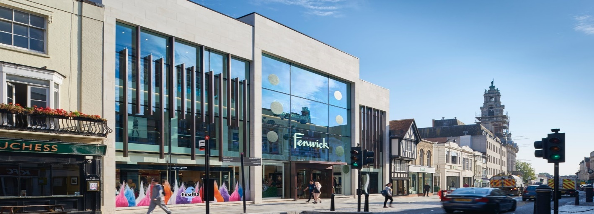

Economic growth, Renewal, Equality and Ambition! We’re laying the foundations for growth.
Collaborate with us to shape a stronger future for our residents.
At Essex County Council we’re already making plans to ensure our county’s long-term economic recovery and we are guided by the core principles of Renewal, Equality & Ambition. These three principles will be embedded in all planned activities. We know many of our people, communities and industries have been hard hit by the pandemic and we want to help them bounce back. We’re taking this opportunity to create a greener, more productive and fairer economy that is stronger and more resilient than ever before.
We’re fostering a new entrepreneurial spirit within Essex. Growing our economy means working with local businesses to help them take advantage of new market opportunities. It means attracting investment to improve digital outreach across the county, supporting hard hit businesses to recover economic prosperity, whilst encouraging their plans for the future, as we drive investment into the revitalisation and regeneration of key places.
And it means helping the people of Essex to grow and develop or transfer their skills, ready to fulfil the needs of a vibrant new economy, where local manufacturers and suppliers meet the demands of market within UK and internationally.
Context & background
Inward investment programme (IIP)
Economic growth is the number one priority for Essex County Council. We want to establish Essex as a great location for the world’s top businesses and ensure that it’s the best possible place to live and work. Our rich mix of urban, rural and coastal economies, and our growing transport links including an international airport, Freeport East and Crossrail mean we’re poised for future success.
- Essex is a diverse economy with a GVA of £ 35.861 billion as per ONS (2013)
- Strong advanced manufacturing base and supply chain companies / trained workforce.
- Excellent transport infrastructure including overseas links through ports, airports and proximity to London & Cambridge.
- Post pandemic bounce back, post Brexit and new technology enabled opportunities.
We want to ensure that our offer is in tune with commercial expectations, ahead of our competitors, innovative, future proof above all inclusive and benefits our residents.
Parallel to the development of the IIP, ECC is preparing a Sector Development Strategy that drives the economic recovery and enables Essex to fully exploit the growth sectors of the future to create a more sustainable, equal, and productive economy that works all in the long term.
An interim report will be published in July 2021 setting out the core sectors of focus and we will be engaging with partners to get their input as we work up a final strategy. The key sector of focus is Green Growth, where we want Essex to be known as a Centre of Excellence for the Green Economy.
The ask & collaborative approach
Our Economic Growth team is excited to be developing a new proactive, commercially astute and tech savvy inward investment service fit for a post Covid and post Brexit Essex. We want to understand Essex’s strengths, its competition and how inward investment decision making has been impacted by current economic and environmental conditions and wish to work collaboratively with inward investment specialists to shape and deliver a world class service. We are planning to go out to tender for a range of consultancy services bespoke to our needs, challenges and aspirations. Depending on your area of expertise an individual consultancy could bid for different elements of the programme or bid for the whole package of work. Equally, we would like to see consortium bids.
Components of the Inward Investment tender package
At heart of this tendering exercise, we are seeking answers from specialists to address several questions which are key to develop a winning proposition. These include:
- What are the most competitive sectors for inward investment in Essex, which DIT would look to promote internationally? What are our USPs and how can we develop propositions that DIT will want to promote?
- How can we attract investment and grow other sectors, identified as less important to DIT but fundamentally important to Essex’s future growth aspirations? Where should our target markets be internationally/nationally? What should our focus be on?
- How strong an offer does Essex have for Tech businesses/ what needs to be in place to provide a better ecosystem for high growth businesses?
- How can the new Inward Investment service benchmark itself with other successful Investment Promotion Agencies (IPAs) across the region, UK and overseas? What are the best operational models that will provide long term sustainability and support both new investment and growth of existing businesses in Essex? What are the recommendations for a new service, team model, approach to marketing bespoke for Essex to beat competition and create an exemplary IPA?
- How has business decision making for new investors been impacted by COVID and the EU exit? How can Essex capitalise?
- Who are our key existing investors and other major employers /how has Covid impacted their operation/what does this mean for their continued presence in Essex? What should Essex offer them to stay and grow etc.
To help us in the process we have designed a 2 phase tendering process.
Independent Phase A: Project name / Description
1.Procurement Proposal for the development of place propositions (Baseline analysis of major opportunities centred around locations or projects in Essex)
2.Procurement Proposal for Tech Companies Attraction Research
3. Procurement Proposal for Major Employers, Anchor FDI companies Retention Post Covid and new investor development strategies Research
4. Inward Investment Market Analysis for DIT’s International Promotion and promotion directly by ECC (Benchmark Essex’s competitiveness Vs DIT criteria in sector promotion)

Interdependent Phase B: Project name / Description
1.Procurement Proposal for Deep Dive & Benchmarking for DIT Criteria Research
(Identify target markets for Inward investment promotion in 3 sectors
(Map Essex’s advantages/links in, e.g. China/India/Europe/US)
2.Development of Sector & Target Market Propositions for Promotion
( for use in promotion/responding to inward investment enquiries. Later built into websites)
2.1 Identify and benchmark best Investment promotion agencies in the UK, EU and abroad, best practices in operational models.
3. Strategy development for Inward Investment.
*The above titles have the flexibility to be changed based on feedback for a better outcome.
We believe this is a learning process and are looking to work closely with consultants who can guide us through deep dive discussions on specific topics, use of data, sharing good practices and ultimately helping us to develop an agile inward investment strategy and recommendations for implementing a great new service.
Based on the above procurement requirements, we request potential suppliers to complete the below questionnaire in a brief manner
(200-250 words max per section) as part of our market engagement for best results.
Supplier Questions | Answer / Feedback
- Will you be interested to provide the above listed services, fully or parts of it?
- Have you delivered a similar service in the UK? If so whom and kindly provide list of some of your key clients and highlight in what areas did you help them?
- How long have you operated in this space? What is the size of your team? Any areas of specialisations or technical expertise?
- Have you previously worked with Essex County Council, local authorities in Essex or neighbouring counties? If so, please name the project?
- What are your initial thoughts about the procurement bundles and else would you have included in that list? Or what is missing?
- As part of the process, are you willing to engage in brainstorming sessions with our team?
- How quickly can you mobilise and deliver the whole contract or parts of it? Please indicate some approximate timescales.

Next steps
As a specialist in inward investment and economic development; this is your opportunity to guide us, develop our thinking and help us implement our ideas.
We are part of the Sustainable Growth Directorate, a new team keen to learn from your experience and deliver a successful programme for the County. Based on your responses to our questionnaire, we will contact you by the end of July regarding the next stages of the procurement process.
Thanks for your time and response in advance.

