DocuSign Envelope ID: 647CB57D-9D17-4AD9-81D0-D975CAC3D05D



|  |
| --- |
| **SERVICE REQUEST FORM**  This is a Service Request as defined in the Framework Agreement made  between Scape Procure Limited (1) and the Perfect Circle JV Ltd (2) dated 29th January 2021 (the ‘Agreement’). Except where the context otherwise requires, all terms defined in the Agreement shall have the same meaning in this Service Request.  **GUIDANCE**  The Service Request is used to identify the service(s) the Client requires. This form is only contractually binding once the Delivery Agreement has been executed and therefore does not require a signature but acknowledgment only at this stage.  The Service Request should be completed **at the earliest opportunity during pre-engagement activity**, and through one or more discussions between the Client and the Partner **together**.  At the end of pre-engagement activities, the Partner is required to issue a proposal to the Client setting out how they intend to deliver the service required. This will form the basis of the Delivery Agreement (call off contract).  Scape supports digitisation and lean working pratices. As such Scape welcomes the use of Partner’s systems to produce the attached Service Request Proposal.  The Service Request Proposal includes the following:   * The service needed by the Client and their desired approach to delivery; * Any further pre-engagement activity required to be undertaken (by each party) to enable the Partner to put forward their proposal and price (Tendered Total); * Identifies the Client’s key value drivers, (including social value and value for money priorities) combined with a comprehensive delivery proposal; * Sets out the outputs that should have been achieved by the conclusion of the pre-engagement stage. |

| 1 | SCAPE Consultancy framework Service Request Form (Truncated) Rev 8 04-10-2021

DocuSign Envelope ID: 647CB57D-9D17-4AD9-81D0-D975CAC3D05D



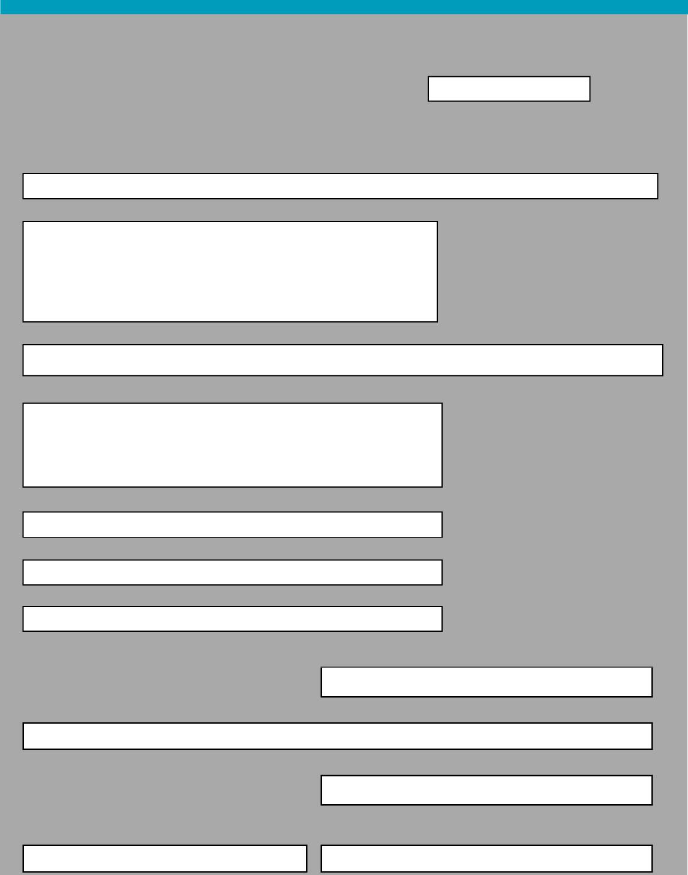

22/9/2022

This Service Request was Acknowledged on::

**THE PARTIES**

The Client

**COMMISSION SUMMARY**

Commission Number/Reference Commission Name

4557

Client estimated budget for Commission

£147,200.60

05/09/2022

31/03/2023

**SERVICE REQUEST FORM**

Defence Infrastructure Organisation

Address

DIO HQ

St George's House

DMS Whittington

Lichfield

Staffordshire WS14 9PY

The Partner

Perfect Circle JV Limited

Address

Halford House   
Charles Street   
Leicester

LE1 1HA

Client contact name

***Redacted***

Address for electronic communications

[***Redacted***](mailto:Stephen.Armour100@mod.gov.uk)

Telephone

[***Redacted***](mailto:Stephen.Armour100@mod.gov.uk)

DSEAR Guidance and Technical Support – ASISP Programme FY22/23

Client anticipated start for Commission Client anticipated end for Commission

| 2 | SCAPE Consultancy framework Service Request Form (Truncated) Rev 8 04-10-2021

DocuSign Envelope ID: 647CB57D-9D17-4AD9-81D0-D975CAC3D05D



**COMMISSION DETAILS**

*Supplied using the Partner’s information systems* **Attach**

The Service Request is attached here.

**SUPPORTING INFORMATION**

Please upload and append any additional supporting information about the commission here.

**Ref Item Description Attach**



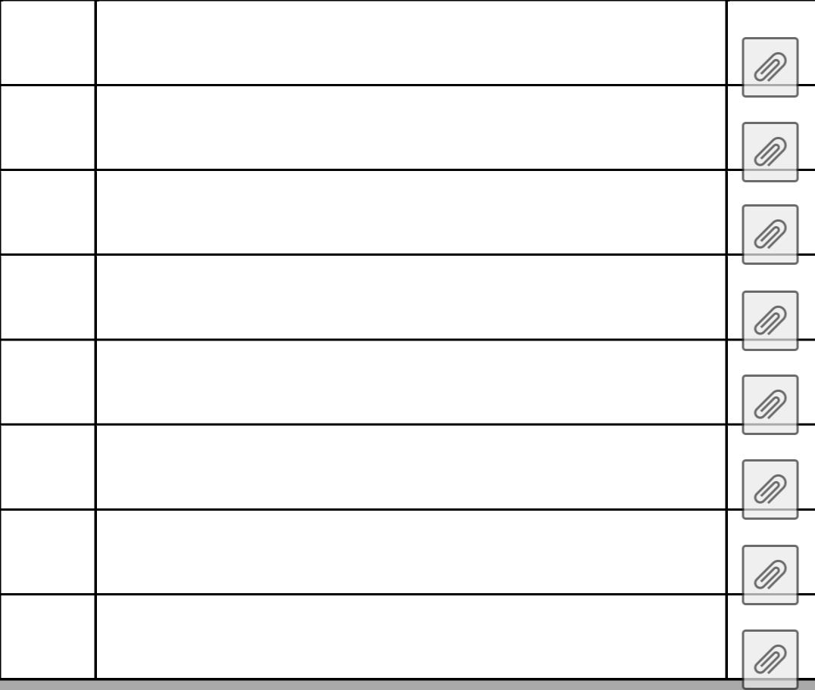

Appendix C - CVs for Delivery Team

001

| 3 | SCAPE Consultancy framework Service Request Form (Truncated) Rev 8 04-10-2021

**DocuSign Envelope ID: 647CB57D-9D17-4AD9-81D0-D975CAC3D05D**



Please select the Approve button below to acknowledge that this Service Request represents an accurate record of pre-engagement discussions, and that you would like the Consultant to proceed with producing a Delivery Agreement based on the proposals contain herein.

Approved by

Client contact name

[***Redacted***](mailto:Stephen.Armour100@mod.gov.uk)

Address for electronic communications

[***Redacted***](mailto:Stephen.Armour100@mod.gov.uk)

Telephone

[***Redacted***](mailto:Stephen.Armour100@mod.gov.uk)

The **Approve button is a DocuSign field that won’t show on the completed form however the date field on the** first page will show the date the form was acknowledged once the approve button has been selected. You can view the full audit history in the summary sheet within DocuSign.

| 4 | SCAPE Consultancy framework Service Request Form (Truncated) Rev 8 04-10-2021



DocuSign Envelope ID: 647CB57D-9D17-4AD9-81D0-D975CAC3D05D

**Service Request Proposal**

(Part C – Detailed Service Requirements) for

**DSEAR (Dangerous Substances and Explosive Atmospheres Regulation) Guidance and Technical Support – ASISP Programme FY22/23**

Commission number: **4557**

**DocuSign Envelope ID: 647CB57D-9D17-4AD9-81D0-D975CAC3D05D**



**Document Change Control**

|  |  |  |  |  |
| --- | --- | --- | --- | --- |
| Issue | Date | Comment | Author | **Chk’d** |
| Draft | 29.06.22 | For Review | A Freeman | K Churchill |
| Revised | 26.07.22 | For Client Comment | A Freeman | G Collins |
| Revised | 25.08.22 | For Issue | A Freeman | G Collins |

Service Request Proposal **–** Built Environment Rev B 2

DocuSign Envelope ID: 647CB57D-9D17-4AD9-81D0-D975CAC3D05D



**Contents**

**1.0 Commission Overview 4**

Background 4



Objectives and Outcomes 4

**2.0 Health, Welfare, Safety, Environment and Sustainability Considerations 5**

**3.0 Value for Money Statement 5**

**4.0 Commission Success Criteria 5**

**5.0 Social Value 6**

**6.0 Detailed Scope of Services 6**

Description of the Services to be Provided 6



Service / Price Exclusions 7

Key Stakeholders, Consultations and Interdependencies 7

Summary of Services at Each Commission Stage 7

Supplier Selection & Competitive Tender Award Criteria 8

Appointment of Principal Designer 8

**7.0 Delivery Team 8**

**8.0 Delivery Programme 8**

**9.0 Schedule of Deliverables 9**

**10.0 Design Specifications & Technical/Quality/Regulatory Standards 9**

**11.0 BIM Requirements & Document Control 9**

**12.0 Client Acceptance Criteria 9**

**13.0 Risk & Opportunities 9**

**14.0 Prerequisites, assumptions & constraints 10**

**15.0 Requirements for Surveys, Investigations and Third-Party Historic Data 10**

**16.0 Pricing Information 11**

Overview of Fee 11



Time Charge Schedule 11

External Consultancy Costs 12

**17.0 Delivery Agreement Professional Service Contract Model 12**

**Appendix A 13**

**Schedule of Activities (Standard Scopes of Service)** 13

**Appendix B 14**

**NEC Professional Services Contract Options** 14

**Appendix C 16**

**CVs for Delivery Team Staff** 16

Service Request Proposal **–** Built Environment Rev B 3

DocuSign Envelope ID: 647CB57D-9D17-4AD9-81D0-D975CAC3D05D



**1.0 Commission Overview**

Background

This Commission is to provide updated guidance and technical support to assist DIO managed facilities with compliance with The Dangerous Substances and Explosive Atmospheres Regulations (DSEAR) 2002, as part of the DIO Asset Safety Improvement Schedule Plan (ASISP) FY22/23.

Objectives and Outcomes

As part of the suite of deliverables that the DIO ASISP programme is seeking to achieve, DIO will provide Top Level Budget holders (TLBs) guidance and technical support to drive effective compliance in respect of the DSEAR regulations across the Defence Estate.

There are four objectives to the Commission as detailed below:

1. Development of high level guidance for Heads of Establishments (HoEs) on how to comply with DSEAR regulations at each facility. This high level guidance will identify potential assets where DSEAR may apply, identify who is the responsible party for ensuring compliance with DSEAR at each asset and signpost to existing MoD JSPs, practitioners guidance and (Health and Safety Executive) HSE guidance to establish the need for appropriate mitigation measures and risk assessments to be in place. Key DSEAR terminology such as ‘hazardous areas’ and ‘zones’ will be defined and explained. Existing relevant MoD guidance, including JSP 375, JSP 317, JSP 418 and Practitioners Guide 2018/01 will be reviewed to identify potential gaps and overlaps which may require updating.
2. Identification and development of an appropriate training package to be delivered to HoEs, DIO, OPA and maintenance management organisations (MMO) on the implementation of DSEAR at DIO managed facilities. This will include responsibilities under DSEAR, identification of assets where DSEAR may apply, development of control and mitigation measures and when these should be reviewed and updated, emergency management plans, how to check contractors and their staff have sufficient knowledge and appropriate training to undertake their work safely, specification and use of ATEX rated equipment, etc.
3. Conduct an initial detailed DSEAR compliance audit in conjunction with the OPA at [***Redacted***](mailto:Stephen.Armour100@mod.gov.uk)
4. to assess how DSEAR regulations are being adopted and managed, and existing MoD guidance is being implemented.
5. Develop a phased rollout across DIO facilities for the implementation of the updated guidance and training with the objective of adopting a standardised approach to managing DSEAR across all DIO managed facilities.

The delivery of the above guidance and technical support will enable DIO ASISP programme to continue to drive confidence that assets, systems and processes are operating in compliance with DSEAR regulations and that consequently the risk of a significant accident resulting from a failure to manage and implement DSEAR can be considered ALARP.

Service Request Proposal – Built Environment Rev B 4





DocuSign Envelope ID: 647CB57D-9D17-4AD9-81D0-D975CAC3D05D



**2.0 Health, Welfare, Safety, Environment and Sustainability Considerations**

Reference will be made to all current and relevant Joint Service Publications (JSPs) and associated MOD/DIO guidance, identifying, if present, any inconsistencies, clarifications or omissions in the existing JSPs and other guidance which require addressing.

**3.0 Value for Money Statement**

Within DIO, there is insufficient skilled DIO Suitably Qualified and Experienced Personnel (SQEP) resource in place and DIO does not have enough capacity to fully support this key element of the DIO ASISP programme of work to achieve the required workstream programme milestones. There is therefore a requirement for external assistance from Suitably Qualified and Experience Personnel (SQEP) to provide technical guidance on the implementation of DSEAR and develop appropriate technical guidance and training to DIO and other vested parties to allow them to ensure compliance with DSEAR at DIO managed facilities.

[***Redacted***](mailto:Stephen.Armour100@mod.gov.uk)

The SCAPE Consultancy Framework facilitates rapid appointment of relevant highly experienced resources to deliver to the required timescales. [***Redacted***](mailto:Stephen.Armour100@mod.gov.uk)Our resources are security cleared and have already established key stakeholder relationships which drives effective service delivery and minimises any potential for re­work due to lack of familiarity with the specific requirements and constraints associated with the Defence Estate. Our resources have already been involved in auditing existing DIO facilities and as such are already familiar with existing MoD guidance including JSPs.

The client has selected the following Value Drivers that best match its organisation’s key objectives for the successful delivery of the commission. These should be referenced by the Client during any subsequent feedback to gauge whether Value for Money has been achieved.

Value for Money Driver [1] – 1) Speed of appointment and delivery   
Value for Money Driver [2] – 5) Best practice and knowledge transfer   
Value for Money Driver [3] – 4) Working with stakeholders

**4.0 Commission Success Criteria**

In addition to the Value Drivers identified in Section 3.0 above, we also monitor the following Performance Indicators as standard for each commission:

* Time Predictability
* Cost Predictability
* Local Spend – Percentage of total spend within 20 miles of Client office/site
* SME Engagement - Percentage of appointments with SME’s compared with total number of Supply Chain appointments
* SME Spend - Percentage spend with SME’s compared with total spend with Supply Chain
* Fair Payment - Payment of Supply Chain within Government Fair Payment guidelines

Service Request Proposal – Built Environment Rev B 5

DocuSign Envelope ID: 647CB57D-9D17-4AD9-81D0-D975CAC3D05D



* Client Satisfaction
* Supply Chain Satisfaction
* Achievement of Client Social Value Targets – as agreed in Section 5.0 below

**5.0 Social Value**

The Public Services (Social Value) Act 2012 for England and Wales requires all public bodies to consider how the services they commission and procure might improve the economic, social and environmental wellbeing of the area for which they are responsible.

We recognise that we have a responsibility to the environment, the communities within which we work, our own people, our supply chain and society. Perfect Circle’s business management systems are fully compliant with the Public Sector (Social Value) Act 2012 and social value is an integral part of Perfect Circle’s approach and operations. Perfect Circle collect data in the following areas are part of our business-as-usual activities:

* Employment including apprenticeships.
* Skills development including activities relating to education and professional bodies.
* Volunteering and charitable activities, including donations in kind through pro-bono work.
* Performance indicators namely local spend, fair payment, SME engagement and spend.

**Guidance on the National TOMs Framework**

The aim of the National TOMs (Themes, Outcomes, Measures) Framework is to provide a minimum reporting standard for measuring social value. For organisations (private and public), it supports embedding social value into their procurement and management processes, it provides an easy-to-use solution that is immediately available, and may be applied to any project.

TOMs – which SCAPE, as a founding member of the National Social Value Taskforce, helped to develop – has been designed around 5 core Themes, 20 core Outcomes and 48 core Measures:

* Themes –The overarching strategic themes that an organisation is looking to pursue
* Outcomes – The objectives or goals that an organisation is looking to achieve that will contribute to the Theme.
* Measures – The measures that can be used to assess whether these Outcomes have been achieved.

Having discussed with the client whether they wish us to augment our Social Value offering by setting

up to 5 targets against the National Data Set of TOMs (Themes, Opportunities, Measures), we confirm that these additional measures are not required on this commission.

**6.0 Detailed Scope of Services**



Description of the Services to be Provided

Details of Scope of Services is provided in Appendix A.

Service Request Proposal – Built Environment Rev B 6

DocuSign Envelope ID: 647CB57D-9D17-4AD9-81D0-D975CAC3D05D



Service / Price Exclusions   
None.

Key Stakeholders, Consultations and Interdependencies

It is recognised that the DSEAR Guidance and Technical Support development must be fully integrated with wider DIO ASISP FY22/23 arrangements and ensure all key stakeholders are consulted.

The governance approach is therefore to work within the current arrangements to minimise any additional time/resource burden to TLBs and DIO.

[***Redacted***](mailto:Stephen.Armour100@mod.gov.uk)

Summary of Services at Each Commission Stage

The services and suppliers proposed for this Commission are summarised below. In addition, we have indicated the procurement route that is intended to be adopted for each service.

|  |  |  |  |  |  |  |  |  |  |
| --- | --- | --- | --- | --- | --- | --- | --- | --- | --- |
| **Non-Core Services** | | **RIBA Stages (**✔**)** | | | | | | | **Procurement Route** |
| **Service** | **Supplier** | **0-1\***  on time charge | **2**  on %  charge | **3**  on %  charge | **4**  on %  charge | **5**  on %  charge | **6**  on %  charge | **7**  on %  charge | **SFR, AFR, CPO, CT, BM, OB, CPS** |
| DSEAR Technical Support | AECOM | ✔ |  |  |  |  |  |  | SFR |

* use RIBA stages 0-1 for non-construction projects

**Procurement Routes**

These are the supply chain procurement routes available through the framework identified in the

tables above:

SFR SCAPE Framework Rates

AFR Alternative Framework Rates

CPO Client Proposed Organisation at Premium Rates

CT Competitive tender with 3 or more suppliers

BM Negotiation with a single provider, using an alternative benchmark mechanism

OB Adopting an Open book arrangements with a single provider

Service Request Proposal – Built Environment Rev B 7







**7.0 Delivery Team - redacted**





DocuSign Envelope ID: 647CB57D-9D17-4AD9-81D0-D975CAC3D05D



CPS **Client determines that a Preferred Supplier’s fee offers value for money**

Supplier Selection & Competitive Tender Award Criteria   
This activity is not required within the scope of the commission.   
Appointment of Principal Designer

This activity is not required within the scope of the commission.

**8.0 Delivery Programme**

Our proposed delivery programme is as follows:

|  |  |  |  |
| --- | --- | --- | --- |
| **RIBA  Stage** | **Activity** | **Start Date** | **End Date** |
|  | Commission Start Date | 5 Sep 22 |  |
| 0-1 | Preparation of Project Plan | Sep 2022 | Sep 2022 |
|  | Client Approvals for Project Plan | Sep 2022 | Sep 2022 |
| 0-1 | Development of DSEAR guidance | Sep 2022 | Nov 2022 |
|  | Client Approvals of DSEAR guidance | Nov 2022 | Nov 2022 |
| 0-1 | Development of Training Package | Dec 2022 | Jan 2023 |
|  | Client Approvals of Training Package | Jan 2023 | Jan 2023 |

Service Request Proposal **–** Built Environment Rev B 8





Jane McCallum Peer Review

Karen Junor Digital Manager

Karl Churchill DSEAR – Technical Delivery

Alex Freeman DSEAR – Technical Management

Allan Storer Technical Publication

Alison Couley DSEAR – Technical Delivery

Glenda Brady Technical Production

Claire Leng

DSEAR – Technical Delivery

DocuSign Envelope ID: 647CB57D-9D17-4AD9-81D0-D975CAC3D05D



|  |  |  |  |
| --- | --- | --- | --- |
| **RIBA  Stage** | **Activity** | **Start Date** | **End Date** |
| 0-1 | Audit of ***redacted*** and preparation of an LfE report | Sep 2023 | Jan 2023 |
|  | Client Approvals of LfE report | Feb 2023 | Feb 2023 |
| 0-1 | Development of DSEAR guidance rollout | Mar 2023 | Mar 2023 |
| 0-1 | Revision of draft guidance and training to  accommodate findings from the LfE report | Mar 2023 | Mar 2023 |
|  | Client Approvals of DSEAR rollout | Mar 2023 | Mar 2023 |
|  | Commission Completion Date | - | 31 Mar 23 |

**9.0 Schedule of Deliverables**

Develop, agree and implement Project Plan to develop the following deliverables:

* Report containing high level DSEAR guidance and roadmap to compliance;
* Development of DSEAR training package;
* Learning from Experience audit report detailing the results of a deep dive DSEAR Compliance audit at ***redacted***; and
* Rollout plan for DSEAR training and technical support.

**10.0 Design Specifications & Technical/Quality/Regulatory Standards**

Reference will be made to all current and relevant JSPs and associated MOD/DIO guidance.

**11.0 BIM Requirements & Document Control**

This activity is not required within the scope of the commission.

**12.0 Client Acceptance Criteria**

Formal approval of each deliverable at Issue Status.

**13.0 Risk & Opportunities**

The following key risks have been identified as constraints to successfully achieving the completion and of the required project delivery. A risk register will be developed and actively managed throughout the life of the project to ensure that the impact of any risks that are realised is mitigated as far as practicable.

***redacted***

The following opportunities have been identified:

***redacted***

**14.0 Prerequisites, assumptions & constraints**

The development of the DSEAR Guidance and Technical Support has the associated key assumptions:

* The guidance document produced will not be an exhaustive guide but is intended to be a high level guide for both technical and non-technical end users. The initial document will be a draft to be updated with findings from the LfE report;
* It is understood that OPA staff, employed directly by DIO, will be engaged and available to support development of the technical guidance;
* The current scope of work includes review of existing JSPs, signposting them and identifying omissions, discrepancies, or inconsistencies. Rewriting the JSPs is not included within the current scope of work;
* The staff provision is intended to be flexible and contingent on staff availability due to ongoing commitments (including other DIO projects).

**15.0 Requirements for Surveys, Investigations and Third-Party Historic Data**

There will be a requirement to conduct site surveys at ***redacted*** Establishment in the UK.

***redacted***

Service Request Proposal – Built Environment Rev B 10





DocuSign Envelope ID: 647CB57D-9D17-4AD9-81D0-D975CAC3D05D



**16.0 Pricing Information - redacted**

Overview of Fee

Our total fee is summarised as follows:

**This comprises as applicable the following elements:**

1. Where the commission relates to a Construction Project; Percentage charges for Prime Core services based on the estimated construction value.
2. Where the commission relates to a Construction Project; Percentage charges for Core services based on the estimated construction value.
3. Time charge fees covering Prime Core, Core and Non-core services. These are detailed in section 16.2 below.
4. Sub-total (A+B+C)
5. Prices secured from suppliers procured using ‘external’ non-framework rates. These are

detailed in section 16.3 below.

Total of Charges (D+E)

1. PSC / PSSC Fee

Total Commission Value (D+E+F)

1. Disbursements & Expenses

Overall Commission Value (D+E+F+G)

These figures are exclusive of VAT

In preparing our fee we have followed the prescribed rules and tendered rates as defined in the Framework Agreement made between Scape Procure Limited and Perfect Circle JV Ltd dated 29th January 2021 (the ‘Agreement’) and updated by all Deed of Variations.

Time Charge Schedule

The calculation of time charge fees is based on an hourly rate by grade and the number of hours allocated. As may be appropriate, in the description for each line we have provided a description as to how these two variables have been used. ***Redacted***

Service Request Proposal – Built Environment Rev B 11

DocuSign Envelope ID: 647CB57D-9D17-4AD9-81D0-D975CAC3D05D



Where non-core services are provided by our Perfect Circle Partners, they have been priced using the hourly rates from the SCAPE framework ‘Agreement’. Value for money is achieved as these rates have been the subject of a significant competitive tender process.

|  |  |
| --- | --- |
|  | Use of teams from our Perfect Circle Partners can bring added value to Commissions in terms of a more efficient team engagement and briefing process, since the teams sit within the same organisations and they have experience of working together.  External Consultancy Costs |

N/A

**17.0 Delivery Agreement Professional Service Contract Model**

A description of the contracting options available to you can be found in Appendix B. We are proposing that this appointment be placed using the NEC4 Professional Services Short Contract (PSSC).

Service Request Proposal – Built Environment Rev B 12

DocuSign Envelope ID: 647CB57D-9D17-4AD9-81D0-D975CAC3D05D



**Appendix A**

**Schedule of Activities (Standard Scopes of Service)**Scope of Services is as detailed below:

1. Development of high level guidance for Head of Establishments on how to comply with DSEAR regulations at each facility. This high level guidance will identify potential assets where DSEAR may apply, identify who is the responsible party for ensuring compliance with DSEAR at each asset and signpost to existing MoD, JSP and practitioners guidance, and the need for appropriate mitigation measures and risk assessments to be in place. Existing MoD guidance will be reviewed to identify potential gaps and overlaps which may require updating.
2. Identify and develop an appropriate training package to be delivered to HoE, DIO, and maintenance management organisations (MMO) on the implementation of DSEAR at DIO managed facilities. This will likely include responsibilities under DSEAR, identification of assets where DSEAR may apply, development of control and mitigation measures and when these should be reviewed and updated, emergency management plans, how to check contractors and their staff have sufficient knowledge and appropriate training to undertake their work safely, use of ATEX rated equipment, etc.
3. Conduct a DSEAR compliance audit at ***Redacted*** in conjunction with the OPA to assess how DSEAR regulations are being implemented and managed and existing MoD guidance is being implemented.
4. Develop a phased rollout across DIO facilities for the implementation of the updated guidance and training with the objective of adopting a standardised approach to managing DSEAR across all DIO managed facilities.

Service Request Proposal **–** Built Environment Rev B 13

DocuSign Envelope ID: 647CB57D-9D17-4AD9-81D0-D975CAC3D05D



**Appendix B**

**NEC Professional Services Contract Options**

**Introduction**

Services provided by Perfect Circle JV Limited (the Consultant) to Clients using the Consultancy Framework shall (unless otherwise directed by Scape) be based on the terms of one of four Model Delivery agreements. Perfect Circle JV Ltd will in turn enter into an agreement with each Supplier providing the services, under which the delivery Agreement obligations are “stepped down”.

The four Model Delivery Agreements available are:

1. NEC4 Professional Services Short Contract (PSSC)
2. NEC4 Professional Services Contract (PSC) Option A – Priced Contract with Activity Schedule
3. NEC4 Professional Services Contract (PSC) Option C – Target Contract
4. NEC3 Professional Service Contract Option G - Term Service Delivery Agreement

A commission that does not have an engrossed Delivery Agreement between Perfect Circle JV Ltd and the Client is non-compliant.

1. **NEC4 Professional Services Short Contract (PSSC)**

The PSSC is a simplified version of the Professional Services Contract which is suitable for less complex appointments.

The PSSC is for use on commissions that impose only low risks on both the client and the Consultant.

1. **NEC4 Professional Services Contract (PSC) - Option A   
   Priced Contract with Activity Schedule**

A lump sum priced contract, in which the risks of being able to provide the service at the agreed

prices in the Activity Schedule are largely borne by the Consultant.

The Client carries some risk through the compensation event procedures.

This contract is only used when the scope of work at tender stage is fully known and capable of being

priced and programmed.

This option should also be used where the prices are based on the cost of construction (percentage fee). Please note the consultant fees vary in accordance with the construction cost.

1. **NEC4 Professional Services Contract (PSC) - Option C   
   Target Contract**

A target fee contract in which the financial risks (savings or over-spend) are shared by the Client and the Consultant.

The Consultant’s share percentages and the share ranges are:

Share range Consultant’s share percentage

Less than 95%. 10%

From 95% to 100% 40%

From 100% to 102.5% 40%

Greater than 102.5% 100

Service Request Proposal – Built Environment Rev B 14

DocuSign Envelope ID: 647CB57D-9D17-4AD9-81D0-D975CAC3D05D



This contract can only be used when good estimates of scope and price can be made at tender stage or where the cost of construction (percentage fee) is used to set the target.

Also used when the scope of work is finalised after some initial work is undertaken under through a PSSC time charge arrangement, or similar. The target is adjusted for compensation events other than changes in Scope approved by the Client which are proposed by the Consultant which reduce the total Time Charge. This provides an incentive to Consultants to propose changes to reduce costs.

**4: NEC3 Professional Service Contract Option G   
Term Contract**

Provides the ability to agree a long-term call-off arrangement using Task Orders.

Option G contains options for time charge and lump sum fee arrangements. The tasks must be defined in the Task Schedule and Delivery Agreement.

This type of contract lends itself to a programme of works where the same contract terms apply for all orders. The Task Schedule should define the projects, the anticipated services required, and an outline budget and programme

**Summary**

For each of the above model contracts, Scape has prescribed through the Framework Agreement several Optional clauses, the inclusion or otherwise is at the discretion of Clients. Other than the above, no other variation to the terms of the Model Delivery Agreements shall be made without the agreement of Scape.

In accordance with the Access Agreement, Clients are entitled to obtain and review a copy of the Framework Agreement to assist them in understanding a Delivery Agreement. The Client should advise the Consultant of the Options that are at the Client’s discretion prior to preparation of the Delivery Agreement.

Service Request Proposal – Built Environment Rev B 15

DocuSign Envelope ID: 647CB57D-9D17-4AD9-81D0-D975CAC3D05D



**Appendix C**

**CVs for Delivery Team Staff**

* ***redacted***

16