Hybrid Council meeting requirements

The solution must be fit for purpose for the size and shape of each of the rooms. The dimensions and capacity of each room are as follows:

Location | Length (M) | Width (M) | Height (M) | Room Capacity
Wimpole Street | 11.00 | 5.40 | 2.80 | 26 people
Colmore Square | 13.30 | 6.85 | 2.70 | 28 people

Both rooms are equipped with a large table with the screen at the head of the table and during meetings (See Appendix A – Board Rooms for images of both rooms):

A presenter does not stand at the head of the room to present but can be located anywhere around the board room table.

Individuals do not typically move around the room and speak from where they are seated

See Appendix A – Board Rooms for images of both rooms.

Evidence must be provided to ensure confidence that the proposed solution will function effectively in both board rooms.

It would be useful to have an onsite demonstration of equipment to provide confidence that it will function effectively in our board rooms. This could be either at the GDC or the supplier’s location. It is acknowledged that some components may not be able to be demonstrated at a GDC location i.e., Fully installed ceiling microphones.

Additionally, the GDC would recommend that site visits to both rooms are completed in order to help enable the development can cost of solutions.

Video Conferencing Equipment:

Must provide full integration with the GDC’s infrastructure including Microsoft Windows, Office365 and MS Teams.

Must natively support Microsoft Teams.

Must provide full MS Teams functionality including:

Allow “Hands-up” functionality and this must be visible on screen for both remote attendees and individuals in each board room.

“Hands-up” must also be visible on screen when documents and presentations are being shared on screen.

Muting remote attendees.

Removing remote attendees from a meeting.

Being able see who has joined and left the meeting remotely.

Viewing all meeting participants.

Sharing of documents and presentations by participants connect to the meeting on their own device.

Sharing of documents and presentations by participants connecting to the video conferencing equipment in each board room.

Allow remotes attendee to wait to join meetings until meeting organiser grants permission for them to be admitted to the room.

There must be a touchpad controller to allow joining and leaving of meeting from board rooms and in-meeting management.

Must be simple and intuitive to use.

Must allow use of MS Teams functionality including:

Viewing meeting participants.

Removing remote participants from the meeting.

Muting remote participants.

Viewing who has “hands-up”.

Allow remote non-GDC attendees to wait to join meetings until meeting organiser grants permission for them to be admitted to the room.

There must be an appropriate number of cameras so that each boardroom can be viewed in its entirety.

Must provide a clear high-quality view based on the size of each room.

Must be able to be manually moved using the touchpad controller to track on a person speaking in the room and replace the view of the whole room with a more focused view of the person speaking or area of the room.

Should allow pre-set camera positions to be set and then triggered using the Touchpad controller to implement tracking of the camera(s) during the meeting to specific predefined presenters and replace the view of the whole room with a more focused view of a person speaking (or area within the room).

On screen it is essential that solution delivers the following views as a minimum:

All remote attendees are able view the whole of both board rooms, all other remote attendees (subject to MS Team constraints) participating either on their own devices or in other MS Teams enabled meeting rooms.

All board room attendees are able to view the whole of the other board room and all remote attendees (subject to MS Team constraints) participating either on their own devices or in other MS Teams enabled meeting rooms.

On screen it would be desirable that the solution delivers the following:

Presentation of a view of a person speaking in each board room AND the whole of each Board room simultaneously to all remote attendees, the other board room and other MS teams enabled meeting rooms.

Control of the view of the speaker could be manually managed via the Touchpad controller either by moving camera(s) on an adhoc basis or by pre-set camera positions.

Camera(s) automatically tracking the speaker in each board room and presenting the required view.

Ceiling microphones must be installed in each board room:

Have a suitable number for the size and shape of each board room.

Must reduce background noise and echoes.

Not pick up audio from the ceiling speakers in each room.

Allow individuals speaking in each room to be clearly heard both in the other board room and for those attending remotely.

Ceiling (or wall) speakers must be installed in each board room:

Have a suitable number for the size and shape of each board room.

Allow individual speaking in a board room or remotely to be heard clearly.

Acoustic treatment:

Both rooms must be acoustically treated to minimise echoes and sound reflections, contributing to a reduction in background noise and enabling the video conferencing equipment to function at maximum effectiveness.

It is appreciated that exact costs are dependent on colours, finish and materials used. A breakdown of a product list and costs would be useful at an initial stage.

Video Conferencing Equipment Installation:

Full installation of video conferencing equipment by the supplier is required.

Full installation of the acoustic treatment by the supplier is required.

The supplier must provide onsite support during the GDCs testing of the installation of the video conferencing equipment and acoustic treatment.

Testing will include a realistically sized meeting comprising of attendees in both meeting rooms and remote attendees.

Training must be provided to GDC IT infrastructure and Service Desk staff so that GDC are able to investigate and resolve minor issues with equipment usage.

Provision of onsite go-live support for first live council meeting.

Warranty:

All hardware and software must have a minimum 12-month warranty period.

There must be an option to be able to extend the warranty to cover additional 3-year term and beyond when the initial warrant expires.

Ability to arrange the extended warranty at the time of initial equipment purchase, so that there is no gap between the initial and extended warranties.

Ongoing 3rd party support is required so that GDC support effort is minimised. This must consist of:

Unlimited technical telephone support.

Remote diagnostics response time to be available within one hour of reporting an issue.

On-site response time to be next working day if a fault is reported before 12.00am.

Support to be available Monday – Friday 9.00am – 5.30pm GMT.

Provision of an annual Preventative Maintenance Visit.

Support must be delivered from the United Kingdom, for both installation, initial warranty, and ongoing support contracts.

Ability to automatically renew support for an additional 12 months at the expiry of each support period.

Ongoing upgrades of software, firmware:

Firmware upgrades must be covered under the support agreement.

Project Management:

Provision of a project manager to support the installation, testing and implementation of the whole solution.

Systems and Data:

All data relating to the GDC contract, installation, warranty, and ongoing support must be held in the United Kingdom both during transit and at rest.

Systems processing the GDC data relating to the contract, installation, warranty, and ongoing support must be hosted in the United Kingdom.

Evidence of the data servers used to support the service in the contract being located within the United Kingdom must be provided.

Appendix A – Board room

Wimpole Street

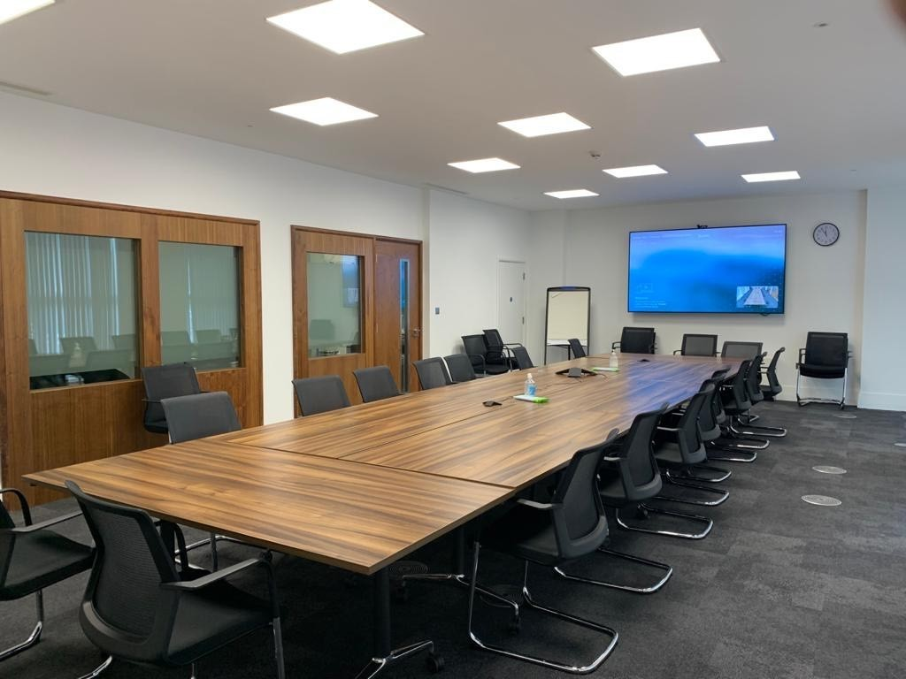 | 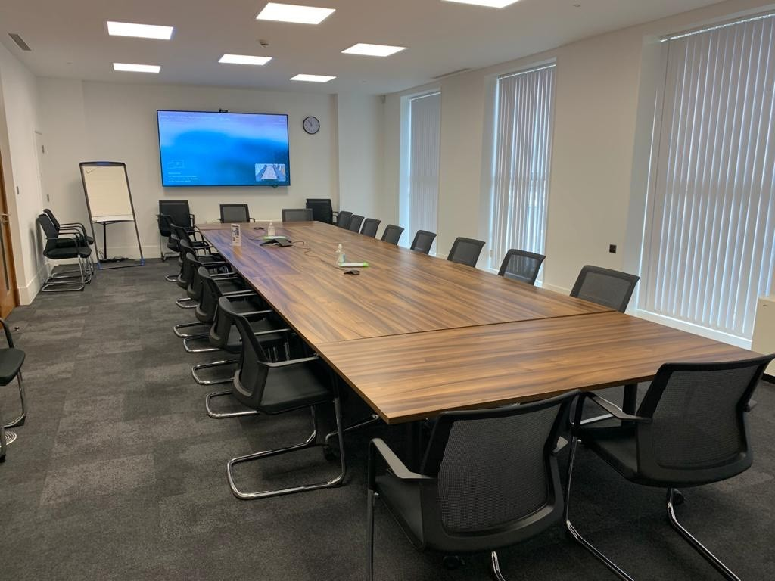

Colmore Square

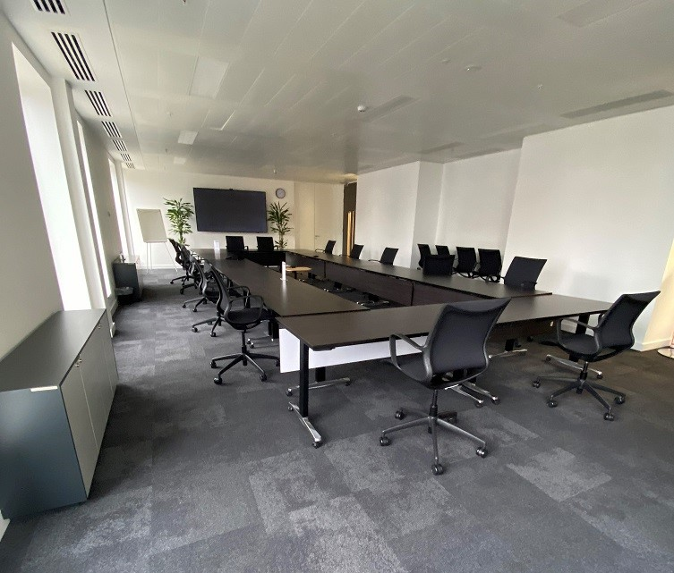 | 