
Nicola Moorcroft - Clerk to the Council
83, Broome Close, Huntington, York, YO32 9RH
Tel: 01904 763902
E-mail: clerk@rawcliffeparishcouncil.gov.uk
www.rawcliffeparishcouncil.gov.uk

Dear Building Contractor,

Rawcliffe Parish Council, in conjunction with Rawcliffe Recreation Association and CYC Rawcliffe and Clifton Without Ward Team, is undertaking some refurbishment of the Rawcliffe Recreation (Bob Eccles) Pavilion at St Mark’s Grove, Rawcliffe, York YO30 5TS and invites you to submit a bid for the contract for work required.

All the relevant information is contained within this tender pack:
- Tender Document.
- Architectural drawings
- Planning development consent notice
- Scope of Works.
- Drawings for electrical work

Opportunity to source further information:
- Open on-site (Rawcliffe Recreation Pavilion) session to be held Saturday 19 May 2018 10am – 12 noon
- Questions by e-mail (clerk@rawcliffeparishcouncil.gov.uk) or telephone: 079758779940 up to deadline for submission of bid.

Time scales:
- Tender bids to be sent to Clerk to Rawcliffe parish Council (either hard copy of via e-mail)
- Closing date for receipt of tender bid (either hard copy of via e-mail) – 5pm, Wednesday 30 May 2018
- Tender bids will be considered at an extra ordinary meeting of Rawcliffe Parish Council to be held Wednesday 30 May at 7.30pm; all those submitting a bid will be notified as to whether they are successful or otherwise as soon as possible after this meeting.

We look forward to receiving your tender bid.
Regards,

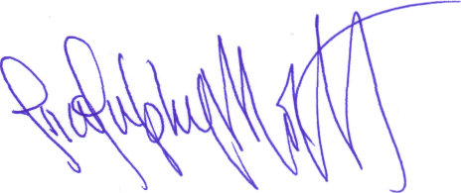
Nicola Moorcroft
Clerk to Rawcliffe Parish Council

