

Request for Expression of Interest

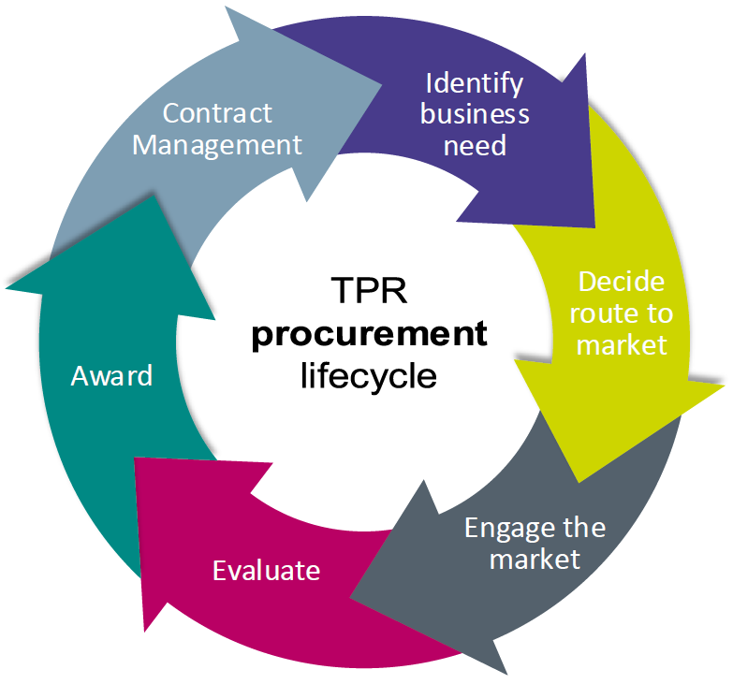

|  |  |
| --- | --- |
| **Procurement title:** | Strategic Communications Support Services |
| **Reference number: TPR** | TPR1520 |

The Pensions Regulator (TPR) will shortly be tendering for Strategic Communications Support Services for 12 months (plus 2 x 12-month optional extensions) via an Invitation to tender through our e-Sourcing portal.

This communication is designed to provide you with a brief overview of the timescales involved in order for your company to decide whether to be involved in the tender when it is anticipated to be issued on the 27/11/2023.

**You are required to please confirm your interest by return email to** [**Hannah.Clarke@tpr.gov.uk**](mailto:Hannah.Clarke@tpr.gov.uk) **(cc’ing** [**Ana.Litvin@tpr.gov.uk**](mailto:Ana.Litvin@tpr.gov.uk)**) no later than 5pm on the 24/11/2023. If we do not receive a response by this time, we will assume that you do not wish to be considered.**

* All companies must confirm in their expression of interest that they have registered to our e-Sourcing portal in order to tender. To register:
  + 1. Click on the link here: <https://thepensionsregulator.bravosolution.co.uk/web/login.shtml>
    2. Click ‘Register Now’ (this is only required once)
    3. Accept the terms and conditions and click ‘Continue’
    4. Enter your business and user details
    5. Note the username you chose and click ‘Save’ when complete
    6. You will shortly receive an email with your unique password (please keep this secure).

Please note, more than one email address can be added to enable multiple users to receive notifications from the portal.

For information about TPR, our remit and activities, please visit: **www.tpr.gov.uk**

Background to the requirement

|  |  |
| --- | --- |
| **The purpose of this procurement exercise is to** | The Pensions Regulator currently has an agreement in place for strategic communication support services which expires with no further extension options on the 21/03/2024. We are looking to reprocure these services via an invitation to tender which we are intending to issue on the 27/11/2023. |

Scope/Specifics

External risks can potentially impact The Pension Regulator’s reputation, credibility and ability to perform our role. We are looking to procure additional strategic communications support to help as required with:

* Select committee preparation and training sessions for relevant staff, and further training options where required.
* On request bookings for additional training with a quick turnaround time
* Strategic advice on reputation management, presentation & messaging
* Strategic advice on political engagement

**The areas that TPR are likely to be focusing on include:**

* TPR’s strategy and approach to regulation: protecting savers’ money; enhancing the pensions system; supporting innovation in savers’ interests
* Regulatory oversight of defined benefit (DB) schemes
* Value for money and good saver outcomes for defined contribution (DC) schemes
* Driving market consolidation
* Standards of pension scheme governance and trusteeship
* Disrupting pension scams working with partner agencies
* Automatic Enrolment and the regulation of Master Trusts
* TPR’s role in Pensions Dashboards
* Regulating new pension scheme models: Collective Defined Contribution and emerging DB Superfunds
* Climate change and Environmental, Social and Governance factors.

**The benefits we would be seeking through this strategic support include:**

* Mitigating risks to TPR’s reputation with external stakeholders and our regulated community
* Select committee preparation: sometimes required at short notice, due to the critical timelines concerned
* Ad hoc strategic advice

We believe it is important in addition to the above that we achieve this with an agency that has a strong reputation and track-record, including political and media contacts and availability of senior staff to provide advice to The Pensions Regulator’s communications team and Board members.

As a Public Sector organisation, in order to drive maximum value for money, we propose an ad hoc arrangement with a single agency.

**To meet this requirement, we are seeking an arrangement with a single agency to provide:**

* 1: Two guaranteed periods of engagement over a 12-month period to prepare senior TPR staff for specific select committee appearances, at which TPR has been invited to give evidence

The two guaranteed engagements would cover instances such as:

* + select committee appearances

and/or

* + advice on significant issues requiring reputational firefighting

and/or

* + advice on key publications and milestones (e.g. relating to The Pensions Regulator’s corporate strategy or regulatory activity)
* 2: An option to provide general training to senior TPR staff about appearing in front of a select committee, or, where necessary, to prepare staff for a third specific select committee appearance within a 12-month period, at which TPR has been invited to give evidence
* 3: An option to provide strategic communications support and advice (reputational management, presentation & messaging/narrative) in relation to, for example, a reputational issue, a planned major TPR publication or a public appearance such as a select committee, speech or media interview; provide political and media engagement advice

All of the above need careful reputational and political handling to maximise strategic opportunity or minimise risk.

Anticipated timeframes

|  |  |
| --- | --- |
| ITT issued by: | 27/11/2023 |
| Return of ITT | 15/12/2023 |
| Presentations: | 24/01/2024 |
| Award of contract: | 12/02/2024 |
| Start of contract: | 01/04/2024 |
| Anticipated duration of contract | 12 months |
| Anticipated extension options: | 2 x 12 months |

These dates are subject to change, any changes to the dates will be communicated to you as soon as practical.

Summary

Please confirm your interest, contact details and registration within our e-Sourcing portal. If you are aware of any conflicts of interest, please advise below.

Supplier response

|  |
| --- |
|  |

Supplier contact details

|  |  |
| --- | --- |
| **Primary contact name** |  |
| **Telephone number** |  |
| **Email address** |  |
| **Confirmation of registration within  our e-Sourcing portal (please include in this section the email address linked to your account and the company name used for your account)** |  |