Site Locations

Future HRA Phases

Lundy Close

Lundy Cl, Southend-on-Sea SS2 6HB
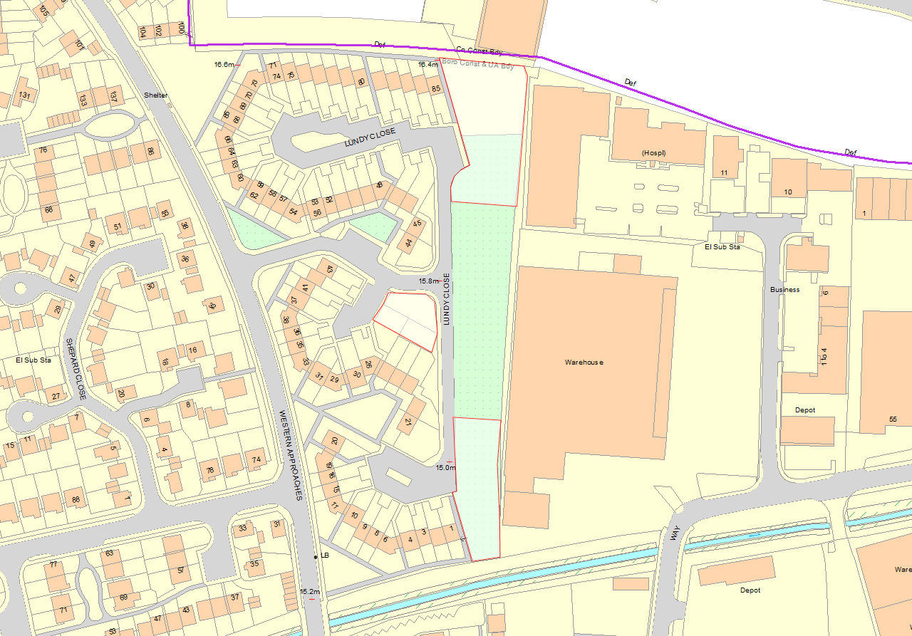
C
B
A

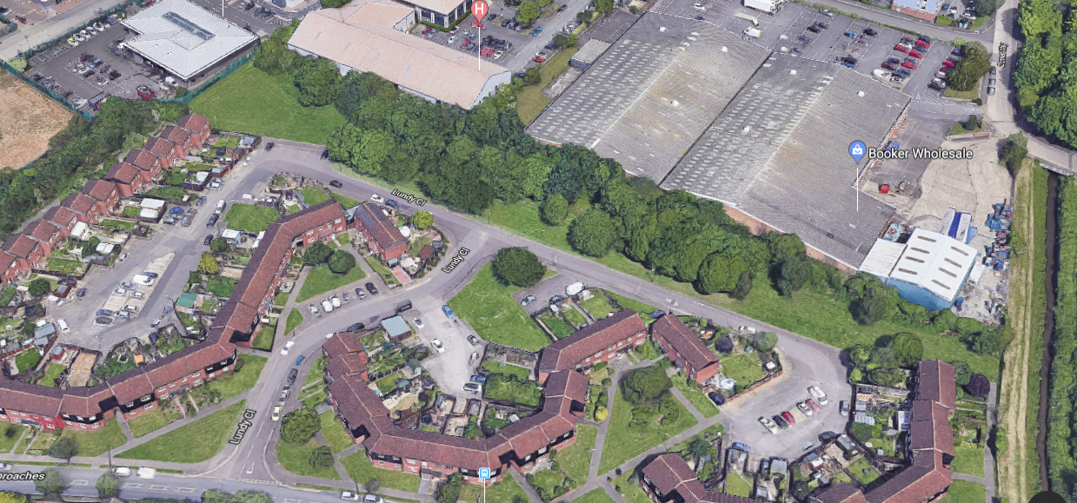

Shoeburyness
Overview
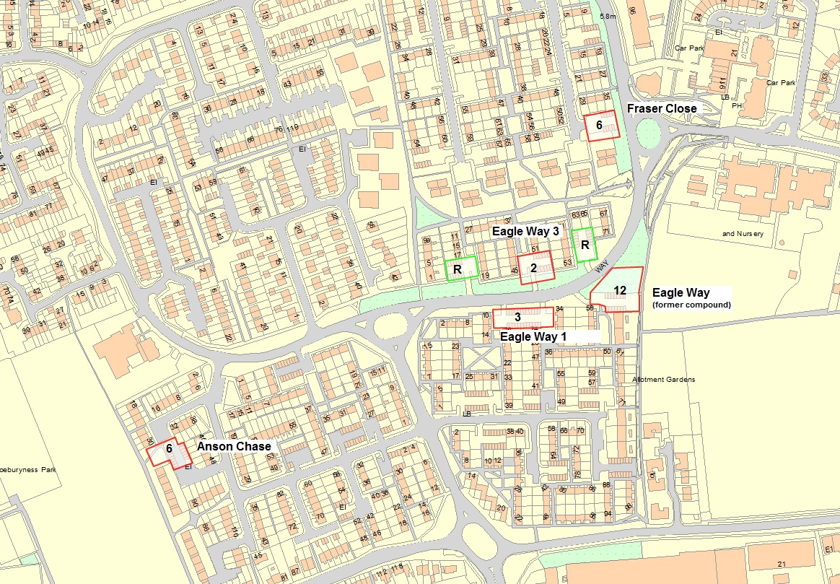

Eagle Way (former compound site)
Eagle Way, Shoeburyness, Essex SS3 9RJ
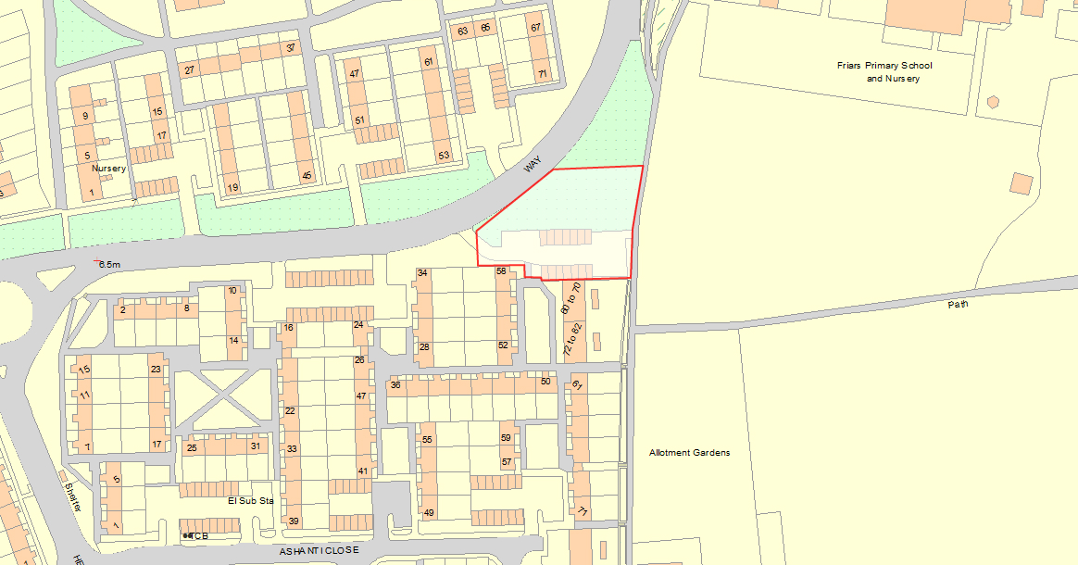
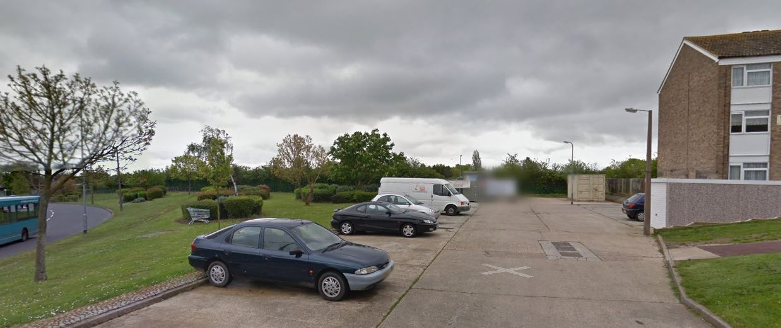

Eagle Way 3
Eagle Way, Shoeburyness, Essex SS3 9RJ

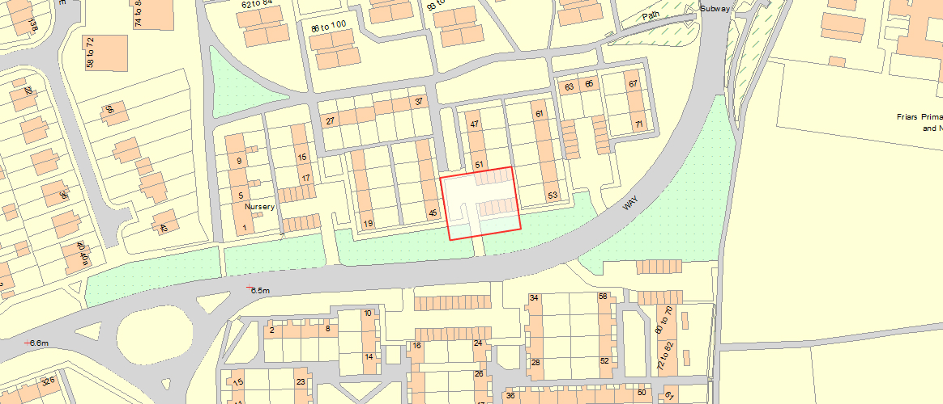
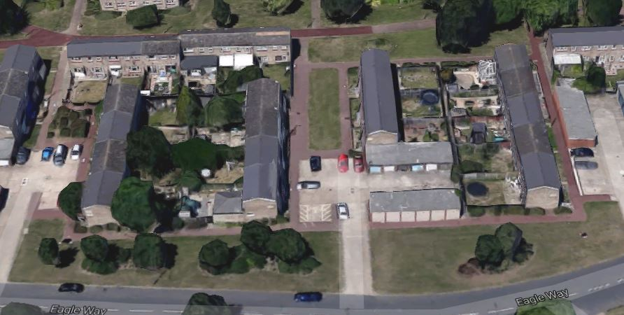

Eagle Way 1
Eagle Way, Shoeburyness, Essex SS3 9RJ
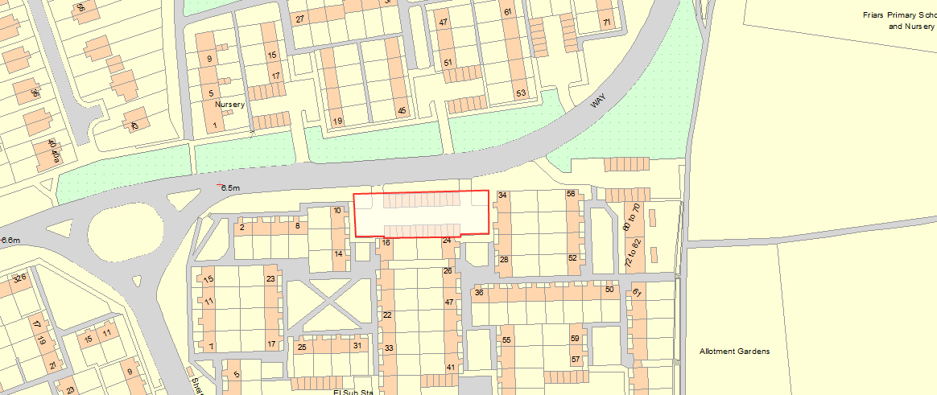
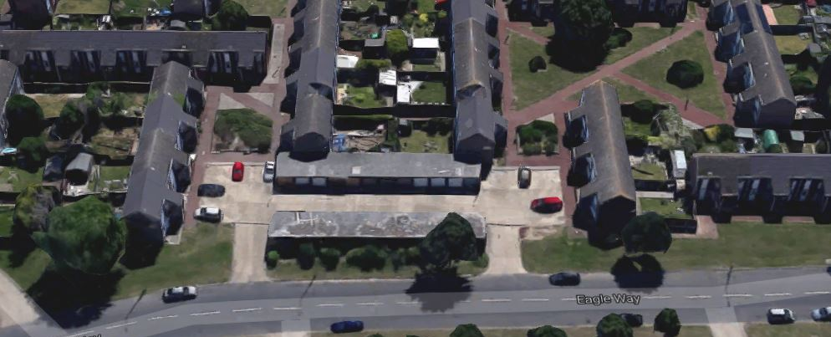

Fraser Close 3
Fraser Close, Shoeburyness, SS3 9YU
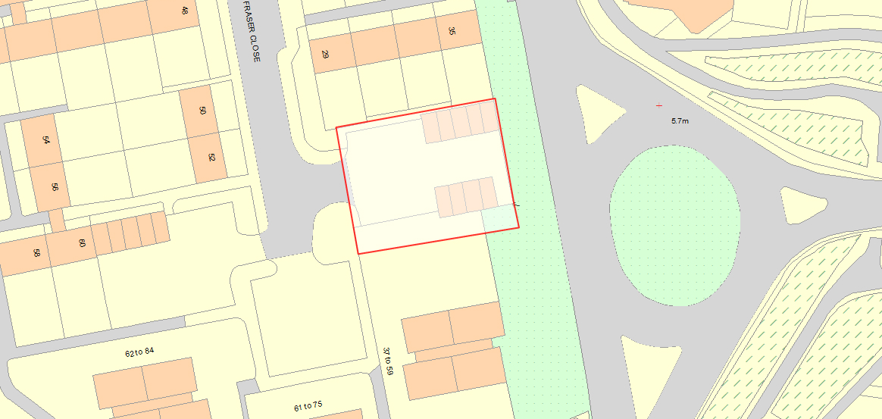
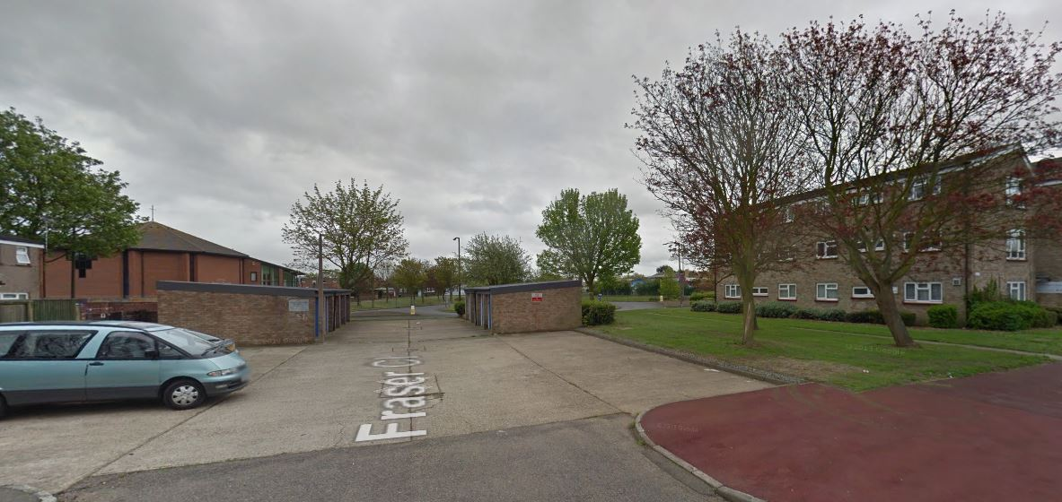

Anson Chase
Anson Chase, Southend-on-Sea SS3 9RG
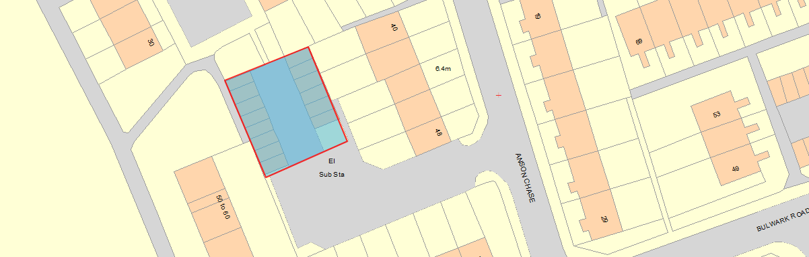
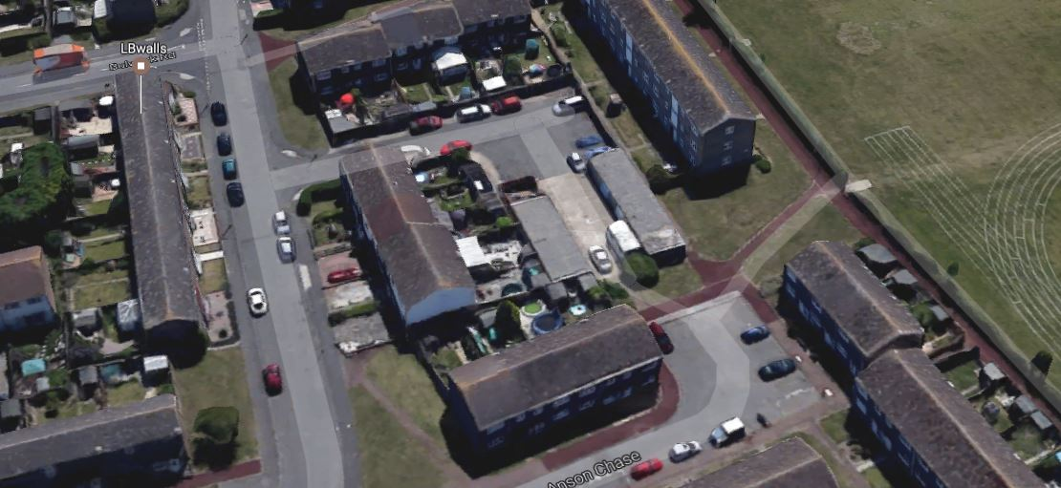

MMC

Saxon Gardens 1
Saxon Gardens, Southend-on-Sea SS3 9PU
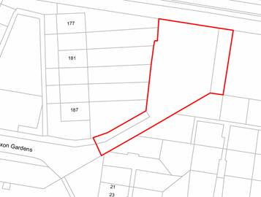
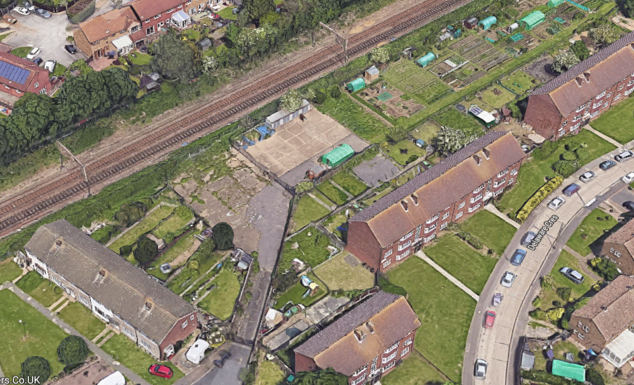

Saxon Gardens 2
Saxon Gardens, Southend-on-Sea SS3 9PU
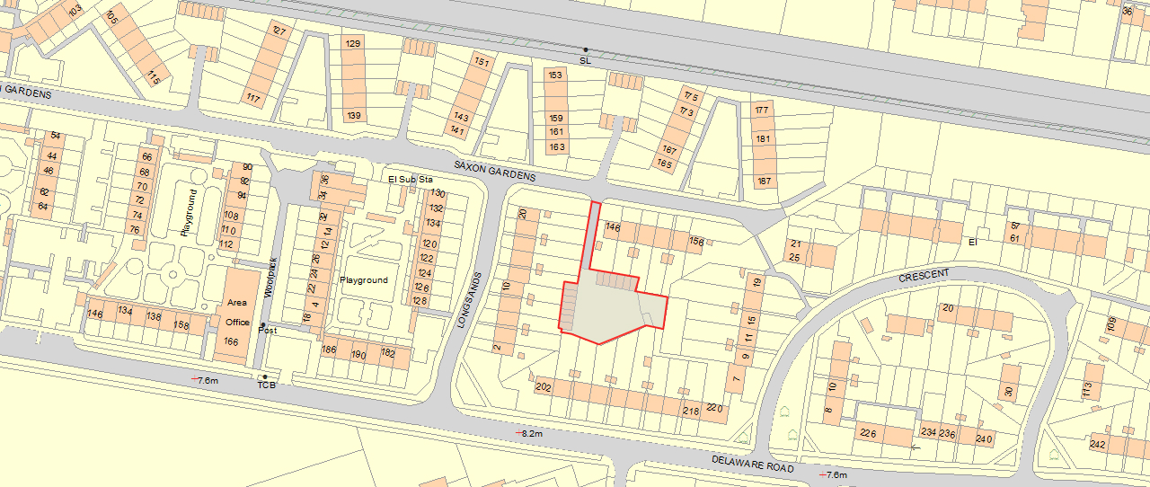

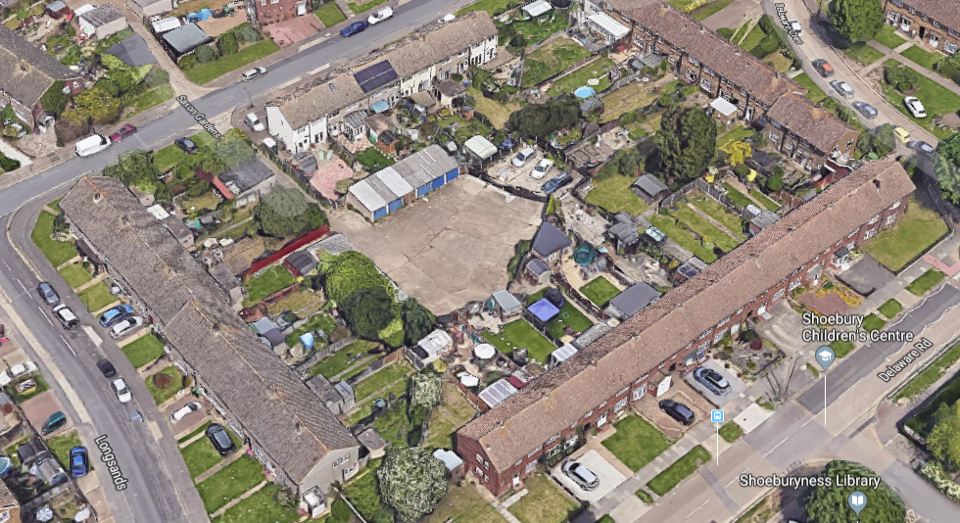

Archer Avenue B
Archer Ave, Southend-on-Sea SS2 4QT
