**Invitation to Quote for Stand Build**

**AHDB Exports Stand (joint with HCC)**

***Annual Meat Conference, Nashville, Tennessee, USA***

***18 – 20 March 2024***

**Contact Name/ Event Lead:** Will be provided to winning bidder

**Company Name:** AHDB **Website:** [www.ahdb.org.uk](http://www.ahdb.org.uk)

**Address**: Middlemarch Business Park

Siskin Parkway East

Coventry

CV3 4PE

United Kingdom

**Show Name:** Annual Meat Conference **Show Dates:** 18 – 20 March 2024

**(exhibition open Tuesday 19 March, 12:30pm – 5:00pm)**

**Stand Number:** 119

**Stand Size:** 10ft x 36ft (360 sqft) **Open Sides:** 2

**Budget:** £40,000 - £45,000

**Show Venue:** Gaylord Opryland, Nashville – [Show website](https://www.meatconference.com/)

**Deadlines:** Latest date forquestions/clarifications – Friday 5January 2024

Quotation to be received by – Friday 12January 2024

Award notification date – Friday 19 January 2024

**Contract Period:** 22 January – 20 April 2024

1. **Introduction**

This document outlines the requirements for the AHDB & HCC stand at the Annual Meat Conference 2024.

AHDB Exports are part of AHDB (the Agriculture, Horticulture Development Board) and based in England. We are a non-departmental Government public body working to promote (Beef, Lamb & Pork) both at home and abroad.

For more information about our work visit [www.ahdb.org.uk](http://www.ahdb.org.uk) or <https://meattheukexporters.com/>

The stand at the event will be joint with HCC, Hybu Cig Cymru – Meat Promotion Wales. This is the industry-led organisation responsible for the development, promotion, and marketing of Welsh red meat.

For more information on HCC visit <https://meatpromotion.wales/en>

**2. Event Objectives**

To provide a platform for meat producers to create new business relationships with international meat buyers and promote products in the US market. AHDB will promote beef, lamb, and pork. HCC will promote lamb and beef. Exporters will utilise the stand for meetings and discussion opportunities. The overall stand design should maximise footfall in the exhibition hall, encouraging show visitors to engage with exporters and sample UK products.

**3. Stand Build Requirements**

The stand measures 10ft by 36ft, a total floor-space of 360 sqft, with 2 open sides.

The organisers of the event have provided IAEE guidelines for display rules and regulations, this includes maximum heights for the stand, please reference the document provided.

The look and feel of the stand are important and must portray the quality of British meat (Beef, Lamb and Pork) and be clearly British. The stand should be open and inviting, encouraging visitors to engage and experience British products. The objective of the stand is to provide an impactful, visible platform promoting the high standard of British meat.

The stand will need to be seen from a distance and be visually appealing - high level branding should reflect GREAT branding, guidance in Section 5 below illustrates.

Solutions incorporating sustainability and energy efficiency are encouraged in your response – note that all lighting should be low heat creating. Ideally, we would like to avoid just lighting from the back wall and instead light from above if possible.

Stand build /breakdown timings are as follows:

* Exhibitor Move In
* Saturday, March 16, 2024, 1:00 pm - 6:00 pm
* Sunday, March 17, 2024, 8:00 am - 5:00 pm
* Monday, March 18, 2024, 8:00 am - 5:00 pm
* Tuesday, March 19, 2024, 8:00 am - 11:00 am
* Show Hours
* Tuesday, March 19, 12:30pm – 5:00pm
* Exhibitor Move Out
* Tuesday, March 19, 5:00pm – 10:00pm
* Wednesday, March 20, 8:00 am - 10:00 am

**The stand will be hypothetically split into three areas but with no walls or dividers. It should include the below elements and provisions:**

**AHDB**

* + AHDB dedicated graphics and messaging
  + AHDB 1 x retail style chiller with display
  + AHDB butchery demo counter & food sample counter (may need to be induction hobs, the venue to confirm requirements around cooking in December, more details to follow)
  + Electrical sockets for charging items
  + Bin

**Middle 1/3 seating & storeroom**

* + Storeroom, ideally with two doors if space allows (one into the AHDB area and one into the HCC area)
  + Plasma TV on the rear wall (position so it’s still visual around the seating)
  + Area with seating (high stools and poser tables) for networking
  + Hospitality package (soft drinks, tea and coffee, water cooler)

**HCC**

* + HCC dedicated graphics and messaging
  + HCC 1 x retail style chiller with display
  + Food sample counter (again more details to follow on cooking).
  + Electrical sockets for charging items
  + Bin

**T**he successful contractor will be responsible for arranging stand cleaning and waste removal pre/post show. There are communal wash areas in the exhibition hall for hands/ dishes.

The stand is indicated in red on the below floorplan:

**4. Graphics**

AHDB will provide full and print ready artwork for all graphics (*both HCC and AHDB*).   
Top level branding (i.e. lampshade or banner) needs to be seen from a distance in all directions and draw people to our stand. This should be co-branded with GREAT as per the below.

**AHDB graphic panels**

The theme will be based on Great British Beef, Lamb and pork using landscape images with livestock and/or food images. Our key message “Quality Meat from Britain” – will need to be shown in a prominent position.

Our unique selling point is based around a quality product and so graphics design needs to reinforce this message.

**5. GREAT Branding**

AHDB have agreed the following overarching principles for use of the GREAT brand at international events.

* Where the stand design does not incorporate a lampshade, AHDB will design a column or back wall which mirrors the agreed logo and brand hierarchy with GREAT as the primary brand.
* In this instance the GREAT header fascia must be clearly separated from the AHDB panels. Ideally there should be a physical gap no less than the same dimension as the height of the header fascia.
* Where this is not achievable the GREAT header fascia must be a definite different colour. If the AHDB background colour is blue, then the GREAT header must be white (or vice versa).

Branding hierarchy:

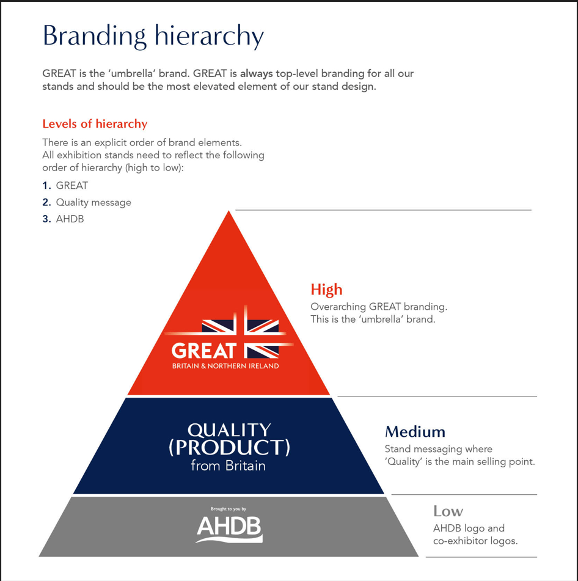

**6. Stand Design**

The visuals below illustrate some previous stands, effectively combining multiple elements i.e. counter, chiller area, networking area and branding.

*The below is included as an example of how height has previously been used, this event will not promote cheese.

**7. Useful information**

The contractor will be responsible for completion and submission of organisers forms relating to the design and construction of the stand, including organiser design approval. A login for the exhibitor portal will be provided after the contract is awarded, and a copy of the exhibitor manual sent electronically.

**8. Tender Process**

The contractor shall deliver the whole of the services, complete in all parts and furnished with every necessary detail, notwithstanding any omission or inconsistency in the specification.

The quote should include ‘to scale’ visuals of your design and be clearly itemised for all services and provision; where possible split by area (AHDB, HCC and storeroom/ seating) stating if any sub-contractors will be used; graphic dimensions and artwork deadline.

Except as otherwise stipulated in the specific conditions of service required, the contract shall remain at the fixed price and rates shall not be revised.

AHDB’s Event Manager can order reasonable additions to, or reduce from, the service specified. These amendments shall be requested in writing and agreed by both parties.

**9. Evaluation of Tenders**

Our award criteria are:

* Understanding of the brief **20%**
* Price **25%**
* Design, creative impression, and equipment **40%**
* Ability to meet event timelines, build-up and break-down **15%**

Please email your design proposals to Procurement procurement@ahdb.org.uk

by Noon on Friday 12 January.

**10. Payment Terms**

A contract will be formed with AHDB and a purchase order number provided. Please note that all invoices submitted to AHDB require a purchase order number to enter onto our payment system. Our payment terms are 30 days from receipt of the invoice.