Hitting

appendix 2: the four actions
Weston Discovery Centre

This part of the station could visually connect to percussion instruments (most associated with a hitting action) by:
- Offering both a tuned and un-tuned hitting experience, perhaps exploring materials like drum skin versus metal.
- Encouraging variations of this action (how you hit, i.e. hard, soft, and where you hit, i.e. edges vs centre).
- Offering direct and indirect hitting with a beater or stick, or just hands.

Connection to the gallery
There are no instruments in the permanent display that involve the hitting action but the act of hitting percussion is universally known.

What do we learn?
- Hitting causes vibration which makes sound
- Different types of instruments from different cultures and times use hitting as their main technique
- A hitting sound has varied characteristics depending on force, tool and material

What do we experience?
- Physical connection to an instrument through an action
- The difference in sound depending on force, tool and material

Pressing
Pressing is associated with keys of different kinds, i.e. the rectangular keys of a keyboard or the circular keys on a wind instrument, and strings (as this is the way string players alter pitch).
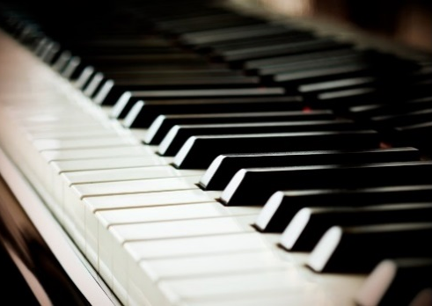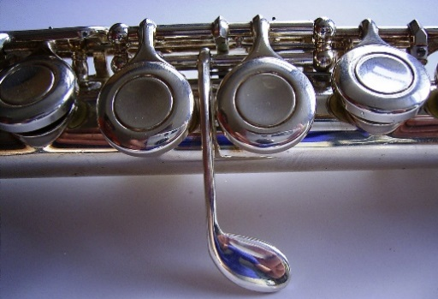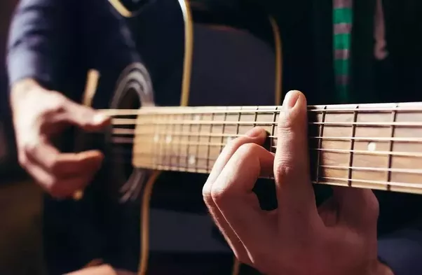

This part of the station could explore:
- Pressing a keyboard key as an indirect experience. The key acts as an interface between the player and the keyboard strings, a lever that triggers a mechanism.
- Exposing the ‘behind the scenes’ workings of a harpsichord and piano. Although the keys on both instruments look the same, the touch and feel is different because harpsichord strings are plucked and piano strings are hammered. Pressing a harpsichord key in a hard or soft way produces very little difference in sound, whereas the name pianoforte implies that you are able to control loud and soft dynamics through touch.
- Wind instrument keys have a different function, opening and closing holes in the side of the instrument pipe thereby shortening or lengthening the resonating tube.
- Pressing different parts of a string lengthens or shortens it. It is a direct way of changing the way the string is vibrating, therefore changing the pitch.

Connection to the gallery
Keyboard keys are explored as interfaces in the permanent display, which features a variety of plucked and hammered keyboard instruments. Wind instruments feature in the display at a point in history where the key feature was being radically developed and extended. All the stringed instruments on display require pressing to change pitch.

What do we learn?
- Pressing in some contexts starts a process to create sound, and in other contexts stops vibration which changes sound
- Different types of instruments use a pressing action for different functions

What do we experience?
- The feeling of starting a process by pressing a key
- Surprise at seeing the complex inner workings of instruments, perhaps for the first time
- The difference in sound depending on force used or key pressed

Plucking
This part of the station could visually connect to stringed instruments (most associated with a plucking action) by:
- Offering an experience of plucking an individual string versus multiple strings at once, at different angles (i.e. down and up like a guitar, across like a harp).
- Encouraging variations of this action (how you pluck, i.e. hard, soft, and where, i.e. edges vs centre)
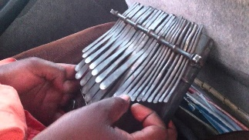
- Offering direct and indirect plucking with a plectrum, or just hands
- Connecting plucking to the mechanism inside a plucked keyboard instrument
- Offering an alternative to a string, i.e. the metal rods of an mbira

Connection to the gallery
Stringed instruments like guitars, members of the violin family, harp, etc. Plucked keyboard mechanisms of harpsichord, spinet, virginal, clavicytherium.

What do we learn?
- Plucking produces vibration which makes sound
- Different types of instruments from different cultures and times use plucking as their main technique
- A plucking sound has these characteristics: it is short in duration and bright in timbre

What do we experience?
- The feeling of generating sound by plucking
- The effect of changing the sound we make by our varying actions

Pulling and Pushing
This part of the station could explore:
- Creating sustained sound, create longer sounds (very much the antithesis of plucking)
- Bows as tools, the material coming into contact with the string (horse hair)
- Pulling or pushing to create and sustain airflow (accordion or barrel organ)

Connection to the gallery
Many of the stringed instruments are bowed. The barrel organ requires this action to operate the bellows and turn the barrel.

What do we learn?
- Pulling and pushing (a harder technique to master) causes vibration which makes sound
- Different types of instruments from different cultures and times use plucking as their main technique
- The aim of the action is normally to create more sustained sound

What do we experience?
- The feeling of sustaining sound

