Conversion of MAN 15T HX77
Support Vehicles to EPLS Mk3 Variant
OSVP/0032

Emergent Work Claim Form

Annex M

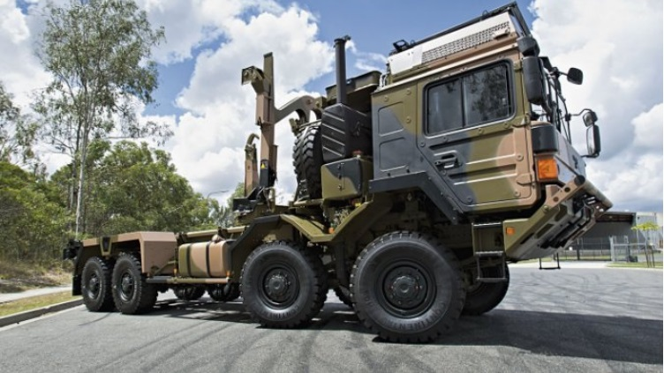V1

EMERGENT WORK CLAIM FORM

CONTRACT NUMBER: OSVP/0032 SUMMARY NUMBER:

PERIOD COVERED: ISSUE NUMBER: 1

PART 1 (to be completed by the Contractor)

To:

The attached list shows the Emergent Work completed within the above period with the associated pricing breakdown in accordance with DEFCON800 further attached and referenced. The Total cost of these tasks is £ excluding VAT. Please confirm that you are content that these tasks are complete. Payment for these out of scope repairs will be claimed via CP&F once approval at Part 2 is confirmed.

Signed:. . (Name and position)

For:. (Contractor)

Date: .. Fax..

PART 2 (to be completed by the Project Team)

A. Project Manager Approval

The Emergent Work reported in the Contractor’s summary are confirmed as complete.

Project Management approval is hereby given for payment of these out of scope repairs, at a cost of £ excluding VAT.

Signed:. . (Name and post)

Date:  Fax

B. Commercial Manager Approval

- The Emergent Work reported in the Contractor’s summary are confirmed as complete and the costs accepted as Allowable in accordance with DEFCON 800.

Commercial Manager Approval is hereby given for the payment of these Out of Scope Repairs, at a cost of £ excluding VAT. A CP&F Purchase Order has been raised, the order number is:

ii. I hereby inform you that a formal offer of amendment shall follow to incorporate on an opportunity basis:

ADD: The following out of scope repairs to the table within Annex K, as follows:

Summary No. | Dates of quarter to which summary relates | Agreed Firm Price
“ |  | ”

Signed: ...... . (Name and post)

Date:  Fax

OSVP/003 CONTRACT - SUMMARY OF EMERGENT WORK

The following repairs were completed between .

PM Ref. No. | Convertor Ref. No. | Date | Description | Price £
003/001

