ESSEX COUNTY COUNCIL

CO0063 LEARNING & DEVELOPLMENT EXTERNAL COACHING SERVICES

SPECIFICATION

Issued 14th December 2020

Procurement Project CO0063

- Essex County Council
  - Essex County Council is dedicated to improving Essex and the lives of our residents. Our ambition is to deliver the best quality of life in Britain. We will achieve this by providing high-quality, targeted services that deliver real value for money.
- Our vision
  - The Essex Organisation Strategy sets out our aims and priorities for the period 2017-21. It articulates how we will achieve better outcomes for Essex and secure the ambitions set out in the Vision for Essex. Our ambition, at the end of this period, is for Essex to be the best local authority in the country.

  - At ECC we are passionate about better lives for people in Essex. We believe prosperity is the best route to achieve that – so people can help each other, and themselves. We are also ready to step in – to protect vulnerable children, to help care for older people and to support our economy to flourish. As a public body it is important we spend taxpayers’ money wisely, on the issues that matter to our residents. To offset reductions in government funding, we must constantly manage demand, reshape and re-imagine services and look for opportunities to generate income. It is also important we work tirelessly to secure investment into the county that can help make Essex an even better place to live and work.

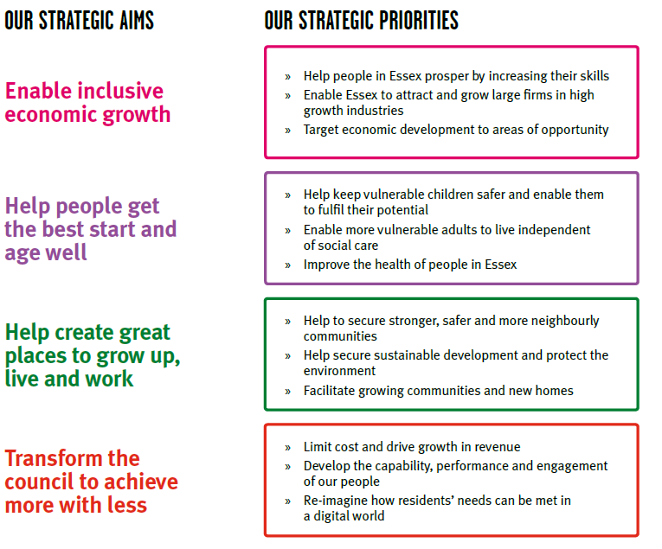
  - Further information can be found on the ECC website.
- Delivering the vision

  - If we are to succeed through these testing times, we must maintain a focus on our core purpose. The challenge ahead strengthens our resolve to:

- increase educational achievement and enhance skills
- develop and maintain the infrastructure that enables our residents to travel and our businesses to grow
- support employment and entrepreneurship across our economy
- improve public health and wellbeing across Essex
- safeguard vulnerable people of all ages
- keep our communities safe and build community resilience
- respect Essex’s environment

  - Our Corporate Outcomes Framework translates our Cabinet’s political ambitions – outlined in their Vision for Essex – into a set of outcomes and supporting indicators that can guide the work of commissioners across ECC. The consolidation of outcomes into a single, authoritative, framework for ECC is designed to:

- provide a clear foundation for the development of our commissioning strategy and plans;
- provide a clear framework for assessing progress – allowing ECC to understand its impact on residents and communities in Essex; and
- allow for the analysis of ECC resources, assets, contracts etc, against a consistent set of outcomes.

  - The Corporate Outcomes Framework, shown in the table below, embeds the principles of Outcomes Based Accountability (OBA) within ECC. OBA is an established and effective approach for expressing, operationalising and ensuring accountability for outcomes. It provides a simple, common sense, low bureaucracy planning model supported by clear terminology.
Essex: a  county where innovation brings prosperity | Children in Essex get the best start in life | People in Essex enjoy good health and wellbeing | People have aspiration and achieve their ambitions through education, training and lifelong-learning
 | - Percentage of children ready for school  - Percentage of children achieving a good level of development by the age of five  - Percentage of families living in temporary accommodation  - Percentage of children living in non-working households | - People in Essex have a healthy life expectancy  - Reduced differential in life expectancy across different areas of Essex  - Percentage of children achieving at school [measured at foundation stage, KS2 and KS4]  - Percentage of working age people in employment  - Prevalence of healthy lifestyles  - Prevalence of mental health disorders among children and adults  - Percentage of Essex residents who consider themselves to be in good health  - Percentage of families living in safe and suitable housing  - Percentage of households living in fuel poverty  - Teenage pregnancy rates  - Life satisfaction rates (ONS condition of wellbeing) | - Rates of literacy and numeracy at all ages  - Percentage of children achieving at school  - Percentage of adults participating in lifelong learning  - Percentage of working age people in employment  - Percentage of people participating in further education/higher education/vocational learning  - Percentage of young people aged 16-19 not in education, employment & training  - Rates of volunteering  - Percentage of children attending a good school

People in Essex live in safe communities and are protected from harm | Sustainable economic growth for Essex communities and businesses | People in Essex experience a high quality and sustainable environment | People in Essex can live independently and exercise control over their lives
- Level of crime in Essex  - Number of children subject to protection plans  - Number of children in care  - Rate of anti-social behaviour in Essex  - Number of people killed or seriously injured on Essex roads  - Percentage of residents who feel that Essex roads are safe  - Hospital admissions caused by injuries to children and young people  - Hospital admissions caused by injuries to adults  - Incidents of domestic abuse  - Percentage of residents who feel safe  - Rates of re-offending | - Job growth in key locations and key sectors  - Housing growth in key locations  - Supply of fit for purpose business premises  - Increased connectivity and journey time reliability on priority route network (PR1)  - Number of bus and/or community transport journeys  - Median earnings  - Coverage of superfast broadband services  - Sustainable business start-up rates  - Percentage of Essex businesses who think they can recruit suitable people  - Percentage of working age people in employment  - Business rates growth | - Residual waste volumes  - Cost of energy to households  - Preventable flooding incidents  - Level of pollution  - Condition of roads and footways  - Access to valuable open spaces  - Perception of the quality of the environment in Essex’s cities, towns and villages | - Proportion of people who live independently  - Percentage of people who regain or increase their level of independence following hospital admissions  - Access to end of life care in their preferred placement of choice  - Number of children and adults who receive social care support  - Number of people with personal budgets

- Introduction
  - Essex County Council (ECC) has undergone significant transformations in recent years, in line with our ambition to make significant improvements to the way that services are delivered and in responding to dramatic changes to public policy, Brexit and the COVID-19 crisis. Over the next five years the nature and pace of change is likely to accelerate even further and the organisation needs to be in the best possible position to thrive, in what we know will continue to be challenging circumstances.
- Background
  - In order to meet these challenges ECC is currently working on a new 4 year Corporate Strategy and the People Plan which underpins it. We need to continue to develop the culture of the organisation in line with our People Plan and to consider the way we behave and operate with all of our internal and external stakeholders.
  - We would like to work with a coaching provider who can support our Senior Leaders through this period of culture change, uncertainty and complex challenge.
- Scope
  - Our published set of leadership behaviours, please see the copy provided with this tender, requires our Leaders to act as one, to shape and enable the culture necessary for success, they are:

  - Inspires: Displays a passion for making a difference. Creates and shares an ideal image of what we can become and motivates others to see exciting opportunities for the future.
  - Innovates: Thinks radically, take risks and is prepared to make mistakes when looking for new ways to improve services. Sees disappointments as learning opportunities. Seeks opportunities to challenge and change the status quo.
  - Enables: Builds energised teams and recognises contribution. Creates an atmosphere of trust, respect and dignity so others feel able to experiment with new or innovative ways of working.
  - Collaborates: Creates and develops networks and involves others to first understand their point of view and then join together in a common purpose. Crosses internal and external organisational boundaries to improve and deliver shared solutions and services in ways that achieve mutual gain.
  - Delivers: Develops a quality service by valuing and modelling professional excellence and expertise to enable the delivery of commercially, financially viable services. Takes into account diverse customer needs and requirements.
  - To support our ambition we also need to continue our journey to become an exemplary Learning Organisation where coaching is an everyday activity. We are currently developing a new coaching and mentoring strategy, which will include our approach to both internal and external coaching & mentoring provision.
  - We are currently looking for an external coaching organisation with a substantial pool of qualified coaches to provide coaching to Senior Leaders (in particular Directors and Heads of Service) across the organisation, through individual executive coaching and team coaching, as required.
- Key Dates
  - Bidder Presentations- Following evaluation of the bidders’ responses the Authority may invite the top three rated bidders to present to the Authority based on their submissions. These presentations will take place during the week commencing 1st February 2021
  - Commencement date – 1st March 2021.
  - Completion date – 28th February 2023
- Statement of Technical Requirements
  - Key Deliverables
- Portfolio of experienced / qualified coaches who are able to support Senior Leaders across the organisation.

- A Coaching Framework / process that is clear, easily understood and incorporates options for both virtual and face to face coaching as appropriate.

- Evaluation of contract and coaching sessions against objectives to be agreed between Essex County Council and the preferred bidder prior to the commencement of delivery of coaching.

- Assessment of longer-term impact of coaching sessions, format to be agreed between Essex County Council and the preferred bidder prior to the commencement of the contract.
  - Minimum Requirements

ECC’s criteria for selection will be based on the following minimum requirements:

- Demonstration of skills/ability/expertise in coaching, across a variety of topic areas and outcomes achieved.

- Evidence of coaching at different levels within an organisation particularly Senior Leaders / Board members / CEO.

- Verifiable track record of coaching within both private and public sector organisations to include clear evidence using examples of areas/topics that have been coached and outcomes achieved.

- An example of an expected coaching framework used with other organisations and that you propose to use within ECC.

- Demonstration of how you will quality assure your service and evaluate successfully achieving the outcomes and impact of the contract and each coaching situation.
- An example of a reporting process you could implement, including details of coaching relationships and progress.

- Evidence of how you will work with ECC, and your expectations/ requirements.

- Positive feedback through references gathered to confirm previous experience and outcomes.

- Evidence of resilience in the event of a key organisational contact or coach becoming unavailable.
  - A schedule for notification periods in the event of rescheduled/ cancelled sessions shall be agreed between both parties.
  - Bidders will be required to complete the Information Security Self-Assessment questionnaire as provided in the Standard Selection Questionnaire (SSQ).
  - Bidders will be required to adhere to the Data Protection Act (DPA) 2018 and General data Protection Regulations.
  - Business Continuity - Preferred bidders will be required to provide a high-level business continuity plan that covers the service(s) they are providing.
- Authorities policies
  - ECC's Information Policy Requirements for Suppliers – A copy of the policy is available to download from the tender document set.
- Insurance and warranties
  - Employer’s liability insurance - Five (£5) million pounds (£5,000,000).
  - Public liability insurance - Five (£5) million pounds (£5,000,000).
  - Professional indemnity insurance - Two (£2) million pounds (£2,000,000).
- E-Procurement Requirements

  - Overview
    - Essex County Council has implemented a fully automated Purchase to Pay system. Purchase to Pay enables the full purchasing and payment process to be carried out on-line, from order creation and authorisation to receipting and invoice matching. It is easier, faster and more efficient than conventional purchasing processes.
    - Marketplace is a Proactis Solution. It is a web based system used by Essex County Council to submit purchase orders electronically and receive and process e-invoices and e-credits.
    - The Marketplace supplier interface is both simple and secure. All the successful bidders will need to access Marketplace using an Internet browser. Marketplace supports the latest release of web browser technologies, for example, Internet Explorer, Firefox, Safari etc.
  - Electronic Ordering
    - A record on Marketplace will be created for the successful bidder and a user ID and password will be issued via e-mail.
    - The user ID and password will allow the successful bidder to:
- View their purchase orders online
- Update their status
- Notify delivery
- Submit and monitor the status of electronic invoices and credits, once they have been submitted.
    - Purchase orders will be sent electronically to the successful bidder’s central e-mail address
  - Emailed Purchase Orders
    - Orders will be sent electronically, via Marketplace, to the successful bidder’s preferred central e-mail address from the contract start date. To ensure continuity of service, the successful bidder will be responsible for ensuring that orders are processed quickly and efficiently. It is therefore not advisable to provide individual e-mail addresses unless appropriate access is available, to ensure that orders are still processed if the main contact is unavailable. There is no transaction charge for e-mail orders which are sent to a preferred central e-mail address, via Marketplace.
  - Electronic Invoicing
    - The successful bidder will be expected to submit electronic invoices and credit notes via Marketplace by utilising the PO Flip method from the contract start date. On approval of the electronic invoice an automatic payment will be made via BACS, direct to the successful bidder’s bank account, in line with Essex County Council’s contracted payment terms. In addition to the above, the successful bidder will be able to view the status of their invoices, via the Marketplace system.
  - Purchase Order Flip (PO Flip)
    - The successful bidder will be able to gain access to the Marketplace system via a web browser, to view their Purchase Orders and turn any outstanding Purchase Orders into electronic invoices, by choosing the PO Flip method. There is no charge for this method.
    - Further information about all of the above can be found on ECC’s website: http://www.essex.gov.uk/Business-Partners/Supplying-Council/Pages/IDeA-Marketplace.aspx
  - Please be aware, the successful bidder will also be registered onto ECC’s Finance system, Oracle. They will in turn receive a registration email to activate their iSupplier portal account. This account is used to:
- View the status of invoice payments
- Amend your supplier details e.g. address, contact details, bank details
- Create additional user accounts
  - E-Procurement Terms of Trading
    - A preferred central e-mail address, (where orders will be sent electronically via Marketplace) must be provided. It is the responsibility of the supplier/ successful bidder to ensure that they can provide a central e-mail address for orders sent electronically via Marketplace from the contract start date. The Successful Bidder/ Supplier/ Contractor will be asked to submit this e-mail address. It is also the supplier’s/ successful bidder’s responsibility to ensure that continuity of service is maintained at all times and that orders are processed promptly.
    - All invoices and credit notes must be submitted electronically by the supplier/ successful bidder to Essex County Council and as a minimum must be raised using the PO Flip method via Marketplace from the contract start date.
    - Goods/Services should only be provided/carried out on receipt of an Official Purchase Order which has been issued via Marketplace by the Authority.
    - The Successful Bidder assumes full responsibility for ensuring that programs or other data downloaded uploaded or in any way transmitted electronically to the Authority are free from viruses, or any other items of a destructive nature whatsoever. The Authority makes every effort to virus check information made available for download from Marketplace. The Authority cannot accept any responsibility for any loss, disruption or damage to your data or your computer system which may occur whilst using material derived from Marketplace. The Authority recommends that users recheck all downloaded material with their own virus check software.
- Agreement term

  - The Agreement term for this agreement with be 2 years with an option to extend for a further two periods of 12 months. The decision to extend the Agreement with is at the sole discretion of Essex County Council.
- Payment

  - The Authority will pay any invoice issued by the Supplier within 30 days of receipt of a valid invoice following the delivery of the Good(s) and/or service(s). On the thirtieth day the payment will leave the account of the Authority
  - The rates/prices stated on the invoice must be those specified under this Agreement.
- Commercial Response

  - The Tenderer is to complete the commercial response detailed within the E-sourcing portal

