INVITATION TO TENDER
For the Design & Build of a children’s play area

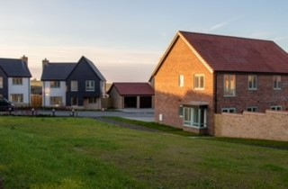

KEY DATES
Tenders are to be returned no later than 31/01/2022, 12:00pm (midday).
Tenders may be emailed to clerk@haddenham-pc.gov.uk or returned by post or hand delivered to:
The Clerk, Haddenham Parish Council, 61 Cherry Orchard, Haddenham, Ely, Cambridgeshire, CB6 3UF

Haddenham Parish Council is wishing to install a new play area at Ovins Rise, Haddenham, Cambs, CB6 3LH. Ovins Rise is a newly developed area of housing which includes a number of properties owned by Haddenham Community Land Trust. The site of the play area will be owned by the Parish Council and the approximate footprint is circa 658m².
The Council is looking to establish a vibrant, focal point for families and carers in order to provide age-appropriate play and stimulus for children up to age 8.
It is the intention to undertake a Design and Build contract for the works. The successful contractor will be responsible for finalising the design and delivering the construction stage of the project. This will involve several key deliverables including the submission of a technical design, liaison with the Council & local community, ensuring a safe construction stage and warranting a smooth handover process.

Location Plan
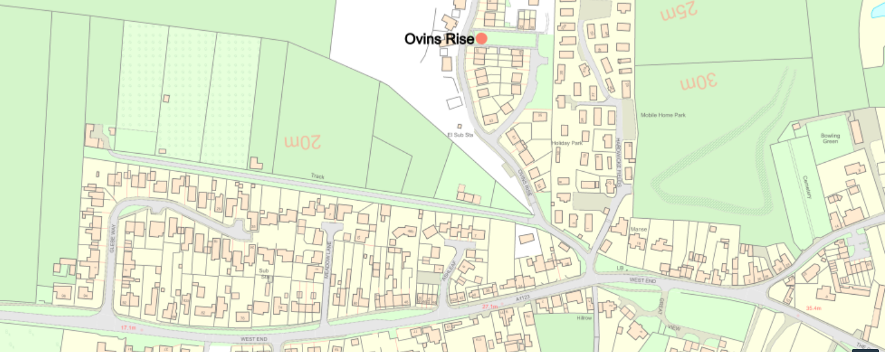
All site visits must be arranged with the Clerk as the area is currently a working building site.

CONTACT FOR THIS PROCUREMENT IS:
Victoria Taylor, Parish Clerk, Haddenham Parish Council, 61 Cherry Orchard, Haddenham, Ely, Cambridgeshire, CB6 3UF
Tel: 01353 749919
Email: clerk@haddenham-pc.gov.uk
INTRODUCTION, TIMELINE & INSTRUCTIONS FOR TENDERERS

INTRODUCTION

  - Haddenham Parish Council (the ‘Council’) invites tenders for the design, supply, and installation of a new children’s play equipment at Ovins Rise, Haddenham, CB6 3LH (the ‘Children’s Park’) with a budget of between £30,000 – 50,000 plus VAT.

  - The purpose of this document is to give detailed instruction on the form of Tender to be complied with. Any tenders that do not comply with the requirements set out below may be rejected by the Council.

  - The site will be owned by the Council.

  - The service and works required for the Children’s Park are outlined in the Design & Build Specification, (the ‘Specification’). The successful tenderer (the ‘Contractor’) will enter into a Design and Build contract with the Council.

  - The Council will evaluate tenders on the basis of quality, design, price and value for money, environmental, & local supplier. The Council does not undertake to accept the lowest, or any, tender submitted.

  - The Council offers no guarantee that any tender will be recommended for acceptance or accepted and will not be held responsible for any cost incurred in the preparation of any tender.

  - The Contractor will fulfil the roles of Principal Designer and Principal Contractor for the purposes of the Construction (Design & Management) Regulations 2015.

PROCESS AND TIMELINE

  - The project stages are detailed below.

PRE-CONTRACT STAGE | DATE
Issue Invitation to Tender | 25th November 2021
Tender Return Deadline | 31st January 2022
Tender Evaluation | 1st February 2022 – 28th February 2022
Contract Awarded / Approval at Full Council | Spring/Summer 2022

DESIGN AND CONSTRUCTION STAGE | DATE
Contract Design Works Commence | To be agreed - 2022
Feedback/Adjustment to Designs Agreed | To be agreed - 2022
Date of Commencement | To be agreed
Date for Completion | To be agreed – but please specify the build time in your tender submission
  - The timetable set out above is intended as a guide only. The Council reserves the right to terminate, amend, or vary the procurement process at any time.

INSTRUCTIONS FOR TENDERERS

  - Tender prices must remain open for acceptance for 12 months from the submission date. Please advise if this is not possible.

  - The Contract will take the form of an exchange of letters based on these preliminaries.

  - Tenderers shall clearly identify the construction material for each element and provide a guarantee of the life expectancy of the facility, which should accompany the designs.

  - Tender prices must include for an independent post installation inspection by an RPII certified inspector. The report is to be issued to the Council as part of the handover process.

  - Without prejudice to anything contained within the Specification, the Tenderer will ensure that any equipment installed is well designed, limits the opportunity for vandalism and has low maintenance aspects to minimise maintenance re-visits. Equipment provided should demonstrate ease of maintenance and access to serviceable parts.

  - In the absence of specific direction to the contrary, the Tenderers price must be fully inclusive, including contingency, covering all labour, materials, temporary works, plant, groundwork preparation, overhead charges, and profit, as well as the general liabilities and taxation payable in so far as any is due, obligations and risks described or implied in the tender documents. Costs relating to items which are not priced will be deemed to have been included elsewhere within the Tenderers budget. For the avoidance of doubt the Tender price will also be deemed to cover all contingencies or costs overruns.

  - In the interests of fair competition if Tenderers discover any anomalies or ambiguities in the bid documents, they are requested to bring them to the Council’s attention as soon as possible so that clarification can be provided to all interested bidders.

  - Should any Tenderer be in doubt as to the interpretation of any part of this ITT, the Tenderer shall submit a request for clarification to the Council.

DESIGN & BUILD SPECIFICATION

2.1 The Council is looking for an innovative design that incorporates into the build best use of the space available. Elements included will offer multiple and varied children’s play equipment.

2.2 Submit a single design for the area with the approximate dimensions.

2.3 The equipment should be aimed at children up to 8 years of age.

2.4 Suggested surfacing should be included and costed.

2.5 The overall design should consider;
- The close proximity of homes to the site including the potential of overlooking from high pieces of equipment.

- Provision of benches for families and carers including picnic benches. These can either be in a dedicated area or interspersed within the Children’s Park. Please separately price for these items but they should be shown in the overall design.

- Limiting and discouragement of anti-social behaviour where possible.

- Provision of a suitable waste bins. Please separately price for these items.
- Land survey to determine that the current surface can support all structures.

2.6 All aspects of the design must conform to the British Standard – BS EN 1176 – Playground Equipment Standard and in respect of any surfacing used – BS EN 1176 and BS EN 1177 and satisfy any applicable recommendations of RoSPA.
2.7 Any equipment shall be installed as per the manufacturer’s instructions and adhere to RoSPA recommendations. A Post Installation Inspection must take place upon completion and the cost included in the Tender.
2.8 Longevity and durability are key considerations and should clearly inform the choice of materials, specification and/or design used in construction. The Tenderer should address these details in their submission.

2.9 Proposed measures to minimise injury in respect of younger children (up to the age of 5 years) should be accommodated and must be clearly demonstrated in the Tender.

2.10 Contractors are advised to visit the site to familiarise themselves with the identity and layout of the site to make best use of the existing site assets including topography and access points. Arrangements for visiting site must be made through the Council.
2.11 Designs received will be subject to technical evaluation and consideration by a variety of stakeholders before eventually being shortlisted and submitted for consultation with user groups.

