xxxxxxxxxx

xxx xxx

24th June 2023

Dear xxxxxxx

Re: Managed Print Contract for St Basils

You are invited to tender for the supply of a Managed Print Replacement Solution to St Basils. The new solution will replace the existing Managed Print Contract.

Accompanying this letter are:

1. A statement of requirements
2. Terms and conditions of this tender
3. The required format for responses, including the criteria which will be used to select the successful supplier
4. The Tender Confidential Document

Please make two copies of the Tender – one copy to be submitted in a sealed, plain A5 envelope with the Tender Label attached. This to arrive no later than 12.00 noon, 23rd July 2023. The other is your copy to keep.

Yours sincerely

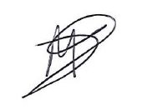

**Mandy Blizard**

**Head of ICT, St Basils**