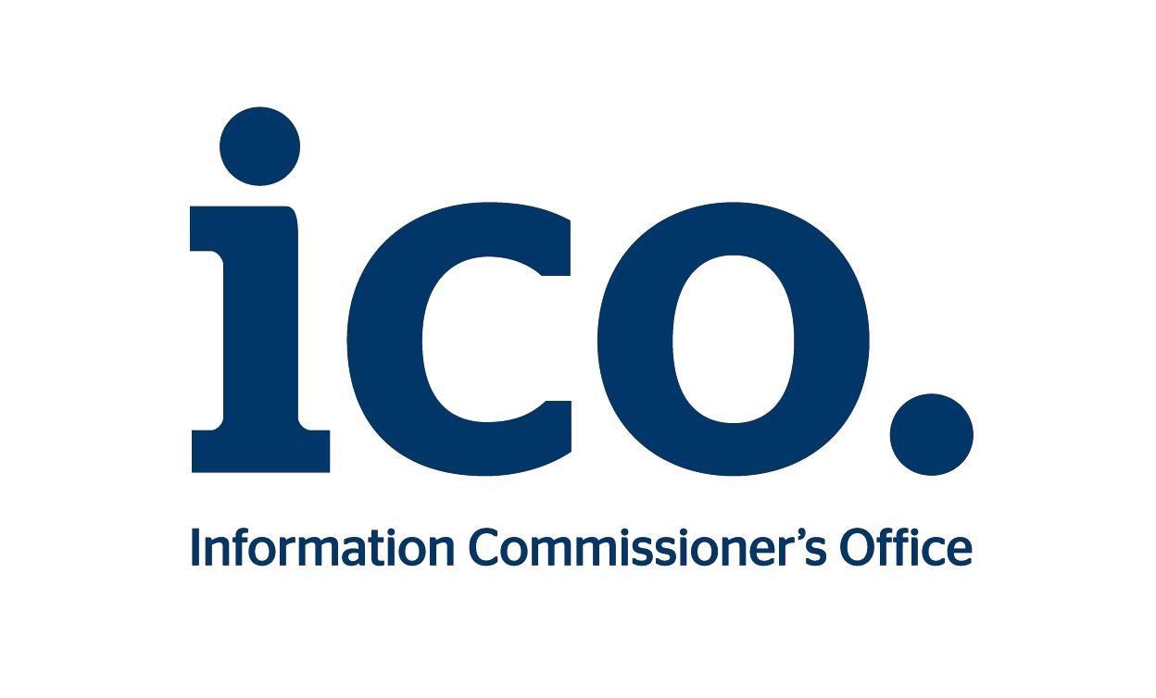

THE INFORMATION COMMISSIONER’S

INVITATION TO TENDER: PART A

Privacy Trust Mark:
Marketing Strategy & Logo Design

Closing date for submission of tender
4:00pm, Friday 2 October 2015

CONTENTS
This document is in two parts:

PART A
Part A is the ITT and provides all the background information, a description of what is required, and instructions for the completion and submission of the tender document.
Note: Part A does not need to be returned to ICO.

Contents
1. INTRODUCTION 4
2. REQUIREMENT & SPECIFICATION 8
3. PROCUREMENT PROCESS 12
4. EVALUATION OF TENDERS 14
5. INSTRUCTIONS FOR COMPLETING AND SUBMITTING A TENDER 17
6. CONDITIONS OF TENDER 19
7. TERMS AND CONDITIONS OF THE CONTRACT 23
APPENDIX 1 - DRAFT CONTRACT

PART B
Part B is the tender submission document that you should complete in full and return to ICO in advance of the deadline and in accordance with the instructions given (see section 5, Instructions for Completing and Submitting a Tender).

Key Terms
Tenderers will find a full description of the requirement, together with any formal definitions for terms and phrases, in the rest of this document and/or any accompanying Appendices. For Tenderers’ convenience however, the following key terms are used throughout this document and are defined as follows:
Contract | means the contract to be entered into between the successful Tenderer and the Information Commissioner;
ICO | means the Information Commissioner and the Information Commissioner’s Office, being the employees and officers, which functions as the administrative and operational body carrying out the duties and powers of the Information Commissioner;
ITT | means this Invitation To Tender document, inviting Tenderers to submit a Tender;
Services | means the requirements and specification for the Services as detailed in section 2 of this document, Requirements.
Tender | means the Tender submitted by the Tenderer;
Tenderer | means an organisation that submits a completed Tender in response to this ITT.

- INTRODUCTION
In this ITT information, instructions and guidance are contained in Part A.

Any Tenderer wishing to submit a Tender in response should complete and return Part B to ICO in accordance with the instructions.

Background on the ICO
The Information Commissioner is the UK's independent public body set up to promote access to official information and to protect personal information. Through his administrative and operational office, the ICO, he regulates and enforces the Data Protection Act, the Freedom of Information Act, the Privacy and Electronic Communications Regulations and the Environmental Information Regulations.

Further information about the ICO and what we do can be found on the ICO website: www.ico.org.uk
ICO’s head office is in Wilmslow, Cheshire, where most of its 400 employees are based. There are smaller regional offices in Edinburgh, Cardiff and Belfast.

Brief Overview
Full details of the requirements and specification for the Services are set out in Section 2. Briefly, the ICO requires:
Phase 1:
(A) A marketing strategy to establish a brand a new, public facing trust mark;
and
(B) The creation of a new and unique logo to represent the trust mark that is capable of being registered in the UK and the EU as a trade mark.

Both aspects of Phase 1 must be delivered together.

Phase 2: (at ICO’s discretion)

We may require support with the implementation of the marketing strategy developed in Phase 1.

Context
The ICO is introducing a new public facing mark in the UK which we intend to register in both the UK and EU as a trade mark. For the purposes of this ITT we call it a “trust mark”.
The trust mark will be used as a ‘stamp of approval’ to indicate that an organisation’s product, process or service has been independently vetted and certified as compliant with data protection law and good practice. A mark that the public will come to understand means that an organisation displaying it will properly look after and respect the personal information that has been given to it.

Such trust marks are also referred to as ‘privacy seals’ within the data protection environment. Our trust mark will work in a similar way to other trust marks such as the British Standards Institute kite-mark or the CE marking – a readily recognisable symbol that signifies quality and provides assurance that a product has been independently assessed to demonstrate it conforms to specific standards and characteristics.

The ICO will not award the trust mark itself. Third parties will set up certification schemes in targeted areas and the ICO will license them to use the trust mark. Organisations wishing to display a trust mark on their product will apply to the licensed third party to be assessed against the requirements of their certification scheme. Organisations that meet the requirements of the certification scheme will be able to display the trust mark, subject to ongoing checks and audits.

The unique selling point of this new trust mark is that the ICO is the UK’s regulator for data protection and where there are serious breaches, it may issue fines of £500,000.

The protection of individuals’ personal information and maintaining privacy in the online world is increasingly high profile – especially in the world of social networking, the internet of things, cloud computing, mobile technology and big data. Individuals are giving out more personal information than ever before. Research indicates that consumers regularly struggle to understand the information presented to them explaining how their data will be used and how to exercise effective choice.
Most UK companies, public sector bodies and charities will be processing personal data and have to comply with the Data Protection Act. Over 300,000 organisations are registered as data controllers with the ICO. Research published by the Direct Marketing Association identified that data privacy is a ‘critical brand differentiator’, with successful organisations keen to demonstrate that they respect their customer’s attitudes to privacy. The ICO is encouraging brands to make a feature of their approach to data protection and privacy, to reflect consumers’ changing attitudes.

The ICO’s work in this area anticipates the future direction of travel at the European level, manifested in the European Commission’s (the EC) proposals for a new General Data Protection Regulation. The Regulation is likely to be agreed by the end of 2015 and will come into force two years later. The EC proposals include specific provisions requiring data protection regulators like the ICO to encourage and develop certification mechanisms as a tool to ensure compliance and to guarantee that internal privacy principles and procedures are implemented, efficient and reliable. The ICO is one step ahead, setting up this trust mark as a trail blazer. An ICO survey indicated that consumers would welcome the introduction of a mark that indicates an organisation has been independently checked as data protection compliant (with 81 per cent of respondents approving the proposed introduction of such a trust mark). This is an opportunity to support the ICO in shaping the future direction of the consumer data protection landscape.

Examples of trust and certification marks
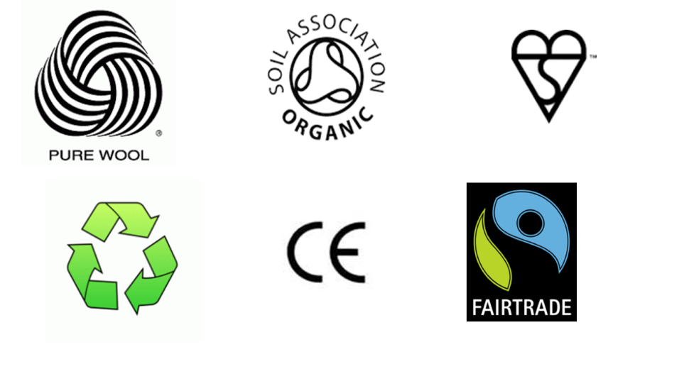

Budget and Duration
Phase 1 of the Contract must be delivered for less than £40,000 exclusive of VAT. It is not possible to assess the value of any potential phase 2 at this stage.
This should not be seen by any Tenderer as a target cost for their Tender as the Contract will be awarded to the most economically advantageous Tender.
The supplier must be ready to start work immediately.
The Contract will be for an initial period of 12 months with an option to extend for a further period of up to 12 months taking the Contract term to a total maximum of 2 years. The Contract is intended to start as soon as possible.
We expect Phase 1 to have been completed by the end of February 2016 at the very latest.

Any extension to the Contract to accommodate phase 2 will be at the sole discretion of ICO and in any event subject to agreement between the parties with regard to pricing. Discussions will be conducted sufficiently far in advance of the Contract expiry date to arrive at an agreed position.

Contract Management
The Contract will be managed by ICO. In view of the need to deliver Phase 1 in good time, the ICO will require regular progress reports with review meetings being held as and when required. The review meetings will enable ICO and the supplier to review the project plan and deal with any challenges to the expected delivery dates.
The supplier under the Contract will be expected to field the appropriate personnel for each review meeting and provide relevant information at no additional cost to ICO.

Questions and Contact Details
All requests for clarification on and questions about this ITT (whether about the ICO’s requirements or Tender submission) should be sent as soon as possible in writing by email (using reference “Privacy Trust Mark: Marketing Strategy & Logo Design“) to:
procurement2@ico.org.uk
The contact for this ITT in the ICO is:
Gemma Farmer
Information Commissioner’s Office
Wycliffe House
Water Lane
Wilmslow
SK9 5AF
Tel: 01625 545870

A copy of all questions raised (anonymised) and answers given will be maintained and distributed periodically to all Tenderers who have contacted ICO to express an interest in submitting a Tender. It is therefore in your interests to let us know if you are interested in submitting a Tender as soon as possible.
Tenderers should not ask confidential questions unless absolutely necessary. Any such question must be clearly marked “In Confidence” and must set out reasons for this. However, if ICO does not consider that the question should be treated as confidential we will inform the Tenderer who may withdraw the question without getting an answer. If the question is not withdrawn the question and any answers will be circulated as above.

Please consider the deadline for raising clarifications and questions in your Tender response planning. ICO is not obliged to answer any questions received after this date.

2. REQUIREMENT AND SPECIFICATION

This section provides Tenderers with the details regarding the ICO’s requirements and will help Tenderers compile their Tender submission.

Delivery Requirements:
Phase 1:
- We require a comprehensive marketing strategy to support the introduction of a new public facing trust mark.
- This must include the creation of a new, unique logo to represent the trust mark that is capable of being registered in the UK and the EU as a trade mark. This will include the creation of brand guidelines for use of the trust mark, consumer research and testing and delivery of the final artwork.
We require completion and delivery of both the above elements by the end of February 2016 at the very latest. If this deadline cannot be met, Tenderers must explain why and provide a timetable that is as close as possible to our preferred deadline.

Phase 2: (at ICO’s discretion)
We may require support with the implementation of the marketing strategy developed in Phase 1. We include this as an anticipated optional extension to the scope of the Contract. Tenderers are asked to confirm their capability to deliver this work later in 2016.

Strategic Objectives of the Trust Mark
The trust mark must resonate with a broad and diverse range of UK consumers. The ICO can do some customer journey mapping to provide direction for the design process. We will be able to more precisely identify specific audiences once we have selected the schemes in early 2016. From our scoping work, we anticipate that the trust mark will be most frequently displayed online and accessed through a range of devices. It is likely to be seen by online shoppers, mobile app users and public service users.

Where they have a choice with a service or transaction, we are aiming to persuade consumers to choose organisations that display the trust mark.

The trust mark should:
(a) For Consumers:
• Easily identify organisations that are data protection compliant and follow good practice.

• Give confidence to consumers that an organisation displaying the mark will properly look after their personal information.

• Assure consumers an organisation has been independently checked by an approved third party and is handling their personal information lawfully and fairly.

• Inform consumer choice enabling them to make decisions quickly and easily.

• Enable consumers to exert more control over which services to use based on how organisations use their personal information.

• Raise the visibility of data protection.

(b) For Organisations:

• Give organisations a competitive advantage by distinguishing those companies going the extra mile to protect and respect their customers’ personal information.

• Emphasise that data protection and privacy is a ‘critical brand differentiator’.

• Build consumer trust.

• Promote accountability by data controllers by helping them better fulfil their data protection obligations.

• Raise the bar for privacy standards by providing incentives for committing to good practice and a high standard of compliance.

(c) For ICO:

• Supports ICO’s regulatory objective to help organisations protect personal information.

• Contributes to performing legal duty to promote the following of good practice by organisations.

• Fulfils policy objectives around consumer protection through collaboration with private and third sector experts, balancing responsibility between the regulator and business and industry.

• Develops new co-regulatory solution within the existing legislative framework to protect the rights of individuals, in an easy to understand, effective way.

Design Requirements for the Trust Mark
(a) A strong visual identity through an instantly recognisable, unique and contemporary logo.

(b) A logo that it can register as a trade mark in the UK and in the EU.

(c) A logo design that conveys messages such as: trust, credibility, transparency, data protection, personal information, security, reliability, confidence, lawfulness and respect.

(d) Designs must be robustly tested with consumers and stakeholders, with clear evidence of support from both groups. The Tenderer must describe how evidence from consumers can enable stakeholder support.

(e) Though the trust mark will derive much of its authority from the fact that the ICO is the regulator, the logo must not contain ICO’s current logo or in any way extend the form of the current ICO logo.

(f) The logo must be capable of being used by a range of different organisations alongside their own brand identity. It will be showcased in a range of environments (eg online and on printed documents). The obvious ones include:

- internet based (websites, social media, mobile apps (eg when agreeing terms and conditions) email marketing, email signatures);
- marketing materials (brochures, advertising, annual reports, presentations); and
- printed corporate stationery (such as letter templates, application forms / contracts / agreements).

It is likely that internet based display will be most relevant. For example, in this context, we anticipate that the logo would be displayed on:

- the webpage header or footer banner (including on home page and other pages). These often contain other types of certification/trust marks - for example, see the display of the Information Standard on the NHS England home page (http://www.nhs.uk/Pages/HomePage.aspx), or the display of the Trusted Shops logo as a ‘verified service’ on the homepage of Zalando.co.uk.

- As part of an ordering or signing up process - ie when explicitly providing personal information, eg form filling / agreeing to marketing /terms and conditions / privacy policy.

- On pages such as a signed in service area and ‘my account’ pages;

- Compliance / corporate information areas or those that specifically refer to privacy and the handling of personal data.

These examples are illustrative rather than exhaustive; we are looking for a high likelihood that a consumer will see the logo. The display of the ‘rust-badge’ as a way of displaying the Trusted Shops trust mark is interesting and perhaps an approach we would consider (see http://www.trustedshops.eu/merchants/integration/trustmark.html).

(g) In terms of sizing, we expect the logo to be consistent with other types of trust marks displayed on company websites.

3. PROCUREMENT PROCESS
_______________________________________________________

Overview
All interested Tenderers are invited to submit a Tender. Please contact the ICO to register your interest as soon as possible.

All compliant Tenders received will be evaluated in accordance with the evaluation criteria as set out below. ICO will select a Tenderer based on the Tender which offers the most economically advantageous solution, taking into account quality and costs.

Tenders should be prepared and submitted (using Part B of this ITT document) in accordance with section 5 of this document. At the ICO’s discretion, Tenderers may be invited to clarify their Tender to help evaluators fully understand the offer made. All Tenderers should nonetheless take care to fully explain their offering in their Tender submission.

The value of the resulting Contract for the Services is expected to be below the relevant threshold for full EU advertisement under the Public Contracts Regulations 2015 and ICO does not believe there will be cross-border interest in this ITT.

This ITT and any subsequent Contract will be published on the Contracts Finder website under the UK government’s transparency regime and in accordance with Ministry of Justice procurement guidelines. Tenderers should note this as Tenders will be accepted and evaluated by ICO on the basis that the Tenderer agrees to such publication.

If there is any information a Tenderer believes should be exempt from publication as it falls within an exemption set out in the Freedom of Information Act the Tenderer should complete the schedule in section 4 of Part B to this ITT, setting out the relevant information, the exemption they believe applies, their reasons for it applying and the time period for the suggested exemption. The ICO’s decision is final on whether any exemption applies, how long it applies for and what is published ultimately. Tenderers should not submit a Tender unless they accept this.

Presentations and/or interviews may be held as part of the procurement process. Please see section 4, Evaluation of Tenders, for further information on how these will form part of the evaluation process.

Indicative Procurement Timetable
The following is an indicative timetable for this procurement exercise. Please be aware that these timescales (with the exception of the deadlines in bold) may be subject to change at the absolute discretion of ICO.

STAGE / ACTIVITY | INDICATIVE DATE
ITT issued | 28 August 2015
Closing date for Tenderers to ask clarifications / questions  (ICO will endeavour to provide all answers by 22 September) | 4:00pm, 17 September 2015
Closing date for submission of Tenders | 4:00 pm, 2 October 2015
Preliminary evaluation of Tenders | by 4:00pm, 9 October 2015
Presentations and/or interviews | 14 October 2015
Contract award | 19 October 2015
Contract start date | 30 October 2015

4. EVALUATION OF TENDERS
Overview
All completed Tenders received will be evaluated by ICO in accordance with the evaluation process described below. Should any Tenderer not understand any element, they should make contact with ICO as per the contact details in section 1 of this ITT.
Stage 1 - Compliance Check
Before proceeding to evaluation a compliance check will be carried out to make sure all sections of Part B to this ITT have been completed and submitted and that there are no mandatory grounds for excluding the Tender.
Grounds for mandatory exclusion are contained in the Public Contracts Regulations 2015, paragraph 57(1)-(3). Each Tenderer must supply a declaration in the form of section 5 to Part B of this ITT, signed by an authorised signatory.

There are also discretionary grounds for extension which ICO will then consider. These grounds are contained in the Public Contracts Regulations 2015, paragraph 57(4)&(8). The Tenderer’s declaration must state whether any of these grounds apply and give further information for ICO’s consideration.

It is the Tenderers responsibility to check and declare whether any of these grounds apply to them.
Stage 2 - Selection Criteria
All Tenders passing the compliance check will then be assessed against the following criteria which Tenderers should evidence by answering the relevant questions in Part B to this ITT:
Economic and financial standing - see questions under A.2 in Part B, assessed on a pass/fail basis;
Stage 3 – Award Criteria
All Tenders passing stage 2 will be assessed against the award criteria. The most economically advantageous Tender will be chosen based on quality and cost scores weighted as follows:
- Quality 80%; and
- Cost 20%.

The methodology for evaluating Tenders against these criteria is as follows:
Evaluating & Scoring Costs 80%
(Lowest cost / cost you are evaluating) x 100 = cost score for that Tender

Abnormally Low & Unacceptably High Tenders

Please note that in accordance with Regulation 69 of the Public Contracts Regulations 2015 ICO is obliged to ask any Tenderer to explain the price or costs proposed in their Tender where it appear to be abnormally low. If ICO seeks such clarification and a Tenderer does not explain the proposed costs to our satisfaction then ICO may reject the Tender as abnormally low.

Furthermore, where ICO reasonably considers that a Tender is abnormally low due to a breach of the Tenderer’s environmental, social or labour obligations, including obligations deriving from relevant collective agreements, ICO is obliged to reject it.

Any Tender that is rejected as abnormally low will be excluded from further consideration regardless of how many points it has scored in all other aspects.

In addition, any Tender which is found to be too high to be acceptable to ICO may also be excluded from further consideration. In this instance, ICO will initially clarify with the Tenderer concerned whether the pricing is correct and has been interpreted correctly. No alternative pricing will be allowed. If following the clarification the costs are too high to be acceptable, that Tender will be rejected regardless of how many points it scores in all other aspects.

Evaluating Quality 80%
Tenderers will be asked to provide full details of their company or organisation, and confirm any sub-contractors details, for information only in section 1 of Part B. This will not be scored.

Scores for quality will be allocated to Tenderer’s answers to the questions in section 2 of Part B. Individual weightings for each question are shown in the table alongside the questions.
Tenderers must make sure that they answer what is being asked. Anything not directly relevant to the particular question should not be included, but where possible please demonstrate how you will go further than what is being asked for to add value.
Tenders should state not just what they will do, but how they will do it, and what their proposed timescales are (as relevant). It is useful to give examples or provide evidence to support the responses. Include all relevant detail, so the evaluation panel gets the fullest possible picture.
Each question and answer will be evaluated individually, one by one in order. When scoring each statement, no consideration is given to information included in other answers so please do not cross reference to responses or information provided elsewhere in your Tender.

Quality Scoring Scale
Please use plain English in all responses. Answers to the questions will be assessed on a scale of 0 to 10 points, as detailed in the table below:
Scores | Classification | Definition
0 | Unacceptable. No response, response not complete or not relevant. | No response at all or insufficient information provided in the response such that it is totally un-assessable and/or incomprehensible.
1-2 | Poor. Partially compliant response but with serious deficiencies and/or major weaknesses. | Substantially unacceptable submission which fails in several significant areas to set out a solution that addresses and meets the requirements. Little or no detail and no supporting evidence provided to demonstrate that the Tenderer is able to provide the services. Considerable reservations in respect of relevant ability, understanding, expertise, skills and/or resources to deliver the requirements.
3-4 | Weak. The response is almost compliant but one or more major weakness and/or several minor areas of weakness remain. | Weak submission which does not fully address and meet the requirements. Response is basic/minimal with minimal detail and insufficient supporting evidence to demonstrate that the Tenderer is able to provide the Services. Some reservations in respect of relevant ability, understanding, expertise, skills and/or resources to deliver the requirements.
5-6 | Good. Satisfactory and acceptable response with no major concerns. | Submission sets out a solution that largely addresses and meets the requirements, with some detail and supporting evidence.  Relevant ability, understanding, expertise, skills and/or resources meet minimum requirements for delivery of the requirements. There may be one or two very minor weaknesses.
7-8 | Excellent. Fully satisfactory /very good response. | Submission sets out a robust solution that fully addresses and meets the requirements, with full details and full and relevant supporting evidence provided to support the solution.  Answer gives full confidence as to the relevant ability, understanding, expertise, skills and/or resources to deliver the requirements.  No weaknesses in any area identified.
9-10 | Outstanding. Fully satisfactory / very good response with some areas exceeding requirements. | Submission sets out a robust solution (as for a 7-8 score) and, in addition, provides or proposes additional value and/or elements of the solution which exceed the requirements in substance and outcomes.  Answer gives full confidence as to the relevant ability, understanding, expertise, skills and/or resources not only to deliver the requirements, but also exceed it as described.
Moderation
Following the evaluation of the written Tenders, Tenderers may be invited to attend an interview with the evaluation panel, which may include making a short presentation. The purpose of this, should it take place, is to moderate the scores awarded to the written Tender and to clarify any outstanding issues.
If this takes place, only those Tenderers with a good chance of being awarded the Contract will be invited. It may not take place if there is a clear leader following evaluation. No additional points have been reserved for this stage. Details of the interview arrangements and format will be provided to the invited Tenderers should the interviews take place.
Award of Contract
Upon conclusion of the evaluation, the scores for cost and quality will be combined to give a total score and the Tenderer considered by ICO to be offering the most economically advantageous Tender based on the evaluation criteria will be the preferred bidder. This Tenderer will be offered the Contract via email and if they accept on the terms offered an award will be made to them.
Tenderers who have not been chosen as preferred bidder will also be advised of this via email. They will be entitled to receive feedback on the characteristics and relative advantages of the successful Tender in relation to their own and the name of the successful Tenderer in accordance with paragraphs 55 and 86 of the Public Contracts Regulations 2015.
The award of the Contract will be subject to a standstill period of 10 days between the notification of the award decision and Contract conclusion.
All Tenderers are advised that no action should be taken, for example commencing the delivery of or implementation of the Services or commencement of any works, until the Contract has been finalised. Any Tenderer doing so does so at its own risk.
Tenderers must not undertake any publicity, marketing or promotional activity based on award of the Contract without prior approval of the ICO.
The ICO is not bound to accept any Tender, and unless a Tenderer expressly states that a partial award will not be acceptable, then the right is reserved to accept a Tender in part.
Upon conclusion of all the above stages, the Contract will be entered into between the ICO and the successful Tenderer. Contracts will be in the name of the Information Commissioner. The terms and conditions governing the Contract will be those set out in the draft terms and conditions accompanying this ITT (see Appendix 1 to section 7). Only minor amendments will be acceptable to ICO. Tenderers should only submit a Tender if they are willing to accept this.

5. INSTRUCTIONS FOR COMPLETING AND SUBMITTING A TENDER
You have received one copy of this ITT document. We require you to submit one ELECTRONIC copy of your Tender and all supporting documents to:
procurement2@ico.org.uk

Please ensure your email is entitled “Tender for Privacy Trust Mark: Marketing Strategy & Logo Design.”

Please note: The largest email size (including attachment) we can receive is 8MB.
Completed tender submissions must be received by 4:00pm on Friday 2 October 2015.
We also recommend you keep a copy for your own records.
ICO will take reasonable measures to safeguard all Tenders received and open them only when the submission deadline has expired.
The date and time the email was received into the ICO’s inbox as stated above will be decisive of the date and time received. Late submissions will be rejected. It is the responsibility of the Tenderer to ensure that submissions are received by ICO on time.
Completing the Tender
So that ICO can assess fully the Tenderer’s suitability, all information requested in this ITT must be provided. Failure to complete the Tender submission in full or failure to follow submission requirements may result in your Tender being rejected.
Please note the following:
- Supply all requested information.
- Answer every question with information relevant to the question being asked.
- If the question does not apply to you please write N/A; if you don’t know the answer please write N/K.
- Questions must be answered in English.
- Any Yes / No questions should clearly show which answer you intend to give by deleting the alternative.
- Answers should be clear, complete and as concise as possible.
- Unclear, ambiguous or irrelevant answers will not achieve high marks.
- Any figures requested should be stated in full (i.e. £1,000,000 not £1m) and in GBP. Where information relates to foreign accounts, amounts in alternative currencies may be stated, but must also be converted to GBP.
ICO expects that information and/or documents submitted on or with any Tender will relate to the Tenderer only - the Tenderer being the organisation which it is proposed will enter into the Contract should their Tender be successful. If anything submitted relates to a sub-contractor this must be clearly marked as such.

ICO may, but is not obliged to, seek further clarification from the Tenderer following submission of completed forms where required.
Format of Tender Submission
Tenderers are required to complete all of the documentation listed below. Please complete the documentation electronically where possible, without making any changes to the structure and/or order of the document provided (except as necessary to accommodate your responses, i.e. enlarging response boxes etc.). Please submit the Tender as a Word document.

In particular, please do not undertake any substantive changes to formatting, or add appendices instead of completing the tables provided, and so on, except as may be expressly requested or are necessary to properly present your Tender.
You should complete and submit all sections of Part B, namely:
- Company Details and General Information
- Response to Requirements & Specification
- Costs Schedule
- Freedom of Information Exclusion Schedule
- Tendering Declaration
- Declaration of Interests or Connections with ICO
- Qualification of Tender
- Enclosures Checklist
The declarations must be signed by a director, partner or other senior authorised representative in her/his own name and on behalf of the Tenderer. The details contained in a Tenderer’s response may be specified in the Contract or may form an appendix thereof. Tenderers should therefore make sure that their responses are authorised at an appropriate level which would enable them, should they be successful, to become the subject of a binding contract.

6. CONDITIONS OF TENDER
In submitting a response to this ITT Tenderers do so on the conditions set out below. In the event of any breach of the conditions the ICO shall be entitled to terminate any arrangement made as a result of such Tender, including terminating any Contract, and to claim damages accordingly.
Warnings and disclaimers
Save where expressly provided to the contrary, the laws of England shall apply to this procurement process and any resulting contract.

The ITT documents are intended as a preliminary explanation of ICO's activities and plans and are not intended to form the basis of any decision on whether to enter into any contractual relationship with the ICO. These documents do not purport to contain all information a prospective contractor may require, or to have been independently verified and should not be considered as an investment recommendation made by the ICO to Tenderers.

No Tender is deemed accepted until the Contract has been agreed and formally approved and signed by ICO, the Tenderer and any other relevant party and declared unconditional. The publication of the ITT does not commit the ICO to the award any contract.

No dialogue or communication with the ICO whether prior to, during or subsequent to the procurement (including any notification of preferred bidder status) imply acceptance of any Tender or an indication that the Tenderer will be awarded the Contract.

Only the express terms of the Contract which is finally agreed and signed on behalf of the relevant parties and which is unconditional shall have any contractual effect in connection with the matters to which it relates.

The ICO does not:
- make any representation or warranty (express or implied) as to the accuracy, reasonableness or completeness of the procurement documentation provided. Any persons considering making a decision to enter into contractual relationships with the ICO following receipt of the ITT should make their own investigations and their own independent assessment of ICO and its requirements and should seek their own professional technical, financial and legal advice;
- accept any liability for the information contained in the ITT;
- accept any liability for loss or damage (other than in respect of fraud or fraudulent misrepresentation) arising as a result of reliance on such information or any subsequent communication. Any and all liability is expressly disclaimed and excluded to the maximum extent permissible by law.

Tenderer conduct and conflicts of interest
  - Tenderers shall not, before the date and time specified for return of the Tender, communicate to any person the amount or approximate amount of the Tender or proposed Tender, except where the disclosure in confidence of the approximate amount of tender is necessary to obtain insurance cover or otherwise prepare the Tender.
  - The Tender shall be bona-fide and shall not be fixed or adjusted by or under or in accordance with any agreement or arrangement with any other person.
  - Tenderers shall not enter into any agreement or arrangement with any other person with the intent that the other person shall refrain from tendering or agree as to the amount of any other Tender to be submitted.
  - Tenderers must not:
- offer any inducement, fee or reward to any member or officer of ICO;
- do anything which would constitute a breach of the Bribery Act 2010;
- canvass any officer or employee of ICO in connection with the Contract; or
- contact anyone at ICO or any person acting as an advisor to ICO (except as authorised by this ITT for the purpose of asking genuine questions about the process or the Contract) about any aspect of the proposed Contract or for soliciting information in connection therewith including (without limitation) to discuss a possible transfer of employment to ICO.
  - Tenderers are responsible for ensuring that no conflicts of interest exist between the Tenderer and its advisors and ICO and its advisors. ICO reserves the right to disqualify a Tenderer where there is an actual or potential conflict of interest. Tenderers are encouraged to seek to clarify ICO's view on actual or potential conflicts prior to submission of their Tender.

Tenderer’s responsibility to submit a complete tender
  - It is the Tenderer’s responsibility to ensure that their Tender is complete, prepared and submitted in accordance with the instructions contained herein, and signed and dated where required. ICO is not obliged to consider any Tender which is incomplete or non-compliant but, at its sole discretion, may offer a Tenderer who submits such a Tender an opportunity to remedy the omission before evaluation of the Tender takes place provided that, in ICO’s judgement, this does not adversely affect the integrity and fairness of the procurement exercise.
  - Unless specifically withdrawn in writing, Tenders shall remain open for acceptance for a period of 90 days from the return date.
Bid costs
- ICO will not be liable for any Tenderer’s costs, expenditure, work, or effort incurred in proceeding with or participating in this procurement process, including if the procurement process is terminated or amended by ICO for any reason.

ICO’s rights
The ICO reserves the right to:
  - seek additional information or clarification from Tenderers at any time during the tender process;
  - disqualify any Tenderer that does not submit a compliant Tender;
  - disqualify any Tenderer that is guilty of serious misrepresentation in relation to its Tender, its declarations or the procurement process;
  - withdraw this ITT at any time, and to re-invite Tenders on the same or any alternative basis;
  - choose not to award the Contract as a result of the procurement process;
  - make whatever changes it sees fit to the timetable, structure or content of the procurement process;
  - retain copies of all Tenders to satisfy its audit obligations and for other purposes.

Confidentiality and Freedom of Information Act
- As a public body, ICO is subject to the provisions of the Freedom of Information Act 2000 in respect of information it holds (including third-party information). Any member of the public or other interested party may make a request for such information.
- ICO shall treat all Tenderers' responses as confidential during the procurement process but not afterwards. Requests for information received following the procurement process shall be considered on a case-by-case basis, applying the principles of the FOIA. If an exemption cannot be justifiably applied the information must be disclosed.
- Whilst ICO aims to consult with third-party providers of information before it is disclosed, it cannot guarantee that this will be done. Therefore, tenderers are responsible for ensuring that any confidential or commercially sensitive information has been clearly identified to ICO in the form provided in the Tender Submission Document (schedule 4 of Part B). However, the ICO’s decision on whether or not to disclose requested information will be final.
- Tenderers should be aware that, in compliance with its transparency obligations, ICO must publish details of its contracts, including the contract values and the identities of its suppliers. Publication may be made on Contracts Finder and/or on ICO’s own website.
- Neither the Commissioner or the ICO will be liable for any loss, damage or harm or other detriment, however caused, arising from disclosure of any information relating to this ITT, the procurement process, any Tender submitted or the resulting Contract.

Publicity
  - No publicity regarding the Contract or its award will be permitted unless and until ICO has given express written consent. For example, no statements may be made to the media (including the internet and email) regarding the nature of any Tender, its contents or any proposals relating to it without the prior written consent of ICO.

Information Sharing
All Central Government Departments and their Executive Agencies and Non Departmental Public Bodies are subject to control and reporting within Government. In particular, they report to the Cabinet Office and HM Treasury for all expenditure. Further, the Cabinet Office has a cross-Government role delivering overall Government policy on public procurement - including ensuring value for money and related aspects of good procurement practice.

For these purposes, the ICO may disclose within Government any of the Tenderer’s documentation/information (including any that the Tenderer considers to be confidential and/or commercially sensitive such as specific bid information) submitted by the Tenderer to the ICO during this Procurement. The information will not be disclosed outside Government. Tenderers taking part in this procurement consent to these terms as part of the ITT process.

7. TERMS AND CONDITIONS OF CONTRACT__________________________

The Contract terms for the Services will be in the form of an ICO agreement, a copy of which is attached to this ITT as Appendix 1.

By submitting a bid, Tenderers are agreeing to be bound by the terms and conditions without further negotiation or amendment, and must sign the Tendering Declaration accordingly.
Whilst ICO may be prepared to give consideration to any changes of a minor nature, including changes and additions indicated in the document, it is not prepared to accept material changes to the terms and conditions.
For the avoidance of doubt therefore, if Tenderers submit a Tender that is subject to a qualification in respect of the terms and conditions which ICO deem ‘material’ and unacceptable, the Tenderer will be invited to withdraw the qualification and the Tender submission will be evaluated without it. Should the Tenderer not wish to withdraw the qualification grounds will exist to exclude their Tender from further consideration.

APPENDIX 1 to Section 7: Draft Contract

