Table of Content

I. Scope of the requirement 2
II. Procurement output 3
III. Outline Purpose: 5
IV. Service offerings: 6
V. The high-level scope of the requirement: 6
VI. 5G R&D SoC Architecture Framework: 8
VII. Evolved Packet Core Architecture 9
VIII. Radio access technologies 11
IX. Session management and control 12
X. Machine Type Computing (MTC) – M2M / IoT 13
XI. Mobile Edge Computing (MEC) 13
XII. Operation, Control & Management 14
XIII. Ancillary Equipment or Nodes 14
XIV. Test and measurement Equipment 14
XV. Additional functionality 15
XVI. Project initialization 15
XVII. KEY MILESTONES 16
XVIII. EVOLUTION AND PRODUCT ROADMAPS 16
XIX. SUPPORT SERVICES CUSTOMER SERVICE 16
XX. ADDITIONAL INFORMATION 17
XXI. Supplementary questions 17

Scope of the requirement
The 5G SoC comprises of virtualized set of interdependent network elements aligning to 4G Long Term Evolution–advanced (LTE-A) mobile network. The proposed architecture should be compliant with a 3GPP release 11, exploiting the capability of SDN/NFV technologies to provide an architectural framework, by this we mean the ability to instantiate network element functions within a cloud environment with the control and user plane segregated and function’s having the ability to be centralized or distributed on a function by function basic.
The 5G SoC will be a fully functional network consisting of a series of interconnected network elements (hardware or software) to form a functional architecture to provide mobile connectivity via a wireless medium. In the case of the 5G SoC this will be in the form of a 4G/5G 3GPP network architecture interconnecting to trusted and untrusted 3GPP and non-3GPP networks
The network will consist of a series of radio access technologies (RAT) to include base stations, access points and associated wireless access gateways to support end user access, this will form an evolved –UMTS radio access network (E-UTRAN). The packet core must conform to 3GPP standard architecture consisting of a Evolved Packet Core made up of the following entities, Mobility Management Entity (MME) to manage the control plane mobility related procedures, a Serving Gateway (SGW) for the user plane, the PDN Gateway provides interconnection and breakout to intra/Inter/extranets. Reporting, Administration, Accounting and user authentication as well as policy enforcement provided by the HSS and PCRF.
EPC nodes may be connected to legacy systems (GERAN, UTRAN) so that LTE systems can co-exist with existing access technologies and facilitate seamless handovers, additional to this the network will be connected to a satellite ground station and other non-3GPP wireless access networks.
IP Multimedia Subsystem (IMS) will be the preferred architecture element in setting up, conducting, and tearing down of multimedia sessions, additionally supported by Media Gateway(MGW), Media Gateway Control Function (MGCF), Session Border Controller (SBC) to support voice services.
Enriching the architecture with more advanced functions such as Mobile Edge Computing (MEC) will be one of a series of function we wish to incorporate into the centre.

Procurement output
The key output from this procurement will be ,but not limited to the following:
A set of virtualized network elements or functions to provide a fully functional non-operation private wireless testbed , this will comprise of the following elements connected in such a way to be able to provide wireless mobile service in support of application and service development.
- Evolved UMTS Terrestrial Radio Access Network (E-UTRAN) / Radio Access Network (RAN) to include:
  - E-Node-b
  - Node-b
  - Picocell.
  - Femto Cell
  - He-Node-b operating in either licensed or unlicensed spectrum bands

- Evolved Packet Core / Core Network elements to include:
  - Mobility Management Entity (MME)
  - Serving Gateway (SGW) / Serving GPRS Support Node (SGSN)
  - PDN GW (Packet Data Network Gateway) / Gateway GPRS Support Node (GGSN)
  - HSS (Home Subscriber Server) /Home Location Register (HLR) – to include EIR/AuC/AAA functions.
  - Policy and Charging Rules Function (PCRF)

- Session Management / ancillary network elements
  - IP Multimedia Sub System (IMS to include P-CSCF ,I-CSCF , S-CSCF)
  - Media Gateway Control Function (MGCF)
  - Media Gateway (MGW)
  - Session Border controller(SBC)
  - Security Gateway (SeG)

- He-Node-b gateway (HeNb GW)
- Mobile Edge Computing –MEC Server / function
- Software Defined Networking controller and associated switches or routers
- Network Function Virtualization Orchestrator
- Server hardware.
- Virtualization software.

Potential bidder may choose to bid specific network element/functions or a complete turnkey solution. In the case of a turnkey solution the proposal must include, power connector, RF connector, network cables, interface cables required to integrate network element or functions into the 5G SoC architecture. This will also include any dimensioning information or calculations, performance figures or architecture / interface models or diagrams used in the design, installation or commissioning, furthermore all data pertaining to performance or capability of the network elements or commissioned architecture.
The main subject of the ITT will be to procure a functional standards based 5G architecture, with this in mind table 1 below is an high-level list of the identified network elements or functions, this is by no means an exhaustive list of component parts or elements to be procured , it should however form the basis of a procurement strategy. It should be noted by the proposer, you may wish to include additional nodes or functional elements as a part of your proposal, however justification will be required as to the purposed additional items within your response document.
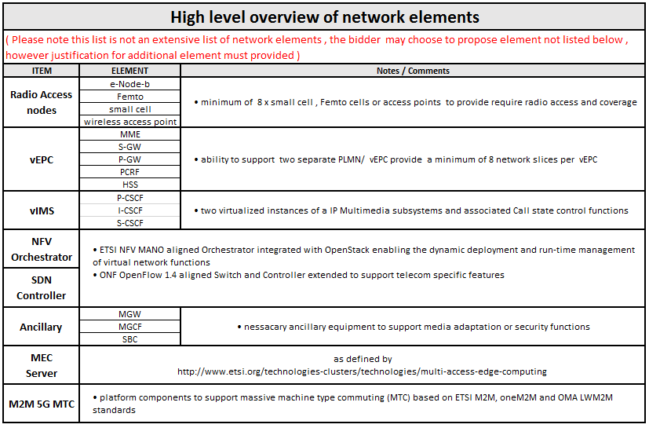
Table 1 - High-level architecture components

Outline Purpose:
It is our direction and as part of the seed funding to enable these organisations to access a state of the art representative 4G/5G and satellite environment equipped to the latest standard at the 5G Reach and Resilient step out centre (5G R&R SoC), the centre will focus on mobile applications and services.
The Centre will offer seamless integration of terrestrial and satellite communications networks to provide services and applications like:
- HD Video.
- M2M and IoT.(MTC)
- Rich communications services (RCS)
- Broadcast services.
- Low bit rate connectivity. NB-IoT ,LTE-M
- Broadband connectivity.
All these applications and services will coexist on wireless heterogeneous technologies, e.g. Satellite, 802.X , LTE, LP-Wan, PAN and new and emerging radio technologies.

Figure 1- A representation of the 5G R&R SoC facility

In addition, the centre will support large open space facilities that currently allow for testing of new infrastructure without the risk of causing interference to existing systems. The location also offers a significant variety of local geographical features that can be used to validate novel concepts of operation and operational technology, which makes it ideal for testing other safety critical systems such as UAVs or autonomous ground vehicles.
The 5G R&R SoC is an environment where start-ups, SME and industrials from around the world are able to develop on a future 5G environment, it has been designed to enable innovative product prototyping in realistic, comprehensive environments, offering interoperability between new prototypes and current CoTS products and existing satellite & 3G/4G network deployments.

Service offerings:
5G R&R SoC enables the rapid deployment of proof-of concepts as well as for resilience, security and reliability evaluations into the different network areas, addressing the highly diverse requirements coming from the different verticals of the 5G domain, 5G R&R SoC features a set of customized functions as basis for different dedicated network slices for:
- M2M, IoT connectivity
- Narrowband & broadband Multimedia for automotive
- Reliability , High availability for mission critical infrastructures
- Support for extended communication platforms - UAV, Helikite, BLIMPS, HAPS
- Security and privacy for dedicated networks. (VPN, enterprise networks)
- Usage of satellite networks for backhauling, broadcast, content delivery.
5G R&R SoC should encompass a comprehensive, highly customizable and re-configurable network environment, based on commercially available components and dedicated toolkits:

The high-level scope of the requirement:
In addressing this ITT, Satellite Applications Catapult wants to achieve an evolution shift in its facilities, offering a very functional, flexible, saleable and manageable set of elements across the network segments including Fronthaul and Backhaul Networks, Access Networks, Aggregation Networks, Core Networks, Mobile Edge Networks, Software Networks, Software-Defined Cloud Networks, Satellite Networks and IoT Networks. The architecture must cater for current and forthcoming applications and services while evolving the baseline to understand how 5G architecture enables new business opportunities meeting the requirements of a large variety of use cases as well as enables 5G to be future proof by means of.
- Implementing network slicing in a cost efficient way; addressing both end-user and operational service needs.
- Supporting NFV or Functional distribution natively across a dynamic architecture; integrating computation, compute and memory whilst minimizing costly hardware investment.
- Integrating heterogeneous technologies (incl. fixed and wireless technologies) within its solution development.
The 5G R&R SoC is essentially an architecture framework consisting of a series of interconnected virtualized and actual network elements (hardware or software) to form a functional architecture. The network will provide mobility and session orchestration via a wireless medium, in the case of the 5G SoC this will be in the form of a 4G/5G 3GPP network architecture interconnecting to trusted and untrusted 3GPP and non-3GPP networks as depicted in Figure 2.
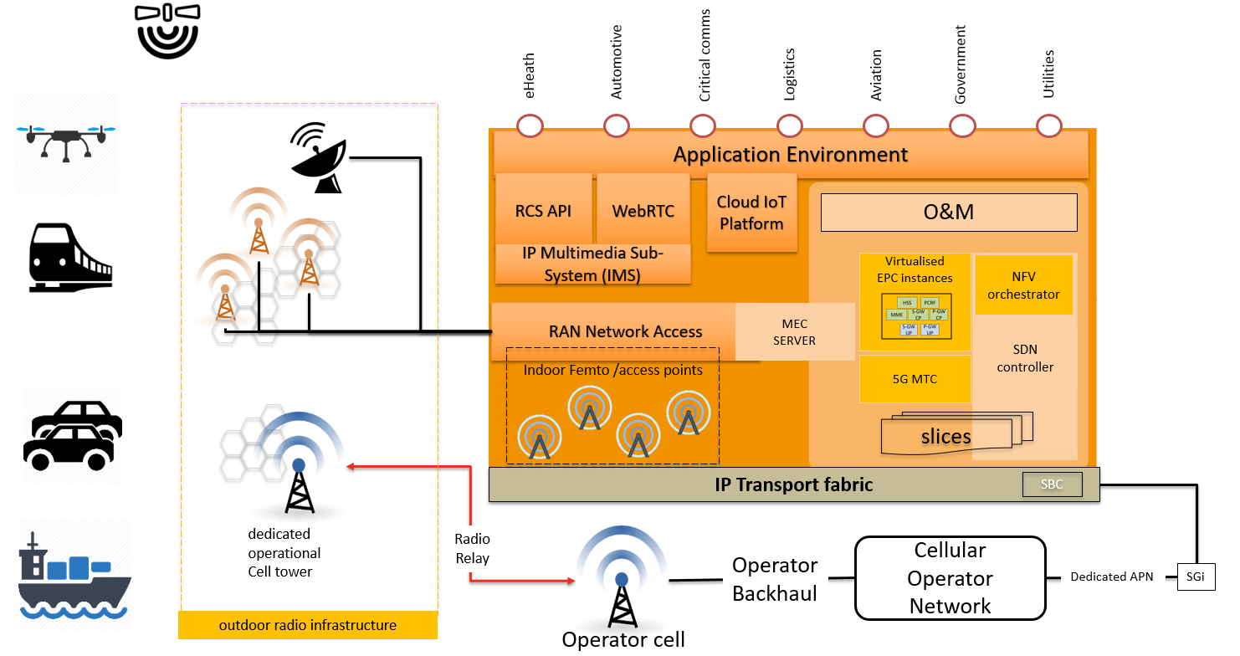
Figure 2 -5G step out center –high-level architecture
The architecture must comprise of a series of network elements aligning to international standards e.g. 3GPP, ITU, ETSI, IETF and ONF. It should be noted that we wish to avoid proprietary solutions that limit flexibility and create vendor lock-in. Therefore the telecommunications architecture solution should be compliant with current or proposed 3GPP standards, proposers should consider 3GPP release 11 or above to be the minimum functional requirement. Figure 3 gives an insight into the functionality we seek in terms of alignment to 3GPP release timelines, our ambition is to have an ongoing evolving architecture we can easily integrate new functions or adapt the architecture to meet the market needs.

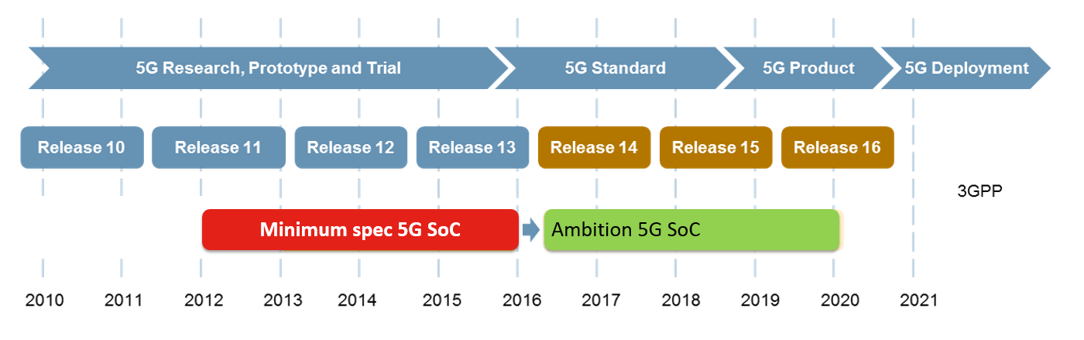
Figure 3 – Release Roadmap

5G R&D SoC Architecture Framework:

We require extensive use of Network Function Virtualization (NFV) and Software Defined Networking (SDN) to provide a flexible and manageable service orchestration environment; this should underpin the network architectural framework and shall be based on SDN/ NFV MANO concepts developed by standards bodies. Figure 2 below shows a high-level architecture and identifies some of the functional blocks to provide such a flexible service and network orientated framework.
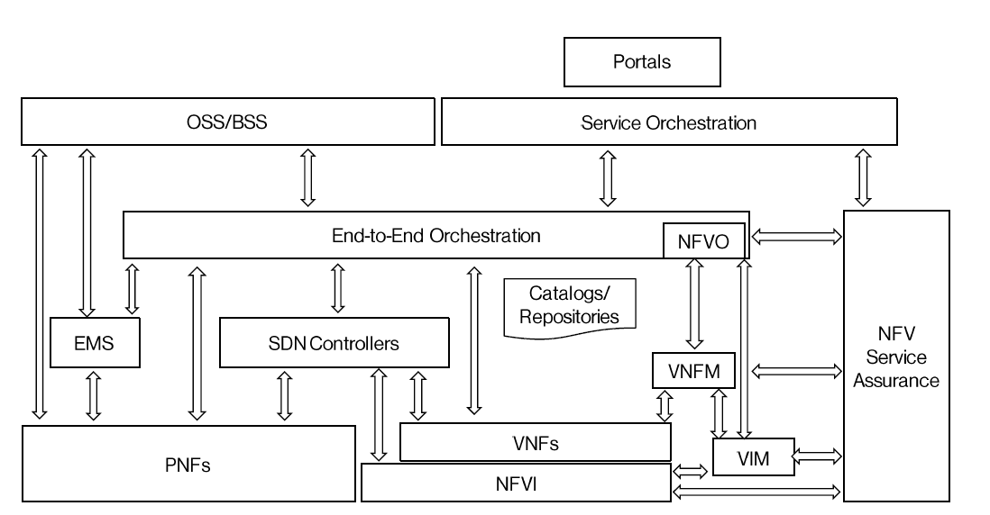
Figure 4 - SDN / NFV Architecture

It is a requirement that the architecture should align with ETSI-defined framework for the management and orchestration of all resources. This includes computing, networking, storage, and virtual machine (VM) resources. The focus of NFV MANO is to allow flexible on-boarding and rapid spin up of network components.
For a more detailed list of the functions, please refer to the following document http://www.etsi.org/deliver/etsi_gs/NFV-MAN/001_099/001/01.01.01_60/gs_NFV-MAN001v010101p.pdf

Evolved Packet Core Architecture
The Evolved Packet Core (EPC) architecture consists of a number of core functions all interconnected using an IP infrastructure to provide packet data services to Radio Access Network (RAN). These functions will be present in both the traditional and virtualized world. The core functions include the following elements:
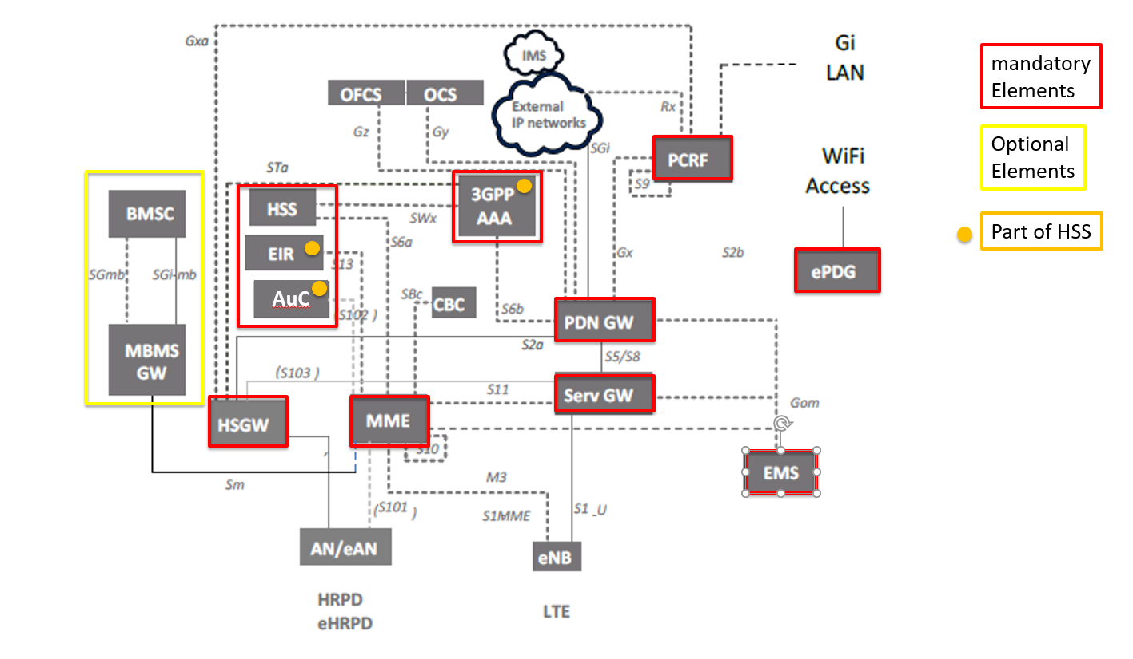
Figure 5 - EPC core elements

Figure 5 details the mandatory & optional network element of a typical Evolved Packet Core (EPC), following our architecture framework mentioned in the previous section we wish to deploy the EPC elements as virtual containerized functions on a SDN/NFV framework. In addition, we require to segregate both Control and User Plane this function is key to our distributed architecture framework; figure 6 details the control and user plane segregation (CUPS)
A proposal must also take into consideration the use of Non-3GPP trusted & untrusted access proposers should specify how this would be catered for in your product or architecture solution, specifically paying attention to the S2a, S2b, & S2c interfaces from the Non-3GPP trusted & untrusted Access e.g. the S2a Mobility over GTP (SaMOG)

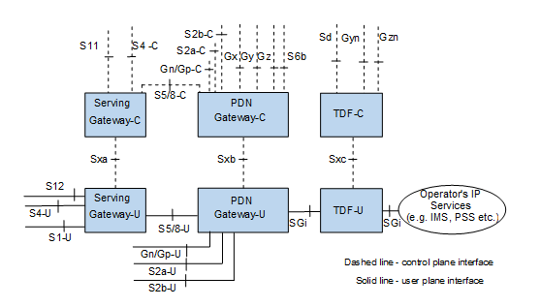
Figure 6 - Control & User Plane Segregation (CUPS)
As a consequence of having a completely distributed architectural framework to deploy the various EPC network functions , proposers should explain to what extent their proposed solution is able to meet the requirements of distribution in the context of centralization and distributed functions, Table 2. Gives centralized and distributed scenarios; proposers should confirm their ability to meet these requirements.
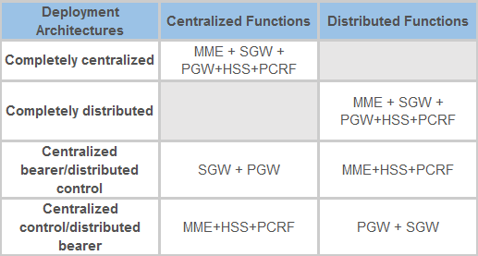
Table 2 - Architecture deployment scenarios

For a more detailed list of the functions these elements perform, please refer to 3GPP TS 23.401 or 23.402.

Radio access technologies
A key element of the 5G R&R SoC will be its radio access technology and the deployment flexibility afforded by the proposers product solution. The 5G R&R SoC will provide an enterprise grade small cell capability with the following outlined specifications, this is not a rigid specification, but an outline, bidders can propose products of a similar capability.
- Enterprise small cell capable of offering two sectors of capacity as LTE.
- LTE operation in two bands, with up to 64 LTE users per band, with a peak LTE throughput of 300 Mbps with Carrier Aggregation.
- Self-Organizing Network (SON) capabilities. radio nodes are able to listen to other radio nodes, as well as to GSM, UMTS and LTE macro-cells.
- LTE-U/LAA enterprise small cell capable.

Session management and control
The IP Multimedia Subsystem (IMS) is an architectural framework for delivering IP multimedia services. Historically, mobile services have provided only voice, video and data services over a switched-circuit-style network, rather than strictly over an IP packet-switched network. In the last decade, we have transitioned from a circuit switched environment to an all IP infrastructure with applications being delivered as rich multimedia services. 3GPP TS 23.228 specifies the IP multimedia sub-system and series of entities to manage the setup, clear down and adaption of rich media services e.g. Voice over IP, Video and multimedia messaging.
Within the architecture framework specified throughout this ITT, we require the capability of a session management entity to undertake control of multimedia services that is 3GPP, IETF or ETSI TISPAN compliant. In this context, we request proposers to define their product capability to provide session management and control. Figure 7 gives a typical example of the IP multimedia Sub-system together with Figure 2 proposers should explain their product and service capability.
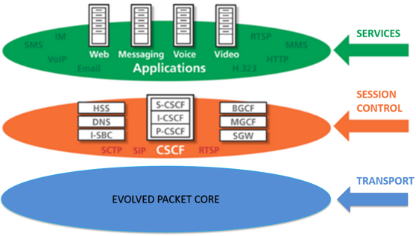
Figure 7 - Session Management & Control

Machine Type Computing (MTC) – M2M / IoT
5G R&R SoC will use its architecture and functionalities to enable the full implementation of services based on the Internet of Things (IoT) concepts. This will result with a completely new communications between different types of machines (M2M, D2D, V2V, etc.) regardless of whether they're mobile, far apart or interconnected with different access technologies.
A core architectural element of the 5G R&R SoC will be a cloud or virtualized standards compliant M2M/IoT services platform that will exploit the highly heterogeneous and dynamic capabilities of our architecture.
Proposers should consider their products ability to integrate into this architecture framework and for a standards based approach based on the M2M standards in oneM2M-TS-0001 and the ETSI Technical Committee M2M in TS 102.921 and TS 102.690.
Considerations should be made towards the following aspects of your product or solution:
- Connectivity control and subscription management
- Secure ownership bootstrapping
- Support for secure network islands
- Support for edge computing M2M applications
- eUICC network support
- Addressing the connectivity of a multitude of devices.

Mobile Edge Computing (MEC)
Within the scope of the ITT, we seek to implement an ETSI MEC standard-based solution, which quickly and effectively offers MEC solutions in support of services for Internet-of-things (IoT), content delivery and enterprise applications. The MEC platform should be a fully virtualized software solution. The MEC standard-based platform should create an open ecosystem for third-party MEC applications.
We seek to procure within the ITT framework a solution capable of providing basic MEC functionality at the edge of the network and close to the radio access network.
The MEC platform should ideally follow the architecture being defined by ETSI, however we are open to proposers making recommendations based on their product, addressing the need for content at the edge and how it would integrate within our architectural framework, whilst avoiding vendor lock in or highly proprietary interface or protocols that would not interwork with other vendor solutions or prevent migration should the standards evolve over time.

Operation, Control & Management
Across the whole of the architecture framework, we require a method to manage, operate and control the various network elements in the architecture; this will include
- Performance management.
- Configuration management.
- Element management.
- Fault, failure diagnostics debugging and logging.
- License and update management.
- Version management.
- Image backup, restore and roll back.

Proposers should state the capability of their approach to managing their proposed product or solution, how would this meet the need for complete visibility of the specified product or solution, how will this be achieved given the required capability stated above. Please specify if this is under a single or multiple EMS that uses a CLI or GUI or both.

Ancillary Equipment or Nodes
With reference to Table 1, in order to interwork with legacy protocols and interfaces including media translation and transcoding we require proposers to provide the following network elements or functions:
- Media Gateways (MGW)
- Media Gateway Control Function (MGCF)
- Session Border Controller (SBC)

Test and measurement Equipment
As a part of the overall facilities capability, we invite test and measurement equipment suppliers to propose test, measurement, emulation or simulation solutions to address the following areas of interest.
- UE emulation & simulation – support for single or multiple UE emulations
- eUTRAN emulation & simulation e.g. looks like a eNodeb to the UE
- EPC protocol analyzers – 3GPP protocol traces
- Spectrum Analyzers – 1Ghz to 30Ghz

Additional functionality
Supporting additional functionally is key to the long term sustainability of the 5G SoC, suppliers are encouraged to demonstrate how they will support additional features or functionality up to the latest 3GPP releases of interest will be implementations of :
- Mission-critical video and mission-critical data services , Mission-Critical Press-to-Talk (MC-PTT)
- Vehicle to infrastructure , LTE support for V2x
- Proximity Services (ProSe) & Direct Mode (D2D)
- E- Multimedia Broadcast Multicast Services eMBMS
- LTE-A Pro encompasses NB-IOT and LTE-M technologies that will provide lower speed narrowband access for low power devices.
- Device-to-network relays for IoT and wearables,
- LTE in unlicensed spectrum (LTE-U)
- Licensed Assisted Access (LAA / eLAA)
- LTE-Hetnet (LTE-H) a.k.a. LTE Wi-Fi Link Aggregation (LWA)
- LTE Relay Node
- eMBMS

Project initialization
The Satellite Application Catapult expects to hold an inception/scoping meeting with the successful supplier. The purpose of the meeting will be to provide the catapult and its stakeholders an opportunity to clarify their approach, confirm key milestones and dates for deliverables, understand risks and how these will be managed etc. Before proceeding or undertaking any activities.
The successful supplier should also prepare to do a presentation to technical and nontechnical members of the Catapult in a clear and concise fashion, to set out the key deliverable and anticipated architecture, key assumptions, performance, and caveats prior to deployment, this is to ensure all commitments are fully understood.

KEY MILESTONES

The selected respondent should note the following key project milestones from contract award and project kick off.

Milestone | Description | Timeframe
1 | Project inception meeting with Satellite Application Catapult and additional vendors | Within week 1 of Contract Award
2 | Preliminary Design Review (PDR) | Within week 2 of Contract Award
3 | Critical Design Review (CDR) | Within week 4 of Contract Award
4 | Finalized Architecture design , implementation plan, project plan, resource plan. | Within week 6 weeks of Contract Award

Table 3 - Project milestones

EVOLUTION AND PRODUCT ROADMAPS
Proposers will be expected to provide a complete and concise view of their relevant product roadmaps with committed timescales. This will include a view of obsolescence and anticipated product lifespan including detailed plans on how the product/service or solution will be supersede or upgrade over the next 3 to 5 years.

SUPPORT SERVICES CUSTOMER SERVICE
The Catapult requires the proposers to provide a sufficient level of resource throughout the duration of the contract in order to deliver a quality service and complete the implementation of the 5G R&R SoC.
Potential Provider’s staff assigned to the contract shall have the relevant qualifications and experience to deliver the contract. The proposer shall provide CV’s of suitably qualified and experienced staff in the execution of this contract.
The Potential Provider shall ensure that staff understand the Catapults vision and objectives and will provide excellent customer service to the Catapult or it stakeholders throughout the duration of the Contract.

ADDITIONAL INFORMATION
The supplier should demonstrate that they are open to working collaboratively with other suppliers contracted by the catapult in order to deliver a fully functional network architecture.

Supplementary questions
Respondents must answer the supplementary questions in Annex A-2 and return their answers as a part of their response to this ITT.

